STAFF REPORT

Agenda Item: | 8 | Name: | Andrew Kim
Proposed No.: | 2021-0384 | Date: | January 26, 2022

SUBJECT

A proposed ordinance to make code changes related to the reporting and oversight of capital projects which include changes to the Mandatory Phased Appropriation process.

SUMMARY

In 2004, the county established the Joint Advisory Group (JAG) to provide a forum for discussing a schedule of all legislation and early policy level dialogue between the executive and the council on major capital project and major real estate matters. The group members include two designees of the council and two designees of the executive. In 2010, in response to an accountability audit by the Washington State Auditor’s Office, the county established a process to designate capital projects greater than $10 million to be Mandatory Phased Appropriation (MPA) projects based on a risk assessment and therefore subject to greater oversight and controls. The JAG is primarily responsible for designating MPA projects based on the risk assessment.

Since 2010, the number of capital projects greater than $10 million has increased exponentially while the number of MPA designated projects has decreased. This has resulted in an increase in the volume of risk assessment work for county agencies that have not necessarily enhanced capital oversight by the council. To enable the council to focus review on the highest-risk capital projects while also reducing administrative burdens on county agencies, Proposed Ordinance 2021-0384 would make the following highlighted code changes:
- Increase threshold to $25 million for capital projects to undergo risk assessment,
- Replace the MPA process with a similar risk monitoring process,
- Dissolve the JAG and place responsibility of designating risk monitored projects solely on the council and the executive, and
- Make other capital project data and reporting changes.

With council’s legal counsel input, council staff has prepared striking amendment S1 which would require council approval of emergent need contingency expenditure authority for risk monitored projects and make other technical changes.
BACKGROUND

Joint Advisory Group (JAG). In 2001, in anticipation of upcoming budget deficits, the council established the Properties Expert Review Task Force (PERT) to review county assets and provide recommendations to council on managing county assets to alleviate the deficits. One of PERT’s recommendation was the creation of the JAG to expedite policy level decisions regarding real estate. As a result, in 2004, Ordinance 14921 established the joint advisory group to provide a forum for discussing a schedule of all legislation and early policy level dialogue between the executive and the council on major capital project and major real estate matters. JAG membership consisted of three councilmembers and three designees appointed by the executive.

In 2014, as part of a broader code clean-up related to capital project oversight, Ordinance 17930 modified the responsibilities and membership of the JAG to what it is today. As per K.C.C. 4A.160.010, JAG responsibilities include the following:
- Review of upcoming legislative transmittals, including scheduling ramifications for capital projects,
- Review of the scope, schedule, and budget information for major capital projects,
- Review of project risk assessment scores and making mandatory phased appropriation determinations for capital projects,
- Discussing emerging projects and issues, as well as ongoing proposals regarding capital projects greater than $10 million or more with major policy considerations, major real estate projects greater than $1 million or more with major policy considerations, and
- Assisting with coordination of capital project and real estate management matters involving the county’s independent elected officials.

As per K.C.C. 4A.160.020, membership includes two designees of the council and two designees of the executive. The current membership includes the following individuals:
- Andrew Kim, council staff, co-lead of budget and fiscal management committee,
- Brandi Vena, council staff, co-lead of budget and fiscal management committee,
- Aaron Rubardt, deputy budget director, Office of Performance, Strategy and Budget, and
- Karan Gill, deputy chief of staff, Office of the Executive

Since 2017, the JAG has conducted approximately 2 to 3 meetings per year, usually during the first half of the year, with the agenda focused solely on reviewing project risk assessment scores and making mandatory phased appropriation determinations for capital projects.

Mandatory Phased Appropriation (MPA) Projects. Over the years, the council had taken various steps to provide capital project oversight for the county. In 2006, by way of the 2007 budget, the council created a capital projects oversight (CPO) pilot program in the county auditor's office to oversees the county's large capital construction projects. In 2008, the council required the executive to transmit a critical analysis report for all current capital improvement projects over $750,000.

However, in 2009, the Office of Washington State Auditor’s 2009 Accountability Audit Report of King County found that “lack of adequate performance measures and expectations prevent the King County Executive and Council from providing adequate oversight of construction activity.” The state Auditor noted, "We believe some of the variances [between initial budget and final project cost] may be attributed to poor budget estimation, inaccurate or incomplete project specifications and/or inadequate cost controls."

As a response, in 2010, the county enacted Ordinance 16764 which established the process for the JAG, in consultation with the CPO program, to determine capital projects to be designated mandatory phased appropriation projects (MPA) based on a risk assessment and therefore subject to greater oversight and controls. The diagram below provides an overview of the current MPA process.

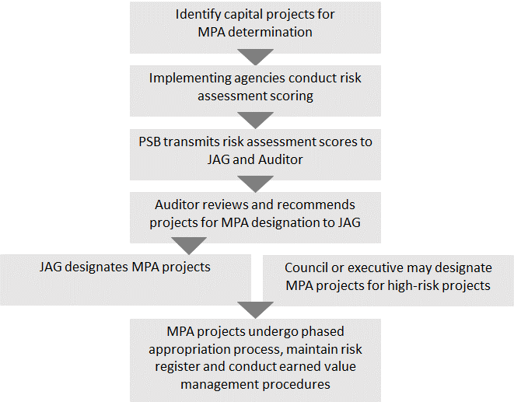
MPA Determination Process Criteria. As per K.C.C. 4A.130.010, capital projects that meet the following criteria shall undergo a MPA determination process:
- The total project cost estimate is over $10 million,
- Total appropriations exceed $250,000 for General Fund projects and $500,000 for Non-General Fund projects, and
- For projects that has already set a project baseline and not had a mandatory phased appropriation determination since setting of its project baseline.

In addition, as per K.C.C. 4A.130.010, the following types of capital projects are exempt from mandatory phased appropriation:
- Information technology projects that do not involve construction and that are subject to the project review board,
- Open space acquisitions,
- Purchase of transit vehicles, and
- Lease-based projects that already comply with phased requirements.

ANALYSIS

Since the MPA process was established in 2010, the number of capital projects greater than $10 million has increased exponentially while the number of MPA designated projects has decreased. This has resulted in an increase in the volume of risk assessment work for county agencies that have not necessarily enhanced capital oversight by the council. Figure 1 on the next page compares the number of capital projects subject to MPA determination with the number of MPA designated projects.

Attachment 6 to the staff report provides a list of all 31 capital projects that are MPA designated. It should be noted that of the 12 capital projects (with cost estimate greater than $10 million) that the council has taken additional budgetary measures (i.e., expenditure restrictions and provisos) since 2017, 3 of those projects are designated MPA projects. The 12 projects are as follows with MPA projects bolded:

- Adult and Juvenile Detention – Jail Management System
- KCIT – Puget Sound Emergency Radio Network (PSERN)
- KCIT – Eastrail Fiber Development
- Parks and Recreation – East Lake Sammamish Trail
- Solid Waste – Facilities Relocation Alternatives
- Solid Waste – Cedar Hills Regional Landfill Area 9 New Area Development
- Solid Waste – Northeast Recycling & Transfer Station
- Transit – Electric Bus Charging Infrastructure
- Transit – ORCA Replacement Project
- Transit – Center City Mobility Project
- Transit – Move Seattle Rapid Ride Expansion
- Transit – Metro Connects Rapid Ride Expansion

In 2019, in collaboration with JAG, county agencies, and the county auditor’s office, executive staff began review of MPA data to find alternative approaches to enable the council to maintain focus review on the highest-risk capital projects while also reducing administrative burdens on county agencies. As a result, the executive has transmitted Proposed Ordinance 2021-0384 which would make changes to the MPA process and other reporting requirements related to capital project oversight. Table 1 on subsequent pages provides a summary of the proposed changes with rationale for each change and Figure 2 compares the current MPA process to the proposed risk monitoring process.

Washington Auditor Report Updates. Of note, the Office of Washington State Auditor has not issued any additional findings related to the county’s oversight of capital projects since its initial finding back in 2009.

Figure 1. Number of capital projects subject to MPA determination,
MPA designated, and with cost estimates > $25 million

Table 1. Comparison of current practice and changes included in Proposed Ordinance 2021-0384.

No. |  | Current Practice |  | Proposed Changes |  | Rationale for Change
1 |  | (K.C.C. 2.16.025.B.8.i) The biennial Benefit Achievement Plan (BAP) summary report shall be about benefits achieved from all technology projects and expected benefits from all technology projects not yet completed. |  | The biennial BAP summary report shall be about benefits achieved for completed technology projects that are $5 million or more and no longer about expected benefits from technology projects not yet completed. |  | Enable the council to focus review on the highest-risk projects in the county 's capital improvement program while also reducing administrative burdens on county agencies.  Council staff analysis of BAP summary report has typically focused on completed projects.
2 |  | (K.C.C. 4A.100.030.B.12) Capital Improvement Program (CIP) data shall include a list of lapsed capital projects for which the appropriation has lapsed because the capital project has been abandoned or no expenditure or encumbrance has been made on the project for three years shall be disappropriated. |  | Such reporting requirement would be removed from CIP data (no longer included in the CIP attachment of proposed budget ordinances) and instead be included in the quarterly management and budget report. |  | Support capital budgeting requirements to be clearer and consistent with current practices.  Council staff has typically categorized such capital project disappropriations in the CIP as technical changes for budget analysis.
3 |  | (K.C.C. 4A.100.030.C.10) CIP data shall provide an explanation of how inflation is incorporated or reference to applicable county policy. |  | Such requirement would be removed from CIP data. |  | Consistent with current practice. Each capital program uses the best information available along with applicable professional standards within the industry to estimate inflation of future costs. PSB recommends using the Office of Economic and Financial Analysis (OEFA) inflation projection when more specific project information is not available.
4 |  | No requirement. |  | (K.C.C. 4A.100.090) Allow transfer of expenditure authority from grant contingency project to an existing project without council approval up to the amount of the grant awarded. Any transferred expenditure authority that is unused may be transferred back to the grant contingency project without council approval. The transfers would be documented in the quarterly management and budget report. |  | Eliminate ambiguity by codifying current practice in county code and also support capital budgeting requirements to be clearer.
5 |  | (K.C.C. 4A.130.010.A) Capital projects shall undergo risk assessment if:  - cost estimate is over $10 million, and  - total appropriations exceed $250,000 for General Fund projects and $500,000 for Non-General Fund projects. |  | Capital projects shall undergo risk assessment if:  - cost estimate is over $25 million,  - total appropriations exceed $3 million, and  - project is less than 3 years away from establishing a project baseline or the project has completed the planning phase |  | Reduce administrative burden on county agencies by limiting the number of capital projects that would need to undergo risk assessment. Figure 1 above compares the number of capital projects above the $10 million threshold compared to capital projects above the $25 million threshold.
6 |  | (K.C.C. 4A.130.020) Capital projects are designated as MPA projects by the Joint Advisory Group (JAG).  For capital projects with characteristics that increase their likelihood of being completed late or over budget at a potentially significant financial cost or other significant impact to the county, the council may designate a capital project as a MPA by motion or the executive may designate a capital project as MPA by letter. |  | JAG would be dissolved.  The council may designate a capital project as a risk monitored project by motion or the executive may designate a capital project as a risk monitored project by letter if: (a) the capital project is recommended by the county auditor; (b) the capital project has not submitted a completed risk assessment scoring instrument as required by this section; or (c) the capital project is otherwise judged to have characteristics that increase its likelihood of being completed late or over budget at a potentially significant financial cost or other significant impact to the county. |  | Reduce administrative burdens on county agencies by reducing the volume of risk assessment work for county agencies that have not necessarily enhanced capital oversight by the council. Place the responsibility of MPA designation directly on the executive and council to enable focus review on the highest-risk capital projects. Figure 1 above shows the decrease in the number of MPA designations since 2010.
7 |  | (K.C.C. 4A.130.040) For all risk monitored projects, earned value analysis shall be updated at least monthly. |  | The earned value analysis would be updated at least quarterly. |  | Enable the council to focus review on the highest-risk projects in the county 's capital improvement program while also reducing administrative burdens on county agencies.

Figure 2. Comparison of current MPA process with proposed risk monitoring process (PO 2021-03484).

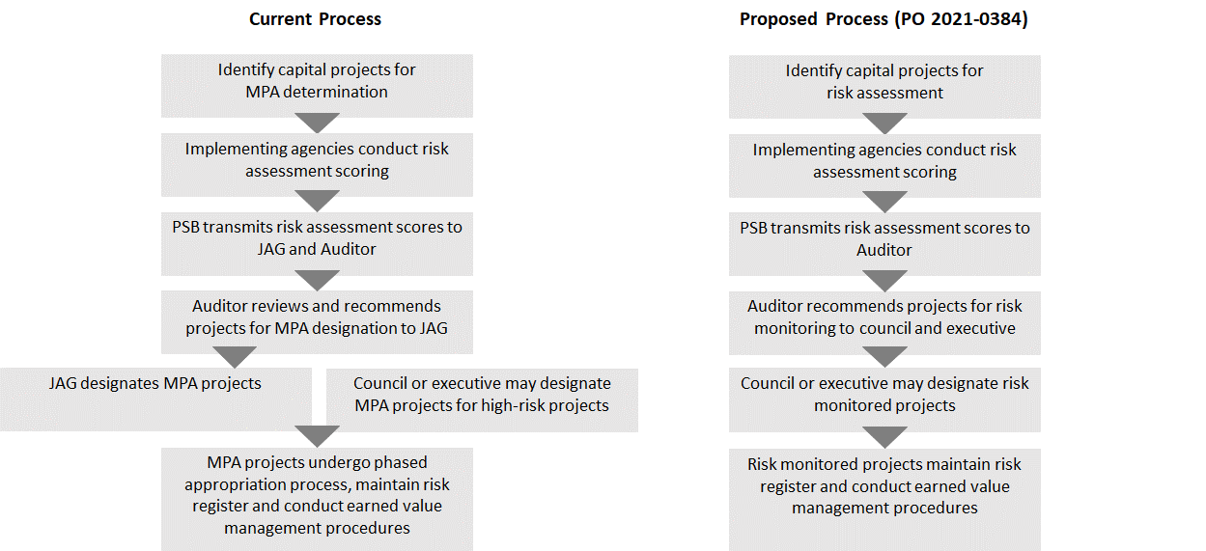

AMENDMENT

With council’s legal counsel input, council staff has prepared striking amendment S1 which would do the following:
- Add a Statement of Facts to provide background information,
- Modify the due date for the county auditor to file risk assessment score results and a letter recommending which capital projects should be designated risk monitored projects to the council and the executive from May 31 of each year to June 30 of each year,
- Require council approval of emergent need contingency expenditure authority for risk monitored projects, and
- Make other technical changes including: (a) replacing the term "project plan" with "capital appropriation proposal form" and (b) replacing the term "risk monitored project determination" with "risk assessment".

Title amendment T1 has also been prepared to reflect striking amendment S1.

INVITED

- Dwight Dively, Director, Office of Performance, Strategy and Budget
- Ben Thompson, Deputy Auditor, County Auditor’s Office

ATTACHMENTS

- Proposed Ordinance 2021-0384
- Striking Amendment S1
- Title Amendment T1
- Transmittal Letter
- Fiscal Note
- Current status of all Mandatory Phased Appropriation (MPA) projects

Ordinance 14106.
Ordinance 15652.
In 2014, Ordinance 17930 permanently included the CPO program as part of the county auditor’s annual work program.
As per K.C.C. 4A.10.469, "Project baseline" means the scope, schedule and budget of a capital project that are set by the implementing agency at the conclusion of a project's preliminary design phase, which is after the preferred alternative has been selected and design has progressed adequately to make reasonable and informed commitments at thirty to forty percent design.
As per Ordinance 14155, the project review board shall act in an advisory capacity to the county's chief information officer on information technology matters. Currently, the members include the chief information officer, the budget director, and the director of executive services.
As prescribed under K.C.C. 4A.130.050.
Proposed Motion 2021-0191 (Motion approving the 2019-2020 biennial technology projects benefits report on the benefits achieved from technology projects.)

