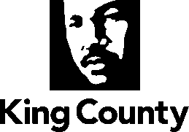
Metropolitan King County Council

News Release
Contact: NEED
Date: DATE

Public hearing planned on proposal to sell county land to City of Issaquah

The Metropolitan King County Council will hold a hearing on DAY/DATE at TIME to gather public comment on a proposed ordinance that would allow the county to sell two parcels of land to the City of Issaquah.

The properties are located at 23240 SE 74th St. and at 17XX SE Newport Way in unincorporated King County.

Copies of the proposed ordinance are available upon request from the Clerk of the King County Council, Room 1200, King County Courthouse, 516 Third Ave., Seattle, WA 98104, or by calling 206-296-1020. The ordinance is also available online at www.kingcounty.gov/council/clerk.aspx by searching for proposed ordinance number 2016-XXXX.

A public hearing on the proposal will be held before the full Council at the King County Courthouse, Room 1001, on DAY/DATE at TIME.

# # #

