STAFF REPORT

Proposed No.: | 2020-0306 | Name: | Andrew Kim

SUBJECT

An ordinance that adopts the 2021-2022 Biennial Budget and makes appropriations for the operation of county agencies and departments and capital improvements for the fiscal period beginning January 1, 2021 and ending December 31, 2022.

SUMMARY AND ANALYSIS

As shown in Table 1 below, the executive is proposing a total appropriation of $12.63 billion for the 2021-2022 Biennial Budget. The proposed appropriation is a 6.2% ($700 million) increase compared to the initial 2019-2020 Biennial Adopted Budget and a 6.7% ($900 million) decrease compared to the 2019-2020 Biennial Revised Budget. The 2019-2020 Biennial Revised Budget includes one-time supplemental appropriations that would not be carried over to the next biennium, including numerous large capital appropriations, and approximately $275 million of COVID-19 related appropriations supported by federal and state grants.

Tables 2, 3, and 4 below provide a summary of the executive proposed appropriation amounts by General Fund Operating, Non-General Fund Operating, and Capital budgets.

Table 1. Executive Proposed 2021-2022 Biennial Budget

Area |  | 2019-2020 Adopted |  | 2019-2020 Revised |  | 2021-2022 Proposed
General Fund |  | $1.86 B |  | $1.99 B |  | $1.92 B
Non-General Fund |  | $8.11 B |  | $9.06 B |  | $9.35 B
Capital Improvement Program |  | $1.92 B |  | $2.46 B |  | $1.36 B
TOTAL |  | $11.89 B |  | $13.51 B |  | $12.63 B

Table 2. Executive Proposed 2021-2022 General Fund Operating Budget

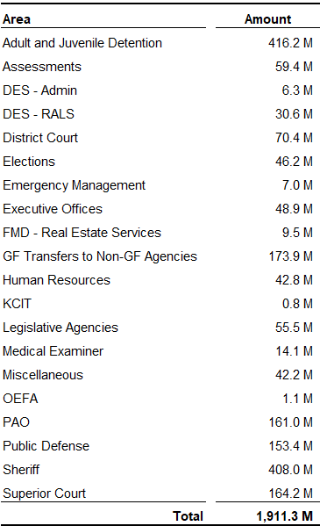

Table 3. Executive Proposed 2021-2022 Non-General Fund Operating Budget

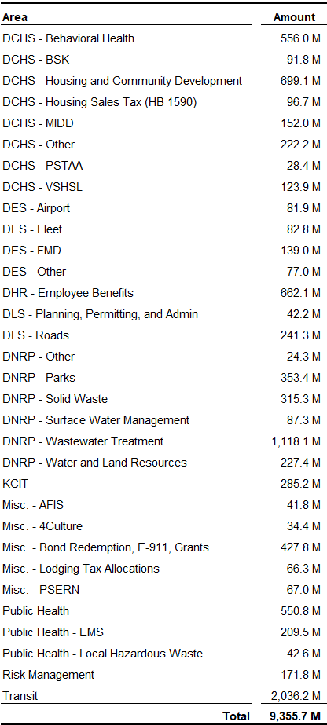
Table 4. Executive Proposed 2021-2022 Capital Budget

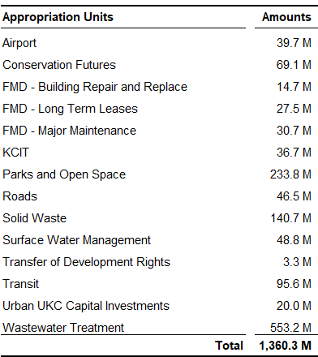

COVID-19 Pandemic Impacts to the 2021-2022 Biennial Budget

Revenues. As a result of the continued worldwide spread of COVID-19 and its significant progression throughout the county and in Washington state, on March 23, 2020, Governor Inslee issued a "Stay Home - Stay Healthy" order prohibiting, with limited exceptions, all people in Washington state from leaving their homes or participating in gatherings and required all nonessential businesses in the state to cease operations except to perform basic minimal operations. On May 31, 2020, the Governor amended the "Stay Home - Stay Healthy" order and renamed it the "Safe Start - Stay Healthy" proclamation which deferred the reopening to a phased approach for each county which would be determined by the trending of COVID-19 infections. King County is currently in Phase 2 of the 4-Phase approach. Phase 2 limits occupancy of many establishments to 25% and limit gatherings to 5 people outside the household.

These preventative measures necessitated by the pandemic have resulted in a recession in the county, Washington State and throughout the country. The executive’s proposed budget book characterizes the recession as the deepest since the Great Depression. According to the Office of Economic and Financial Analysis (OEFA), the unemployment rate peaked to 14.9% in April and the latest data from the State’s Employment Security Department showed unemployment rate at 7.2% for August. In comparison, the unemployment rate during the peak of the 2008 Great Recession was just below 10.0%. The executive’s proposed 2021-2022 Biennial Budget is based on OEFA’s August 2020 revenue forecasts. The following highlights key indicators from the forecast and its impacts to county revenues for the 2021-2022 biennium:

- Countywide Assessed Value and New Construction – For countywide assessed value, there is an estimated 6.0% growth in 2020 which is lower than the 13.4% per year growth for both 2018 and 2019. This is compounded by a 2.0% growth in 2021 and a 2.0% decline in 2022. For new construction, there is an estimated 4.6% decline in 2020 compared to double digit growth per year over the last six years. This is compounded with a 26.8% decline in 2021 and a further 9.4% decline in 2022. Most of the decline is in new commercial construction. As a result, the impacts to key county revenues for the 2021-2022 biennium are as follows:
  - Average 2.0% growth in General Fund revenues.
  - Average 4.0% growth in Parks Levy revenues.
  - Average 4.8% growth in Veteran, Seniors and Human Services Levy (VSHSL) revenues.
  - 4.3% growth in Best Starts for Kids (BSK) levy revenues.
  - Average 2.2% growth in Conservation Futures levy revenues.
  - Average 1.6% growth in Roads levy revenues.
  - Average 2.2% growth in Transit levy revenues.

- Sales and Use Tax – A 14.7% decline in 2020 with projected growth of 5.9% in 2021 and 7.1% in 2022 will result in sales tax revenues not returning to 2019 levels until 2023. As a result, the impacts to key county revenues for the 2021-2022 biennium are as follows:
  - $15.0 million decline in General Fund compared to 2019 revenue levels.
  - $85.0 million decline in Transit Fund compared to 2019 revenue levels.
  - $9.5 million decline in Mental Illness and Drug Dependency (MIDD) levy fund compared to 2019 revenue levels.

- Lodging Tax – $27.2 million decline in revenues compared to the August 2018 OEFA forecast (base revenue assumptions as established by Ordinance 18788).

General Fund. The General Fund financial plan that corresponds to the executive’s proposed budget shows a 20212022 Ending Undesignated Fund Balance of $46.2 million which is approximately $15 million lower than the 2019-2020 Estimated Budget. This reduces the Ending Undesignated Fund Balance from 8% to 6%, which is the minimum level recommended by the county’s Comprehensive Financial Management Policies. The county’s financial management policies recommend at least a 6% of Ending Undesignated Fund Balance of annual revenues, less intergovernmental receipts and inter-fund transfers, in order to maintain the county's credit rating, meet seasonal cash flow shortfalls, help maintain services during short periods of economic decline, and meet emergency conditions. In comparison, the Ending Undesignated Fund Balance level during the 2008 Great Recession period was 7.7% for 2008, 7.4% for 2009, and 6.0% for 2010. Figure 1 shows the General Fund Unending Designated Fund Balance and Rainy Day Reserve Fund amounts from 2008 through the executive proposed 2021-2022 biennial budget.

Figure 1. GF Ending Undesignated Fund Balance and Rainy Day Reserve Fund,
2008 through 2022

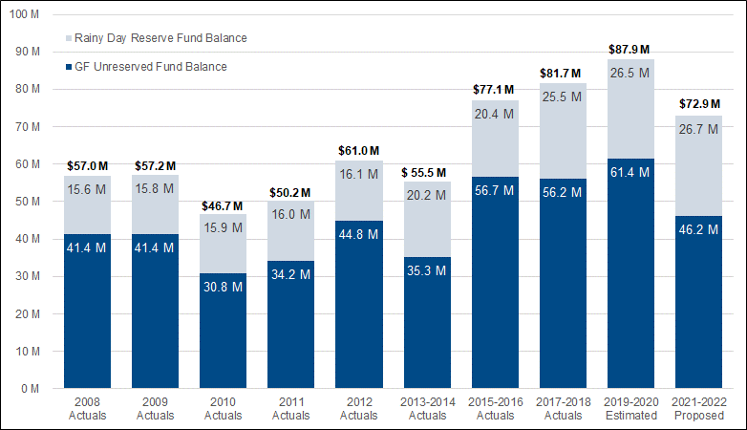

The executive proposed budget book states that in order to achieve this 6% level and mitigate the declining revenues due to COVID-19, budget reductions are proposed by eliminating positions, reducing or eliminating services, finding efficiencies in service delivery, and requiring internal service agencies to reduce their costs and charges. Most notably, the executive requested General Fund agencies to identify 5% reductions for 2021 and a further 5% reduction for 2022 (average 7.5% over the biennium).

Table 5 below shows the reduction target amounts for each General Fund agency and the percent of the target achieved by each agency in the proposed budget. The table also includes reduction targets by internal service agencies. Only a portion of the reduction targets of internal service agencies benefit the General Fund, however, such reductions benefit all agencies across the county. Executive staff noted that the reduction targets did not include costs beyond the agency’s control (e.g. DPD case filings, DAJD jail population, etc.) or any costs that would be revenue backed.

Table 5. General Fund and Internal Service Agencies Reduction Targets

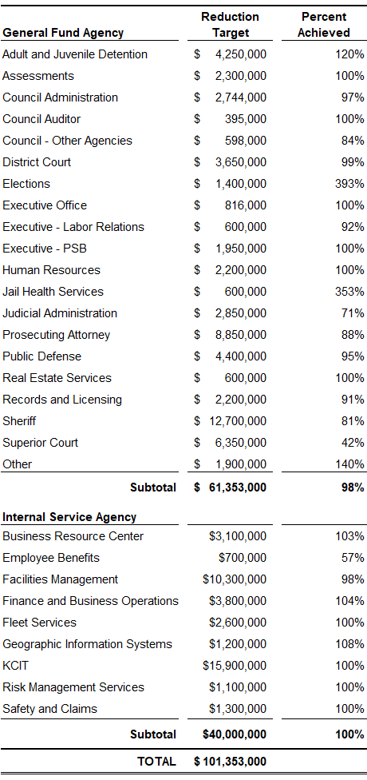
Position Reductions, Layoffs and Furloughs. For General Fund and internal service agencies, reduction targets resulted in proposed reductions of FTEs. Such reductions of FTEs was also necessary for Non-General Fund agencies to mitigate the revenue declines due COVID-19 and to ensure financial stability of their funds. Table 6 below provides a summary of the FTE reductions that are proposed throughout the county for both General Fund and Non-General Fund agencies. Most of the position reductions are proposed to be accomplished through attrition, employees opting into the county’s Voluntary Separation Program (VSP), and removal of vacant positions. Therefore, the executive proposed budget includes a smaller number of layoffs relative to the total number of FTE reductions.

Table 7 below provides a summary of agencies that are proposing to implement furloughs as part of their reduction measures. As Table 7 shows, few agencies have opted to utilize this option. Lastly, Table 8 is provided as reference to show the total number of FTEs that the executive is proposing in the 2021-2022 biennial budget. It should be noted that FTE levels change throughout the biennium, so the table shows the estimated FTE levels on December 2021 and December 2022.

Table 6. 2021-2022 Biennium Proposed Position Reductions and Layoffs

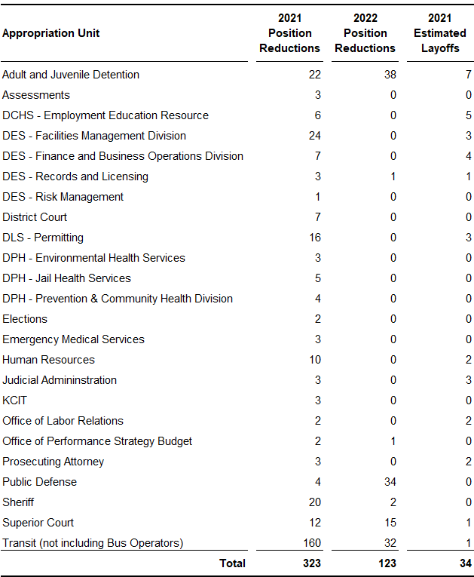

Table 7. 2021-2022 Biennium Proposed Furloughs

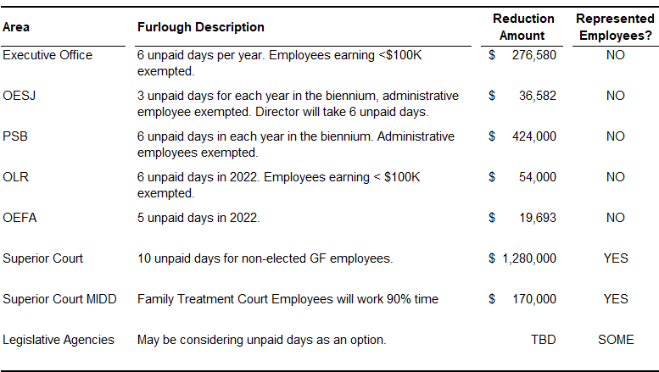

Table 8. Executive Proposed FTEs by Agency for 2021-2022 Biennium Budget

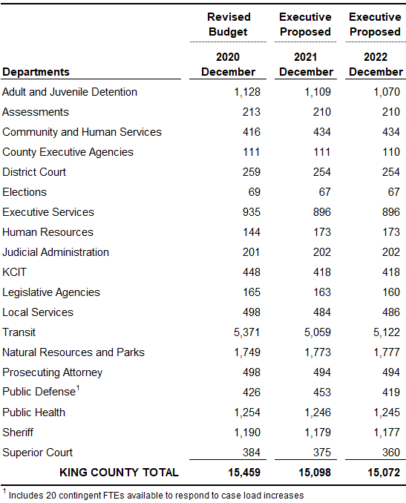

Base Budget Assumptions. In order to maintain the 6% Ending Undesignated Fund Balance level for the General Fund, the executive is also proposing to minimize labor cost growth. This includes no General Wage Increase (GWI) in 2021 and a 2.0% GWI for 2022 for employees represented by the Master Labor Agreement, the Corrections Guild and non-represented employees. The executive proposed budget book states that this assumption was based on the recently adopted King County Correctional Officers Guild contract. Table 9 below shows the GWI assumptions for all employees throughout the county for the proposed 2021-2022 Biennial Budget.

Table 9. Executive Proposed 2021-2022 Biennial Budget – GWI Assumptions
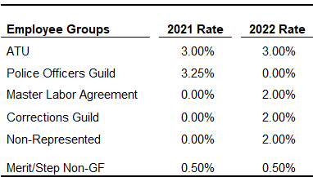

In addition to the GWI assumptions, the base budget adjustment of each appropriation unit also includes other personnel costs including retirement benefits, taxes, medical and dental benefits, and industrial insurance.

COVID-19 Response. For some appropriation units, the base budget adjustments include the removal of one-time supplemental appropriations related to the county’s response to the COVID-19 pandemic. According to the executive proposed budget book, the county received $575 million of federal and state funding to support the county’s response efforts to COVID-19. This included $530 million from the Coronavirus Aid, Relief, and Economic Security (CARES) Act of which $262 million is an allocation from the Treasury Department's Coronavirus Relief Fund and $243 million is an allocation to support Metro Transit. This amount does not include additional reimbursements that the county will receive from the Federal Emergency Management Agency (FEMA). The executive proposed budget book states that this reimbursement amount is unknown but it is estimated to be on the order of tens of millions of dollars.

Through four supplemental appropriation ordinances throughout 2020, the council has appropriated the use of these funds. Thus far, the council has appropriated $275 million to support the county’s COVID-19 pandemic response by various agencies. Table 10 below provides a breakdown of the supplemental appropriations by appropriation unit. The $243 million allocation to Metro Transit will not require council’s appropriation authority since such funding can be used to support revenue losses as a result of the COVID-19 pandemic.

Of note, the executive’s proposed budget does not include any appropriations to support the county’s COVID response in 2021. The executive proposed budget book states that an estimated $100 million would be needed to continue the current Public Health response, continue to operate the isolation, quarantine and de-escalation facilities throughout the county through 2021. The State does have federal funding to support the county’s Public Health efforts but the state legislature has not appropriated such funds and therefore is not included in the executive proposed budget. In addition, Congress has not taken any action on additional federal funding and therefore such revenues and corresponding appropriations are not proposed in the executive’s budget.

Table 10. 2020 Appropriations related to COVID-19 Pandemic Response

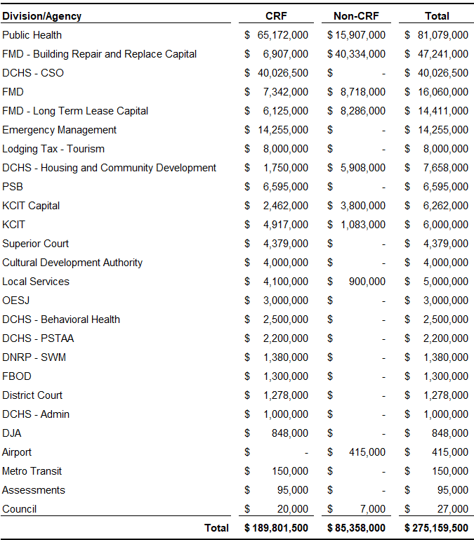

Investment Pool, Debt Ratio and Bond Ratings. As discussed above, the executive state that maintaining a 6% Ending Undesignated Fund Balance level will allow the county to maintain its AAA bond rating with the three credit agencies (Moody’s, Fitch and Standard and Poor’s), which is the highest possible ratings for county general obligation bonds. Executive staff state recent rating calls with the three rating agencies indicate that the county will most likely maintain its credit rating despite the economic conditions of the county and the reduction of the Ending Undesignated Fund Balance levels from 8% to 6%.

The executive proposed budget book states that the debt service limit is proposed to be about 3.7% in 2021 and 3.9% in 2022. This is below the debt service limit of 6% set by county policy for the General Fund. In addition, the county’s limited tax general obligation debt capacity is $9.6 billion, which is based on the countywide assessed value. According to the executive proposed budget book, as of the end of 2019, the county has only used $2.5 billion of debt capacity.

Lastly, it should be noted that the county’s investment pool, which invests cash reserves for all county agencies, special levy districts, and public authorities, currently holds approximately $8 billion.

Related Legislation
Along with the proposed 2021-2022 biennial budget ordinance, the executive has also transmitted related legislation that would support the executive’s proposed budget. Attachment 1 of the staff report includes the executive transmittal letter that summarizes all of the related legislation that was transmitted along with the budget ordinance. The following list highlights the notable legislation for possible council action:

- Housing Sales Tax – Proposed Ordinance 2020-0337 would authorize the levying of a councilmanic 0.1% sales tax as authorized by HB 1590 to support affordable housing and behavioral health.

- Use of Rainy Day Funds – Proposed Ordinance 2020-0324 would authorize the use $4 million of rainy day reserve funds to support the operation of isolation/quarantine and shelter de-intensification facilities for one month in 2021 in response to the COVID-19 pandemic.

- Emergency Budget Crisis – Proposed Ordinances 2020-0323 and 2020-0317 would proclaim an emergency budget crisis to allow implementation of furloughs and make code changes related to county furlough provisions.

- General Wage Increases (GWI) for Non-Represented Employees – Proposed Ordinance 2020-0316 would adopt the 2021-2022 Salary Schedules which would allow a 0.0% GWI for 2021 and 2.0% GWI for 2022.

ATTACHMENTS

- Transmittal Letter

For example, $82 million for Transit Hybrid and Electric fleet, $15 million acquisition of Downtown Public Health Center, $83 million for PSERN, $24 million for KC Correctional Facility Emergency Water pipe Replacement, etc.
The BSK levy will expire at the end of 2021.
Note that the Executive transmitted Proposed Ordinance 2020-0311, which would impose a housing sales tax. However, the Council introduced and plans to consider an alternate version (Proposed Ordinance 2020-0337).

