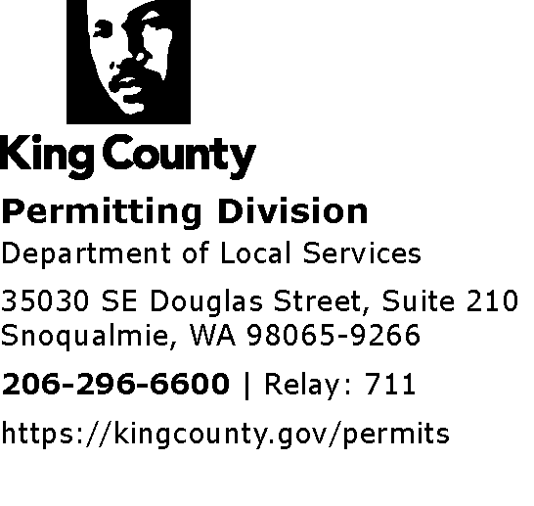
MEMORANDUM
Date: June 9, 2022
To: Erin Auzins, Supervising Legislative Anlst-Ccl, King County Council
From: Ty Peterson, PLM-Commercial, Dept. of Local Services – Permitting Div.
Re: State Environmental Policy Act (SEPA) Threshold Determination of Nonsignificance (DNS) for Non-Project action Ordinance 19030 & proposed Ordinance No. 2022-0147 re: regulations for Wineries, Breweries and Distilleries (WBD)
Erin,
As a SEPA official within the Permitting Division of the Department of Local Services with 25 years’ experience as a SEPA Official, I was tasked with performing the SEPA review and threshold determination under SEPA for the proposed Winery, Brewery, and Distillery (WBD) ordinance Ord. No. 2018-0241.2 and again for the adopted Ordinance 19030 and again for proposed Ordinance No. 2022-0147. All related.
As part of that process, I reviewed the original checklist, revised and expanded checklist, proposed ordinances, existing codes, regulations and policies, associated studies, analysis and the process and versions under which the proposed ordinance was developed.
The original DNS was issued and published on April 26, 2019, with a comment period ending May 17, 2019. A voluminous amount of public comment was received. After the County received direction from the Growth Hearings Board that a more thorough review under SEPA should be undertaken, a second SEPA review was conducted with an expanded Environmental Checklist and revised answers to the SEPA checklist. Another SEPA Determination of Non-significance was issued on January 15, 2021, with comment period ending on February 12, 2021. Again, a significant amount of public comment was received.
Since that time, a new ordinance addressing the same or less legislative scope has been introduced as proposed Ordinance No. 2022-0147. This ordinance aims to address concerns raised by interested parties and by the Growth Hearings Board. This is addressed further below.
As SEPA Official, I have a duty to review and consider public comments. I have reviewed the public comments, including those comments specifically stating or asking that the DNS be withdrawn and a Determination of Significance (DS) be issued initiating the Environmental Impact Statement (EIS) process.
After thoughtful consideration of these comments and consultation with other King County staff and Department of Ecology web resources, I have concluded that a DS is not necessary in this context and that proposed non-project action is not likely to result in a more than moderate impact on environmental quality. The reasons and process for coming to this conclusion are summarily enumerated below.

- This proposal was evaluated as a non-project action as required under SEPA for the adoption of legislation concerning general zoning and land use requirements. Project level impacts cannot be anticipated or forecasted with any responsible certainty and would result in gross speculation. There are instances, where as a result of new or amended regulation, reasonable anticipation of probable environmental impacts can be analyzed, however this is not the case with the amendments associated with this proposed ordinance, especially when considering the existing regulatory framework when compared to the proposal. Under proposed Ordinance No 2022-0147 the scope has been further reduced by eliminating the proposed uses from the Agricultural zones and eliminating the demonstration project area “A” in the Rural Area zone near Woodinville as well other minor amendments.

- Many of the comments received seemed not to understand that these are amendments to existing regulations, as opposed to new regulations establishing and allowing such uses. The exception being the creation of a demonstration project area for “tasting rooms” that has since been proposed to be removed under proposed Ordinance No. 2022-0147. Most of the proposed amendments result in further restriction and limitations on WBD uses, not expansion or introduction of new uses that are not already allowed under code. These uses are already allowed through various land use mechanisms and permitting in current code, prior to the adoption of Ordinance 19030. While amendments are considering changes to the zoning definitions and requirements for WBDs, the large amount of land use and environmental regulations remain unchanged and still applicable. However, consideration was given to whether the proposed amendments are likely to result in significant environmental impacts.

- Consideration of the potential for a likely significant impact / more than a probable adverse impact must consider existing environmental and existing built conditions, scope of the non-project action, and whether existing regulations mitigate any potential impacts.

- The proposed amendments do not change or alter any of the following environmental regulatory protections or areas of code.
  - No changes to critical areas regulations,
  - No changes to existing surface water management (drainage) regulations,
  - No change to flood plain regulations,
  - No change to Shoreline regulations,
  - Other than potential creation or elimination of Demonstration Project areas, no changes to zoning map / or change in zoning designations,
  - No change to Agricultural Protection District (APD) boundaries,
  - No change to Special Overlay (SO) agricultural buffer designations or applicability,
  - No change to clearing or grading regulations,
  - No change to the King County Road Standards, traffic concurrency requirements and related standards,
  - No change to noise regulations.

- Utilizing the process under SEPA (WAC 197-11-330) the environmental review finds that those potential impacts of concern identified in public comment either:
  - do not constitute a more than probable adverse environmental impact,
  - are mitigated through implementation of regulations not affected by the proposal,
  - are specifically designed to further limit and restrict the WBD uses and mitigate potential impacts; for example; restrictions on the size of buildings, further limitations on impervious surfaces, increased setbacks, minimum lot areas, restrictions on access and limits on associated events.
  - are misunderstanding the effect of proposed amendments,
  - are most appropriately analyzed at the project level under SEPA.

- Comments received are more appropriately considered and categorized as character, policy, philosophical, growth management and land use arguments. Those are all valid considerations for proposed legislation, and it is appropriate for Council to consider those comments in that context. However, none of the comments have identified unmitigated environmental impacts of the limited code changes that would result in a reasonable likelihood of more than a moderate adverse impact on environmental quality (WAC197-11-794).

- Furthermore, I understand that currently under consideration by Council is an Ordinance (proposed Ordinance No. 2022-0147) amending the previously adopted ordinance (19030) that would further restrict the proposed uses that the legislation aims to regulate and reducing the scope of the regulations under consideration. Some of those amended regulations include:

- prohibiting WBD uses within the Agricultural zoned areas,
- further restrictions in the RA zoned areas, and
- elimination of the Demonstration Project Area “A” for remote tasting rooms.
- The proposed amendments in 2022-0147 further reduce the scope of the proposal that had been reviewed under SEPA and further address a large percentage of the public comments where concerns about potential loss of Agricultural lands was a significant topic in those comments.

- Lastly, additional research was conducted, and data collected by King County staff that included more detailed county-wide parcel analysis of the available parcels and land that could potentially accommodate these uses. I have evaluated that data in part of the SEPA review and post comment consideration as well.

Please let me know if you have further questions or concerns.

