Legislative Review Form
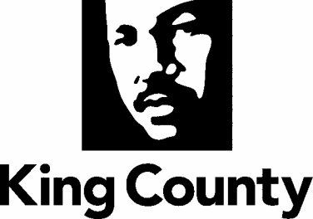

Agency: PSB Contact person: Dwight Dively Phone: 263-9687

Ordinance Motion Proviso Report Other

Civil Division Prosecuting Attorney Review

Name Janine Joly Version Final Date 9/8/20

Dept. Director or Designee Review

Name Dwight Dively Version Final Date 9/17/20

Performance Strategy & Budget Office Review

Name Aaron Rubardt Version Final Date 9/9/20

Technical Form/Code Reviser Review – Confirm adherence to legislative format

Name Bruce Ritzen Version Final Date 9/1/20

Executive Office Review & Transmittal Approval

Name Dwight Dively Version Final Date 9/17/20

ENTRANCE CRITERIA REVIEW
EXEC OFFICE (initials) KCC CLERK
Fiscal note? Y NA BB Y NA
KC Strategic Plan reference in letter? Y NA BB Y NA
Proof read for spelling and grammar? Y NA BB Y NA
All pertinent attachments listed/labeled? Y NA BB Y NA
Costs identified/described in letter Y NA BB Y NA
Regulatory Note Required and Complete? Y NA BB Y NA
Formatted/Delivered in word-searchable doc format? Y NA BB Y NA
Potential Annexation Area (PAA) impacts identified? Y NA BB Y NA
Advertising required? if yes, cite all pertinent code/laws. Y NA BB Y NA
Any special circumstances affecting processing time? Y NA BB Y NA

