Legislative Review Form
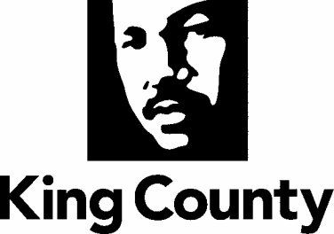

Agency: Metro Transit Department Contact person: Jeremy Fichter Phone: 206-477-5848

Ordinance Motion Proviso Report Other

Civil Division Prosecuting Attorney Review

Name Andrew Marcuse Version FINAL Date 11/22/22

Dept. Director or Designee Review

Name Terry White Version FINAL Date 11/21/22

Performance Strategy & Budget Office Review

Name T.J. Stutman Version Final Date 12/22/22

Technical Form/Code Reviser Review – Confirm adherence to legislative format

Name Bruce Ritzen Version FINAL Date 11/22/22

Executive Office Review & Transmittal Approval

Name Mina Hashemi Version Final Date 1/10/22

ENTRANCE CRITERIA REVIEW
EXEC OFFICE (initials) KCC CLERK
Fiscal note? Y NA Y NA
KC Strategic Plan reference in letter? Y NA Y NA
Proof read for spelling and grammar? Y NA Y NA
All pertinent attachments listed/labeled? Y NA Y NA
Costs identified/described in letter Y NA Y NO
Regulatory Note Required and Complete? Y NA Y NO
Formatted/Delivered in word-searchable doc format? Y NA Y NA
Potential Annexation Area (PAA) impacts identified? Y NA Y NO
Advertising required? if yes, cite all pertinent code/laws. Y NA Y NO
Any special circumstances affecting processing time? Y NA Y NO

