Legislative Review Form
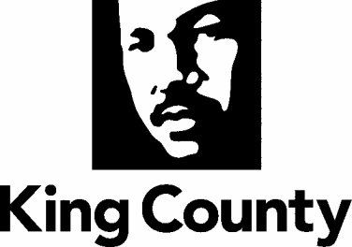

Agency: Metro Transit Department Contact person: Dave VanderZee Phone: (206) 477-0091

Ordinance Motion Proviso Report Other

Civil Division Prosecuting Attorney Review

Name Cheryl Carlson Version Final Date 1/12/21

Dept. Director or Designee Review

Name Terry White Version Final Date 2/10/2021

Performance Strategy & Budget Office Review

Name Shelley DeWys Version Final Date 3/8/21

Technical Form/Code Reviser Review – Confirm adherence to legislative format

Name Bruce Ritzen Version Final Date 1/7/21

Executive Office Review & Transmittal Approval

Name Karan Gill Version Final Date 3/8/21

ENTRANCE CRITERIA REVIEW
EXEC OFFICE (initials) KCC CLERK
Fiscal note? Y NA BB Y NA
KC Strategic Plan reference in letter? Y NA BB Y NA
Proof read for spelling and grammar? Y NA BB Y NA
All pertinent attachments listed/labeled? Y NA BB Y NA
Costs identified/described in letter Y NA BB Y NO
Regulatory Note Required and Complete? Y NA BB Y NO
Formatted/Delivered in word-searchable doc format? Y NA BB Y NA
Potential Annexation Area (PAA) impacts identified? Y NA BB Y NO
Advertising required? if yes, cite all pertinent code/laws. Y NA BB Y NO
Any special circumstances affecting processing time? Y NA BB Y NA

