Attachment C-1

Refunded Loans
Loan # | Project |  | Principal Balance (per DOE) | Interest | DOE Payoff Total
L0800012 | Brightwater Outfall |  | 2,181,843.10 | 1,297.15 | 2,183,140.25
L1100009 | Ballard Siphon |  | 23,324,175.22 | 73,359.32 | 23,397,534.54
L1300013 | Barton CSO |  | 3,064,670.67 | 19,723.04 | 3,084,393.71
L1300005 | Fremont Siphon |  | 951,833.41 | 11,476.76 | 963,310.17
L080009A | Carnation Treatment Plant |  | 4,117,444.52 | 46,160.50 | 4,163,605.02
L080009B | Carnation Treatment Plant |  | 1,322,327.66 | 18,193.78 | 1,340,521.44
EL150080 | South Magnolia |  | 20,941,261.28 | 63,512.26 | 21,004,773.54
EL150092 | Barton CSO |  | 4,515,020.74 | 24,047.12 | 4,539,067.86
L1300004 | South Magnolia |  | 3,609,394.95 | 27,233.63 | 3,636,628.58
L1300012 | Murray CSO |  | 3,351,259.25 | 2,479.01 | 3,353,738.26
L1300011 | North Beach CSO |  | 1,974,870.61 | 1,460.86 | 1,976,331.47
L0900001 | Brightwater Outfall |  | 5,911,929.14 | 3,061.25 | 5,914,990.39
EL150091 | North Beach CSO |  | 2,377,440.98 | 29,721.27 | 2,407,162.25
EL150072 | Fremont Siphon |  | 21,455,171.32 | 252,348.08 | 21,707,519.40
L0700009 | Brightwater Outfall |  | 503,491.75 | 251.06 | 503,742.81
EL160606 | Murray CSO |  | 23,672,352.31 | 158,766.90 | 23,831,119.21
EL160572 | North Beach CSO |  | 7,079,716.23 | 4,655.16 | 7,084,371.39
L0700007 | Carnation Treatment Plant |  | 401,108.47 | 4,657.25 | 405,765.72
L0400007 | SW Interceptors |  | 892,629.34 | 3,741.71 | 896,371.05
L060010A | Vashon Treatment Plant |  | 1,489,060.51 | 4,405.99 | 1,493,466.50
L0300032 | Henderson MLK |  | 14,064,447.75 | 94,212.53 | 14,158,660.28
 | TOTAL |  | 147,201,449.21 | 844,764.63 | 148,046,213.84

Attachment C-2

Refunded 2015A Sewer Bonds
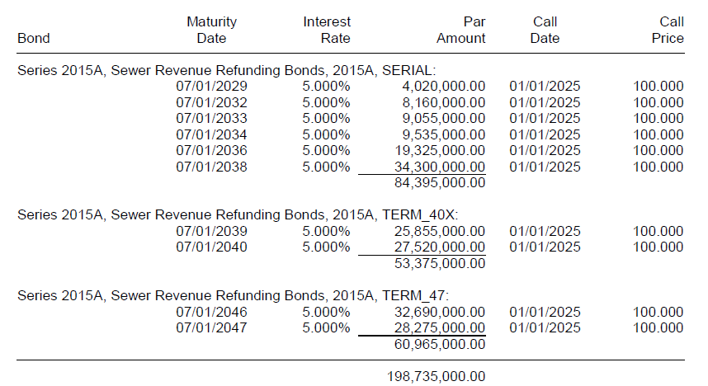

Attachment C-3

Refunded 2015A LTGO (Sewer) Bonds

