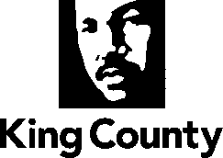

Metropolitan King County Council
Committee of the Whole

REVISED STAFF REPORT

Agenda Item: |  | Name: | Mac Nicholson
Proposed No.: | 2020-0399 | Date: | December 1, 2020

Proposed Substitute Motion 2020-0399.2 adopting the King County 2021 State Legislative Agenda (Attachment A) passed out of committee on December 1, 2020, with “No Recommendation” and was expedited to the December 8, 2020, Council agenda. The Motion was amended in committee with Amendment 1 to add attachment A. 2021 State Legislative Agenda.

SUBJECT

King County 2021 State Legislative Agenda

SUMMARY

Briefing and possible action on Motion 2020-0399, establishing the King County 2021 State Legislative Agenda. The substantive agenda document will be added to the Motion via amendment as Attachment A.

BACKGROUND

Each year King County develops a State Legislative Agenda. The Council and the Executive work together through their respective government relations staff to decide on the policy positions that are most important to bring to the attention of the Washington State Legislature. These are then reduced to writing in the form of a Legislative Agenda.

