ATTACHMENT 6  December 5, 2017 |  |  | 1B  to S1
SLHAAB and VLAB 50%
 | Sponsor: | Dembowski
[ML]
 | Proposed No.: | 2017-0360.1
AMENDMENT TO STRIKING AMENDMENT S1 TO PROPOSED ORDINANCE 2017-0360, VERSION 1
In Attachment A. Veterans, Seniors and Human Services Levy Governance Plan, Updated December 5, 2017, on page 2, after line 53, strike the table and insert:
"The following table provides a high-level summary of the proposal. Under this proposal, the Seniors Levy & Healthy Aging Advisory Board (SLHAAB) and the Veterans Levy Advisory Board (VLAB) will jointly oversee the distribution of the portion of the VSHSL’s proceeds restricted by subsections in section 4.B.2. of Ordinance 18555, which sets aside funds for capital facilities and regional health and human services for seniors who are also veterans or military servicemembers and their respective caregivers and families. After the conditions in either of the subsections in section 4.B.2. of Ordinance 18555 have been satisfied, the VLAB will not have any oversight responsibility regarding funds expended under section 4.B.2. of Ordinance 18555.

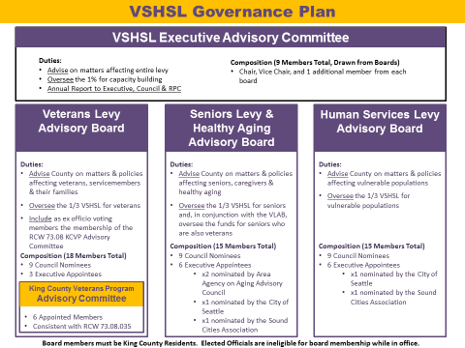"

In Attachment A. Veterans, Seniors and Human Services Levy Governance Plan, Updated December 5, 2017, on page 3, line 81, after "populations." insert "In accordance with the provisions of section 4.B.2 of Ordinance 18555, two of the boards would together oversee funds set aside for seniors who are also veterans, their caregivers and families."

In Attachment A. Veterans, Seniors and Human Services Levy Governance Plan, Updated December 5, 2017, on page 7, line 254, after "families." insert "In conjunction with the Seniors Levy & Healthy Aging Advisory Board (SLHAAB), the VLAB will also oversee the distribution of the portion of the VSHSL’s proceeds restricted by subsections in section 4.B.2. of Ordinance 18555, which sets aside funds for capital facilities and regional health and human services for seniors who are also veterans or military servicemembers and their respective caregivers and families. After the conditions in either of the subsections in section 4.B.2. of Ordinance 18555 have been satisfied, the VLAB will not have any oversight responsibility regarding funds expended under section 4.B.2. of Ordinance 18555."

In Attachment A. Veterans, Seniors and Human Services Levy Governance Plan, Updated December 5, 2017, on page 7, line 265, after "caregivers." insert "The SLHAAB will also, in conjunction with the VLAB, oversee the distribution of the portion of the VSHSL’s proceeds restricted by the subsections in section 4.B.2. of Ordinance 18555, which sets aside funds for capital facilities and regional health and human services for seniors who are also veterans or military servicemembers and their respective caregivers and families. After the conditions in either of the subsections in section 4.B.2. of Ordinance 18555 have been satisfied, the SLHAAB will have sole oversight responsibility regarding funds expended under section 4.B.2. of Ordinance 18555."

In Attachment A. Veterans, Seniors and Human Services Levy Governance Plan, Updated December 5, 2017, on page 8, after line 309, insert "
- In conjunction with the Seniors Levy & Healthy Aging Advisory Board (SLHAAB), the VLAB will also oversee the distribution of the portion of the VSHSL’s proceeds restricted by subsections in section 4.B.2. of Ordinance 18555, which sets aside funds for capital facilities and regional health and human services for seniors who are also veterans or military servicemembers and their respective caregivers and families. After the conditions in either of the subsections in section 4.B.2. of Ordinance 18555 have been satisfied, the VLAB will not have any oversight responsibility regarding funds expended under section 4.B.2. of Ordinance 18555."

In Attachment A. Veterans, Seniors and Human Services Levy Governance Plan, Updated December 5, 2017, on page 9, after line 375, insert "
- The SLHAAB will also, in conjunction with the VLAB, oversee the distribution of the portion of the VSHSL’s proceeds restricted by the subsections in section 4.B.2. of Ordinance 18555, which sets aside funds for capital facilities and regional health and human services for seniors who are also veterans or military servicemembers and their respective caregivers and families. After the conditions in either of the subsections in section 4.B.2. of Ordinance 18555 have been satisfied, the SLHAAB will have sole oversight responsibility regarding funds expended under section 4.B.2. of Ordinance 18555."

Engross any adopted amendments to the striking amendment. The code reviser is instructed, if applicable, to update the page numbers identified in the table of contents in the attachment in accordance with any adopted amendments to the striking amendment.

Line numbers have been added to the attachment for ease of reference. The code reviser is instructed to remove line numbers in the attachment on the final version of this legislation adopted by the council before presentation to the executive.

EFFECT: Provides for joint oversight by the Veterans Levy Advisory Board (VLAB) and the Seniors Levy & Healthy Aging Advisory Board (SLHAAB) of the distribution of the portion of the VSHSL’s proceeds controlled by section 4.B.2. of Ordinance 18555 that are set aside to fund capital facilities and regional health and human services for seniors who are also veterans or military servicemembers and their respective caregivers and families. After the conditions in either of the subsections in section 4.B.2. of Ordinance 18555 have been satisfied, the VLAB will not have any oversight responsibility regarding funds expended under section 4.B.2. of Ordinance 18555.

