REVISED STAFF REPORT

Agenda Item: | 11 | Name: | Hiedi Popochock  Lise Kaye
Proposed No.: | 2016-0279 | Date: | August 30, 2016

COMMITTEE ACTION

Proposed Substitute Motion 2016-0279.2, which would approve the drainage trunk line inventory report, passed out of committee on August 30, 2016, with a “Do Pass” recommendation. The motion was amended in committee with Striking Amendment 1 and Title Amendment 1 to correct the budget proviso section and number references in the motion and in the report.

SUBJECT

A Motion approving a report on the road right-of-way drainage trunk line inventory prepared by the Water and Land Resources Division and the Road Services Division.

SUMMARY

Proposed Motion 2016-0279 would approve a report on King County’s road right-of-way drainage trunk line inventory transmitted by the Department of Natural Resources and Parks’ Water and Land Resources Division (WLRD) and the Department of Transportation’s Road Services Division (RSD) in accordance with 2015/2016 Biennial Budget Ordinance 18110, Section 30, Proviso P3.

WLRD and RSD transmitted the budget proviso response on May 27, 2016 prior to the May 30, 2016 deadline outlined in the budget proviso. The Report provides an extrapolated inventory of the drainage trunk system within major road rights-of-way in unincorporated King County, with an associated low level of confidence in the resultant accuracy of the database. Approximately 15 percent of the drainage system assets were mapped and inspected to verify condition in the assessment. Council may wish to consider a number of associated policy issues in the 2017/2018 budget process.

Council staff has prepared a title and technical striking amendment to correct the budget proviso section and proviso number referenced in the Proposed Motion and Attachment A, Road Right-of-Way Drainage Trunk Line Inventory (Attachment 2 & 3).

BACKGROUND

Following King County’s merger in 1994 with the Municipality of Metropolitan Seattle, the then-Public Works Department was dissolved and its functions reassigned to a new Department of Natural Resources and Parks (DNRP) and a new Department of Transportation (KCDOT). This reorganization directed how the county’s surface water drainage system would be managed: KCDOT’s new Roads and Engineering Division (now Road Services Division or RSD) would manage drainage infrastructure located within the rights-of-way (ROW) of unincorporated King County, and DNRP’s new Water and Land Resources Division (WLRD) would manage the drainage infrastructure located outside of the ROW in unincorporated King County.

In the 2015/2016 budget process, WLRD requested to transfer $1 million to RSD for data collection. The data collection tasks would create an inventory of the drainage trunk system that would provide baseline data for the extent and condition of the system within major road ROW. The $1 million was a mid-range estimate of the costs of this effort, which included county and consultant-supported record compilation, field investigations using mobile cameras, and prioritization of acquired data. The result of this effort would be mapped assets and asset condition information that could inform future prioritization of a program for replacement and repair, and identify risks of failure and failure impacts.

The County Council approved Ordinance 17941 that required the executive to transmit a report that provided a comprehensive assessment of King County’s drainage trunk line inventory.

The 2015/2016 Budget Ordinance 18110, Section 30, Proviso P3 reads:

“Of this appropriation, $1,000,000 shall not be expended or encumbered until the executive transmits a drainage trunk line inventory report and a motion that approves the report and the motion is passed by the council. The motion shall reference the subject matter, the proviso's ordinance, ordinance section and proviso number in both the title and body of the motion.

The report shall include, but not be limited to:

A. The location and condition of the drainage trunk system within major road rights-of-way in unincorporated King County;
B. The estimated accuracy of the resultant database;
C. An analysis of the data to assess risks of failure and failure impacts; and
D. A prioritized program for maintenance, including replacement schedule and costs.

The executive must file the report and motion required by this proviso by May 30, 2016, in the form of a paper original and an electronic copy with the clerk of the council, who shall retain the original and provide an electronic copy to all councilmembers, the council chief of staff, the policy staff director and the lead staff for the transportation, economy and environment committee, or its successor.”

ANALYSIS

WLRD and RSD transmitted the Road Right-of-Way Drainage Trunk Line Inventory Report (“the Report”) to Council on May 27, 2016 prior to the May 30 deadline as outlined in the budget proviso P3, previously described in this staff report. The Report provides information on the four required elements prescribed in the budget proviso and are described below. The Report provides an extrapolated inventory of the drainage trunk system within major road ROW in unincorporated King County, with an associated low level of confidence in the resultant accuracy of the database. Approximately 15 percent of the drainage system assets were mapped and inspected to verify condition in the assessment. The Report also provides a link to the report (“the Consultant Report”) that HDR, Inc. (“the Consultant”) prepared detailing its assessment of King County’s drainage trunk system.

Location and condition of the drainage trunk system. The Report explains that historically, when King County road drainage systems were built, they were not necessarily mapped or recorded, nor was the condition of the drainage assets that were mapped and assessed were updated on a regular basis. In order to locate and assess the condition of King County’s drainage trunk line system, the Report notes that WLRD and RSD hired the Consultant to conduct an inventory assessment (Phase 1) and a business risk assessment (Phase 2) within the major road ROW. According to the Report, WLRD and RSD directed the Consultant to develop different data sets according to three criteria: 1) whether the assets were known; 2) whether they were mapped; and 3) whether their condition was verified by onsite inspection.

The Consultant Report indicates that WLRD provided the Consultant with approximately 1,266 pre-selected drainage assets to be inspected. Of the 1,266 pre-selected assets, 1,174 were active (i.e., not retired), 24-inches in diameter or greater and were inspected in Phase 1.

According to the Report, the analysis is built on the following asset data sets:

- Mapped and inspected to verify condition: The Report indicates that there were 897 assets where the age and material suggested that these assets could be of concern; these were inspected by the Consultant to verify the condition.

- Mapped, condition not verified: The Report further notes that 123 assets were not accessible for inspection and the age and material of 3,315 assets suggested they were not of concern in the near term; for purposes of analysis, the asset conditions were presumed based on age and material rather than inspection.

- Unknown therefore not mapped and not inspected: By utilizing a Geographic Information System (GIS) model to extrapolate assumed assets where the actual location and condition was unknown, the Report states that the model projected approximately 1,627 assets by looking at areas of similar zoning and ratios of drainage assets to roadway length.

Table 1 below summarizes the results of the asset inspections, the extrapolation model projections and the level of confidence of the condition rating provided by the Consultant in the Report.

Table 1. Summary of Assets by Data Set
Data Set | # of Assets in Data Set | % of Total Assets | # of Critical Assets | % of Critical Assets in Data Set | Confidence Level in Condition Rating
Mapped assets, inspected to verify condition | 897 | ~15% | 33 | ~3.7% | 71%
Mapped assets, not inspected, condition not verified | 3,438 | ~58% | 104 | ~3% | 37%
Unknown and unmapped assets, condition not known | 1,627 | ~27% | 102 | ~6% | 6%
TOTAL: | 5,962 | 100% | 239 | ~4%

To illustrate the location of the drainage assets within the major road ROW, the Consultant divided the unincorporated areas of King County into 14 areas as shown in Figure 1. In addition to locating the assets, the Report indicates that assets in each data set and area were rated critical, high, medium and low for risk exposure according to the verified, presumed, or extrapolated condition assessment. Critical assets were defined as posing an imminent threat of failure. Table 2 below summarizes the mapped and inspected assets that have a critical or high risk exposure in the 14 areas in King County, according to the Report.

Figure 1. Map areas used to locate drainage assets in major road ROW

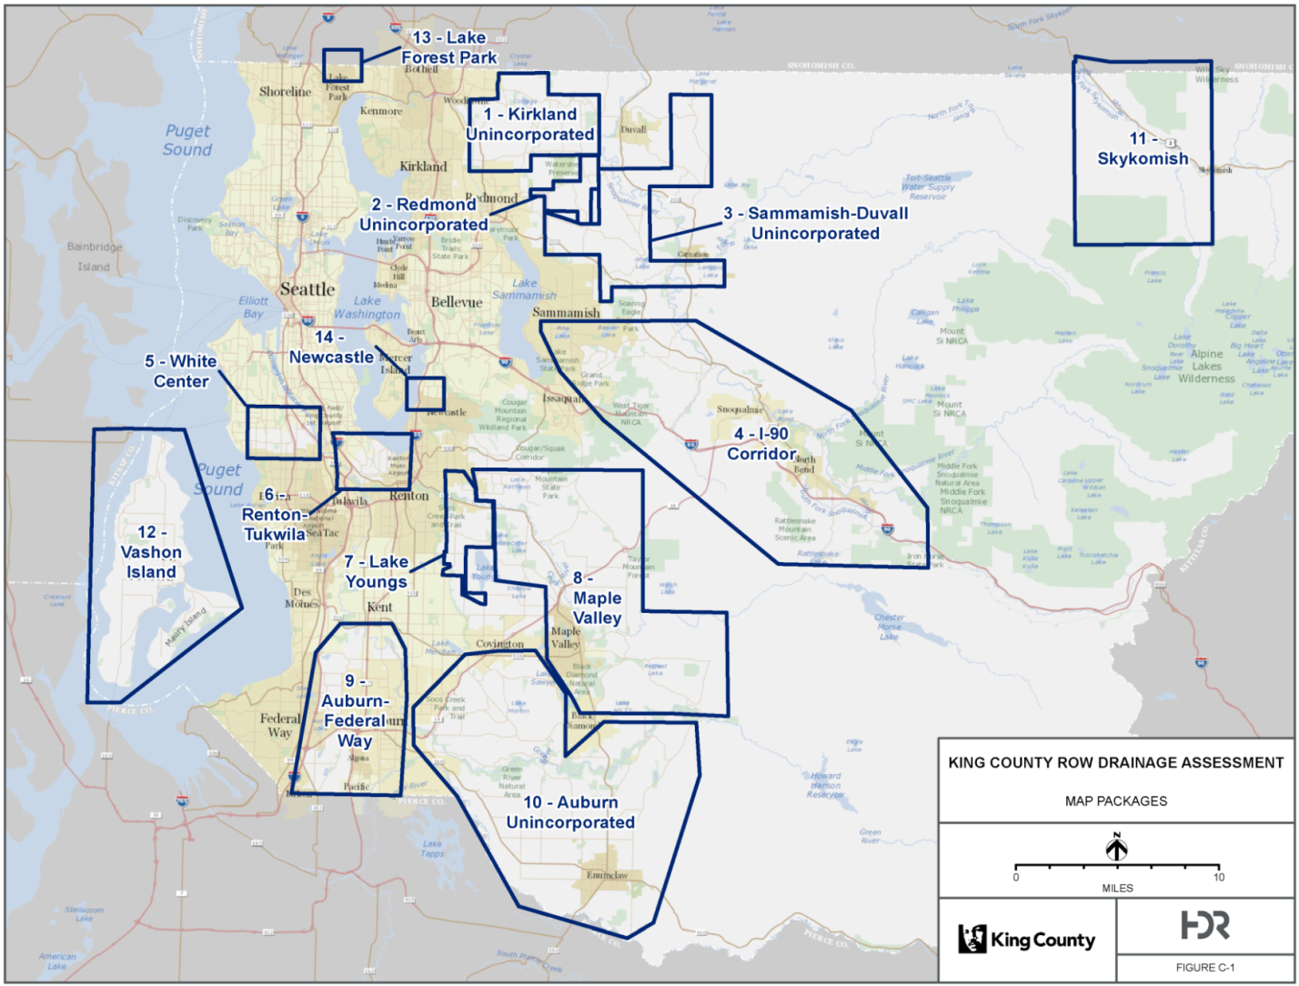

Table 2. Number of Assets Mapped and Inspected by Area including the Number of Assets that have a Critical/High Risk Exposure

Map  Area  # |  | Area | Total Assets Mapped & Inspected | # of Mapped  & Inspected Assets w/ Critical/High  Risk Exposure | % of Mapped & Inspected Assets w/ Critical/High  Risk Exposure | % of Total Critical/High Risk Exposure Assets
1 | Kirkland Unincorporated |  | 58 | 39 | 67% | 11%
2 | Redmond Unincorporated |  | 183 | 33 | 18% | 9%
3 | Sammamish-Duvall Unincorporated |  | 73 | 41 | 56% | 11%
4 | I-90 Corridor |  | 82 | 40 | 49% | 11%
5 | White Center |  | 41 | 18 | 44% | 5%
6 | Renton/Tukwila |  | 58 | 28 | 48% | 8%
7 | Lake Youngs |  | 100 | 42 | 42% | 12%
8 | Maple Valley |  | 117 | 44 | 38% | 12%
9 | Auburn-Federal Way |  | 66 | 16 | 24% | 4%
10 | Auburn Unincorporated |  | 74 | 37 | 50% | 10%
11 | Skykomish |  | 7 | 5 | 71% | 1%
12 | Vashon Island |  | 33 | 16 | 48% | 4%
13 | Lake Forest Park |  | 1 | 1 | 100% | 0%
14 | Newcastle |  | 4 | 2 | 50% | 1%
 | Totals: |  | 897 | 362

Estimated accuracy of the resultant database. As shown in Table 1 above, the Report shows that the Consultant has a confidence level of 71 percent for the condition ratings of the 897 assets that were inspected. Alternatively, the Consultant’s confidence level for the 3,438 assets that were mapped but not inspected is 37 percent, but the confidence level is only six percent for the 1,627 assets that were extrapolated, unmapped and uninspected.

Analysis of the data to assess risks of failure and failure impacts. According to the Report, the Consultant projected four different levels of service over a 10-year and 100-year period in order to compare the risks of failure and failure impacts for different maintenance and investment strategies in the near and long-terms.

- Level of Service A – This level would manage all assets to lowest risk tolerance and would not create a backlog in the future.

- Level of Service B – This level would manage all assets to lowest risk tolerance; eliminate the backlog in 25 years and would prevent a new backlog accumulating.

- Level of Service C – This level would manage only critical risk assets; slowly eliminate the backlog however, it would increase the backlog over time.

- Level of Service D – This level would run assets to failure and would respond to emergencies only.

Table 3 below illustrates three of the four levels of service, including each level’s business risk exposure and the costs of ownership by levels of service. The Report does not list Level of Service B in Table 3 since the assumptions used treated the backlog of actions inconsistently from the other levels of service, resulting in skewed preservation costs that could not be fairly compared to the other levels of service. The Consultant Report states that the business risk exposure rating was calculated by using the product of two input values: Probability of Failure (POF) multiplied by the Consequence of Failure (COF). The Consultant Report also notes that the estimated ownership costs has a margin of error range of -50 percent to +100 percent. Level of Service D, which would run assets to failure and respond to emergencies has a business risk exposure of 81, the highest of the three levels, and ownership costs of $335 million in real costs over the next 10 years.
Table 3. Costs of Ownership by Levels of Service

ID | Level of Service | Backlog | Ownership Costs over Next 100 Years, in Net Present Value | 100-Year Maximum Business Risk Exposure | Ownership Costs over Next 10 Years, in Real Costs | Variance:  -50% to +100%,  in Real Costs*
A | Manage all assets to lowest risk tolerance | Eliminated in first year, none created in future | $750M | 58 | $500M | $250M – $1B
C | Manage critical risk assets | Slowly eliminated, more added over time | $815M | 66 | $348M | $174M – $696M
D | Run assets to failure, respond to emergencies | Grows over time | $829M | 81 | $335M | $167.5M – $670M
*Costs represents Class 5 estimates as defined by the Association for the Advancement of Cost Estimating with an expected accuracy range of -50 percent to +100 percent.

The Report further notes that the Consultant found the highest level of service (A) costs the most to manage in the 10-year timeframe. Under this scenario, assets are rehabilitated or replaced prior to their expected failure date, which increases the near-term management costs but decreases the long-term costs associated with potential asset collapse.

Prioritized program for maintenance, including replacement schedule and costs. The Report states that the Consultant provided estimates of the costs associated with one-time preservation actions and ongoing operations in order to recommend immediate actions for the mapped assets where the condition was verified through inspection. Table 5 below summarizes the estimated costs over a 10-year period and the associate risk mitigation action needed for the 897 assets that were mapped and inspected. The Consultant Report notes that the cost estimates are in 2016 dollars based on the average costs from RSD’s records, recent available contractor bids and RSMeans construction cost data.
Table 5. Cost estimate for near-term risk mitigation actions for
mapped and inspected assets

Action | Cost Estimate | Cost Basis
On-going mapping, inventory, and condition assessment | $2,000,000 | 10-year cost
Enhanced condition assessment ª | $900,000 | 10-year cost
Routine inspection ^{b} | $140,000 | 10-year cost
Triggered inspection ^{c} | $60,000 | 10-year cost
Maintenance cleaning ^{d} | $340,000 | 10-year cost
Maintenance repair ^{e} | $1,720,000 | 10-year cost
Preservation rehabilitation ^{f} | $700,000 | one-time cost
Preservation replacement ^{g} | $19,880,000 | one-time cost
Total Cost: | $25,740,000

Assumptions used to build the prioritized maintenance program in Table 5:
a. Enhanced condition assessment for 140 assets every 2 years, 116 assets every 5 years, and 242 assets every 10 years; assigned based on calculated business risk exposure scores.
b. Routine inspection of 25% of assets each year.
c. Triggered inspection of 10% of assets each year.
d. Cleaning of 30% of manhole and catch basin assets and 10% of pipe and culvert assets each year.
e. Repair of 2% of assets each year.
f. Rehabilitation of 23 catch basins and 21 pipes with a total length of 1500 feet.
g. Replacement of 39 culverts, 23 catch basins, 21 pipes with a total length of 1500 feet, and 1 manhole. Includes cost estimates for the NE Union Hill Road @ 225th Ave NE box culvert ($1.35 M) and S 96th St stormwater pipes projects ($1.48 M).

The Consultant Report also provides a breakdown of cost estimates categorized by the risk condition of the asset: critical, high, medium and low. Table 6 provides a list of estimated near-term preservation rehabilitation and replacement costs needed for assets that were inspected in Phase 1.

Table 6. Near Term Preservation Costs by Risk Category for Inspected Assets

Risk Category | Number of Asset | Preservation Action Cost
Critical | 33 | $6,460,000
High | 93 | $12,620,000
Medium | 2 | $1,500,000
Low | 0 | $0
Total: | 128 | $20,580,000

Policy considerations. Council may wish to consider a number of policy considerations in the Report and in the Consultant Report when deliberating the potential surface water management fee rate increase in the 2017/2018 budget process in which proposed Motion 2016-0279 and proposed Motion 2016-0348 may assist in guiding budget discussions.

Confidence level of assessment. As previously discussed, the Report does not reflect a map and/or inspection of all of the county’s drainage trunk line system assets. The Consultant mapped and inspected a total of 897 drainage assets of the estimated 5,962 assets. This represents only 15 percent of the projected total drainage system assets within the major road ROW in unincorporated King County. Of note, the Consultant provided a confidence level of the condition of the 897 assets at 71 percent. The remaining drainage assets have a confidence level of 37 percent (3,438 assets) or 6 percent (1,627 assets). The absence of reliable information presents challenges when seeking to prioritize investments or to cost out anticipated levels of service for system maintenance. The finding with respect to mapped and inspected assets in critical states of disrepair appears to present a reliable picture of that data set of assets.

Future SWM/RSD investments. Council may also wish to evaluate how the Report’s findings affect future SWM and RSD funding for roadway drainage projects. The Strategic Plan for Road Services (2014 Update) estimated a $90 million backlog of drainage project needs and estimated that an annual investment of $15 million per year would reduce the backlog of needs in 2020 by 80 percent, to $24 million. According to the Report, even the lowest estimated level of service (allowing systems to fail and then providing emergency response) would cost $335 million over the next 10 years. Council may wish to see comparative analyses of these two projections.

Unknown implementation costs. The Consultant Report provides a number of recommended actions for the county to implement for its drainage system. However, it does not provide estimated costs related to the specific recommendation. Table 6 provides a list of recommendations provided by the Consultant where the costs associated with the action were not quantified. Funding for some or all of these actions may be considered in upcoming budget discussions.
Table 6. Programmatic Asset Management Recommendations Costs not included in the Consultant Report

Programmatic Asset Management Recommendations
Costs for implementing steps to select the desired level of service
Costs for using inspection data to adjust the asset management framework and update plans accordingly
Costs to review/revise probability of failure to include failure factors beyond mortality
Costs to review and revise consequence of failure factors based on selected level of service alternative
Costs to validate unmapped asset inventory
Costs to validate business risk exposure risk scores for uninspected assets
Costs to administer an enhanced condition assessment program and rescoring risks or updating risk mitigation actions and associated cost estimates
Costs to conduct hotspot mapping to identify problem areas in the system
Costs to develop and implement a formal CIP prioritization process
Costs to formalize the stormwater asset management program

The proposed Motion would approve the report prepared by WLRD and RSD as required by the budget proviso. The Consultant Report’s Executive Summary is attached to this staff report as Attachment 5.

AMENDMENT

Striking amendment 1 would correct the internal references of the budget proviso section and proviso number for the required SWM Drainage Trunk Line Inventory Report. Title amendment 1 would reflect the changes in striking amendment 1.

ATTACHMENTS

- Proposed Motion 2016-0279 and Attachment A, Road Right-of-Way Drainage Trunk Line Inventory
- Striking Amendment 1
- Title Amendment 2
- Transmittal Letter
- King County Road Right-of-Way Drainage Trunk Line Assessment Executive Summary prepared by HDR, Inc.

INVITED

- John Taylor, Assistant Division Director, King County Water and Land Resources Division
- Jay Osborne, Deputy Director, Road Services Division
- Tricia Davis, Budget Manager, Performance, Strategy and Budgeting

Subsequent to the passage of Ordinance 17941, Council approved Ordinance 18110, which included moving the budget proviso from the Road Operating Fund to the Surface Water Management Local Drainage Services Fund.
http://your.kingcounty.gov/dnrp/library/water-and-land/stormwater/KC_ROW_Drainge_Assessment_Final_Report.pdf
According to Executive staff, the pre-selected asset information was extracted from WLRD’s Stormwater Geodatabase.
The Consultant Report notes that the “age” of the assets ranged from less than 25 years to greater than 100 years.
The Consultant Report notes that the “material” of the assets consisted of corrugated metal pipe, high density polyethylene pipe, poly vinyl chloride pipe, concrete, ductile iron and corrugated plastic pipe made by Advanced Drainage Systems (ADS).
The Consultant Report defines “imminent threat” as a threat of failure which is present now, although the impact of the threat may not be felt until later.
According to the Consultant Report, POF is defined as the relative likelihood that an asset might fail. This factor is driven largely by structural condition. COF is defined as the relative cost (i.e., monetary, public health, safety, etc.) that may result from failure. This factor is driven largely by an asset’s location relative to other structures and is less sensitive to structural condition.
The business risk exposure runs on a scale of 0 to 100, where 0 is the lowest risk exposure and 100 is the highest.
Source: HDR, Inc report on King County’s Drainage Trunk Line System Assessment, Section 5.6, page 75 http://your.kingcounty.gov/dnrp/library/water-and-land/stormwater/KC_ROW_Drainge_Assessment_Final_Report.pdf
RSMeans data was used to estimate costs for pipe bursting only.
Source: Strategic Plan for Road Services, page 24

