JUNE 2014
PUBLIC TRANSPORTATION SERVICE
CHANGE FOR KING COUNTY
(Not including administratively implemented changes)

ROUTE: 22

OBJECTIVES:
Improve the productivity of Metro Transit’s network of bus routes by eliminating or reducing low performing routes, or by restructuring service according to the Strategic Plan for Public Transportation, 2011-2021 and King County Metro Service Guidelines:

- Strategic Plan Strategy 6.1.1: Manage the transit system through service guidelines and performance measures.

- Strategic Plan Strategy 6.2.1: Continually explore and implement cost efficiencies, including operational and administrative efficiencies.

- Service Guidelines, Performance Management, Productivity:
Productivity measures identify routes where performance is weak as candidates for reduction or restructuring. Low performance is defined as having productivity that ranks in the bottom 25 percent of routes within a category and time period.

IMPACTED SERVICE AREA:
Arbor Heights, Westwood Village, Gatewood, Alaska Junction
SERVICE CHANGE:

Discontinue route.

The C Line and Route 128 will provide alternate service along California Avenue Southwest between Morgan Junction and Alaska Junction. Route 21 Local will provide alternate service along 35th Avenue Southwest between Westwood Village and Gatewood. Routes 21 Express will provide alternative service during peak periods in Arbor Heights.

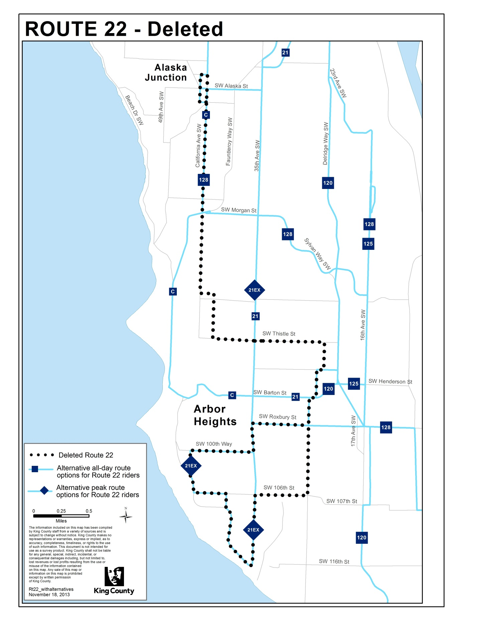
ROUTE: 37

OBJECTIVES:
Improve the productivity of Metro Transit’s network of bus routes by eliminating or reducing low performing routes, or by restructuring service according to the Strategic Plan for Public Transportation, 2011-2021 and King County Metro Service Guidelines:

- Strategic Plan Strategy 6.1.1: Manage the transit system through service guidelines and performance measures.

- Strategic Plan Strategy 6.2.1: Continually explore and implement cost efficiencies, including operational and administrative efficiencies.

- Service Guidelines, Performance Management, Productivity: Productivity measures identify routes where performance is weak as candidates for reduction or restructuring. Low performance is defined as having productivity that ranks in the bottom 25 percent of routes within a category and time period.

IMPACTED SERVICE AREA:
Alaska Junction, Alki, Downtown Seattle
SERVICE CHANGE:

Discontinue route.
Route 56 will provide alternative service during weekday peak hours (approximately 6:00 – 9:00 a.m. and 3:00 – 6:00 p.m.) between 61st Avenue Southwest / Alki Avenue Southwest and Downtown Seattle via the Admiral District and the Alaskan Way Viaduct. Routes 773 and 775 will provide alternative service along portions of Alki Avenue Southwest and Harbor Avenue Southwest with connections to/from the West Seattle Water Taxi between Seacrest Park on Harbor Avenue Southwest and Pier 50 on the Seattle waterfront.

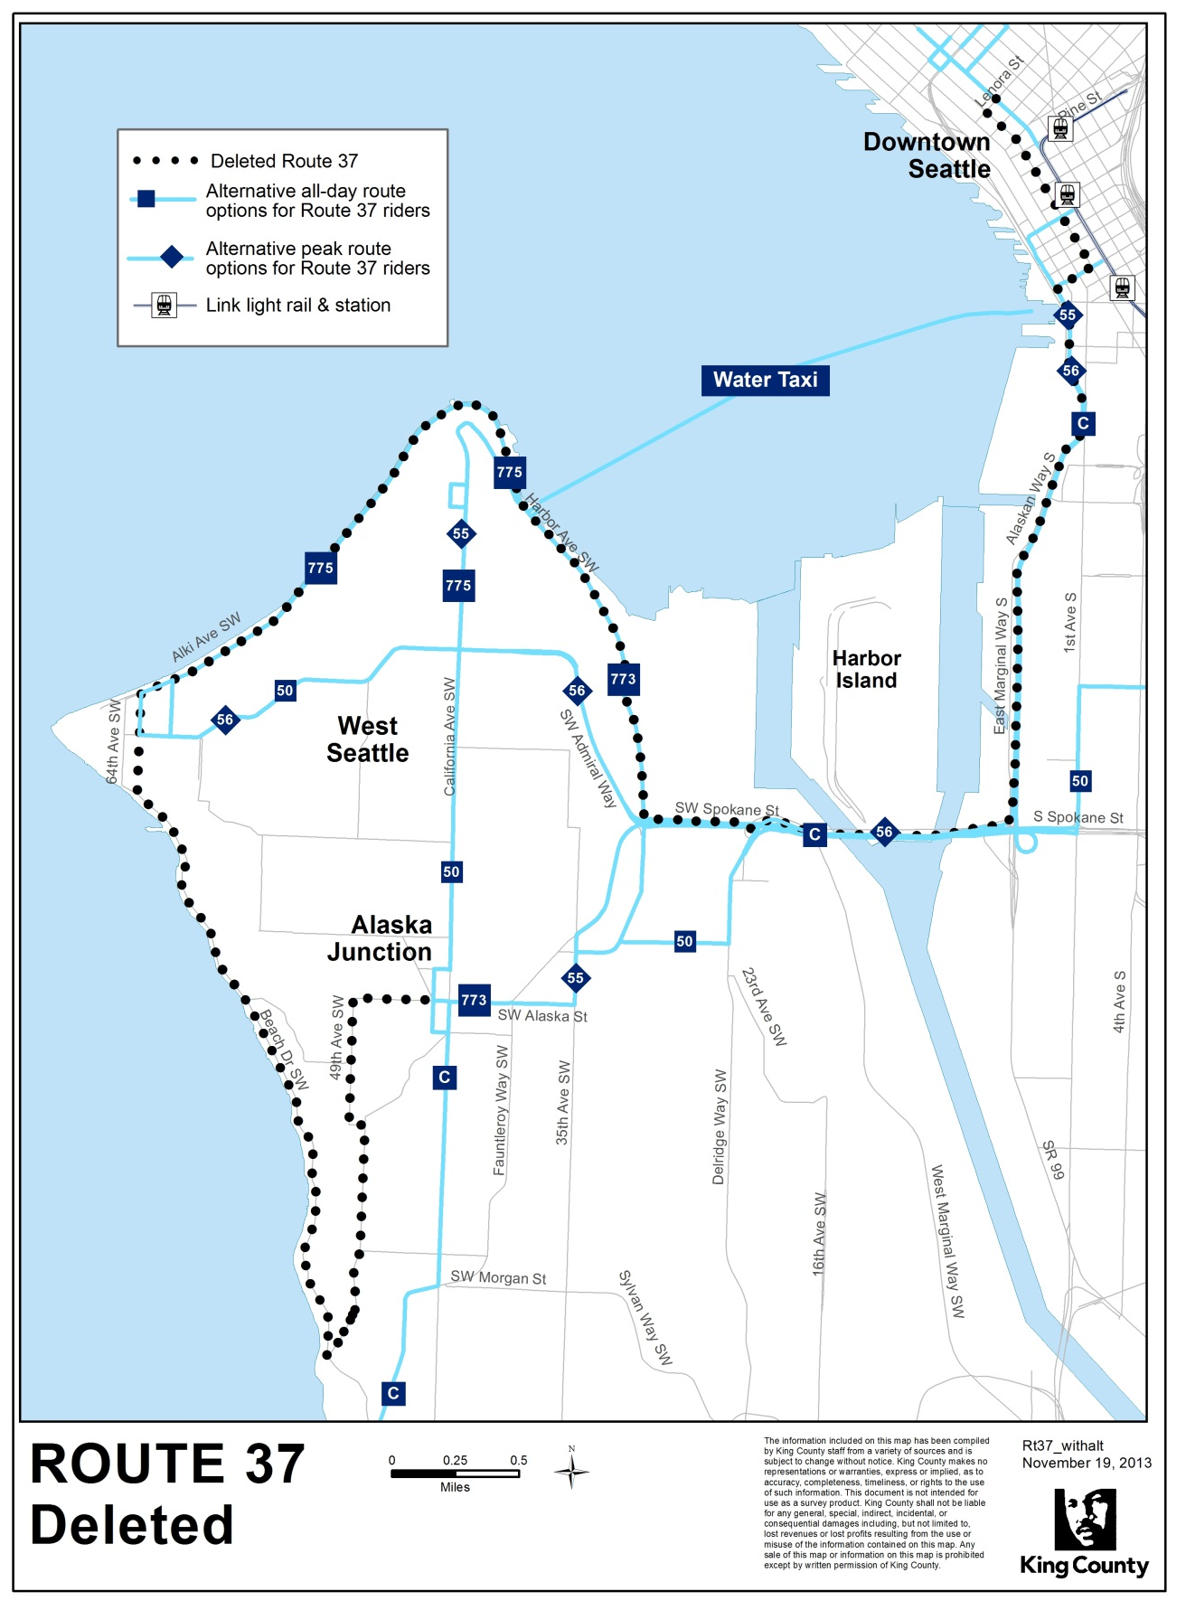
ROUTE: 55

OBJECTIVES:
Improve the productivity of Metro Transit’s network of bus routes by eliminating or reducing low performing routes, or by restructuring service according to the Strategic Plan for Public Transportation, 2011-2021 and King County Metro Service Guidelines:

- Strategic Plan Strategy 6.1.1: Manage the transit system through service guidelines and performance measures.

- Strategic Plan Strategy 6.2.1: Continually explore and implement cost efficiencies, including operational and administrative efficiencies.

- Service Guidelines, Performance Management, Productivity: Productivity measures identify routes where performance is weak as candidates for reduction or restructuring. Low performance is defined as having productivity that ranks in the bottom 25 percent of routes within a category and time period.

IMPACTED SERVICE AREA:
Admiral District, Alaska Junction, Downtown Seattle
SERVICE CHANGE:

Revise the service levels on Route 55 to operate six morning trips and five afternoon trips during the weekday peak hours (approximately 6:00 – 9:00 a.m. and 3:00 – 6:00 p.m.).

ROUTE: 57

OBJECTIVES:
Improve the productivity of Metro Transit’s network of bus routes by eliminating or reducing low performing routes, or by restructuring service according to the Strategic Plan for Public Transportation, 2011-2021 and King County Metro Service Guidelines:

- Strategic Plan Strategy 6.1.1: Manage the transit system through service guidelines and performance measures.

- Strategic Plan Strategy 6.2.1: Continually explore and implement cost efficiencies, including operational and administrative efficiencies.

- Service Guidelines, Performance Management, Productivity: Productivity measures identify routes where performance is weak as candidates for reduction or restructuring. Low performance is defined as having productivity that ranks in the bottom 25 percent of routes within a category and time period.

IMPACTED SERVICE AREA:
Alaska Junction, Genesee Hill, Admiral District, Downtown Seattle
SERVICE CHANGE:

Discontinue route.

Route 56 will provide alternative service between the Admiral District and Downtown Seattle. Route 55 will provide alternative service along California Avenue Southwest between the Admiral District, Alaska Junction and Downtown Seattle.

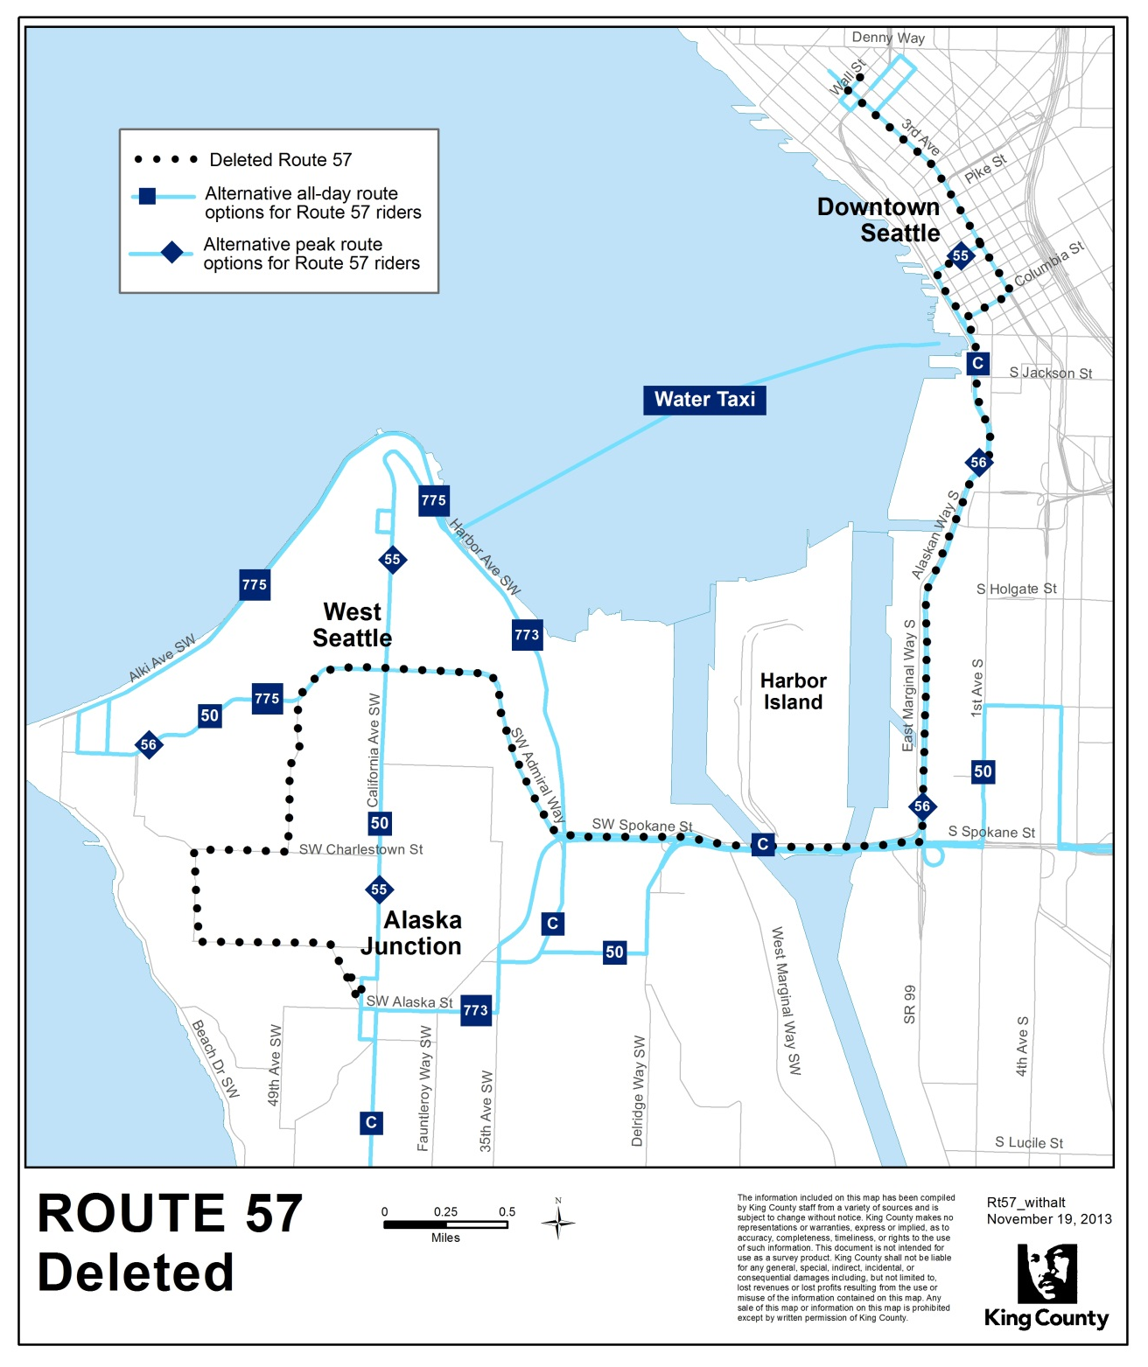
ROUTE: 113

OBJECTIVES:
Improve the productivity of Metro Transit’s network of bus routes by eliminating or reducing low performing routes, or by restructuring service according to the Strategic Plan for Public Transportation, 2011-2021 and King County Metro Service Guidelines:

- Strategic Plan Strategy 6.1.1: Manage the transit system through service guidelines and performance measures.

- Strategic Plan Strategy 6.2.1: Continually explore and implement cost efficiencies, including operational and administrative efficiencies.

- Service Guidelines, Performance Management, Productivity: Productivity measures identify routes where performance is weak as candidates for reduction or restructuring. Low performance is defined as having productivity that ranks in the bottom 25 percent of routes within a category and time period.

IMPACTED SERVICE AREA:
Shorewood, White Center, Olson-Myers Park and Ride, Downtown Seattle
SERVICE CHANGE:

Discontinue route.

No alternative fixed-route service will be available between Shorewood and Downtown Seattle. Alternative commuter options may include carpooling and vanpooling. Route 120 will provide alternative service between White Center and Downtown Seattle. Route 60 will provide service between the Olson-Myers Park and Ride and Beacon Hill with connections to downtown Seattle via Route 124 in Georgetown.

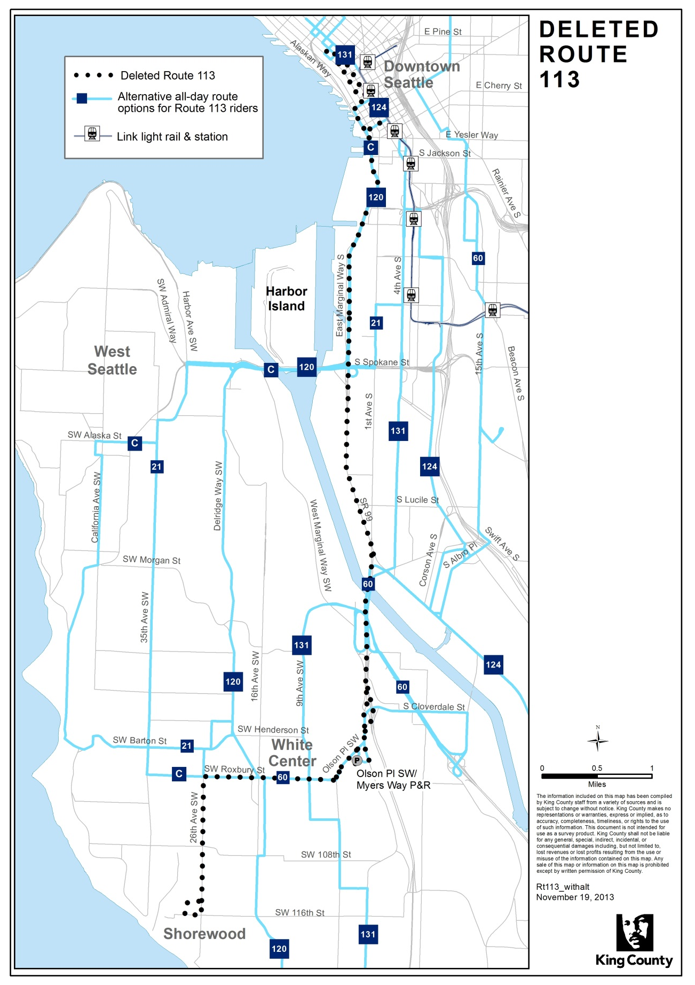
ROUTE: 118 Express

OBJECTIVES:
Improve the productivity of Metro Transit’s network of bus routes by eliminating or reducing low performing routes, or by restructuring service according to the Strategic Plan for Public Transportation, 2011-2021 and King County Metro Service Guidelines:

- Strategic Plan Strategy 6.1.1: Manage the transit system through service guidelines and performance measures.

- Strategic Plan Strategy 6.2.1: Continually explore and implement cost efficiencies, including operational and administrative efficiencies.

- Service Guidelines, Performance Management, Productivity: Productivity measures identify routes where performance is weak as candidates for reduction or restructuring. Low performance is defined as having productivity that ranks in the bottom 25 percent of routes within a category and time period.

IMPACTED SERVICE AREA:
Vashon Island, Fauntleroy, West Seattle, Downtown Seattle
SERVICE CHANGE:

Revise the service levels on Route 118 Express to operate one morning trip starting at approximately 6:30 a.m. and one afternoon trip starting at approximately 4:30 p.m.
Route 118 Local will provide alternative service on Vashon Island with connections to/from Washington State Ferries operating between Vashon and Fauntleroy. The RapidRide C Line and Route 116 Express will provide alternative service between Fauntleroy, West Seattle, and Downtown Seattle.

ROUTE: 121

OBJECTIVES:
Improve the productivity of Metro Transit’s network of bus routes by eliminating or reducing low performing routes, or by restructuring service according to the Strategic Plan for Public Transportation, 2011-2021 and King County Metro Service Guidelines:

- Strategic Plan Strategy 6.1.1: Manage the transit system through service guidelines and performance measures.

- Strategic Plan Strategy 6.2.1: Continually explore and implement cost efficiencies, including operational and administrative efficiencies.

- Service Guidelines, Performance Management, Productivity: Productivity measures identify routes where performance is weak as candidates for reduction or restructuring. Low performance is defined as having productivity that ranks in the bottom 25 percent of routes within a category and time period.

IMPACTED SERVICE AREA:
Highline Community College, Des Moines, Normandy Park, Burien, Downtown Seattle
SERVICE CHANGE:

Revise the service levels on Route 121 to operate six morning trips and seven afternoon trips during the weekday peak hours (approximately 6:00 – 9:00 a.m. and 3:00 – 6:00 p.m.).

