Lease Property Summary

Photo of Property

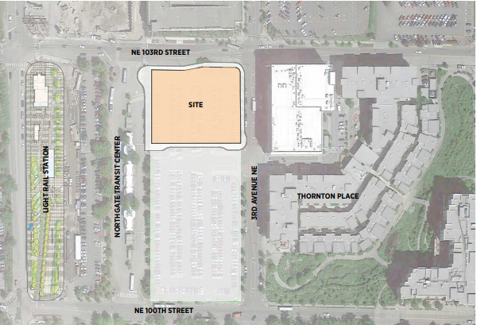

Property Owner: King County Metro
Address: 10200 1st Avenue NE, Seattle WA 98125. A new address will be assigned to the project following a forthcoming Lot Boundary Adjustment process.
Term: 75-year ground lease
Rent: $1.00 per year, paid in a single payment at lease commencement
Square Footage: 48,138
Council District: One
Funding Source: 36250 - EXT L T SPACE FAC RENT
Previous Location: N/A
Offer Expiration: The offer does not expire; however, the project’s development costs are based on an October, 2021, council action, a 24-month permit process and a 24-month construction schedule. To mitigate project cost escalation Metro and the developer entered into a separate agreement to advance early design. This agreement requires that the Ordinance be transmitted to Council by October 15, 2021 or Metro might be obligated to pay a portion of Early Design Guidance design package cost not to exceed $170,000.
Declared Surplus December 6, 2018

Lease Synopsis:
Per RFQ/C No. 1207-18-VLN issued in 2018, Metro seeks authorization to enter into a 75-year ground lease with the development team of Bridge Housing and Community Roots Housing, who plan to redevelop the northern half of the Northgate Park and Pool lot shown on the site plan attached hereto. The development team will develop and operate 232 units of housing affordable to households making at or below 60 percent of the area median income. Ten percent of the project’s units are set-aside for system-connected households. The project includes a 10,000 square foot early learning facility on the ground floor and a 250 square foot comfort station designed and delivered for Metro as a part of this project. This project meets the goals of Metro’s Equitable Transit Oriented Communities policy that prioritizes affordable housing outcomes on Metro property and strengthening the pedestrian-orientation of transit communities. With the opening of Northgate Link immediately adjacent to the neighboring Northgate transit center, Metro believes that the northern portion of the Park and Pool parking lot is no longer needed to support Metro’s riders and that pursuing redevelopment of that area is the site’s highest and best use.

Context
Located just eight miles from downtown Seattle, Northgate is an evolving neighborhood. Long the home of one of America’s oldest malls, the neighborhood is becoming an urban center with new housing, community amenities, the redevelopment of the Northgate Mall property, the introduction of professional hockey facilities, and, in the fall of 2021, the new Multi-modal transit station. The station will feature an integrated LINK/Bus facility that is anticipated to serve over 15,000 people per day in 2030, a new pedestrian bridge, and, on the adjacent Park & Pool lot, a large Transit Oriented Development that will be delivered in phases. This affordable housing project represents the first phase of King County’s Transit Oriented Development at Northgate.

King County issued a request for qualifications and concepts, number 1207-18-VLN ("the RFQ/C"), through which King County sought proposals for the development of its Northgate Park and Pool lot. Among other things, the RFQ/C required proposals to include a minimum of two hundred units of subsidized affordable housing for a minimum of fifty years to serve households earning up to sixty percent of Area Median Income ("AMI"), with a mix of unit sizes and configurations and with a minimum of ten percent of the units to be "system connected," serving very-low to extremely-low income households below fifty percent AMI. The RFQ/C resulted in three proposals, and King County selected a developer team and commenced negotiations with the selected team. After extensive negotiations, Metro Transit determined that the County should award a ground lease of a portion of the county-owned land located at the Northgate Park and Pool lot to Bridge Housing Corporation and Community Roots Housing (collectively, "Bridge/CRH") for an affordable housing project to include two hundred thirty-two units of affordable housing for seventy-five years with at least twenty-four units designated for system-connected households with incomes of fifty percent or less of the area median income. Metro Transit successfully negotiated a ground lease with Bridge/CRH for a portion of the county-owned land located at the Northgate Park and Pool lot.

Rationale for transaction: This transaction meets a stated goal of the RFQ/C to provide land at no cost for affordable housing as a part of the Transit Oriented Development (TOD) strategy at the Northgate Transit Center and satisfies both King County and City of Seattle goals to locate subsidized housing proximate to frequent transit service in order to have greater impact on lowering overall cost of living for qualified households. This project has $20 million of guaranteed funding from King County’s TOD Bond fund and has benefitted from support from The City of Seattle’s Office of Housing. This transaction is the first phase of a multi-phased redevelopment of King County’s Northgate Transit Center properties.

Policy considerations: This project meets the goals of Metro’s Equitable Transit Oriented Communities Policy, supports the goals of King County’s Strategic Climate Action Plan, which calls out the importance of dense development and specifically affordable housing near transit as a key strategy for reaching Climate goals, and delivers on the goals for King County’s Transit Oriented Development Bond Fund that seeks to target housing subsidies near frequent transit service.

Political considerations: Transit Oriented Development at Northgate has been a shared goal of the City of Seattle and King County for over a decade with affordable housing as a key component. For the RFQ/C, both City and County funders partnered to secure funds for 200+ units of affordable housing focused on households at or below 60 percent of area median income (AMI) at this location. Originally, the City and King County’s Department of Community and Human Services (DCHS) were each going to contribute $10 million towards the project. Subsequently, the City determined that it did not have the authority to fund a ground lease, as compared to a fee simple project; however, DCHS and the City agreed to shift the City’s originally planned $10 million share to other King County projects, which allowed DCHS to double its contribution to $20 million. For this and other reasons, this project has taken much longer than anticipated to advance. Despite that delay, there is both tremendous political and community support for this project to move forward.

Community considerations or partnerships: The Northgate neighborhood supports the provision of affordable housing in the station area. There is desire for the project to deliver active space for the community. Metro believes the ground floor early learning center meets the community’s goal.

Fiscal considerations: This property’s unrestricted fair market value was determined by appraisal in February of 2021 at $12.85M. The appraisal also valued the affordable housing restriction imposed by the RFQ/C and determined that the restricted land value was $5M. King County Metro seeks to proceed with this ground lease on the basis that the county will retain long-term ownership and eventually all improvements made to the site.

CIP/operational impacts: This transaction will reduce commuter parking at the Northgate Park and Pool lot by 186 stalls (159 permanently + 27 temporary during construction) beginning in 2023 and will require the relocation of existing ADA compliant parking stalls to the southern portion of the remaining park and pool lot, where a total of 309 commuter parking stalls will remain. Over 1,500 publicly-owned or -leased commuter parking stalls will remain available in the vicinity of the integrated bus and light rail station, roughly the same as existed before Sound Transit commenced construction of its Northgate Link station. The affordable housing project will be maintained by the developer at no cost to Metro.

Change in property use: 186 (159 permanently + 27 temporary during construction) surface parking stalls available for commuter parking will be replaced by 232 units of housing affordable to households making at or below 60 percent of AMI, a comfort station for Metro operators, and a 10,000 sf early learning center. 309 commuter parking stalls will remain on the southerly portion of the Park & Pool lot.

SEPA Review Required yes/no: Yes

King County Strategic Plan impact: Proceeding with this transaction to add 232 affordable homes in the Northgate Station area, which would meet two Strategic Plan goals: (1) Encourage dense affordable housing near transit; and (2) Reduce Car trips. By locating a mixed-use, multi-family housing project adjacent to the existing Northgate Transit Center and proximate to the new Link station, this project both increases existing density and seeks to reduce car trips. Additionally, this project will be built sustainably, meeting the Evergreen Sustainable Development Standard.

Equity and Social Justice impact: Proceeding with this transaction will provide 232 additional homes affordable to households making at or below 60 percent of the area median income in the Northgate neighborhood of Seattle. Because this project is the redevelopment of a surface parking lot, it does not displace existing residents and is not expected to disproportionally negatively impact low-income communities, communities of color, or limited English proficient communities at this location, but rather provides those populations with additional opportunities to live in the station areas. Locating affordable homes in the Northgate station area will promote greater use of the transit investment the region has made and will provide residents with excellent regional access to jobs and regional services and amenities.

Energy Efficiency impact: Converting a surface parking lot to a 7-story mixed-use building will inevitably use more energy than the existing surface parking lot does currently. The project does not include residential parking, and it is expected that the future residents of the project will be able to use transit for most of their transportation needs, lowering their individual carbon footprints. The building itself is required to meet the Evergreen Sustainable Development Standard, a green building standard specific to affordable housing projects.

Lease Alternatives Analysis
The alternatives to pursuing this transaction are:
- leaving the existing surface parking lot
- creating additional bus layover spaces
- Pursuing a market-rate mixed use project
- Reissuing the original RFP for a market-rate master developer and non-profit partner

After considering the alternatives, King County executive leadership has made the policy decision to advance the proposed development of 232 units of housing affordable to households making at or below 60 percent of AMI, a comfort station for Metro operators, and a 10,000 sf early learning center consistent with King County strategic mobility and economic development, equity and social justice, and sustainability goals.

Vicinity View Map
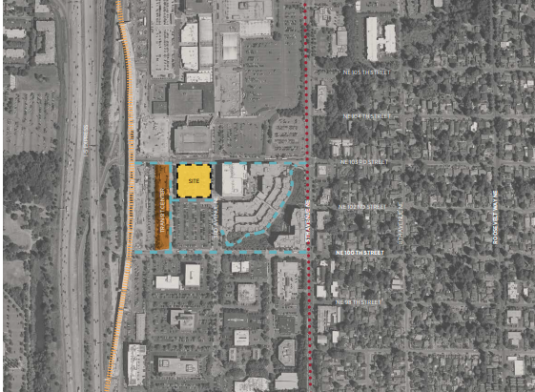

Parcel Map (placeholder until Line Boundary Assessment)
