Legislative Review Form
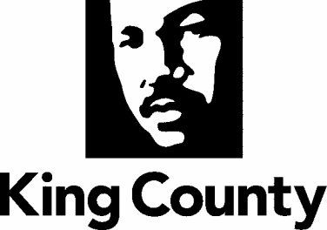

Agency: DHR Contact person Jason Cossette Phone 206-477-3157

Ordinance Motion Proviso Report Other

Civil Division Prosecuting Attorney Review

Name Susie Slonecker Version Final Date 11/15/2021

Dept. Director or Designee Review

Name Jay Osborne Version Final Date 11/22/2021

Performance Strategy & Budget Office Review

Name Chris McGowan Version Final Date 11/22/2021

Technical Form/Code Reviser Review – Confirm adherence to legislative format

Name Bruce Ritzen Version Final Date 11/15/2021

Executive Office Review & Transmittal Approval

Name Shannon Braddock Version Final Date 11/23/2021

ENTRANCE CRITERIA REVIEW
EXEC OFFICE (initials) KCC CLERK
Fiscal note? Y NA Y NA
KC Strategic Plan reference in letter? Y NA Y NA
Proof read for spelling and grammar? Y NA Y NA
All pertinent attachments listed/labeled? Y NA Y NA
Costs identified/described in letter Y NA Y NO
Regulatory Note Required and Complete? Y NA Y NO
Formatted/Delivered in word-searchable doc format? Y NA Y NA
Potential Annexation Area (PAA) impacts identified? Y NA Y NO
Advertising required? if yes, cite all pertinent code/laws. Y NA Y NO
Any special circumstances affecting processing time? Y NA Y NO

