March 2020
SEPTEMBER 2020
RENTON KENT AUBURN AREA MOBILITY PLAN SERVICE CHANGES

Route: 105 (revise)
OBJECTIVES:
Increase service on Route 105 in the Renton Highlands in accordance with the Strategic Plan for Public Transportation, 2011-2021 and King County Metro Service Guidelines.
- Strategic Plan Strategy 2.1.1: Design and offer a variety of public transportation products and services appropriate to different markets and mobility needs.
- Strategic Plan Strategy 2.2.1: Provide travel opportunities for historically disadvantaged populations, such as low-income people, students, youth, seniors, people of color, people with disabilities, and others with limited transportation options.
- Strategic Plan Strategy 2.3.1: Provide products and services that are designed to provide geographic value in all parts of King County.
- Strategic Plan Strategy 3.1.1: Through investments and partnerships with regional organizations, local jurisdictions and the private sector, provide alternatives to driving alone that connect people to jobs, education and other destinations essential to King County’s economic vitality.
- Strategic Plan Strategy 3.2.1: Expand services to accommodate the region’s growing population and serve new transit markets when financially feasible.
- Strategic Plan Strategy 3.4.1: Serve centers and other areas of concentrated activity, consistent with Transportation 2040.
- Strategic Plan Strategy 5.1.1: Provide service that is easy to understand and use.
- Strategic Plan Strategy 6.1.1: Manage the transit system through service guidelines and performance measures.
  - Service Design Guideline – Routes should be designed in the context of the entire transportation system.
  - Service Design Guideline – Demand-responsive service may be considered where fixed-route service is unlikely to be successful or where unique conditions exist that can be met more effectively through flexible service.
- Strategic Plan Strategy 6.2.3: Develop and implement alternative public transportation services and delivery strategies.
IMPACTED SERVICE AREA:
Renton
SERVICE CHANGE:
Add weekday peak-period service to the Route 105 to increase service from every 30 minutes to every 15 minutes from 5AM – 9AM and 3PM-6PM.

 | Weekday |  |  | Weekend
 | Peak | Midday | Night | Saturday | Sunday
CURRENT | 30 | 30 | 30 | 30-60 | 60
PROPOSED | 15 | No change | No change | No change | No change

 | Weekdays | Saturday | Sunday
CURRENT | 4:25 AM – 10:00 PM | 6:20 AM – 11:50 PM | 7:20 AM – 11:45 PM
PROPOSED | No change | No change | No change

Route: 148 (revise)
OBJECTIVES:
Revise service on Route 148 through the Benson Hill neighborhood of Renton to serve new community amenities and increasing density in accordance with the Strategic Plan for Public Transportation, 2011-2021 and King County Metro Service Guidelines.
- Strategic Plan Strategy 2.1.1: Design and offer a variety of public transportation products and services appropriate to different markets and mobility needs.
- Strategic Plan Strategy 2.2.1: Provide travel opportunities for historically disadvantaged populations, such as low-income people, students, youth, seniors, people of color, people with disabilities, and others with limited transportation options.
- Strategic Plan Strategy 2.3.1: Provide products and services that are designed to provide geographic value in all parts of King County.
- Strategic Plan Strategy 3.1.1: Through investments and partnerships with regional organizations, local jurisdictions and the private sector, provide alternatives to driving alone that connect people to jobs, education and other destinations essential to King County’s economic vitality.
- Strategic Plan Strategy 3.4.1: Serve centers and other areas of concentrated activity, consistent with Transportation 2040.
- Strategic Plan Strategy 5.1.1: Provide service that is easy to understand and use.
- Strategic Plan Strategy 6.1.1: Manage the transit system through service guidelines and performance measures.
  - Service Design Guideline – Routes should be designed in the context of the entire transportation system.
  - Service Design Guideline – A route that operates directly between two locations is faster and more attractive to riders than one that takes a long, circuitous path.
  - Service Design Guideline – The length of bus routes should provide useful connections for riders and be more attractive than other travel modes.
- Strategic Plan Strategy 6.2.3: Develop and implement alternative public transportation services and delivery strategies.
IMPACTED SERVICE AREA:
Renton
SERVICE CHANGE:
Modify the routing of Route 148 to better serve community assets, including a new community center (to open in 2020), and housing along 116th​ Ave SE.

 | Weekday |  |  | Weekend
 | Peak | Midday | Night | Saturday | Sunday
CURRENT | 30 | 30 | 60 | 60 | 60
PROPOSED | No change | No change | No change | No change | No change

 | Weekdays | Saturday | Sunday
CURRENT | 5:45 AM – 9:25 PM | 7:45 AM – 10:00 PM | 7:45 AM – 7:00 PM
PROPOSED | No change | No change | No change

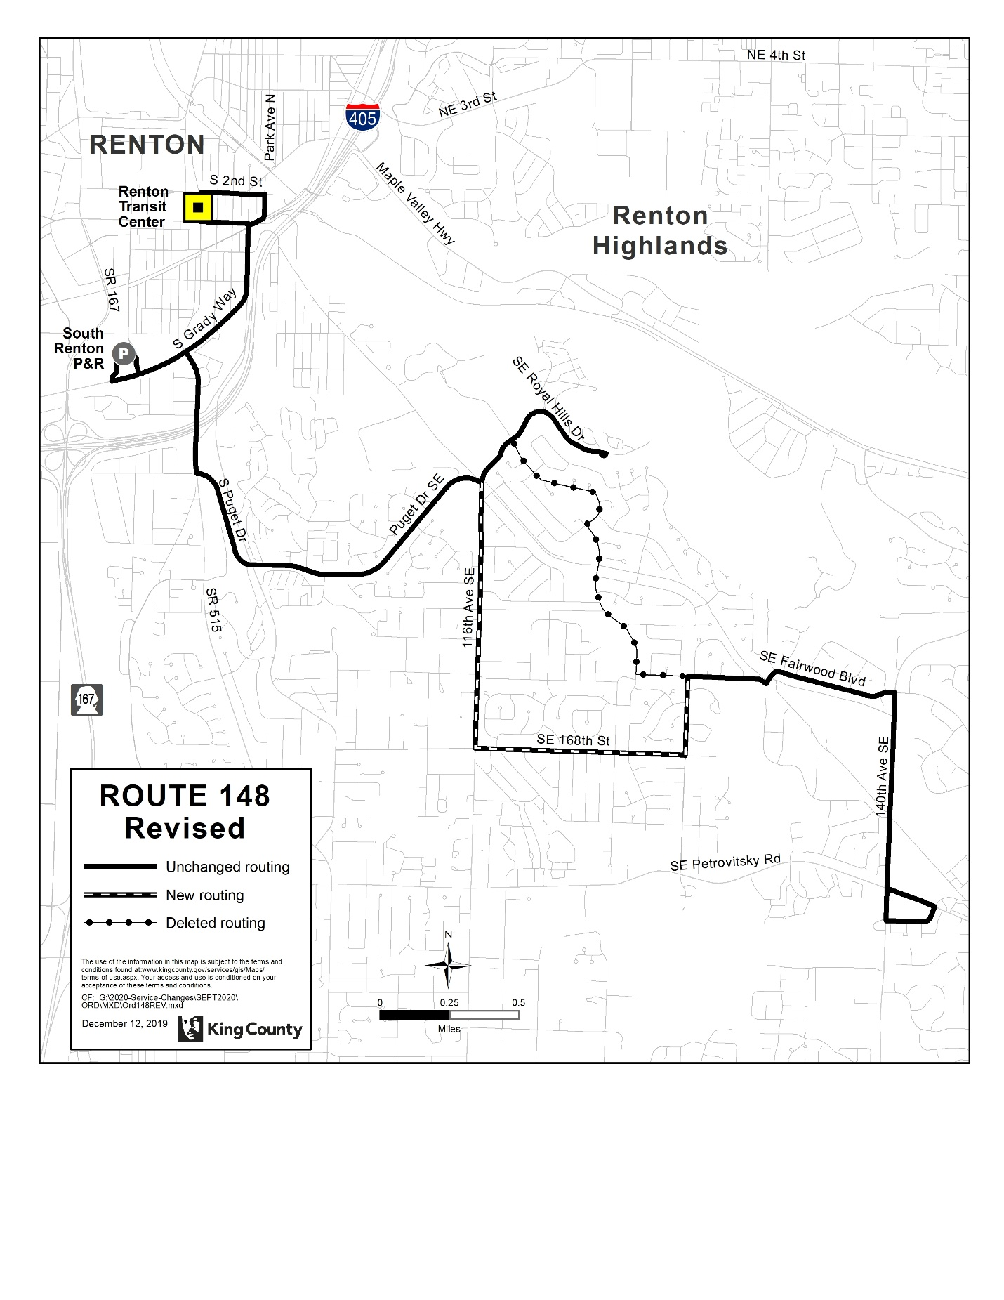
Route: 157 (revision)
OBJECTIVES:
Restructure service to avoid duplication in accordance with the Strategic Plan for Public Transportation, 2011 – 2021, and King County Metro Service Guidelines.
- Strategic Plan Strategy 3.4.1: Serve centers and other areas of concentrated activity, consistent with Transportation 2040.
- Strategic Plan Strategy 6.1.1: Manage the transit system through service guidelines and performance measures.
  - Service Design Guideline - Routes should be designed in the context of the entire transportation system.
  - Service Design Guideline - Routes should be designed to avoid competing for the same riders.
  - Strategic Plan Strategy 6.2.3: Develop and implement alternative public transportation services and delivery strategies.
IMPACTED SERVICE AREA:
Kent East Hill
SERVICE CHANGE:
Revise Route 157 to serve 132nd Ave SE and SE 256th St and not SE Kent Kangley Rd to avoid duplication with new Route 162.

 | Weekday |  |  | Weekend
 | Peak | Midday | Night | Saturday | Sunday
CURRENT | 4 AM trips,  3 PM trips | N/A | N/A | N/A | N/A
PROPOSED | 4 AM trips,  3 PM trips | N/A | N/A | N/A | N/A

 | Weekdays | Saturday | Sunday
CURRENT | 5 AM to 7 AM,  4 PM to 5 PM | N/A | N/A
PROPOSED | 5 AM to 7 AM,  4 PM to 5 PM | N/A | N/A

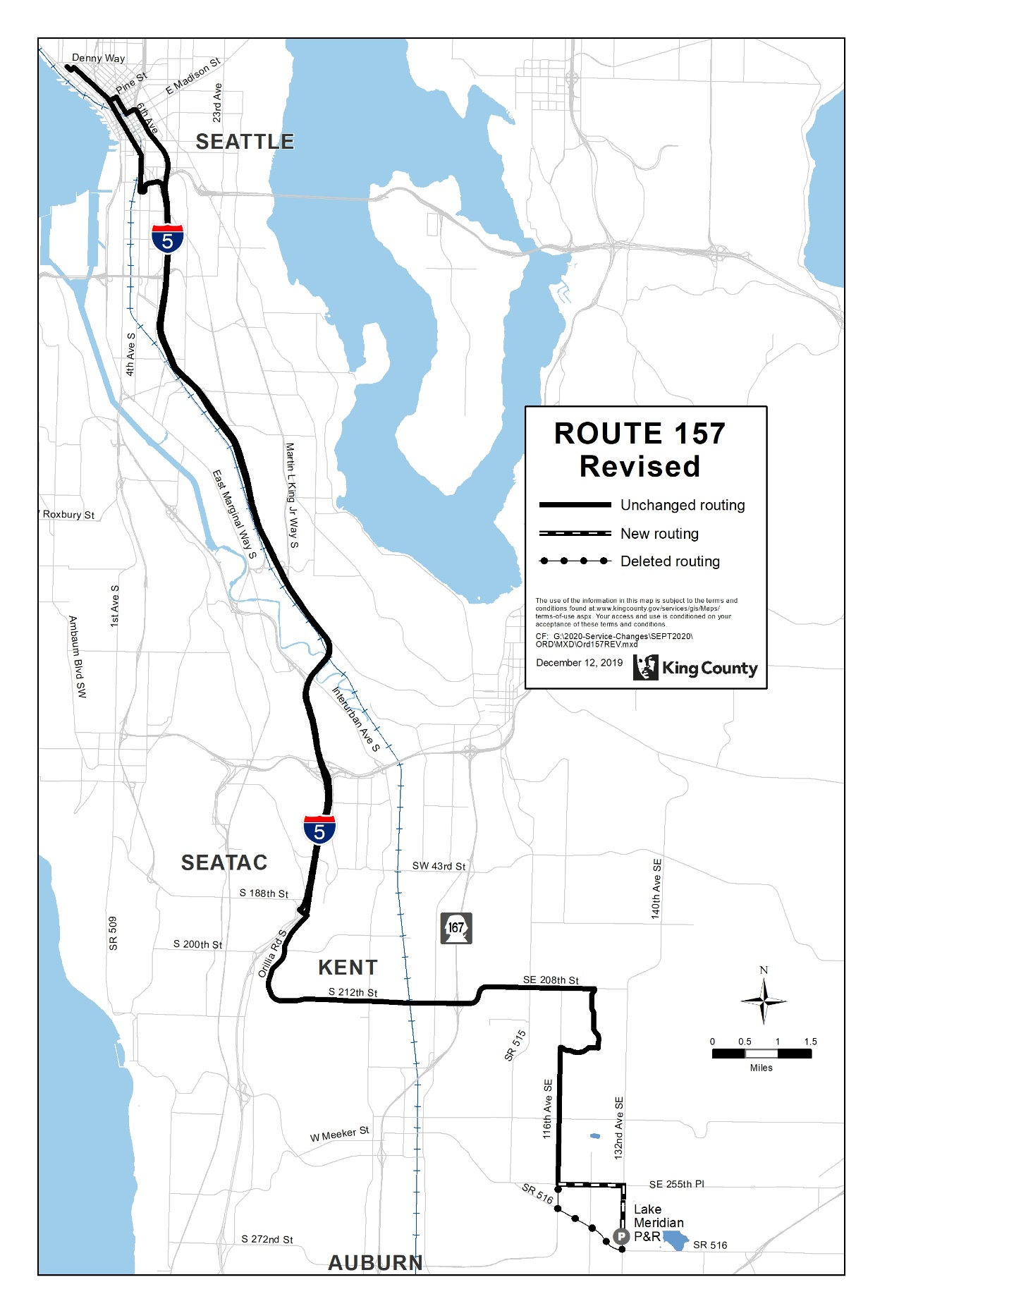

Route: 158 (delete)
OBJECTIVES:
Replacement service for Route 158 will be provided by new Routes 165 and 162.
Restructure service on Kent East Hill for simplified design, improved efficiency, and increased frequency and span of service in accordance with the Strategic Plan for Public Transportation, 2011 – 2021, and King County Metro Service Guidelines.
- Strategic Plan Strategy 2.1.1: Design and offer a variety of public transportation products and services appropriate to different markets and mobility needs.
- Strategic Plan Strategy 2.1.2: Provide travel opportunities and supporting amenities for historically disadvantaged populations, such as low-income people, students, youth, seniors, people of color, people with disabilities, and others with limited transportation options.
- Strategic Plan Strategy 3.4.1: Serve centers and other areas of concentrated activity, consistent with Transportation 2040.
- Strategic Plan Strategy 5.1.1: Provide service that is easy to understand and use.
- Strategic Plan Strategy 6.1.1: Manage the transit system through service guidelines and performance measures.
  - Service Design Guideline - When designing a network of services, Metro should consider locations where transfer opportunities could be provided for the convenience of customers and to improve the efficiency of the transit network.
  - Service Design Guideline - Routes are more efficient when designed to serve multiple purposes and destinations rather than specialized travel demands.
  - Service Design Guideline - Routes should have predictable and direct routings, and the frequency and span of service should be appropriate to the market served.
  - Service Design Guideline - Routes should be designed to avoid competing for the same riders.
  - Service Design Guideline - A route that operates directly between two locations is faster and more attractive to riders than one that takes a long, circuitous path.
  - Service Design Guideline - Buses should be routed primarily on arterial streets and freeways, except where routing on local or collector streets is necessary to reach layover areas or needed to ensure that facilities and fleet used in all communities is equivalent in age and quality.
- Strategic Plan Strategy 6.2.1: Continually explore and implement cost efficiencies, including operational and administrative efficiencies.
- Strategic Plan Strategy 6.2.3: Develop and implement alternative public transportation services and delivery strategies.
IMPACTED SERVICE AREA:
Kent
SERVICE CHANGE:
Delete Route 158 to reduce duplicative and low-performing service. Alternative service will be provided by new Route 162, connecting Lake Meridian Park and Ride to Downtown Seattle via SE Kent Kangley Rd and Kent Station, and new Route 165, which will provide replacement service on 132nd Ave SE and SE 240th St.

 | Weekday |  |  | Weekend
 | Peak | Midday | Night | Saturday | Sunday
CURRENT | 6 AM trips,  6 PM trips | N/A | N/A | N/A | N/A
PROPOSED | N/A | N/A | N/A | N/A | N/A

 | Weekdays | Saturday | Sunday
CURRENT | 4 AM to 7 AM,  3 PM to 6 PM | N/A | N/A
PROPOSED | N/A | N/A | N/A

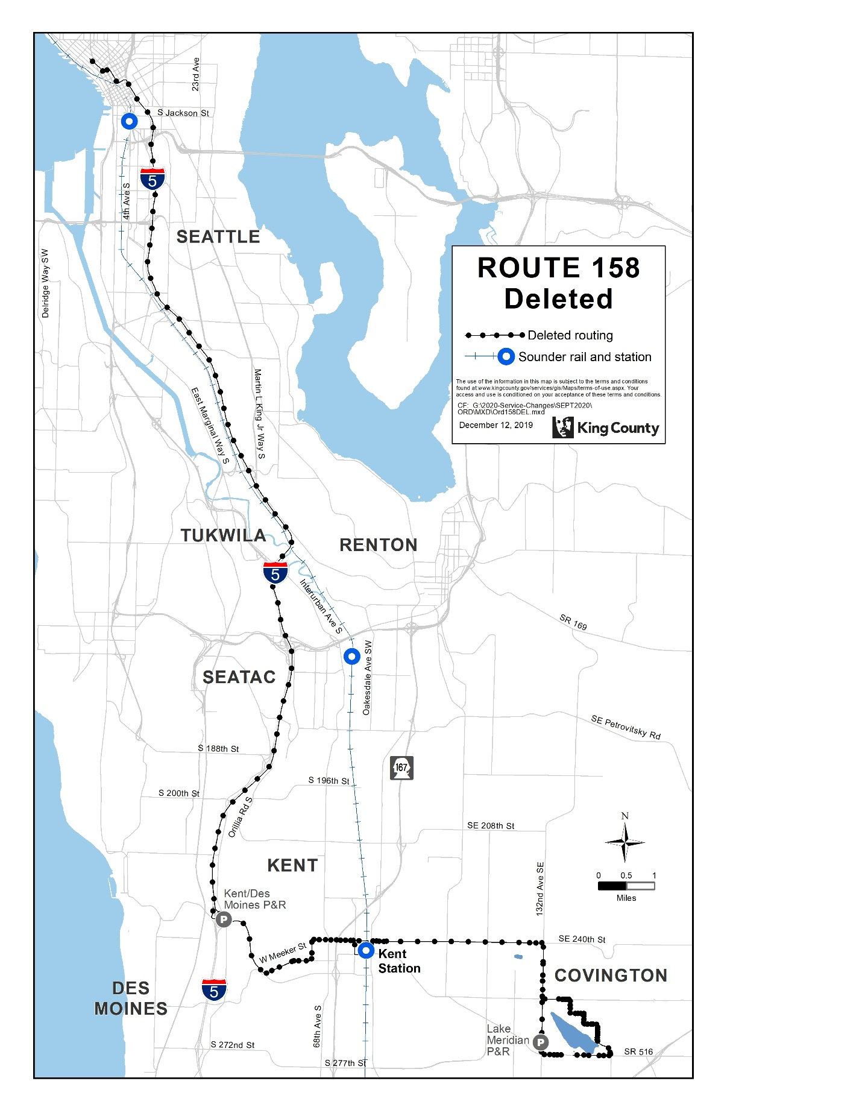
Route: 159 (delete)
OBJECTIVES:
Replacement service to Route 159 will be provided by revised Route 168 and new Route 162.
Restructure service in Covington and the Kent East Hill for simplified design, improved efficiency, and increased frequency and span of service in accordance with the Strategic Plan for Public Transportation, 2011 – 2021, and King County Metro Service Guidelines.
- Strategic Plan Strategy 2.1.1: Design and offer a variety of public transportation products and services appropriate to different markets and mobility needs.
- Strategic Plan Strategy 2.1.2: Provide travel opportunities and supporting amenities for historically disadvantaged populations, such as low-income people, students, youth, seniors, people of color, people with disabilities, and others with limited transportation options.
- Strategic Plan Strategy 5.1.1: Provide service that is easy to understand and use.
- Strategic Plan Strategy 6.1.1: Manage the transit system through service guidelines and performance measures.
  - Service Design Guideline - When designing a network of services, Metro should consider locations where transfer opportunities could be provided for the convenience of customers and to improve the efficiency of the transit network.
  - Service Design Guideline - Routes are more efficient when designed to serve multiple purposes and destinations rather than specialized travel demands.
  - Service Design Guideline - Routes should be designed to avoid competing for the same riders.
  - Service Design Guideline - Buses should be routed primarily on arterial streets and freeways, except where routing on local or collector streets is necessary to reach layover areas or needed to ensure that facilities and fleet used in all communities is equivalent in age and quality.
- Strategic Plan Strategy 6.2.1: Continually explore and implement cost efficiencies, including operational and administrative efficiencies.
- Strategic Plan Strategy 6.2.3: Develop and implement alternative public transportation services and delivery strategies.
IMPACTED SERVICE AREA:
Covington, Kent
SERVICE CHANGE:
Delete Route 159 to reduce duplicative and low-performing service. Alternative service will be provided by new Route 162 connecting Lake Meridian Park and Ride to Downtown Seattle via SE Kent Kangley Rd and Kent Station, and local Route 168, which will receive increased service.

 | Weekday |  |  | Weekend
 | Peak | Midday | Night | Saturday | Sunday
CURRENT | 5 AM trips,  4 PM trips | N/A | N/A | N/A | N/A
PROPOSED | N/A | N/A | N/A | N/A | N/A

 | Weekdays | Saturday | Sunday
CURRENT | 5 AM to 6 AM,  3 PM to 6 PM | N/A | N/A
PROPOSED | N/A | N/A | N/A

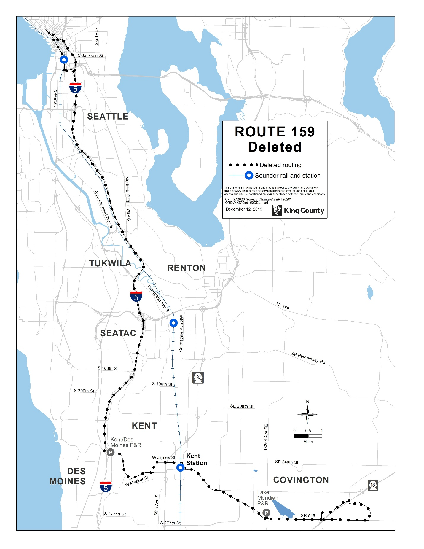

Route: 160 (new)
OBJECTIVES:
Restructure service to connect Renton, Kent, and Auburn with frequent service on Route 160, creating a single route operating throughout the future RapidRide I Line corridor in accordance with the Strategic Plan for Public Transportation, 2011-2021 and King County Metro Service Guidelines.
- Strategic Plan Strategy 2.1.1: Design and offer a variety of public transportation products and services appropriate to different markets and mobility needs.
- Strategic Plan Strategy 2.1.2: Provide travel opportunities and supporting amenities for historically disadvantaged populations, such as low-income people, students, youth, seniors, people of color, people with disabilities, and others with limited transportation options.
- Strategic Plan Strategy 2.1.3: Provide products and services that are designed to provide geographic value in all parts of King County.
- Strategic Plan Strategy 3.1.1: Encourage land uses, policies, and development that lead to communities that have good access to transit and that transit can serve efficiently and effectively.
- Strategic Plan Strategy 3.2.1: Expand services to accommodate the region’s growing population and serve new transit markets.
- Strategic Plan Strategy 3.4.1: Serve centers and other areas of concentrated activity, consistent with Transportation 2040.
- Strategic Plan Strategy 4.1.1: Increase the proportion of travel in King County that is provided by public transportation products and services.
- Strategic Plan Strategy 5.1.1: Provide service that is easy to understand and use.
- Strategic Plan Strategy 6.1.1: Manage the transit system through service guidelines and performance measures.
  - Service Design Guideline - Routes should be designed in the context of the entire transportation system.
  - Service Design Guideline - When designing a network of services, Metro should consider locations where transfer opportunities could be provided for the convenience of customers and to improve the efficiency of the transit network.
  - Service Design Guideline - Routes are more efficient when designed to serve multiple purposes and destinations rather than specialized travel demands.
  - Service Design Guideline -Routes should be designed to avoid competing for the same riders.
  - Service Design Guideline - A bus route should be long enough to provide useful connections for riders and to be more attractive than other travel modes.
  - Service Design Guideline - Where many routes converge, such as in regional growth centers, they may be through-routed to increase efficiency, reduce the number of buses providing overlapping service, and reduce the need for layover space in congested areas.
- Strategic Plan Strategy 6.2.1: Continually explore and implement cost efficiencies, including operational and administrative efficiencies.

IMPACTED SERVICE AREA:
Renton, Kent, Auburn

SERVICE CHANGE:
Implement new Route 160, which will provide service between Renton Transit Center, Kent Station, and Auburn Station. On weekdays, Route 160 will operate every 30 minutes from approximately 4:15 AM until 5:45 AM with 15 minute or better frequency from 6AM-6PM and will operate every 30-60 minutes in the evenings from 6:00 PM until 3:00 AM. On weekends, Route 160 will operate every 30 minutes from approximately 5:25 AM to 9:00 PM and every 30-60 minutes from approximately 9:00 PM until 3:00 AM.
 | Weekday |  |  | Weekend
 | Peak | Midday | Night | Saturday | Sunday
CURRENT | N/A | N/A | N/A | N/A | N/A
PROPOSED | 15 | 15 | 30-60 | 30 | 30

 | Weekdays | Saturday | Sunday
CURRENT | N/A | N/A | N/A
PROPOSED | 4:15AM – 3:00 AM | 5:25 AM – 3:00 AM | 5:25 AM – 3:00 AM

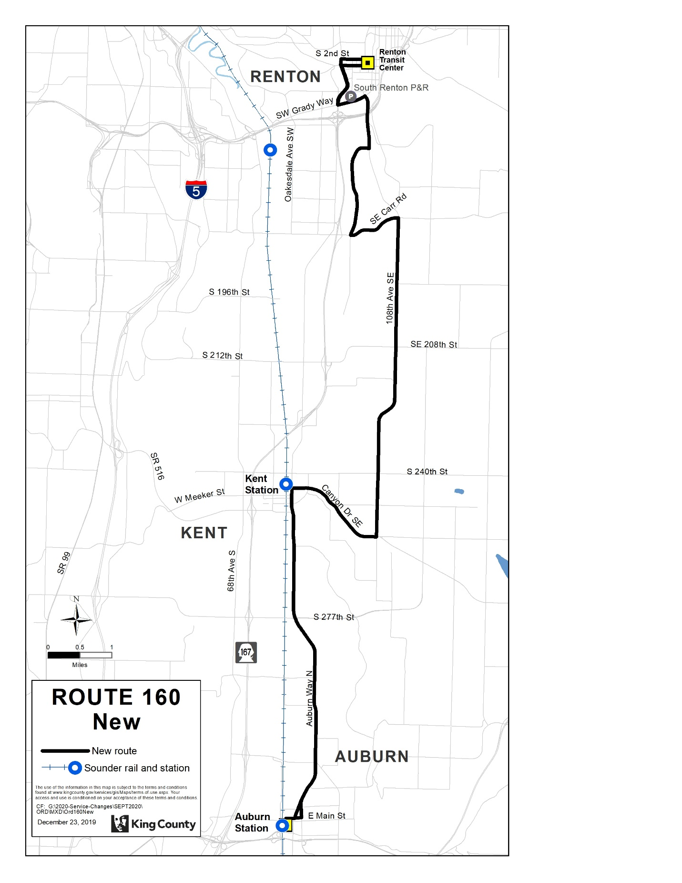
Route: 161 (new)
OBJECTIVES:
Restructure service to connect Kent, SeaTac, and Burien while reducing duplication and increasing service levels in accordance with the Strategic Plan for Public Transportation, 2011-2021 and King County Metro Service Guidelines.
- Strategic Plan Strategy 2.1.1: Design and offer a variety of public transportation products and services appropriate to different markets and mobility needs.
- Strategic Plan Strategy 2.1.2: Provide travel opportunities and supporting amenities for historically disadvantaged populations, such as low-income people, students, youth, seniors, people of color, people with disabilities, and others with limited transportation options.
- Strategic Plan Strategy 3.4.1: Serve centers and other areas of concentrated activity, consistent with Transportation 2040.
- Strategic Plan Strategy 5.1.1: Provide service that is easy to understand and use.
- Strategic Plan Strategy 6.1.1: Manage the transit system through service guidelines and performance measures.
  - Service Design Guideline - Routes should be designed in the context of the entire transportation system.
  - Service Design Guideline - When designing a network of services, Metro should consider locations where transfer opportunities could be provided for the convenience of customers and to improve the efficiency of the transit network.
  - Service Design Guideline - Routes are more efficient when designed to serve multiple purposes and destinations rather than specialized travel demands.
  - Service Design Guideline -Routes should be designed to avoid competing for the same riders.
  - Service Design Guideline - A bus route should be long enough to provide useful connections for riders and to be more attractive than other travel modes.
  - Service Design Guideline - Where many routes converge, such as in regional growth centers, they may be through-routed to increase efficiency, reduce the number of buses providing overlapping service, and reduce the need for layover space in congested areas.
- Strategic Plan Strategy 6.2.1: Continually explore and implement cost efficiencies, including operational and administrative efficiencies.
IMPACTED SERVICE AREA: Kent, SeaTac, Burien
SERVICE CHANGE:
Implement new Route 161, which will replace Route 180 service between Kent Station and Burien Transit Center. On weekdays, Route 161 will operate every 15-30 minutes from approximately 3:00 AM until 9:00 PM and will operate every 30-60 minutes in the evenings from 9:00 PM until 2:15 AM. On weekends, Route 161 will operate every 30 minutes from approximately 5:15 AM to 9:00 PM and every 30-60 minutes from 9:00 PM until 3:30 AM.

 | Weekday |  |  | Weekend
 | Peak | Midday | Night | Saturday | Sunday
CURRENT | N/A | N/A | N/A | N/A | N/A
PROPOSED | 15-30 | 30 | 30 | 30 | 30

 | Weekdays | Saturday | Sunday
CURRENT | N/A | N/A | N/A
PROPOSED | 3 AM to 2:15 AM | 5:15 AM to 3:30 AM | 5:15 AM to 3:30 AM

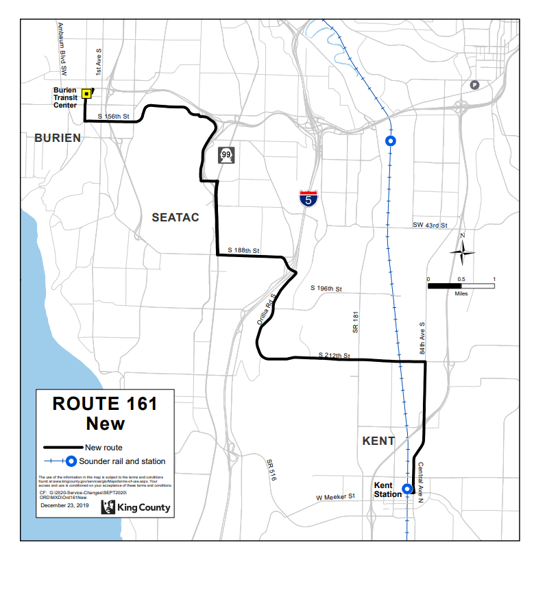
Route: 162 (new)
OBJECTIVES:
Restructure service on Kent East Hill for simplified design, improved efficiency, and increased frequency and span of service in accordance with the Strategic Plan for Public Transportation, 2011 – 2021, and King County Metro Service Guidelines.
- Strategic Plan Strategy 2.1.1: Design and offer a variety of public transportation products and services appropriate to different markets and mobility needs.
- Strategic Plan Strategy 2.1.2: Provide travel opportunities and supporting amenities for historically disadvantaged populations, such as low-income people, students, youth, seniors, people of color, people with disabilities, and others with limited transportation options.
- Strategic Plan Strategy 3.4.1: Serve centers and other areas of concentrated activity, consistent with Transportation 2040.
- Strategic Plan Strategy 5.1.1: Provide service that is easy to understand and use.
- Strategic Plan Strategy 6.1.1: Manage the transit system through service guidelines and performance measures.
  - Service Design Guideline - When designing a network of services, Metro should consider locations where transfer opportunities could be provided for the convenience of customers and to improve the efficiency of the transit network.
  - Service Design Guideline - Routes should have predictable and direct routings, and the frequency and span of service should be appropriate to the market served.
  - Service Design Guideline - Routes should be designed to avoid competing for the same riders.
  - Service Design Guideline - A route that operates directly between two locations is faster and more attractive to riders than one that takes a long, circuitous path.
  - Service Design Guideline - Buses should be routed primarily on arterial streets and freeways, except where routing on local or collector streets is necessary to reach layover areas or needed to ensure that facilities and fleet used in all communities is equivalent in age and quality.
- Strategic Plan Strategy 6.2.1: Continually explore and implement cost efficiencies, including operational and administrative efficiencies.
- Strategic Plan Strategy 6.2.4: Provide alternative or “right-sized” services in the context of overall system financial health and the need to reduce, maintain or expand the system.
IMPACTED SERVICE AREA:
Kent
SERVICE CHANGE:
Implement new Route 162, which will provide service between Lake Meridian Park and Ride and Downtown Seattle via SE Kent Kangley Rd and Kent Station. Route 162 will operate approximately ten trips between approximately 5 AM and 9 AM and approximately nine trips between approximately 3 PM and 6 PM.

 | Weekday |  |  | Weekend
 | Peak | Midday | Night | Saturday | Sunday
CURRENT | N/A | N/A | N/A | N/A | N/A
PROPOSED | 10 AM trips,  9 PM trips | N/A | N/A | N/A | N/A

 | Weekdays | Saturday | Sunday
CURRENT | N/A | N/A | N/A
PROPOSED | 5 AM to 7 AM,  3 PM to 6 PM | N/A | N/A

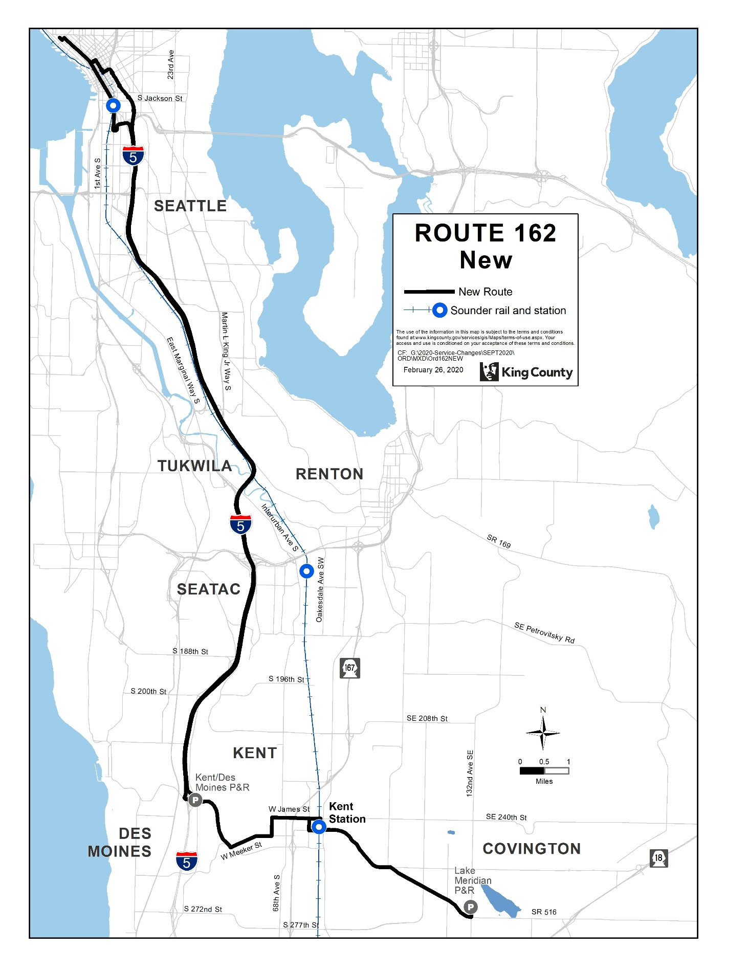
Route: 164 (delete)
OBJECTIVES:
Replacement service to Route 164 will be provided by new Route 165.
Restructure service to provide better east-west connections between Green River College, Kent, Highline College, Des Moines, and Burien while increasing service levels, introducing new Sunday service, and better distributing service pathways on the Kent East Hill in accordance with the Strategic Plan for Public Transportation, 2011 – 2021, and King County Metro Service Guidelines.
- Strategic Plan Strategy 2.1.1: Design and offer a variety of public transportation products and services appropriate to different markets and mobility needs.
- Strategic Plan Strategy 2.1.2: Provide travel opportunities and supporting amenities for historically disadvantaged populations, such as low-income people, students, youth, seniors, people of color, people with disabilities, and others with limited transportation options.
- Strategic Plan Strategy 2.1.3: Provide products and services that are designed to provide geographic value in all parts of King County.
- Strategic Plan Strategy 3.4.1: Serve centers and other areas of concentrated activity, consistent with Transportation 2040.
- Strategic Plan Strategy 5.1.1: Provide service that is easy to understand and use.
- Strategic Plan Strategy 6.1.1: Manage the transit system through service guidelines and performance measures.
  - Service Design Guideline - Routes should be designed in the context of the entire transportation system.
  - Service Design Guideline - When designing a network of services, Metro should consider locations where transfer opportunities could be provided for the convenience of customers and to improve the efficiency of the transit network.
  - Service Design Guideline - Routes are more efficient when designed to serve multiple purposes and destinations rather than specialized travel demands.
  - Service Design Guideline - Routes should have predictable and direct routings, and the frequency and span of service should be appropriate to the market served.
  - Service Design Guideline - As budget allows, routes should be targeted for a minimum service level of at least every 60 minutes.
  - Service Design Guideline - A bus route should be long enough to provide useful connections for riders and to be more attractive than other travel modes.
  - Service Design Guideline - Where many routes converge, such as in regional growth centers, they may be through-routed to increase efficiency, reduce the number of buses providing overlapping service, and reduce the need for layover space in congested area
- Strategic Plan Strategy 6.2.1: Continually explore and implement cost efficiencies, including operational and administrative efficiencies.
IMPACTED SERVICE AREA:
Green River College, Kent East Hill, Central Kent
SERVICE CHANGE:
Delete Route 164 and replace with new Route 165 to provide a one-seat ride between Green River College, Kent, Highline College, Des Moines, and Burien with increased frequency and span.

 | Weekday |  |  | Weekend
 | Peak | Midday | Night | Saturday | Sunday
CURRENT | 30 | 30 | 30 | 30 | N/A
PROPOSED | N/A | N/A | N/A | N/A | N/A

 | Weekdays | Saturday | Sunday
CURRENT | 5 AM to 10 PM | 7 AM to 10 PM | N/A
PROPOSED | N/A | N/A | N/A

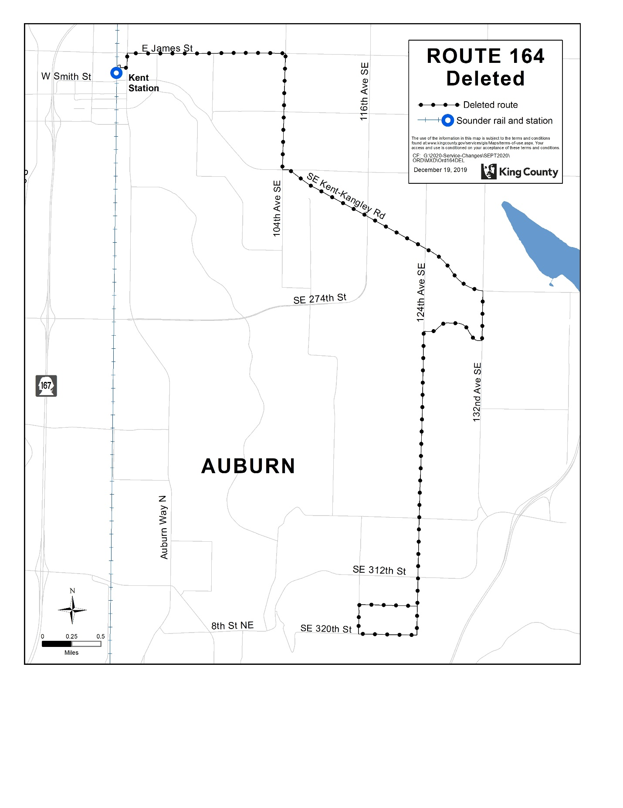

Route: 165 (new)
OBJECTIVES:
Restructure local service to provide better east-west connections between Green River College, Kent, Highline College, Des Moines, and Burien while increasing service levels, introducing new Sunday service between Kent Station and Green River College, and better distributing service pathways on both the Kent East Hill and Kent West Hill in accordance with the Strategic Plan for Public Transportation, 2011 – 2021, and King County Metro Service Guidelines.
- Strategic Plan Strategy 2.1.1: Design and offer a variety of public transportation products and services appropriate to different markets and mobility needs.
- Strategic Plan Strategy 2.1.2: Provide travel opportunities and supporting amenities for historically disadvantaged populations, such as low-income people, students, youth, seniors, people of color, people with disabilities, and others with limited transportation options.
- Strategic Plan Strategy 2.1.3: Provide products and services that are designed to provide geographic value in all parts of King County.
- Strategic Plan Strategy 3.4.1: Serve centers and other areas of concentrated activity, consistent with Transportation 2040.
- Strategic Plan Strategy 5.1.1: Provide service that is easy to understand and use.
- Strategic Plan Strategy 6.1.1: Manage the transit system through service guidelines and performance measures.
  - Service Design Guideline - Routes should be designed in the context of the entire transportation system.
  - Service Design Guideline - When designing a network of services, Metro should consider locations where transfer opportunities could be provided for the convenience of customers and to improve the efficiency of the transit network.
  - Service Design Guideline - Routes are more efficient when designed to serve multiple purposes and destinations rather than specialized travel demands.
  - Service Design Guideline - Routes should have predictable and direct routings, and the frequency and span of service should be appropriate to the market served.
  - Service Design Guideline - As budget allows, routes should be targeted for a minimum service level of at least every 60 minutes.
  - Service Design Guideline - A bus route should be long enough to provide useful connections for riders and to be more attractive than other travel modes.
  - Service Design Guideline - Where many routes converge, such as in regional growth centers, they may be through-routed to increase efficiency, reduce the number of buses providing overlapping service, and reduce the need for layover space in congested area
  - Service Design Guideline - Bus routes should operate as fixed routes in order to provide a predictable and reliable service for a wide range of potential riders.
- Strategic Plan Strategy 6.2.1: Continually explore and implement cost efficiencies, including operational and administrative efficiencies.
IMPACTED SERVICE AREA:
Green River College, Kent, Highline College, Des Moines, Burien TC
SERVICE CHANGE:
Implement new Route 165 which will provide a one-seat ride between Green River College, Kent, Highline College, Des Moines, and Burien and increase local service levels. On weekdays, Route 165 will operate trips timed to Sounder departures (every 20-30 minutes) from approximately 4:30 AM to 9 AM and 3 PM to 7 PM and will operate every 30 minutes in the midday and hourly in the evenings until approximately 11 PM. On Saturday, the route will operate every 30 minutes from 6 AM to 9 PM and hourly from approximately 9 PM to 11 PM. On Sunday, the route will operate hourly from approximately 6 AM to 10 PM.

 | Weekday |  |  | Weekend
 | Peak | Midday | Night | Saturday | Sunday
CURRENT | N/A | N/A | N/A | N/A | N/A
PROPOSED | 20-30 | 30 | 30 | 30 | 60

 | Weekdays | Saturday | Sunday
CURRENT | N/A | N/A | N/A
PROPOSED | 4 AM to 11 PM | 6 AM to 11 PM | 6 AM to 10 PM

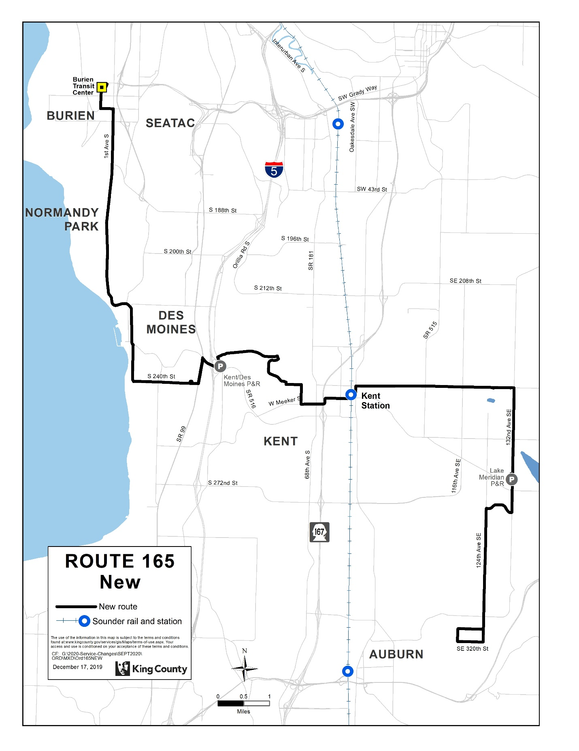

Route: 166 (delete)
OBJECTIVES:
Replacement service to Route 166 will be provided by new Route 165.
Restructure service to provide better east-west connections between Green River College, Kent, Highline College, Des Moines, and Burien while increasing service levels, and better distributing service pathways on the Kent West Hill in accordance with the Strategic Plan for Public Transportation, 2011 – 2021, and King County Metro Service Guidelines.
- Strategic Plan Strategy 2.1.1: Design and offer a variety of public transportation products and services appropriate to different markets and mobility needs.
- Strategic Plan Strategy 2.1.2: Provide travel opportunities and supporting amenities for historically disadvantaged populations, such as low-income people, students, youth, seniors, people of color, people with disabilities, and others with limited transportation options.
- Strategic Plan Strategy 2.1.3: Provide products and services that are designed to provide geographic value in all parts of King County.
- Strategic Plan Strategy 3.4.1: Serve centers and other areas of concentrated activity, consistent with Transportation 2040.
- Strategic Plan Strategy 5.1.1: Provide service that is easy to understand and use.
- Strategic Plan Strategy 6.1.1: Manage the transit system through service guidelines and performance measures.
  - Service Design Guideline - Routes should be designed in the context of the entire transportation system.
  - Service Design Guideline - When designing a network of services, Metro should consider locations where transfer opportunities could be provided for the convenience of customers and to improve the efficiency of the transit network.
  - Service Design Guideline - Routes are more efficient when designed to serve multiple purposes and destinations rather than specialized travel demands.
  - Service Design Guideline - Routes should have predictable and direct routings, and the frequency and span of service should be appropriate to the market served.
  - Service Design Guideline - As budget allows, routes should be targeted for a minimum service level of at least every 60 minutes.
  - Service Design Guideline - A bus route should be long enough to provide useful connections for riders and to be more attractive than other travel modes.
  - Service Design Guideline - Where many routes converge, such as in regional growth centers, they may be through-routed to increase efficiency, reduce the number of buses providing overlapping service, and reduce the need for layover space in congested area
- Strategic Plan Strategy 6.2.1: Continually explore and implement cost efficiencies, including operational and administrative efficiencies.

IMPACTED SERVICE AREA:
Kent West Hill, Highline College, Des Moines, Burien TC
SERVICE CHANGE:
Delete Route 166 and replace with new Route 165 to provide a one-seat ride between Green River College, Kent, Highline College, Des Moines, and Burien with increased frequency and span.

 | Weekday |  |  | Weekend
 | Peak | Midday | Night | Saturday | Sunday
CURRENT | 30 | 30 | 60 | 30 | 60
PROPOSED | N/A | N/A | N/A | N/A | N/A

 | Weekdays | Saturday | Sunday
CURRENT | 4 AM to 11 PM | 6 AM to 11 PM | 7 AM to 8 PM
PROPOSED | N/A | N/A | N/A

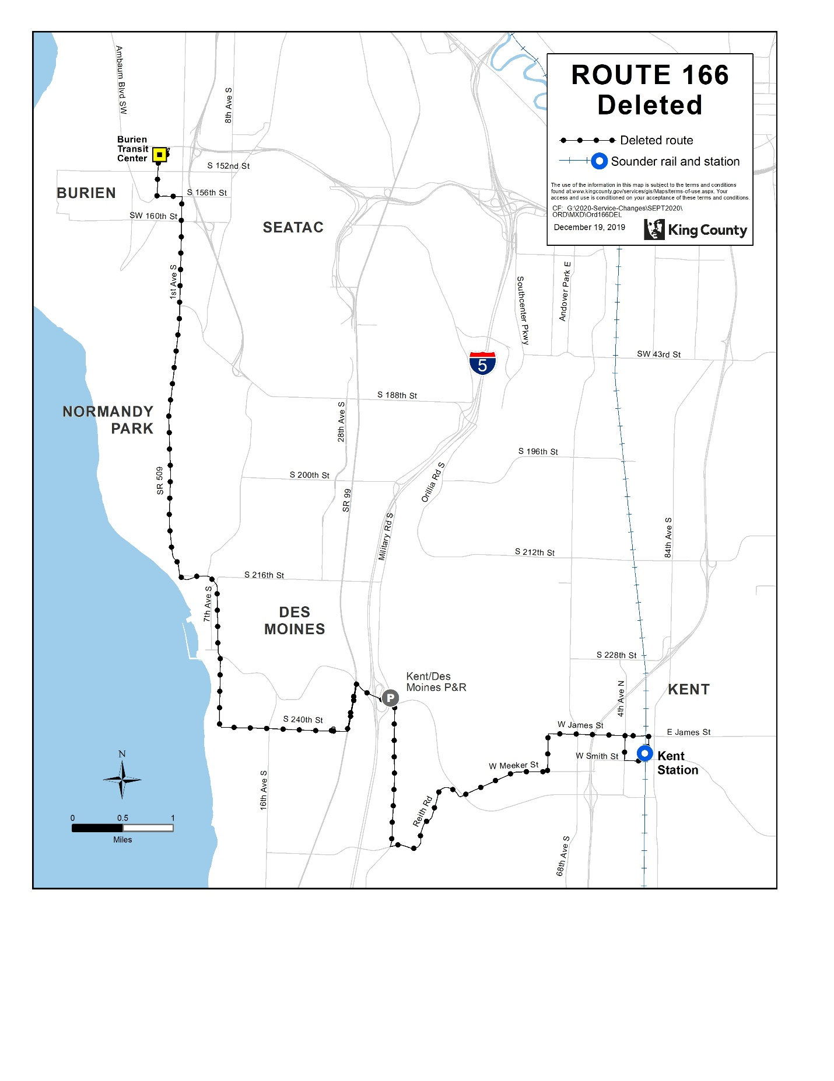

Route: 168 (revise)
OBJECTIVES:
Restructure service to more directly connect Maple Valley, Covington, and Kent while increasing service levels in accordance with the Strategic Plan for Public Transportation, 2011 – 2021, and King County Metro Service Guidelines.
- Strategic Plan Strategy 2.1.1: Design and offer a variety of public transportation products and services appropriate to different markets and mobility needs.
- Strategic Plan Strategy 2.1.2: Provide travel opportunities and supporting amenities for historically disadvantaged populations, such as low-income people, students, youth, seniors, people of color, people with disabilities, and others with limited transportation options.
- Strategic Plan Strategy 2.1.3: Provide products and services that are designed to provide geographic value in all parts of King County.
- Strategic Plan Strategy 3.2.1: Expand services to accommodate the region’s growing population and serve new transit markets.
- Strategic Plan Strategy 3.4.1: Serve centers and other areas of concentrated activity, consistent with Transportation 2040.
- Strategic Plan Strategy 6.1.1: Manage the transit system through service guidelines and performance measures.
  - Service Design Guideline - Routes should be designed in the context of the entire transportation system.
  - Service Design Guideline - When designing a network of services, Metro should consider locations where transfer opportunities could be provided for the convenience of customers and to improve the efficiency of the transit network.
  - Service Design Guideline - Routes should have predictable and direct routings, and the frequency and span of service should be appropriate to the market served.
  - Service Design Guideline - Routes should be designed to avoid competing for the same riders.
  - Service Design Guideline - A route that operates directly between two locations is faster and more attractive to riders than one that takes a long, circuitous path.
  - Service Design Guideline - Where many routes converge, such as in regional growth centers, they may be through-routed to increase efficiency, reduce the number of buses providing overlapping service, and reduce the need for layover space in congested areas.
IMPACTED SERVICE AREA:
Maple Valley, Covington, Kent
SERVICE CHANGE:
Route 168 will be revised to serve SE Kent Kangley Dr and Canyon Dr SE and not 132nd Ave SE, SE 256th St, 104th Ave SE, and SE 240th. Alternative service on streets no longer served by Route 168 will be provided by Routes 160, 164, and 914.
On weekdays, Route 168 will operate 30-minute service from approximately 4:30 AM to 9 PM and hourly from approximately 9 PM to 1:30 AM. On weekends, the route will operate 30-minute service from approximately 5:15 AM to 9 PM and hourly from approximately 9 PM to 12 AM.

 | Weekday |  |  | Weekend
 | Peak | Midday | Night | Saturday | Sunday
CURRENT | 30 | 30 | 60 | 60 | 60
PROPOSED | 30 | 30 | 30 | 30 | 30

 | Weekdays | Saturday | Sunday
CURRENT | 4 AM to 11 PM | 5 AM to 10 PM | 7 AM to 8 PM
PROPOSED | 4 AM to 1 AM | 5 AM to 12 AM | 5 AM to 12 AM

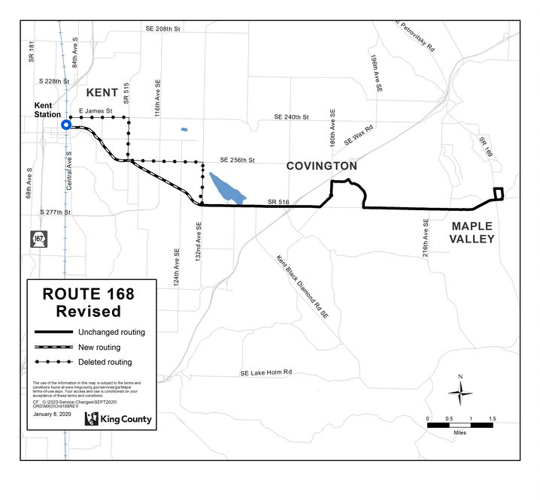

Route: 169 (delete)
OBJECTIVES:
Replacement service for Route 169 will be provided by new Route 160.
Restructure service in Renton, Kent, and Auburn for simplified design, increased frequency and span of service, and improved resource stewardship in accordance with the Strategic Plan for Public Transportation, 2011-2021 and King County Metro Service Guidelines.
- Strategic Plan Strategy 2.1.1: Design and offer a variety of public transportation products and services appropriate to different markets and mobility needs.
- Strategic Plan Strategy 2.1.2: Provide travel opportunities and supporting amenities for historically disadvantaged populations, such as low-income people, students, youth, seniors, people of color, people with disabilities, and others with limited transportation options.
- Strategic Plan Strategy 2.1.3: Provide products and services that are designed to provide geographic value in all parts of King County.
- Strategic Plan Strategy 3.4.1: Serve centers and other areas of concentrated activity, consistent with Transportation 2040.
- Strategic Plan Strategy 5.1.1: Provide service that is easy to understand and use.
- Strategic Plan Strategy 6.1.1: Manage the transit system through service guidelines and performance measures.
  - Service Design Guideline - Routes should be designed in the context of the entire transportation system.
  - Service Design Guideline - When designing a network of services, Metro should consider locations where transfer opportunities could be provided for the convenience of customers and to improve the efficiency of the transit network.
  - Service Design Guideline - Routes are more efficient when designed to serve multiple purposes and destinations rather than specialized travel demands.
  - Service Design Guideline - Routes should have predictable and direct routings, and the frequency and span of service should be appropriate to the market served.
  - Service Design Guideline - As budget allows, routes should be targeted for a minimum service level of at least every 60 minutes.
  - Service Design Guideline - A bus route should be long enough to provide useful connections for riders and to be more attractive than other travel modes.
  - Service Design Guideline - Where many routes converge, such as in regional growth centers, they may be through-routed to increase efficiency, reduce the number of buses providing overlapping service, and reduce the need for layover space in congested area
- Strategic Plan Strategy 6.2.1: Continually explore and implement cost efficiencies, including operational and administrative efficiencies.

IMPACTED SERVICE AREA:
Renton, Kent
SERVICE CHANGE:
Delete Route 169 to reduce duplicative service. Alternative service will be provided by new Route 160 between Renton and Kent.

 | Weekday |  |  | Weekend
 | Peak | Midday | Night | Saturday | Sunday
CURRENT | 15-30 | 15 | 30 | 30 | 60
PROPOSED | N/A | N/A | N/A | N/A | N/A

 | Weekdays | Saturday | Sunday
CURRENT | 4 AM to 11 PM | 6 AM to 11 PM | 7 AM to 11 PM
PROPOSED | N/A | N/A | N/A

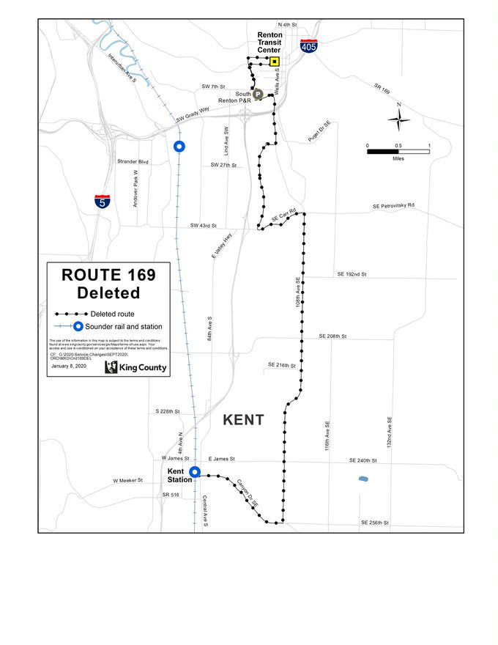

Route: 180 (delete)
OBJECTIVES:
Replacement service to Route 180 will be provided by new Routes 160, 161, and 184.
Restructure service in Renton, Kent, and Auburn for simplified design, increased frequency and span of service, and improved resource stewardship in accordance with the Strategic Plan for Public Transportation, 2011-2021 and King County Metro Service Guidelines.
- Strategic Plan Strategy 2.1.1: Design and offer a variety of public transportation products and services appropriate to different markets and mobility needs.
- Strategic Plan Strategy 2.1.2: Provide travel opportunities and supporting amenities for historically disadvantaged populations, such as low-income people, students, youth, seniors, people of color, people with disabilities, and others with limited transportation options.
- Strategic Plan Strategy 3.4.1: Serve centers and other areas of concentrated activity, consistent with Transportation 2040.
- Strategic Plan Strategy 5.1.1: Provide service that is easy to understand and use.
- Strategic Plan Strategy 6.1.1: Manage the transit system through service guidelines and performance measures.
  - Service Design Guideline - Routes should be designed in the context of the entire transportation system.
  - Service Design Guideline - When designing a network of services, Metro should consider locations where transfer opportunities could be provided for the convenience of customers and to improve the efficiency of the transit network.
  - Service Design Guideline - Routes are more efficient when designed to serve multiple purposes and destinations rather than specialized travel demands.
  - Service Design Guideline - Routes should have predictable and direct routings, and the frequency and span of service should be appropriate to the market served.
  - Service Design Guideline - As budget allows, routes should be targeted for a minimum service level of at least every 60 minutes.
  - Service Design Guideline - A bus route should be long enough to provide useful connections for riders and to be more attractive than other travel modes.
  - Service Design Guideline - Where many routes converge, such as in regional growth centers, they may be through-routed to increase efficiency, reduce the number of buses providing overlapping service, and reduce the need for layover space in congested area
- Strategic Plan Strategy 6.2.1: Continually explore and implement cost efficiencies, including operational and administrative efficiencies.

IMPACTED SERVICE AREA:
Burien, SeaTac, Kent, Auburn
SERVICE CHANGE:
Delete Route 180 to reduce duplicative service. Alternative service will be provided by service on new Route 160 between Auburn Station and Kent Station, new Route 161 between Kent Station and Burien Transit Center, and new Route 184 between South Auburn and Auburn Station.

 | Weekday |  |  | Weekend
 | Peak | Midday | Night | Saturday | Sunday
CURRENT | 15-30 | 30 | 30 | 30 | 30
PROPOSED | N/A | N/A | N/A | N/A | N/A

 | Weekdays | Saturday | Sunday
CURRENT | 3 AM to 2 AM | 3 AM to 2 AM | 3 AM to 2 AM
PROPOSED | N/A | N/A | N/A

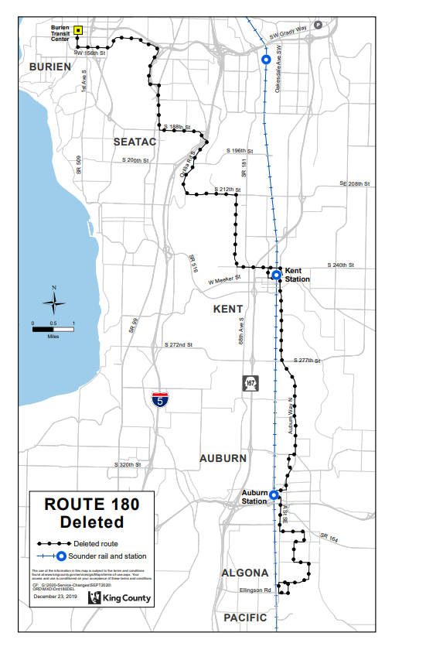
Route: 184 (new)
OBJECTIVES:
Restructure local service in Auburn to provide better north-south connections between South Auburn and Auburn Station, providing trips better timed to Sound service to allow for simplified design and improved efficiency in accordance with the Strategic Plan for Public Transportation, 2011 – 2021, and King County Metro Service Guidelines.
- Strategic Plan Strategy 2.1.1: Design and offer a variety of public transportation products and services appropriate to different markets and mobility needs.
- Strategic Plan Strategy 2.1.2: Provide travel opportunities and supporting amenities for historically disadvantaged populations, such as low-income people, students, youth, seniors, people of color, people with disabilities, and others with limited transportation options.
- Strategic Plan Strategy 2.1.3: Provide products and services that are designed to provide geographic value in all parts of King County.
- Strategic Plan Strategy 3.3.1: Encourage land uses, policies, and practices that promote transit-oriented development and lead to communities that have good access to transit and that transit can serve efficiently and effectively.
- Strategic Plan Strategy 3.4.1: Serve centers and other areas of concentrated activity, consistent with Transportation 2040.
- Strategic Plan Strategy 5.1.1: Provide service that is easy to understand and use.
- Strategic Plan Strategy 6.1.1: Manage the transit system through service guidelines and performance measures.
  - Service Design Guideline - Routes should be designed in the context of the entire transportation system.
  - Service Design Guideline - When designing a network of services, Metro should consider locations where transfer opportunities could be provided for the convenience of customers and to improve the efficiency of the transit network.
  - Service Design Guideline - Routes are more efficient when designed to serve multiple purposes and destinations rather than specialized travel demands.
  - Service Design Guideline - Routes should have predictable and direct routings, and the frequency and span of service should be appropriate to the market served.
  - Service Design Guideline - Routes should be designed to avoid competing for the same riders.
  - Service Design Guideline - As budget allows, routes should be targeted for a minimum service level of at least every 60 minutes.
  - Service Design Guideline - A bus route should be long enough to provide useful connections for riders and to be more attractive than other travel modes.
  - Service Design Guideline - Bus routes should operate as fixed routes in order to provide a predictable and reliable service for a wide range of potential riders.
- Strategic Plan Strategy 6.2.1: Continually explore and implement cost efficiencies, including operational and administrative efficiencies.

IMPACTED SERVICE AREA:
Central Auburn, South Auburn
SERVICE CHANGE:
Implement new Route 184, which will replace Route 180 service between Auburn Station and South Auburn. On weekdays, Route 184 will operate trips timed to Sounder departures (every 20-30 minutes) from approximately 4:30 AM to 8:30 AM and 3 PM to 7 PM, will operate every 30 minutes in the midday and evenings until 8PM, and will operate hourly from approximately 8 PM to 1 AM. On weekends, Route 184 will operate every 30 minutes from approximately 6:30 AM to 9:00 PM, and will operate hourly from approximately 9:00 PM to 1:00 AM and 5:30 AM to 6:30 AM.
 | Weekday |  |  | Weekend
 | Peak | Midday | Night | Saturday | Sunday
CURRENT | N/A | N/A | N/A | N/A | N/A
PROPOSED | 20 | 30 | 30-60 | 30-60 | 30-60

 | Weekdays | Saturday | Sunday
CURRENT | N/A | N/A | N/A
PROPOSED | 5:00 a.m. to 1:00 a.m. | 5:30 a.m. to midnight | 5:30 a.m. to midnight

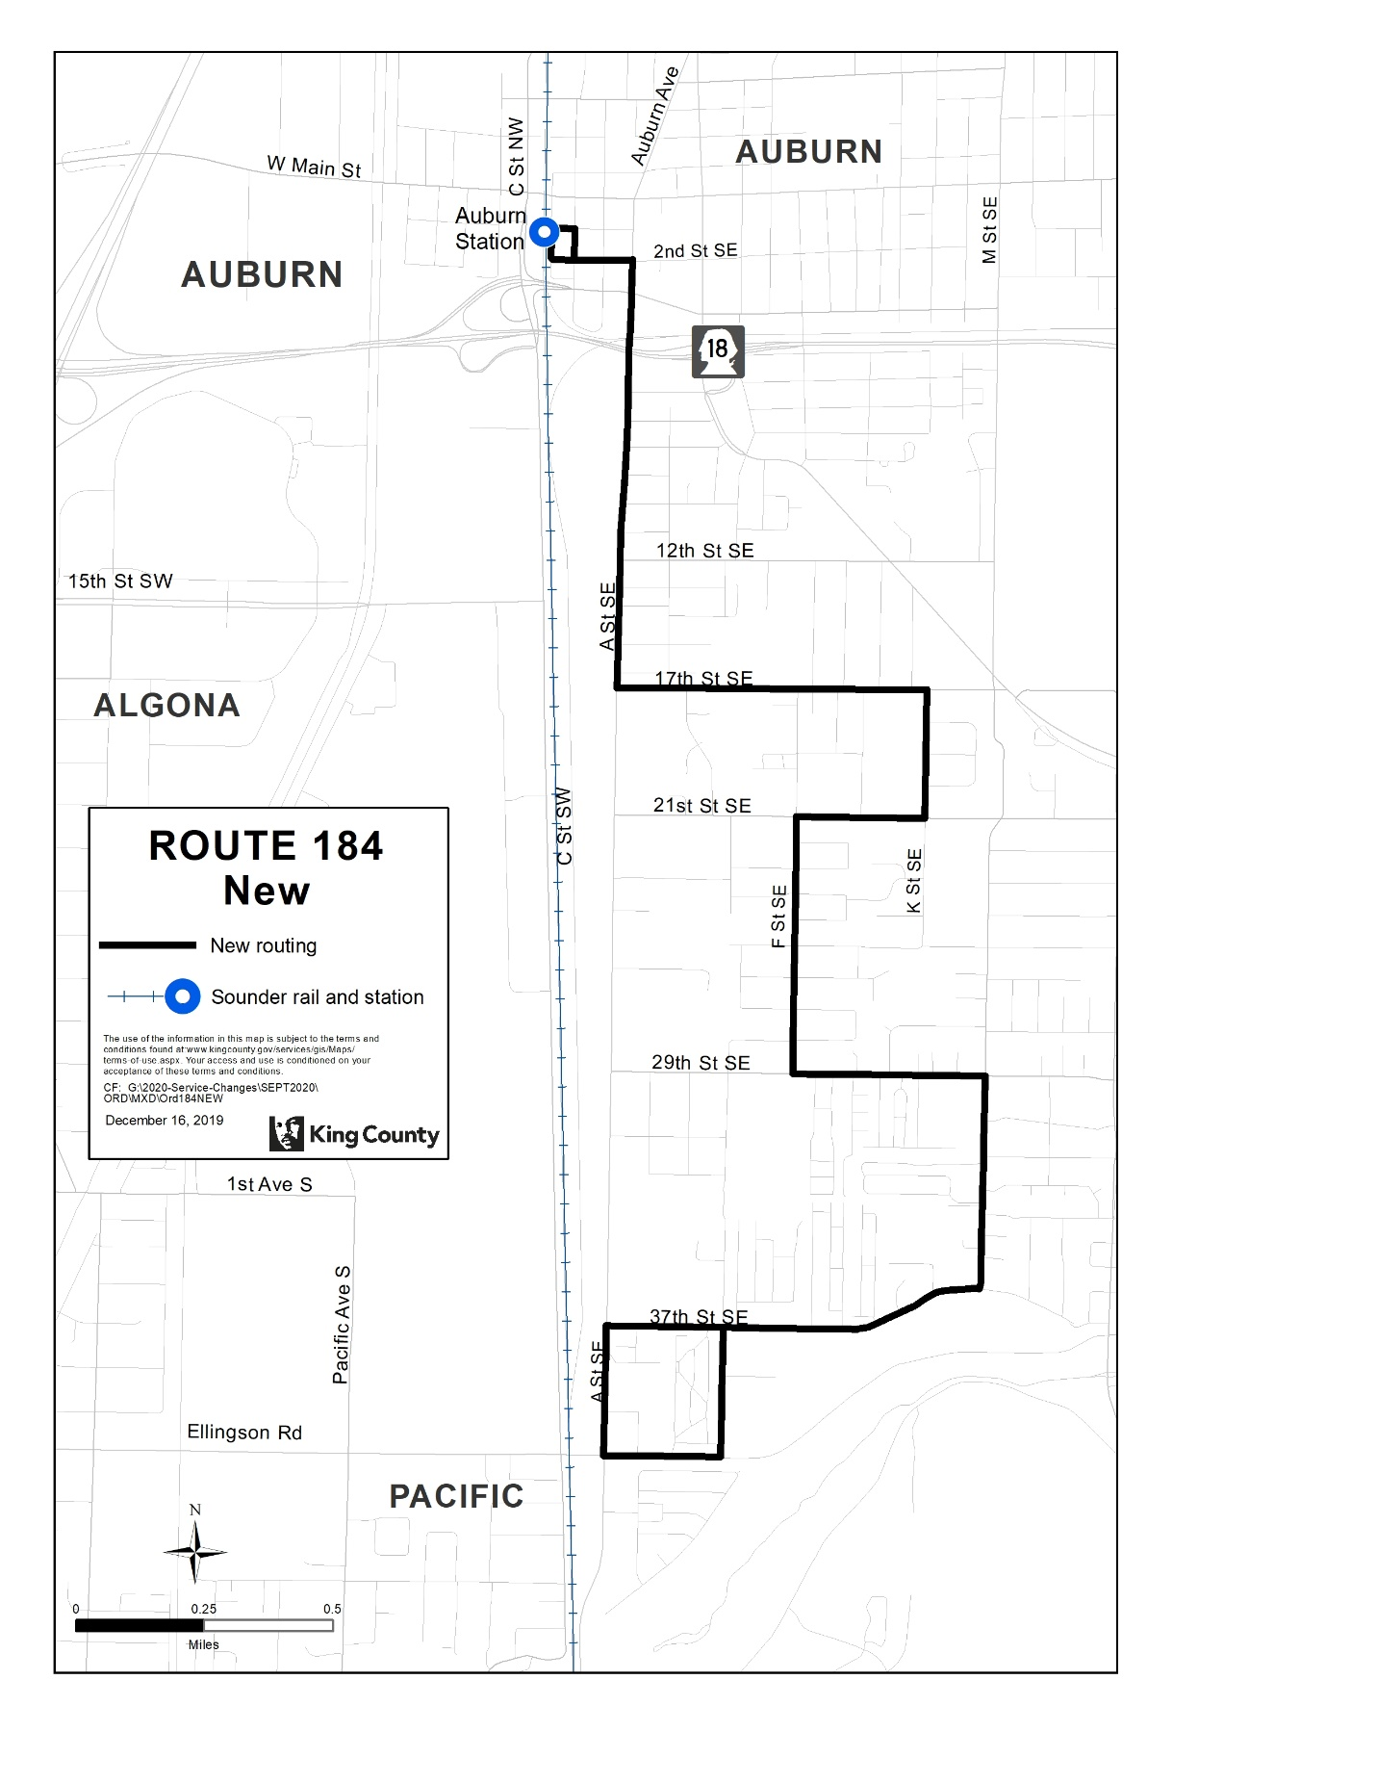

Route: 192 (delete)
OBJECTIVES:
Replacement service to Route 192 will be provided by new Route 162 and revised Route 190.
Restructure peak service on Kent West Hill for simplified design, reduced duplication and improved resource stewardship in accordance with the Strategic Plan for Public Transportation, 2011-2021 and King County Metro Service Guidelines.
- Strategic Plan Strategy 3.4.1: Serve centers and other areas of concentrated activity, consistent with Transportation 2040.
- Strategic Plan Strategy 5.1.1: Provide service that is easy to understand and use.
- Strategic Plan Strategy 6.1.1: Manage the transit system through service guidelines and performance measures.
  - Service Design Guideline - Routes should be designed to avoid competing for the same riders.
  - Service Design Guideline - A route that operates directly between two locations is faster and more attractive to riders than one that takes a long, circuitous path.
  - Service Design Guideline - Buses should be routed primarily on arterial streets and freeways, except where routing on local or collector streets is necessary to reach layover areas or needed to ensure that facilities and fleet used in all communities is equivalent in age and quality.
- Strategic Plan Strategy 6.2.1: Continually explore and implement cost efficiencies, including operational and administrative efficiencies.
- Strategic Plan Strategy 6.2.4: Provide alternative or “right-sized” services in the context of overall system financial health and the need to reduce, maintain or expand the system.
IMPACTED SERVICE AREA:
Kent West Hill
SERVICE CHANGE:
Delete Route 192 to reduce duplicative and low-performing service. Alternative service will be provided by new Route 162, connecting Kent to Downtown Seattle, and revised Route 190, connecting Kent Des-Moines Park and Ride to Downtown Seattle.

 | Weekday |  |  | Weekend
 | Peak | Midday | Night | Saturday | Sunday
CURRENT | 4 AM trips,  4 PM trips | N/A | N/A | N/A | N/A
PROPOSED | N/A | N/A | N/A | N/A | N/A

 | Weekdays | Saturday | Sunday
CURRENT | 6 AM to 7:30 AM,  3 PM to 6 PM | N/A | N/A
PROPOSED | N/A | N/A | N/A

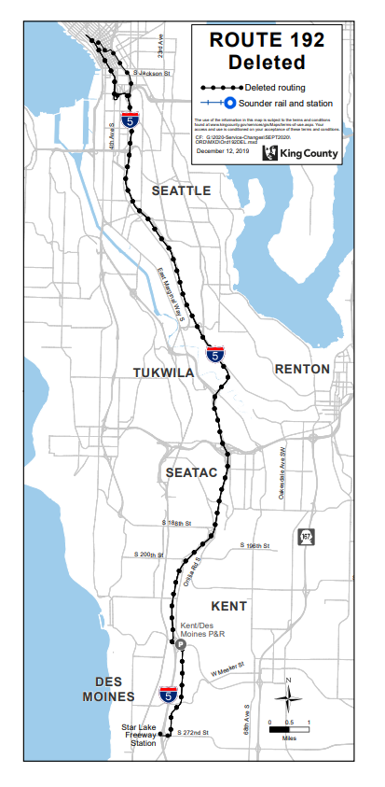
Route: 906 (revise)
OBJECTIVES:
Revise service to provide a more direct pathway, and increase service levels in accordance with the Strategic Plan for Public Transportation, 2011 – 2021, and King County Metro Service Guidelines.
- Strategic Plan Strategy 2.1.1: Design and offer a variety of public transportation products and services appropriate to different markets and mobility needs.
- Strategic Plan Strategy 2.1.2: Provide travel opportunities and supporting amenities for historically disadvantaged populations, such as low-income people, students, youth, seniors, people of color, people with disabilities, and others with limited transportation options.
- Strategic Plan Strategy 2.1.3: Provide products and services that are designed to provide geographic value in all parts of King County.
- Strategic Plan Strategy 3.2.1: Expand services to accommodate the region’s growing population and serve new transit markets.
- Strategic Plan Strategy 3.2.4: Work in collaboration with transit partners, WSDOT and other public and private partners to address transit parking capacity demand through a range of approaches that use resources efficiently and enable more people to access transit.
- Strategic Plan Strategy 3.4.1: Serve centers and other areas of concentrated activity, consistent with Transportation 2040.
- Strategic Plan Strategy 4.1.1: Increase the proportion of travel in King County that is provided by public transportation products and services.
- Strategic Plan Strategy 5.1.1: Provide service that is easy to understand and use.
- Strategic Plan Strategy 5.1.3: Improve transit speed and reliability.
- Strategic Plan Strategy 6.1.1: Manage the transit system through service guidelines and performance measures.
  - Service Design Guideline – Routes should be designed in the context of the entire transportation system.
  - Service Design Guideline – A route that operates directly between two locations is faster and more attractive to riders than one that takes a long, circuitous path.
  - Service Design Guideline – Metro should consider locations where transfer opportunities could be provided for the convenience of customers and to improve the efficiency of the transit network.
  - Service Design Guideline – Routes are more efficient when designed to serve multiple purposes and destinations rather than specialized travel demands.
  - Service Design Guideline – Bus routes should also be designed to avoid places where traffic congestion and delay regularly occur, if it is possible to avoid such areas while continuing to meet riders’ needs.
  - Service Design Guideline – Routes should have predictable and direct routings, and the frequency and span of service should be appropriate to the market served.

IMPACTED SERVICE AREA:
Renton, Tukwila, Fairwood
SERVICE CHANGE:
Add service and revise route pathway to stay on SE Petrovitsky Road rather than deviating to serve SE 168th Street. Replacement service on SE 168th Street will be provided by the revised Route 148. On weekdays, service will meet every Sounder train during peak periods (service every 20-30 minutes), and run every 30 minutes through 11 PM. Add Sunday service at existing Saturday service levels (hourly from 8AM – 6PM).
 | Weekday |  |  | Weekend
 | Peak | Midday | Night | Saturday | Sunday
CURRENT | 30 | 60 | N/A | 60 | N/A
PROPOSED | 20-30 | 30 | 30-60 | No change | 60

 | Weekdays | Saturday | Sunday
CURRENT | 6:00 AM – 6:25 PM | 8:20 AM – 6:20 PM | N/A
PROPOSED | 4:45 AM – 11:00 PM | No change | 8:20 AM – 6:20 PM

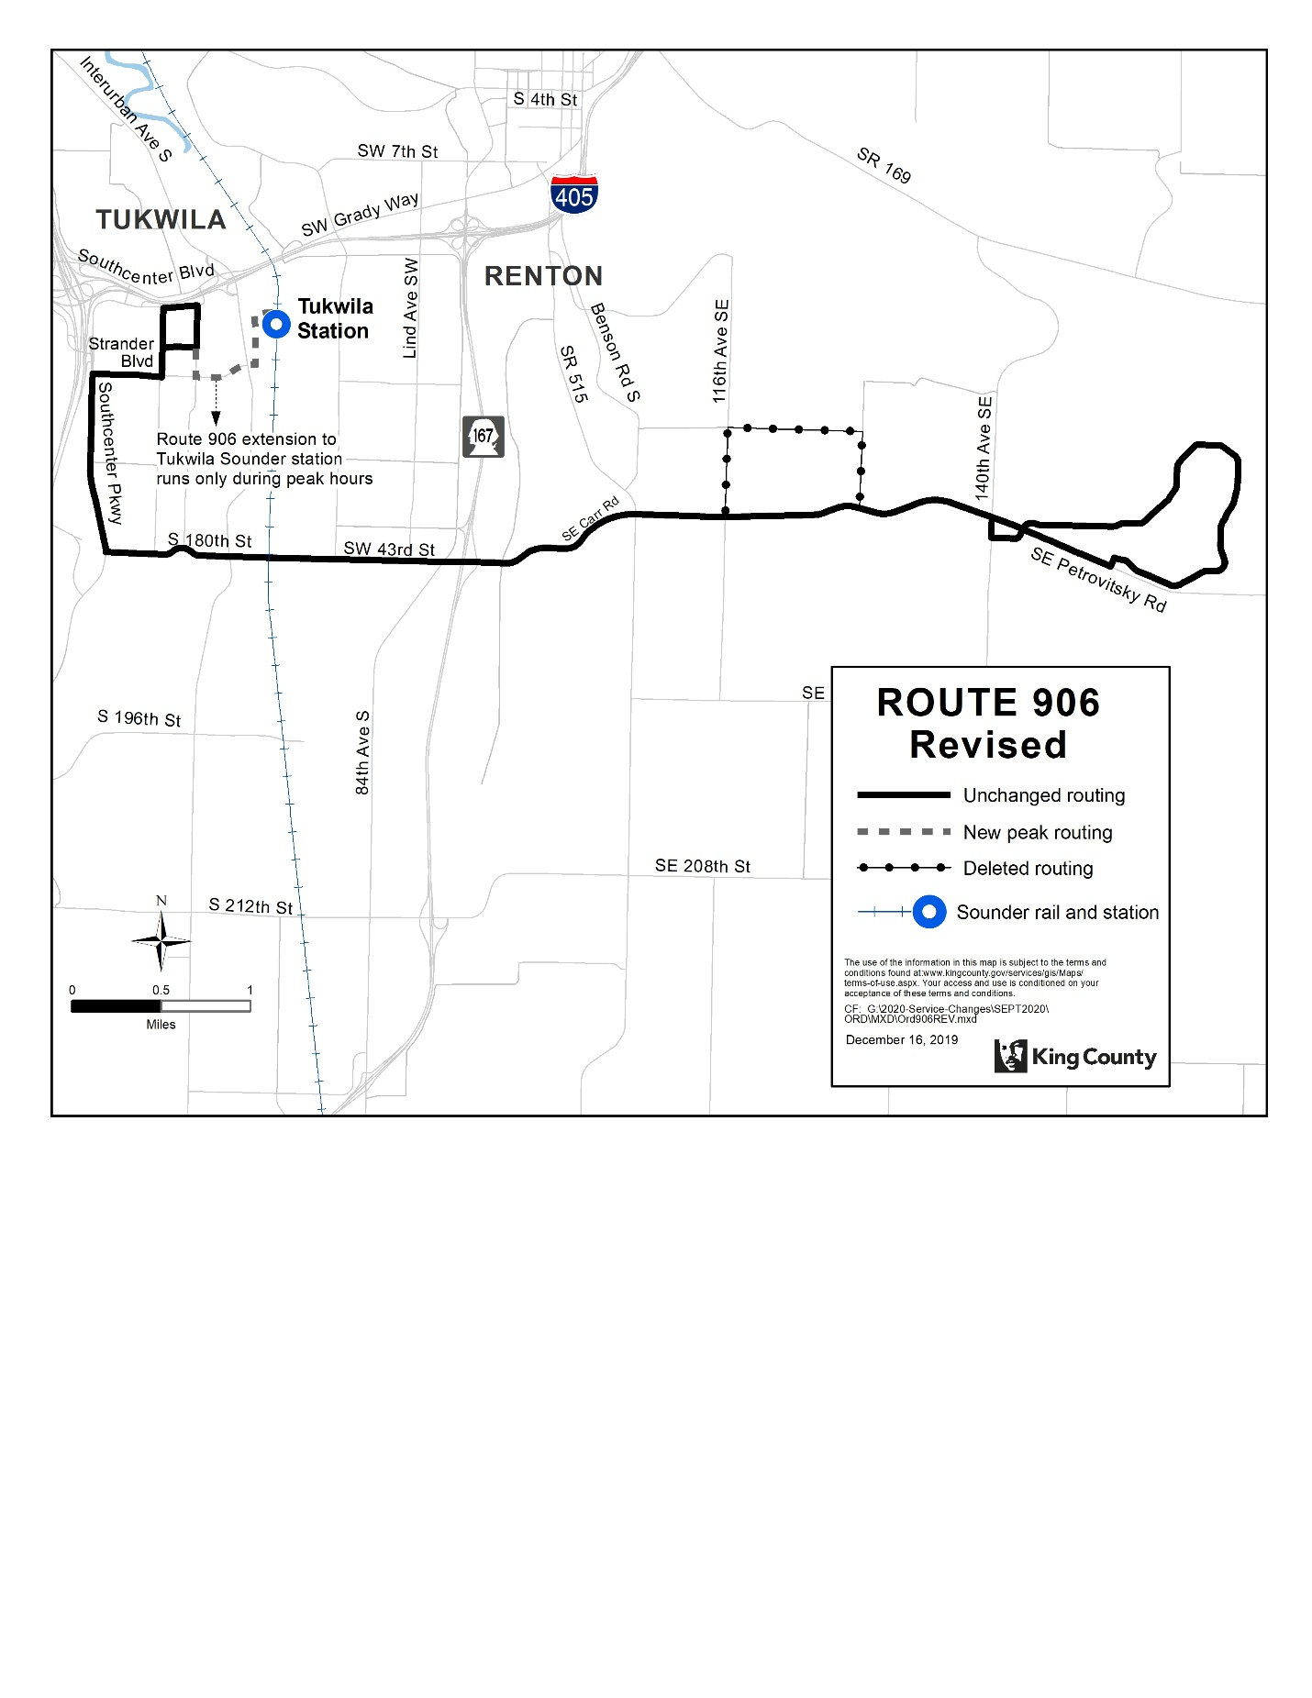
Route: 908 (delete)
OBJECTIVES:
Replacement service will be provided by Route 105, which will have additional service during peak periods on weekdays.
Restructure service in the Renton Highlands for simplified design, increased frequency, and improved resource stewardship in accordance with the Strategic Plan for Public Transportation, 2011-2021 and King County Metro Service Guidelines.
- Strategic Plan Strategy 2.1.1: Design and offer a variety of public transportation products and services appropriate to different markets and mobility needs.
- Strategic Plan Strategy 2.2.1: Provide travel opportunities for historically disadvantaged populations, such as low-income people, students, youth, seniors, people of color, people with disabilities, and others with limited transportation options.
- Strategic Plan Strategy 2.3.1: Provide products and services that are designed to provide geographic value in all parts of King County.
- Strategic Plan Strategy 3.1.1: Through investments and partnerships with regional organizations, local jurisdictions and the private sector, provide alternatives to driving alone that connect people to jobs, education and other destinations essential to King County’s economic vitality.
- Strategic Plan Strategy 3.2.1: Expand services to accommodate the region’s growing population and serve new transit markets when financially feasible.
- Strategic Plan Strategy 3.2.2: Coordinate and develop services and facilities with other providers to create an integrated and efficient regional transportation system.
- Strategic Plan Strategy 3.4.1: Serve centers and other areas of concentrated activity, consistent with Transportation 2040.
- Strategic Plan Strategy 5.1.1: Provide service that is easy to understand and use.
- Strategic Plan Strategy 6.1.1: Manage the transit system through service guidelines and performance measures.
  - Service Design Guideline – Routes should be designed in the context of the entire transportation system.
  - Service Design Guideline – A route that operates directly between two locations is faster and more attractive to riders than one that takes a long, circuitous path.
  - Service Design Guideline – Routes should serve connection points where riders can connect to frequent services, opening up the widest possible range of travel options.
  - Service Design Guideline – Routes are more efficient when designed to serve multiple purposes and destinations rather than specialized travel demands.
  - Service Design Guideline – The length of bus routes should provide useful connections for riders and be more attractive than other travel modes.
  - Service Design Guideline – Demand-responsive service may be considered where fixed-route service is unlikely to be successful or where unique conditions exist that can be met more effectively through flexible service.
- Strategic Plan Strategy 6.2.1: Continually explore and implement cost efficiencies, including operational and administrative efficiencies.
- Strategic Plan Strategy 6.2.3: Develop and implement alternative public transportation services and delivery strategies.
IMPACTED SERVICE AREA:
Renton Highlands
SERVICE CHANGE:
Delete Route 908 due to low performance. Alternative service will be provided by expanded service on Route 105, providing additional frequency.
 | Weekday |  |  | Weekend
 | Peak | Midday | Night | Saturday | Sunday
CURRENT | 60 | 60 | N/A | 60 | N/A
PROPOSED | N/A | N/A | N/A | N/A | N/A

 | Weekdays | Saturday | Sunday
CURRENT | 8:20 AM – 5:45 PM | 8:50 AM – 5:15 PM | N/A
PROPOSED | N/A | N/A | N/A

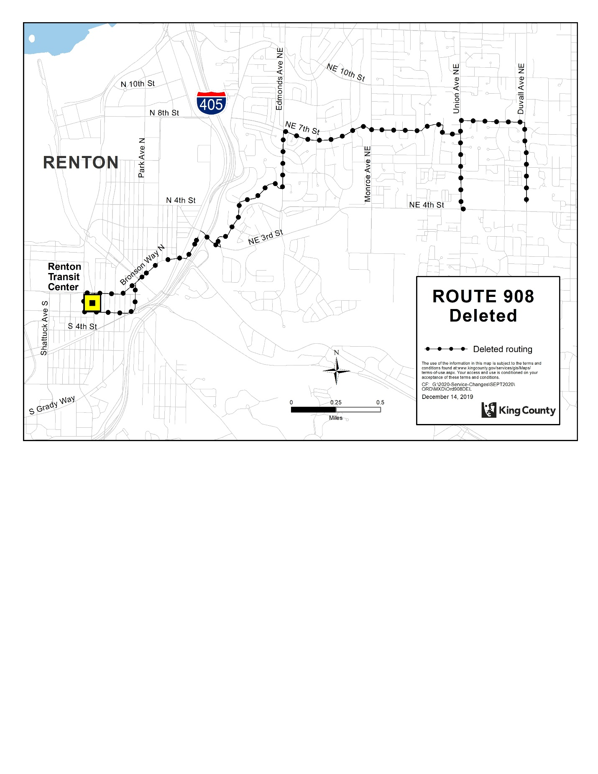

Route: 910 (delete)
OBJECTIVES:
Replacement service to Route 910 will be provided by new Route 160 and revised Route 917.
Restructure local service to provide better connections between North Auburn, Auburn Station, and Outlet Collection while increasing service levels and introducing new Sunday service in accordance with the Strategic Plan for Public Transportation, 2011 – 2021, and King County Metro Service Guidelines.

- Strategic Plan Strategy 2.1.1: Design and offer a variety of public transportation products and services appropriate to different markets and mobility needs.
- Strategic Plan Strategy 2.1.2: Provide travel opportunities and supporting amenities for historically disadvantaged populations, such as low-income people, students, youth, seniors, people of color, people with disabilities, and others with limited transportation options.
- Strategic Plan Strategy 2.1.3: Provide products and services that are designed to provide geographic value in all parts of King County.
- Strategic Plan Strategy 3.3.1: Encourage land uses, policies, and practices that promote transit-oriented development and lead to communities that have good access to transit and that transit can serve efficiently and effectively.
- Strategic Plan Strategy 3.4.1: Serve centers and other areas of concentrated activity, consistent with Transportation 2040.
- Strategic Plan Strategy 5.1.1: Provide service that is easy to understand and use.
- Strategic Plan Strategy 6.1.1: Manage the transit system through service guidelines and performance measures.
- Service Design Guideline - Routes should be designed in the context of the entire transportation system.
- Service Design Guideline - When designing a network of services, Metro should consider locations where transfer opportunities could be provided for the convenience of customers and to improve the efficiency of the transit network.
  - Service Design Guideline - Routes are more efficient when designed to serve multiple purposes and destinations rather than specialized travel demands.
  - Service Design Guideline - Routes should have predictable and direct routings, and the frequency and span of service should be appropriate to the market served.
  - Service Design Guideline - Routes should be designed to avoid competing for the same riders.
  - Service Design Guideline - A route that operates directly between two locations is faster and more attractive to riders than one that takes a long, circuitous path.
  - Service Design Guideline - As budget allows, routes should be targeted for a minimum service level of at least every 60 minutes.
  - Service Design Guideline - A bus route should be long enough to provide useful connections for riders and to be more attractive than other travel modes.
  - Service Design Guideline - Bus routes should operate as fixed routes in order to provide a predictable and reliable service for a wide range of potential riders.
- Strategic Plan Strategy 6.2.1: Continually explore and implement cost efficiencies, including operational and administrative efficiencies.

IMPACTED SERVICE AREA:
North Auburn, Central Auburn, Outlet Collection.
SERVICE CHANGE:
Delete Route 910 due to low performance. Replacement service will be provided by new frequent Route 160 between Auburn Station and North Auburn and increased service on Route 917 between Auburn Station and the Outlet Collection.
 | Weekday |  |  | Weekend
 | Peak | Midday | Night | Saturday | Sunday
CURRENT | N/A | 60 | N/A | 60 | N/A
PROPOSED | N/A | N/A | N/A | N/A | N/A

 | Weekdays | Saturday | Sunday
CURRENT | 8AM to 4:30 PM | 8:30AM to 5:00PM | N/A
PROPOSED | N/A | N/A | N/A

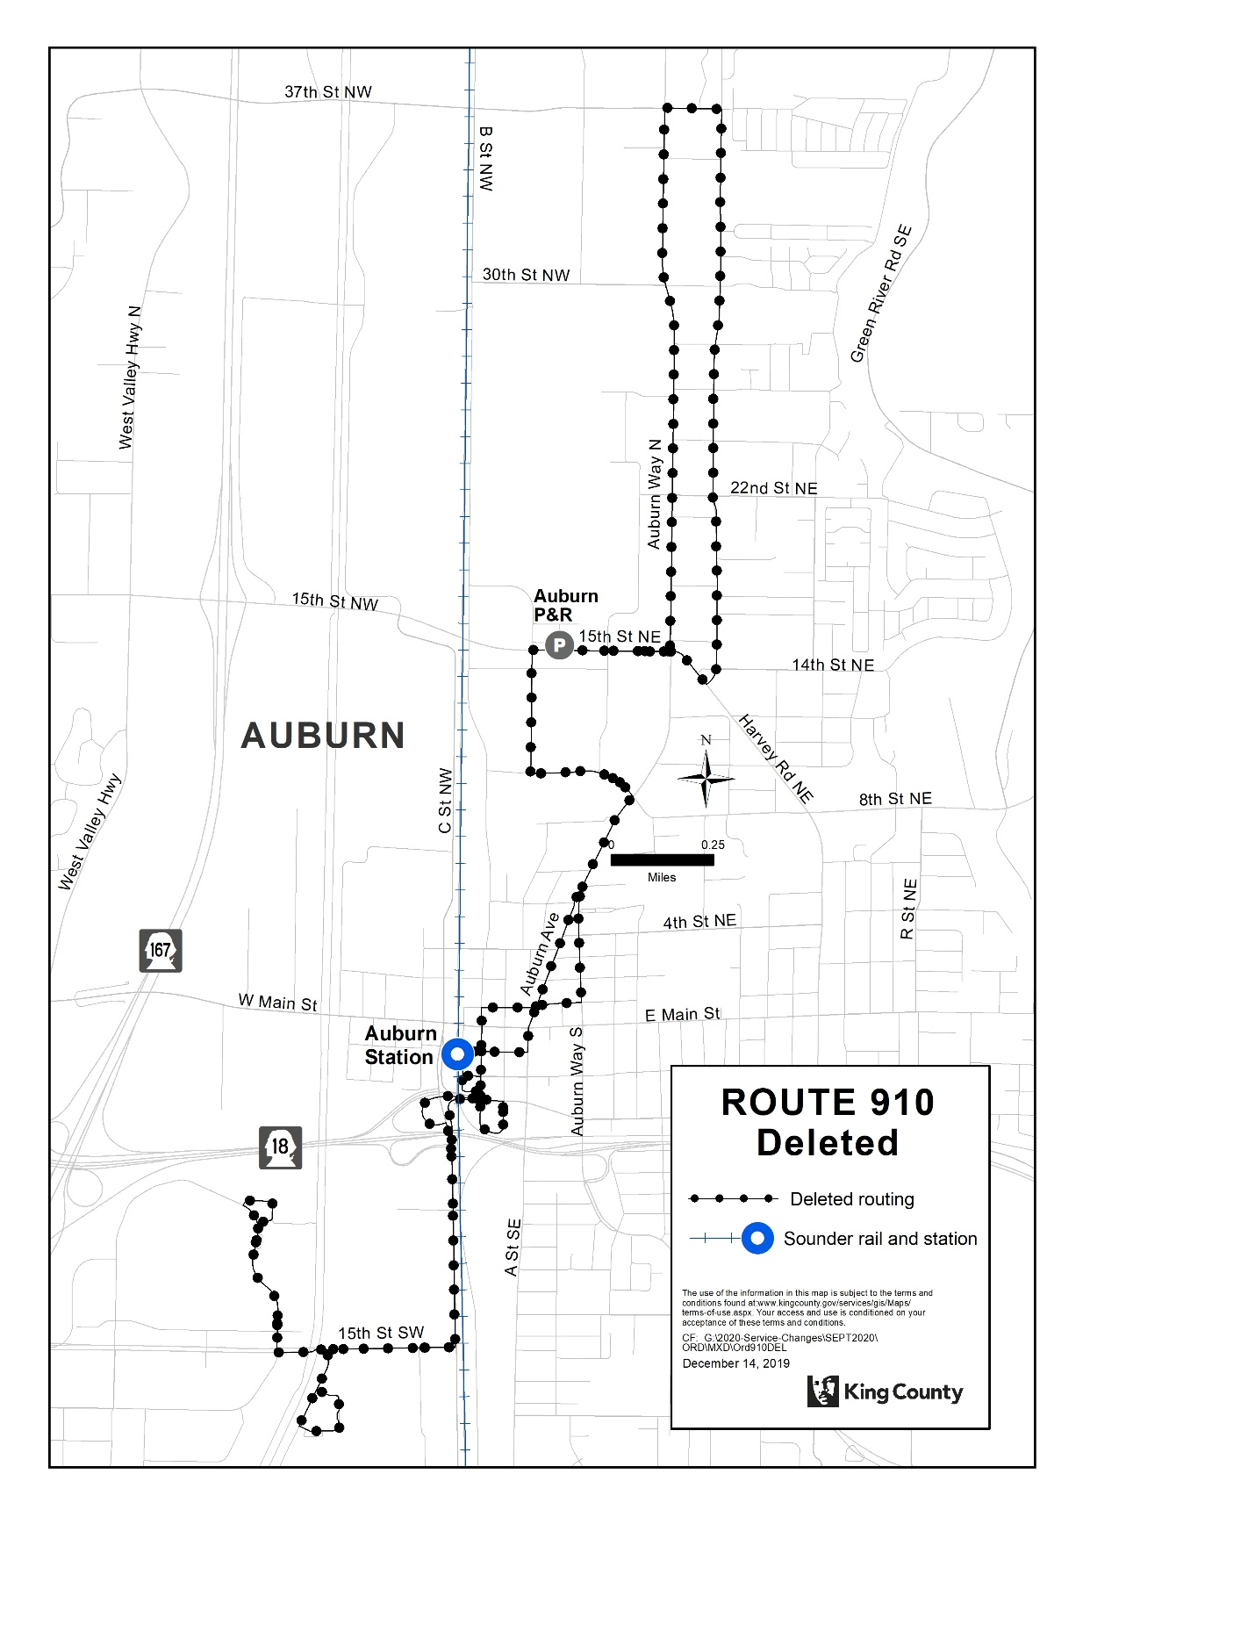
Route: 913 (delete)
OBJECTIVES:
Replacement service to Route 913 will be provided by Routes 150 and 183 and new Routes 161 and 165.
Restructure service on the Kent West Hill for simplified design, improved efficiency, increased frequency and span of service, and delete low-performing services in accordance with the Strategic Plan for Public Transportation, 2011 – 2021, and King County Metro Service Guidelines.
- Strategic Plan Strategy 2.1.1: Design and offer a variety of public transportation products and services appropriate to different markets and mobility needs.
- Strategic Plan Strategy 2.1.4: In areas that are not well-served by fixed-route service or where geographic coverage service gaps exist, seek to complement or “right-size” transportation service by working with partners to develop an extensive range of alternative services to serve the general public.
- Strategic Plan Strategy 3.1.2: Partner with employers to make public transportation products and services more affordable and convenient for employees.
- Strategic Plan Strategy 3.2.2: Coordinate and develop services and facilities with other providers, local jurisdictions and the private sector to create an integrated and efficient regional transportation system that takes innovative approaches to improving mobility.
- Strategic Plan Strategy 3.4.1: Serve centers and other areas of concentrated activity, consistent with Transportation 2040.
- Strategic Plan Strategy 5.1.1: Provide service that is easy to understand and use.
- Strategic Plan Strategy 6.1.1: Manage the transit system through service guidelines and performance measures.
  - Service Design Guideline - Routes should be designed in the context of the entire transportation system
  - Service Design Guideline - Routes are more efficient when designed to serve multiple purposes and destinations rather than specialized travel demands.
  - Service Design Guideline - A route that operates directly between two locations is faster and more attractive to riders than one that takes a long, circuitous path.
  - Service Design Guideline - Bus routes should operate as fixed routes in order to provide a predictable and reliable service for a wide range of potential riders.
- Strategic Plan Strategy 6.2.1: Continually explore and implement cost efficiencies, including operational and administrative efficiencies.
- Strategic Plan Strategy 6.2.3: Develop and implement alternative public transportation services and delivery strategies.
- Strategic Plan Strategy 6.2.4: Provide alternative or “right-sized” services in the context of overall system financial health and the need to reduce, maintain or expand the system.

IMPACTED SERVICE AREA:
Central Kent, Kent Industrial Valley.
SERVICE CHANGE:
Delete Route 913 due to low performance. Replacement service will be provided by Route 161 along S 212th St, new Route 165 along S 231st Way and through the Lakes community, and Routes 150 and 183 along W James St.

 | Weekday |  |  | Weekend
 | Peak | Midday | Night | Saturday | Sunday
CURRENT | 6 AM trips,  9 PM trips | N/A | N/A | N/A | N/A
PROPOSED | N/A | N/A | N/A | N/A | N/A

 | Weekdays | Saturday | Sunday
CURRENT | 5:30 AM to 8 AM.  3 PM to 7 PM | N/A | N/A
PROPOSED | N/A | N/A | N/A

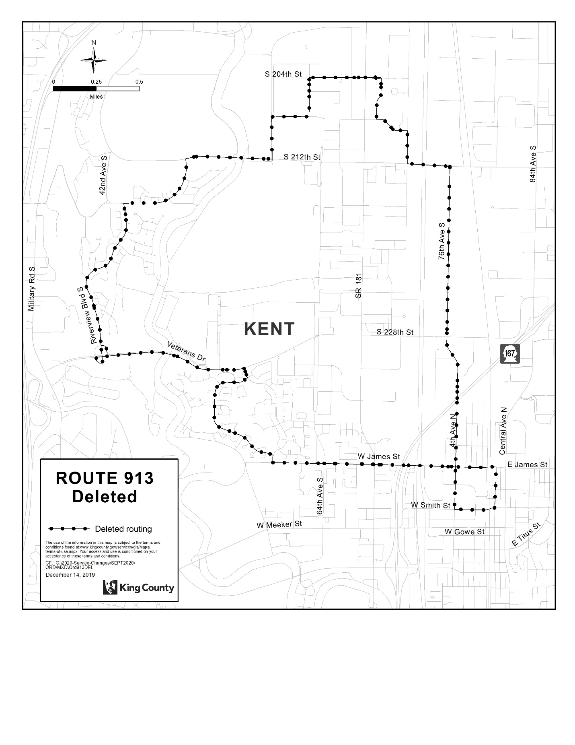

Route: 914 (revise)
OBJECTIVES:
Restructure service on the Kent East Hill for simplified design and increased frequency in accordance with the Strategic Plan for Public Transportation, 2011 – 2021, and King County Metro Service Guidelines.
- Strategic Plan Strategy 2.1.1: Design and offer a variety of public transportation products and services appropriate to different markets and mobility needs.
- Strategic Plan Strategy 2.1.2: Provide travel opportunities and supporting amenities for historically disadvantaged populations, such as low-income people, students, youth, seniors, people of color, people with disabilities, and others with limited transportation options.
- Strategic Plan Strategy 3.4.1: Serve centers and other areas of concentrated activity, consistent with Transportation 2040.
- Strategic Plan Strategy 5.1.1: Provide service that is easy to understand and use.
- Strategic Plan Strategy 6.1.1: Manage the transit system through service guidelines and performance measures.
  - Service Design Guideline - Routes should be designed in the context of the entire transportation system.
  - Service Design Guideline - When designing a network of services, Metro should consider locations where transfer opportunities could be provided for the convenience of customers and to improve the efficiency of the transit network.
  - Service Design Guideline - Routes are more efficient when designed to serve multiple purposes and destinations rather than specialized travel demands.
  - Service Design Guideline - Routes should have predictable and direct routings, and the frequency and span of service should be appropriate to the market served.
  - Service Design Guideline - Routes should be designed to avoid competing for the same riders.
  - Service Design Guideline - A bus route should be long enough to provide useful connections for riders and to be more attractive than other travel modes.
- Strategic Plan Strategy 6.2.1: Continually explore and implement cost efficiencies, including operational and administrative efficiencies.
- Strategic Plan Strategy 6.2.4: Provide alternative or “right-sized” services in the context of overall system financial health and the need to reduce, maintain or expand the system.
IMPACTED SERVICE AREA:
Kent
SERVICE CHANGE:
On the Kent East Hill, the route will be revised to serve new portions of 101st Ave SE, SE 248th St, 100th Ave SE, SE 240th St, 120th Ave SE, and SE 256th St. The route will no longer serve some portions of SE 248th St, 116th Ave SE, SE 240th St, 132nd Ave SE, Canyon Dr, and SE 260th St. The route will operate every 30 minutes from approximately 9 AM to 4 PM on weekdays and Saturdays. Routing on the Kent West Hill (Shopper Shuttle) and at Kent Station will not change.

 | Weekday |  |  | Weekend
 | Peak | Midday | Night | Saturday | Sunday
CURRENT | 60 | 60 | N/A | 60 | N/A
PROPOSED | 30 | 30 | N/A | 60 | N/A

 | Weekdays | Saturday | Sunday
CURRENT | 9 AM to 4 PM | 9 AM to 4 PM | N/A
PROPOSED | 9 AM to 4 PM | 9 AM to 4 PM | N/A

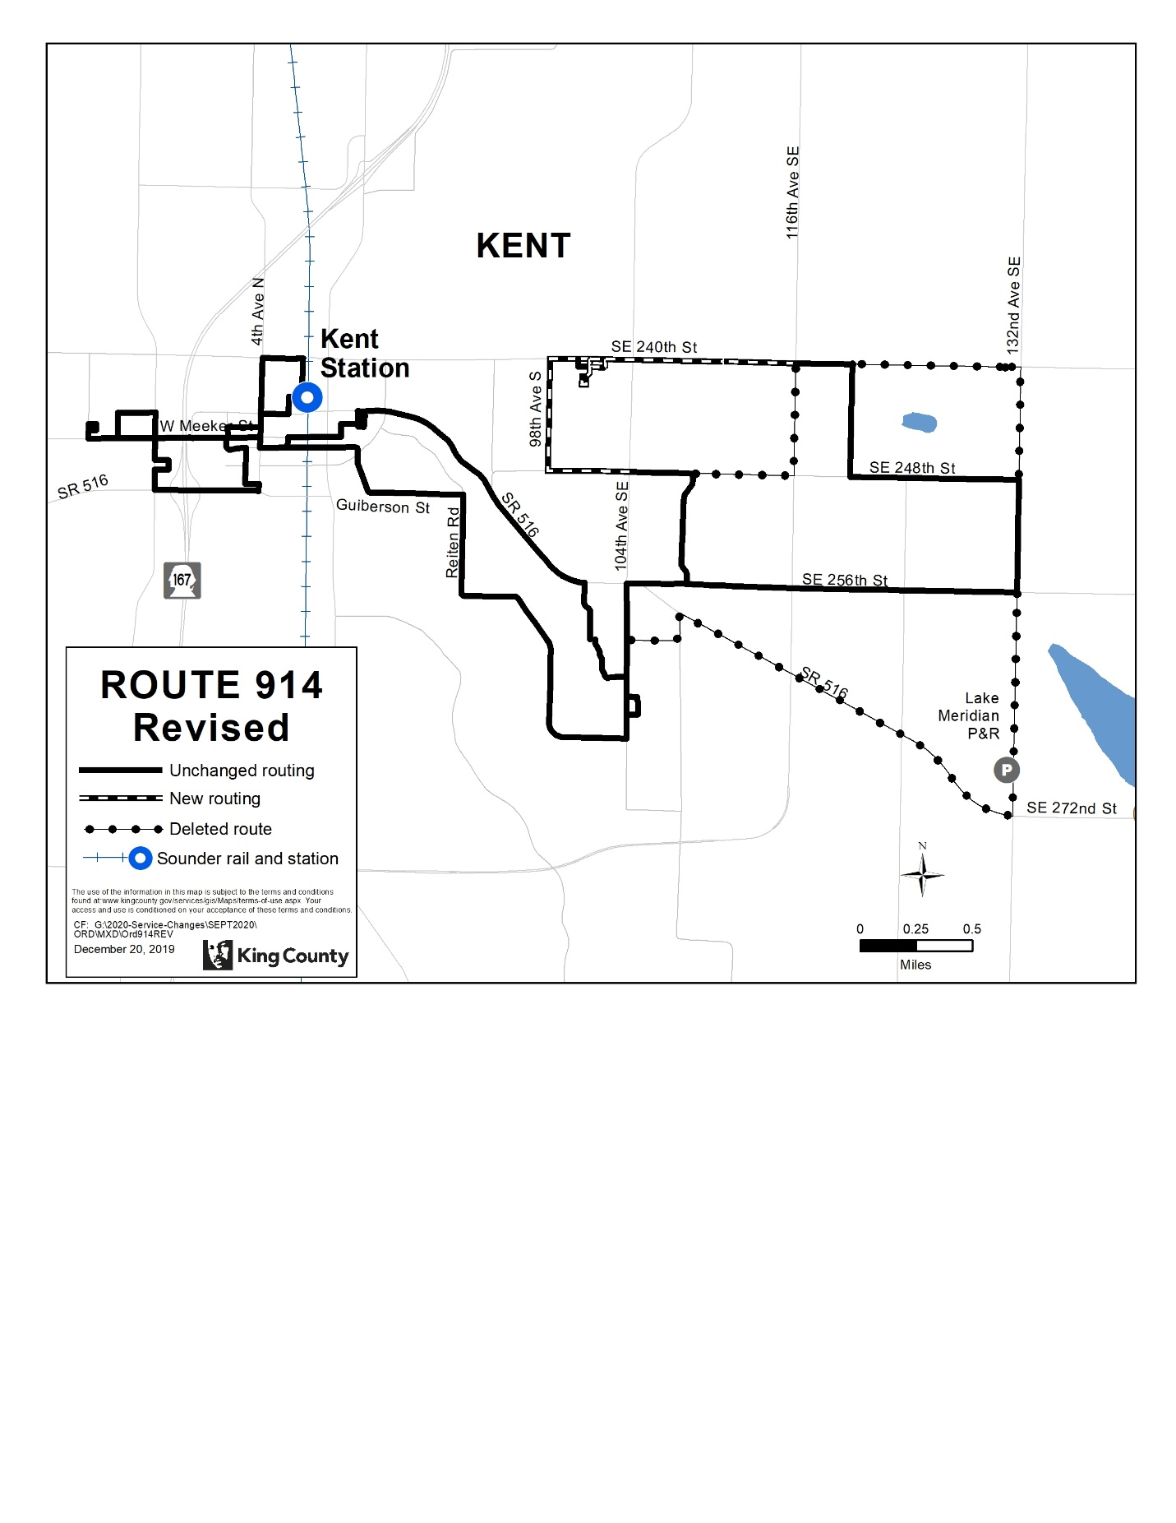

Route: 916 (delete)
OBJECTIVES:
Replacement service to Route 916 will be provided by revised Route 914 and Routes 160, 164, and 168 on the Kent East Hill.
Restructure service on the Kent East Hill for simplified design and increased frequency in accordance with the Strategic Plan for Public Transportation, 2011 – 2021, and King County Metro Service Guidelines.
- Strategic Plan Strategy 2.1.1: Design and offer a variety of public transportation products and services appropriate to different markets and mobility needs.
- Strategic Plan Strategy 2.1.2: Provide travel opportunities and supporting amenities for historically disadvantaged populations, such as low-income people, students, youth, seniors, people of color, people with disabilities, and others with limited transportation options.
- Strategic Plan Strategy 3.4.1: Serve centers and other areas of concentrated activity, consistent with Transportation 2040.
- Strategic Plan Strategy 5.1.1: Provide service that is easy to understand and use.
- Strategic Plan Strategy 6.1.1: Manage the transit system through service guidelines and performance measures.
  - Service Design Guideline - Routes should be designed in the context of the entire transportation system.
  - Service Design Guideline - When designing a network of services, Metro should consider locations where transfer opportunities could be provided for the convenience of customers and to improve the efficiency of the transit network.
  - Service Design Guideline - Routes are more efficient when designed to serve multiple purposes and destinations rather than specialized travel demands.
  - Service Design Guideline - Routes should have predictable and direct routings, and the frequency and span of service should be appropriate to the market served.
  - Service Design Guideline - Routes should be designed to avoid competing for the same riders.
  - Service Design Guideline - A bus route should be long enough to provide useful connections for riders and to be more attractive than other travel modes.
- Strategic Plan Strategy 6.2.1: Continually explore and implement cost efficiencies, including operational and administrative efficiencies.
- Strategic Plan Strategy 6.2.4: Provide alternative or “right-sized” services in the context of overall system financial health and the need to reduce, maintain or expand the system.
IMPACTED SERVICE AREA:
Kent
SERVICE CHANGE:
Delete Route 916 to reduce duplicative service and provide simplified route and service design. Alternative service will be provided by revised Route 914 and Routes 160, 164, and 168 on the Kent East Hill.

 | Weekday |  |  | Weekend
 | Peak | Midday | Night | Saturday | Sunday
CURRENT | 60 | 60 | N/A | 60 | N/A
PROPOSED | N/A | N/A | N/A | N/A | N/A

 | Weekdays | Saturday | Sunday
CURRENT | 9 AM to 4 PM | 9 AM to 4 PM | N/A
PROPOSED | N/A | N/A | N/A

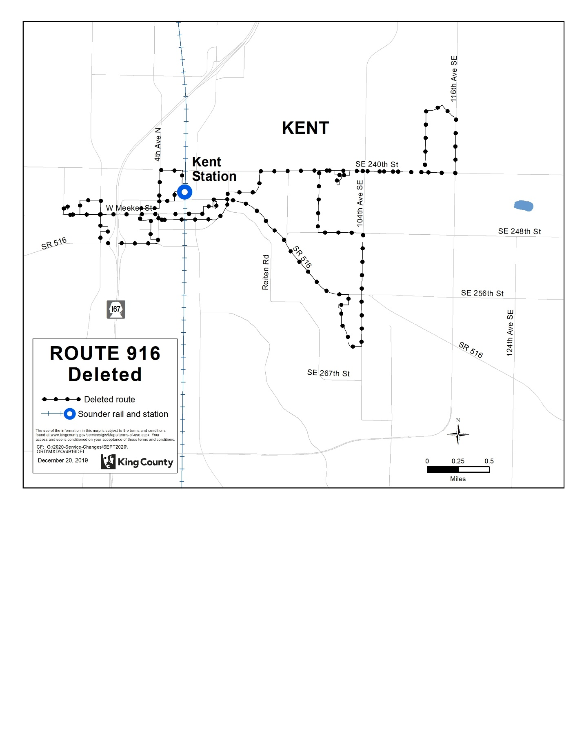
Route: 917 (revised)
OBJECTIVES:
Restructure service to provide better connections between Auburn Station, Outlet Collection, Algona, and Pacific while increasing service levels and introducing new Sunday service in accordance with the Strategic Plan for Public Transportation, 2011 – 2021, and King County Metro Service Guidelines.
- Strategic Plan Strategy 2.1.1: Design and offer a variety of public transportation products and services appropriate to different markets and mobility needs.
- Strategic Plan Strategy 2.1.2: Provide travel opportunities and supporting amenities for historically disadvantaged populations, such as low-income people, students, youth, seniors, people of color, people with disabilities, and others with limited transportation options.
- Strategic Plan Strategy 2.1.3: Provide products and services that are designed to provide geographic value in all parts of King County.
- Strategic Plan Strategy 3.1.1: Encourage land uses, policies, and development that lead to communities that have good access to transit and that transit can serve efficiently and effectively.
- Strategic Plan Strategy 3.2.1: Expand services to accommodate the region’s growing population and serve new transit markets.
- Strategic Plan Strategy 3.3.1: Encourage land uses, policies, and practices that promote transit-oriented development and lead to communities that have good access to transit and that transit can serve efficiently and effectively.
- Strategic Plan Strategy 3.4.1: Serve centers and other areas of concentrated activity, consistent with Transportation 2040.
- Strategic Plan Strategy 5.1.3: Improve transit speed and reliability.
- Strategic Plan Strategy 6.1.1: Manage the transit system through service guidelines and performance measures.
- Service Design Guideline - Routes should be designed in the context of the entire transportation system.
- Service Design Guideline - When designing a network of services, Metro should consider locations where transfer opportunities could be provided for the convenience of customers and to improve the efficiency of the transit network.
  - Service Design Guideline - Routes are more efficient when designed to serve multiple purposes and destinations rather than specialized travel demands.
  - Service Design Guideline - Routes should have predictable and direct routings, and the frequency and span of service should be appropriate to the market served.
  - Service Design Guideline - Routes should be designed to avoid competing for the same riders.
  - Service Design Guideline - A route that operates directly between two locations is faster and more attractive to riders than one that takes a long, circuitous path.
  - Service Design Guideline - As budget allows, routes should be targeted for a minimum service level of at least every 60 minutes.
  - Service Design Guideline - A bus route should be long enough to provide useful connections for riders and to be more attractive than other travel modes.
  - Service Design Guideline - Bus routes should operate as fixed routes in order to provide a predictable and reliable service for a wide range of potential riders.
  - Service Design Guideline – Demand-responsive service may be considered where fixed-route service is unlikely to be successful or where unique conditions exist that can be met more effectively through flexible service.
- Strategic Plan Strategy 6.2.1: Continually explore and implement cost efficiencies, including operational and administrative efficiencies.

IMPACTED SERVICE AREA:
Central Auburn, Outlet Collection, Algona, Pacific
SERVICE CHANGE:
Revise Route 917 to remove a low ridership stops at White River Junction and General Services Administration to improve travel time and reliability. Improve weekday service from hourly to every 30-40 minutes, from approximately 5am to 7pm. Add new hourly Sunday service from approximately 9am to 5pm.
 | Weekday |  |  | Weekend
 | Peak | Midday | Night | Saturday | Sunday
CURRENT | 50-70 | 60 | N/A | 60 | N/A
PROPOSED | 30-40 | 30-40 | N/A | 60 | 60

 | Weekdays | Saturday | Sunday
CURRENT | 5 AM to 6:30 PM | 8:30 AM to 5 PM | N/A
PROPOSED | No change | No change | 8:30 AM to 5 PM

