Legislative Review Form
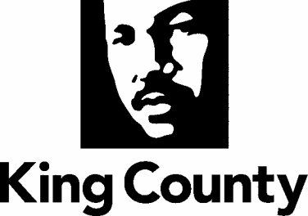

Agency: KCSO Contact person Mark Ellerbrook Phone 206-477-8016

Ordinance Motion Proviso Report Other

Civil Division Prosecuting Attorney Review

Name Erin Overbey Version Final Date 8/30/22

Dept. Director or Designee Review

Name Patti Cole Tindall Version Final Date 8/30/22

Performance Strategy & Budget Office Review

Name Andy Bauck Version Final Date 9/2/22

Technical Form/Code Reviser Review – Confirm adherence to legislative format

Name Bruce Ritzen Version Final Date 8/29/22

Executive Office Review & Transmittal Approval

Name Mina Hashemi Version Final Date 9/27/22

ENTRANCE CRITERIA REVIEW
EXEC OFFICE (initials) KCC CLERK
Fiscal note? Y NA Y NA
KC Strategic Plan reference in letter? Y NA Y NA
Proof read for spelling and grammar? Y NA Y NA
All pertinent attachments listed/labeled? Y NA Y NA
Costs identified/described in letter Y NA Y NA
Regulatory Note Required and Complete? Y NA Y NO
Formatted/Delivered in word-searchable doc format? Y NA Y NA
Potential Annexation Area (PAA) impacts identified? Y NA Y NO
Advertising required? if yes, cite all pertinent code/laws. Y NA Y NO
Any special circumstances affecting processing time? Y NA Y NO

