Poverty Bay Shellfish Protection District
Closure response plan

November, 2018

Department of Natural Resources and Parks
Water and Land Resources Division

Table of Contents

Preface 2
Introduction 2
Boundaries of the Shellfish Protection District 3
Description of the Area 3
Strategy and Actions 4
Appendix A: Poverty Bay Shellfish Protection District Maps 10
Appendix B: Poverty Bay Pollution Identification Process Flow Chart: 14

Preface
The goal of the Poverty Bay Shellfish Protection District (SPD) is to identify and eliminate sources of bacterial pollution within the district boundaries. This Closure Response Plan is an iterative document designed to evolve and change in response to the needs of the Shellfish Protection District.

Introduction
Poverty Bay is located along the eastern coast of Puget Sound from Federal Way to Des Moines. The shellfish harvesting area is nearly 1,000 acres. Half of the wild geoducks are harvested by the Puyallup Tribe while the remaining are auctioned off by the Washington State Department of Natural Resources (DNR). The proceeds fund aquatic restoration projects throughout Puget Sound.

Based on marine water quality sampling stations #722 and #720 failing the National Shellfish Sanitation Program standard, the Washington State Department of Health (DOH) downgraded approximately 125 acres in the Poverty Bay commercial shellfish growing area from “Approved” to “Conditionally Approved” in 2016. In accordance with RCW 90.72 this triggered the requirement for the development of a Shellfish Protection District (SPD), and the need for a strategy to address bacterial pollution in the area.

RCW 90.72.040 requires counties to cooperate with cities, towns, and water-related special districts to establish shellfish protection district boundaries and implement shellfish protection programs. In response to the notification from DOH, King County formed the Poverty Bay Technical Committee (TC), and initiated a bacterial Pollution Identification and Correction (PIC) field monitoring program with National Estuary Program funds from the EPA. The TC consists of representatives from state and local entities with regulatory authority or activities in the area including King County, the cities of Des Moines, Federal Way, Kent, and SeaTac, DOH, Washington State Department of Ecology, Washington State Department of Natural Resources (DNR), Washington State Parks and Recreation Commission, Washington State Department of Transportation, Lakehaven and Midway Sewer Districts, the University of Washington, and the Puyallup Tribe.

Boundaries of the Shellfish Protection District
The basin for the attached boundary map (Appendix A) is nearly 10 square miles of mostly urban and suburban residential development with some commercial corridors, parks, playfields, several major arterial roadways, and almost no agricultural lands. The boundary encompasses parts of the City of Des Moines, Federal Way, Kent, and SeaTac, and both Lakehaven and Midway Sewer districts operate within this basin. There are five primary freshwater creeks that discharge within the boundary limits. Starting with the most southerly and moving northward they are Cold, Redondo, Woodmont, the South Fork of McSorley, and Massey creeks.

The map boundaries were drawn to include all areas with the potential to further influence the status of the downgraded shellfish bed. The boundary map includes areas in which nonpoint pollution may be threatening water quality and the restoration of shellfish harvesting. The TC has identified the need to develop a process for reviewing and recommending revisions to the SPD boundaries if applicable. Recommended revisions will be submitted to the King County Council. Modifications to boundaries will require council approval.

There is currently no plan to use the Poverty Bay SPD as a funding mechanism. All parties are working towards the upgrade of the identified shellfish beds and designations that will allow for the year-round harvest of shellfish with existing resources, programs, and actions. This will be accomplished through a series of coordinated education and outreach, pollution identification, and source control efforts outlined in Table 1.

Description of the Area
The SPD includes ten different catchments that drain to nearly five miles of shoreline. Approximately four miles of shoreline falls within the City of Des Moines, and about one mile is located within the City of Federal Way. Additionally, a small portion of shoreline falls within Saltwater State Park and is the responsibility of the Washington State Parks and Recreation Commission. There is approximately 1000 acres of shellfish harvesting beds in Poverty Bay. In nearly 500 acres shellfish harvesting is “prohibited”, and it is “approved” in about 300 acres and now “conditionally approved” in 225 acres. The shellfish beds that are designated as “conditionally approved” present an actual or potential public health hazard during predictable periods of time during the year, from June 1st to November 30th. Shellfish cannot be harvested from those beds during that timeframe. About half of the geoduck are exclusively available to the Puyallup Tribe and the other available by auction and managed by Washington State DNR. This Closure Response Plan sets forth proposed actions intended to restore the acres that are classified as “conditionally approved” to an “approved” classification.

Site investigations have identified 20 discharge locations along the shoreline from Saltwater State Park to the mouth of Redondo Creek, where there are pipes that discharge to the beach, with many more located up each of the major creek systems. More extensive shoreline investigations are planned.

The cities of Des Moines, Federal Way, Kent, and SeaTac are all responsible for administering stormwater management programs under their municipal National Pollutant Discharge Elimination System permit. Actions required by the permit include, but are not limited to, conducting routine inspections and maintenance on stormwater infrastructure, detecting and eliminating illicit connections or discharges of pollutants, and making low impact development the preferred and most commonly used approach when developing or redeveloping properties.

Wastewater collection and disposal is managed by three primary organizations. Midway Sewer District and Lakehaven Sewer District both operate within the SPD boundaries. Lakehaven Sewer District operates a Wastewater Treatment Plant within the SPD boundaries. While the Wastewater Treatment Plant for Midway Sewer district is adjacent to Des Moines Creek, it sits outside the proposed SPD boundary.

In addition, Public Health - Seattle & King County’s septic system program reviews and approves the design and installation of new on-site sewage (septic) systems (OSS) and repair proposals and installations for failing on-site sewage systems. Public Health – Seattle & King County is typically made aware of failures from repair applications, reports by OSS professionals, complaints by neighbors, or at a time of sale inspection. When a failure is suspected, Public Health will investigate the site for evidence of surfacing sewage. If a failure is confirmed, they will ensure the system is repaired or connected to sanitary sewer lines, if possible. Within the SPD boundary, there are 2,292 parcels with OSS. Only about 50 of them are commercial and the remaining are residential. It is likely there are OSS that are failing without anyone knowing. On-the-ground investigations help to track failing OSS and broken sewer pipes.

There are no major agricultural activities identified within the SPD. Most likely there are a few hobbyists operating some small scale domestic animal operations, including chicken coops and private pony or horse barns, within the guidelines of various city ordinances, but these potential sources of bacteria are not considered a priority to the SPD at this time.

Boating and accessing the shoreline are the primary recreational activities within the SPD. Only a couple of businesses are located along the shoreline, with the bulk of commercial activity located upland in the Woodmont Creek, McSorley Creek, and Massey Creek drainage basins. The city of Des Moines operates a marina for 840 vessels on the northernmost edge, just outside of the SPD boundary where they offer free pump out of sewage included in the moorage fee. The city of Des Moines also operates a boat launch at Redondo Beach where there is public beach access.

Strategy and Actions
The King County Department of Natural Resources and Parks is the lead agency administering and coordinating the Shellfish Protection District and Closure Response Plan. The cities of Des Moines, Federal Way, Kent, and SeaTac are all involved as partner organizations. In addition, DOH, Washington State Department of Ecology, Washington State Department of Transportation, DNR, Washington State Parks and Recreation Commission, and Lakehaven and Midway Sewer Districts are also partners in the Shellfish Protection District.

Closure Response Plan activities are dependent upon the results of an ongoing sampling program and will evolve to reflect the outcomes of traditional bacterial culture and bacteriological genetic analyses designed to more accurately identify sources of bacteria. For the following table the designation of “Cities/County” means Des Moines, Federal Way, Kent, SeaTac, and King County:

Table 1: Poverty Bay Shellfish Protection District Proposed Actions
Task & Objective | Lead Agency/ Partner | Timeline | Funding Source | Priority | Status | Actions/ Products/Outcomes | Comments/ Challenges/ Resources Needed
Objective 1: Planning, Coordination, and Reporting
Create Shellfish Protection District | King County / All | 1st Quarter of 2018 | King County | High | In progress | District created
Develop a closure response plan/shellfish protection program | King County / All | Started | King County | High | Drafted | Adaptive management plan
Develop a Shellfish Protection District work group | King County / All | 1st Quarter of 2018 | King County | High | Completed | Workgroup and email distribution list
Regular meetings of the Shellfish Protection District Committee or work group | King County / All | Started | King County | High | Ongoing | Regular meetings
Annual Reporting to DOH under RCW 90.72 | King County | Started | King County | High | Ongoing | Annual report
Develop a Pollution Identification and Correction Program | King County / All | Unknown | King County | High | Not started | PIC program documentation | Dependent on sampling results for genetic markers
Create Pollution Identification Process Flowchart | King County | Completed | King County | High | Completed | Flowchart | Attached to this document (Appendix B)
Develop a formal process for recommending boundary changes, if applicable | King County/ All | 3rd Quarter of 2018 | King County | High | Not started | Clear process for recommending boundary changes to be made by the King County council, if applicable
Objective 2: Monitor Water Quality, Sampling and Analyses
Conduct marine water quality monitoring of the Growing Area | DNR / DOH | Started | DNR / DOH | High | Ongoing
Ambient freshwater monitoring program | King County / UW / Des Moines / Federal Way | Started | King County / University of Washington / Des Moines / Federal Way / National Estuary Program | High | Ongoing
Shoreline sampling and analyses | King County / DNR / DOH | Started | DNR / King County | High | Ongoing
Develop PIC sampling protocol including “hot spot” criteria and bracketed sampling | King County | Complete | Septage Fee |  | Completed | Quality Assurance Project Plan finalized
Identify source tracing team roles and responsibilities | Cities/ County | Not started | King County | High | Not started | Documented roles and responsibilities  Sampling for bacteria in the Municipal Separate Storm Sewer System
Circulation study of the growing area | DOH | Not started | Unknown | Low
Advanced fecal coliform source methodology (Sewage Sniffing Dog, Microbial Source Tracing, Male Specific Coliphage, Chemical Tracers) | King County / University of Washington | Started | King County / National Estuary Program | Medium | Ongoing
Water quality data management | King County | Started | King County | High | Drafted | Singular location for storing all the data | Combining existing datasets from various agencies is complicated
Share water quality data with stakeholder group | All Parties | Started | All | High | In progress | Singular location for storing all the data
Objective 3: Control OSS Sources
Implement enhanced OSS Operation and Management | Seattle - King County Public Health | TBD | Septage fee | Low | Not Started |  | Low priority until source of bacteria is determined pending approved authority
Identify location and risk level of septic systems in the shellfish protection district | Seattle - King County Public Health | TBD | Septage fee | Low | In progress | Location – Complete  Risk level – not determined | Low priority until source of bacteria is determined
Sanitary/Parcel Surveys of marine and freshwater shoreline properties | Lakehaven sewer district, Midway sewer district, Seattle - King County Public Health | TBD | Partner agencies | Low | Not started |  | Low priority until source of bacteria is determined
Septic Operations & Maintenance notification and incentives | Seattle - King County Public Health | TBD | Septage fee | Low | Not started |  | Low priority until source of bacteria and funding is determined
Develop dye test protocol and dye test where warranted | Seattle - King County Public Health | Complete |  | Low - High | Drafted |  | Low priority until suspected source of bacteria are determined, then high
Objective 4: Control Storm Water Sources
National Pollutant Discharge Elimination System (NPDES) Program Implementation | Des Moines / Federal Way / Kent / SeaTac | Started | Des Moines / Federal Way / Kent / SeaTac | High | Ongoing | Annual Report and Stormwater Management Program Plans
Illicit discharge detection and elimination program | Des Moines / Federal Way / Kent / SeaTac | Started | Des Moines / Federal Way / Kent / SeaTac | High | Ongoing | Ongoing record keeping of identified and eliminated discharges
Storm water facility maintenance and inspection | Des Moines / Federal Way / Kent / SeaTac | Started | Des Moines / Federal Way / Kent / SeaTac | High | Ongoing | Compliance with Municipal NPDES permit
Low impact development | Des Moines / Federal Way / Kent / SeaTac | Started | Des Moines / Federal Way / Kent / SeaTac | High | Ongoing | Compliance with Municipal NPDES permit
Objective 5: Education/Outreach
Develop a communication/ social marketing plan | Cities/ County | TBD | Team NPDES Programs | High | Not started | Communication tool with general focus | Genetic testing will provide more guidance on targeted outreach
Create Website for project history, summary and updates | King County | TBD | Unknown | Medium | Not started | Centralized website for district information/data/ studies | Funding and time are the greatest obstacles
Pet waste outreach program | Cities/ County | TBD | Team NPDES Programs | Low | Not started |  | Genetic testing will provide more guidance on targeted outreach
Septic workshops for homeowners and realtors | Seattle – King County Public Health | TBD | Unknown | Low | Unfunded | Public workshops or easily accessible information | Genetic testing will provide more guidance on targeted outreach
Community Outreach Events | Cities/ County | TBD | Team NPDES Programs | Medium | Not started | Tabling at public festivals and various events | Need materials specific to the district, and a presence at events
Objective 6: Control Agricultural Sources
Identify location and risk level of farms | Cities | Started |  | Low | Ongoing |  | Agricultural sources of bacteria will be identified through source control inspections and illicit discharge detection and elimination programs
Objective 7: Point Sources - Waste Water Treatment Plants and Marinas
Review WWTP records and performance | Midway and Lakehaven sewer districts | Started | Midway and Lakehaven sewer districts | High | Ongoing | Compliance with regulations
Collection system and Combined Sewer Overflows  evaluation | Midway and Lakehaven sewer districts | Started | Midway and Lakehaven sewer districts | High | Ongoing | Compliance with regulations
Develop procedures for identifying and cleaning up homeless encampments | All Parties | Started | All | Medium | Ongoing | Defined procedures for each jurisdiction | Politically sensitive issue

Appendix A: Poverty Bay Shellfish Protection District Maps
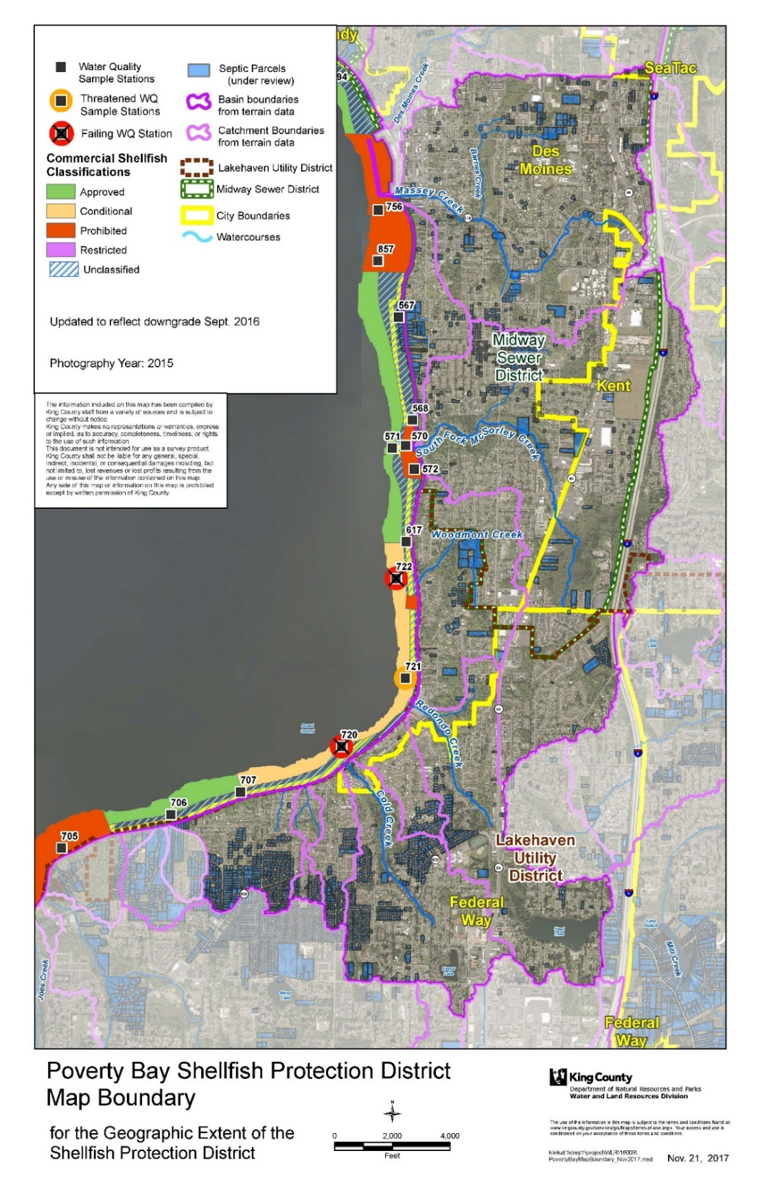

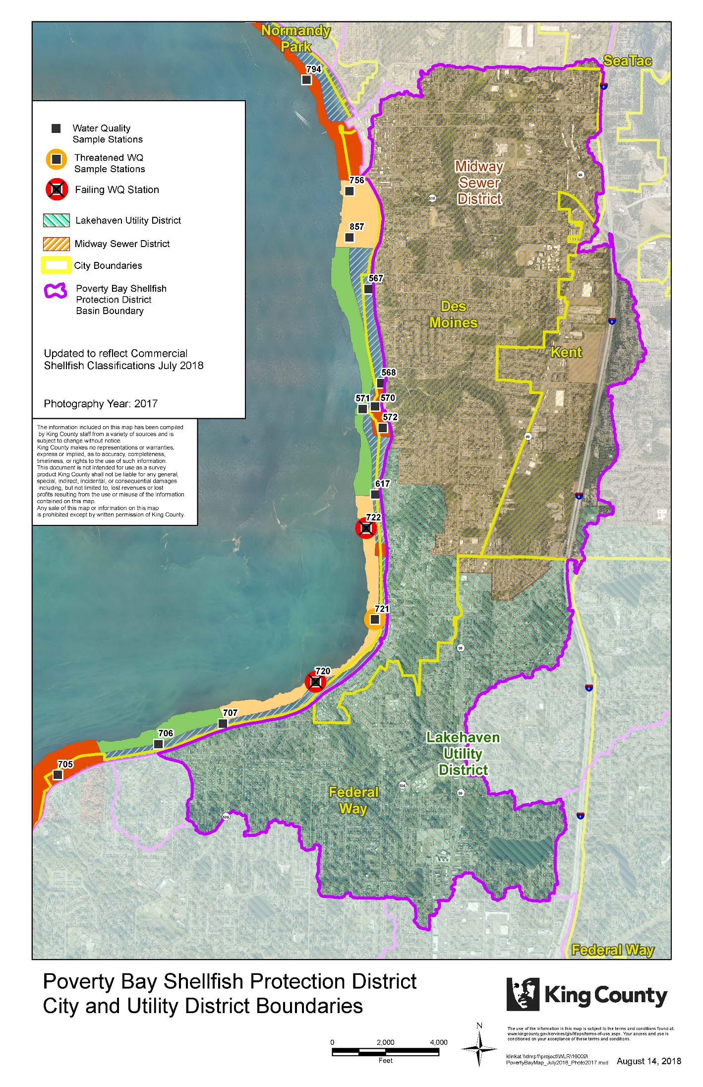
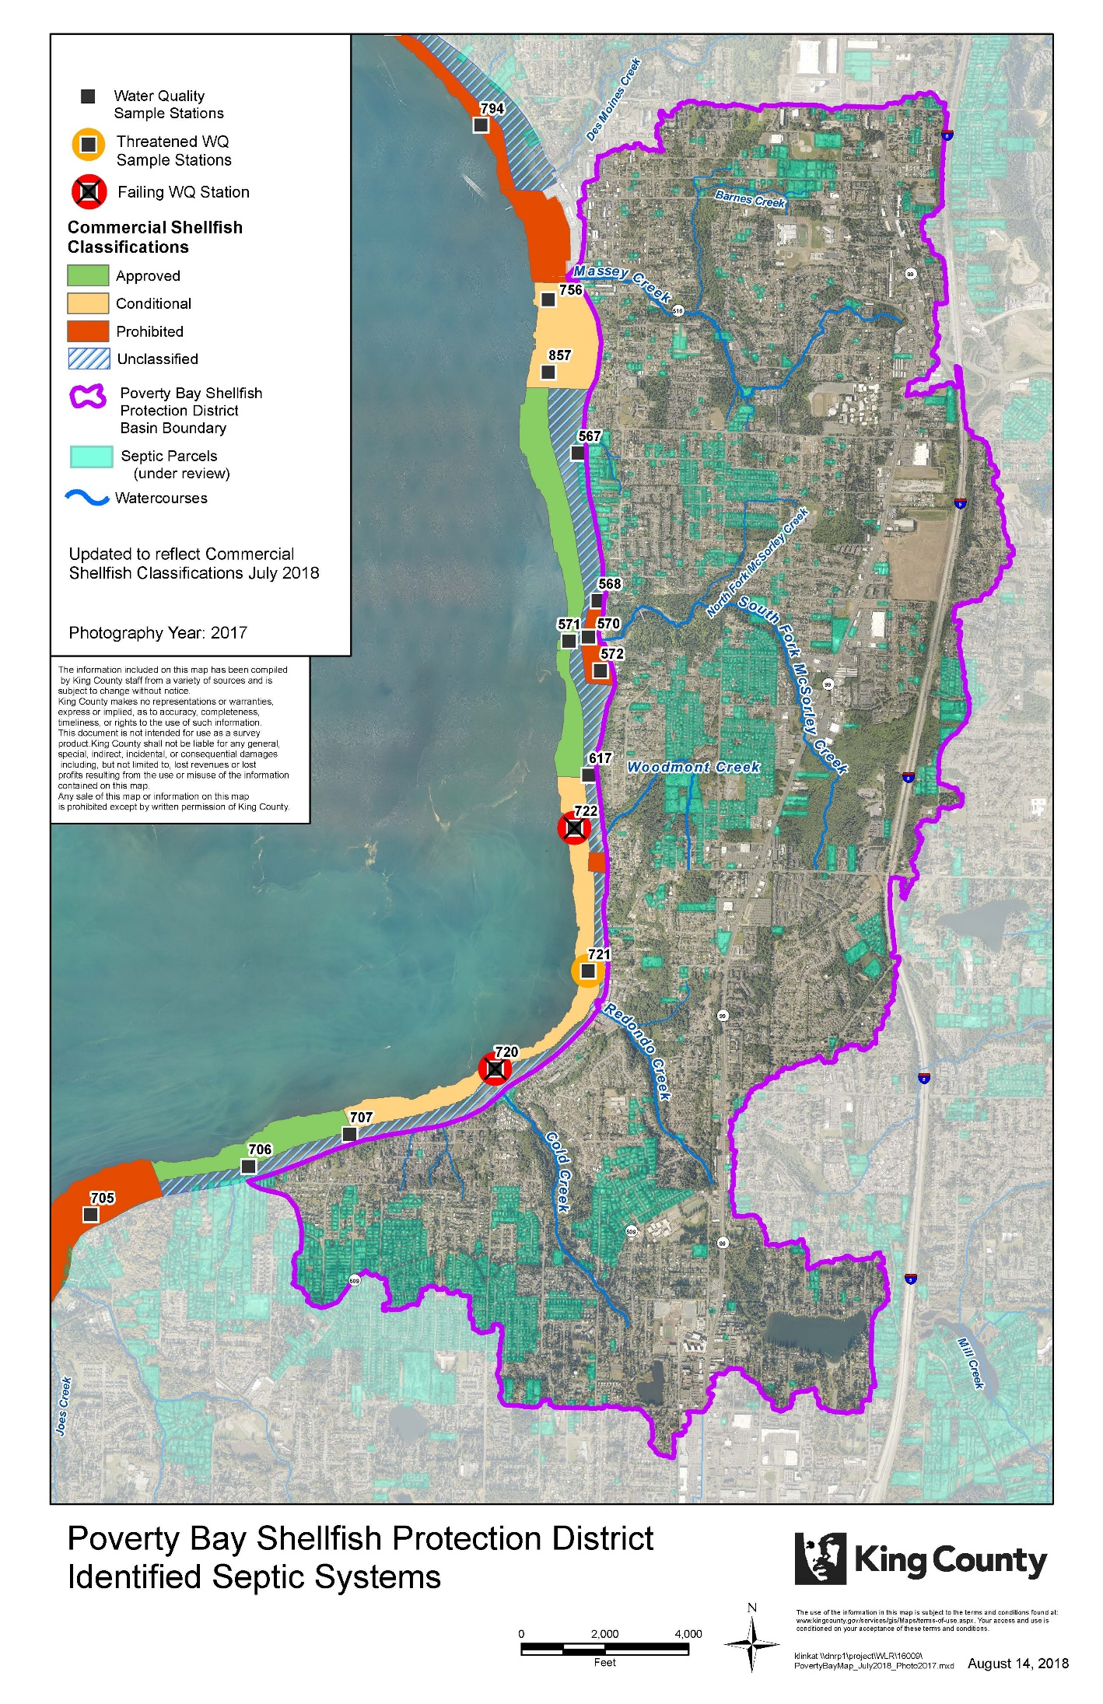
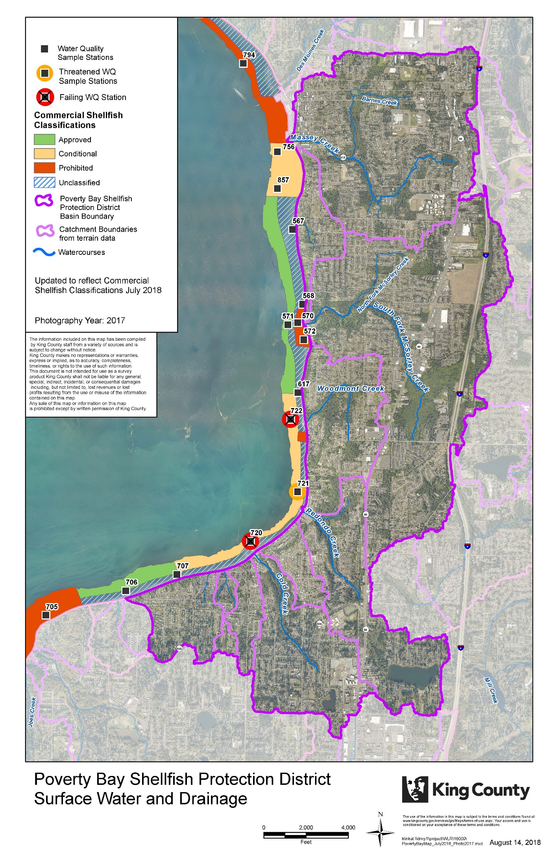

Appendix B: Poverty Bay Pollution Identification Process Flow Chart:
