Legislative Review Form
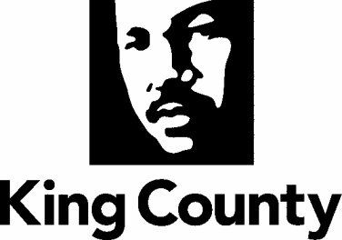

Agency: Metro Transit Department Contact person: David Goodman Phone: 206-263-3595

Ordinance Motion Proviso Report Other

Civil Division Prosecuting Attorney Review

Name Cheryl Carlson Version Final Date February 8, 2022

Dept. Director or Designee Review

Name Michelle Allison (Acting for Terry White) Version Final Date March 7, 2022

Performance Strategy & Budget Office Review

Name Shelley De Wys Version Final Date March 24, 2022

Technical Form/Code Reviser Review – Confirm adherence to legislative format

Name Bruce Ritzen Version Final Date February 8, 2022

Executive Office Review & Transmittal Approval

Name Mina Hashemi Version Final Date March 25, 2022

ENTRANCE CRITERIA REVIEW
EXEC OFFICE (initials) KCC CLERK
Fiscal note? Y NA Y NA
KC Strategic Plan reference in letter? Y NA Y NA
Proof read for spelling and grammar? Y NA Y NA
All pertinent attachments listed/labeled? Y NA Y NA
Costs identified/described in letter Y NA Y NA
Regulatory Note Required and Complete? Y NA Y NO
Formatted/Delivered in word-searchable doc format? Y NA Y NA
Potential Annexation Area (PAA) impacts identified? Y NA Y NO
Advertising required? if yes, cite all pertinent code/laws. Y NA Y NO
Any special circumstances affecting processing time? Y NA Y NO

