Attachment B
Dow Constantine
King County Executive

401 Fifth Avenue, Suite 800
Seattle, WA 98104

206-296-9600 Fax 206-296-0194
TTY Relay: 711
www.kingcounty.gov

July 19, 2018

Dear 4Culture Task Force Members,

In accordance with Ordinance 18684, Section 19, the King County Executive and King County Council, in coordination with 4Culture, are to convene a 4Culture Task Force. The task force will conduct the community stakeholder process and the task force should use the results of the assessment and evaluation to make a report of recommendations to 4Culture’s practices, governance and oversight structure to promote geographic, social and racial equity in the allocation of funding and to promote development of cultural infrastructure across King County to improve accessibility to both patrons and practitioners of arts, cultural, heritage and historic preservation programs countywide. The report is to be transmitted to the King County Council and the King County Executive by April 1, 2019

The purpose of this letter serve to notice the following individuals of their appointment to the King County 4Culture Task Force effective immediately:

- Dominica Meyers | - Sharon Williams | - Janelle Johnson
- Julie Ziegler | - Josef Krebs | - Kelly Dylla
- Jeanne Burbidge | - Tera Beach | - Scott Gray
- Jennifer Meisner | - Brian Carter | - Dwight Gee
- Ronda Billerbeck (SCA Primary Rep.) | - Shannon Halberstadt | - Mari Horita
- Manny Cawaling | - Patricia Cosgrove | - Kji Kelly
- Laura Reynolds | - Marie McCaffrey | - Tim Lennon
- Julianna Ross | - Latha Sambamurti | - Cassie Chin
- Carolyn Busch | - Matias Valenzuela | - Lawrence Ellis (SCA Alternate)

If you have questions regarding this task force, please contact Shannon Braddock, Deputy Chief of Staff, at 206-477-0982.

Sincerely,
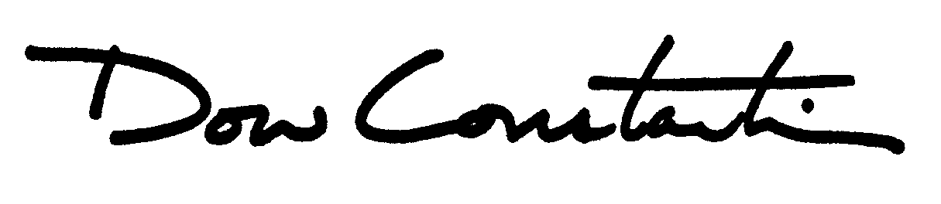

Dow Constantine
King County Executive

cc: The Honorable King County Council
4Culture Task Force Members

