Legislative Review Form
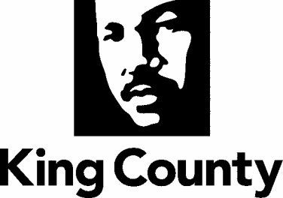

Agency: Performance, Strategy and Budget Contact person Dwight Dively Phone 206-263-9687

Ordinance Motion Proviso Report Other

Civil Division Prosecuting Attorney Review

Name Janine Joly Version Final Date 5/26/22

Dept. Director or Designee Review

Name Aaron Rubardt Version Final Date 5/27/22

Performance Strategy & Budget Office Review

Name James Walsh Version Final Date 5/27/22

Technical Form/Code Reviser Review – Confirm adherence to legislative format

Name Bruce Ritzen Version Final Date 5/25/22

Executive Office Review & Transmittal Approval

Name April Putney Version Final Date 6/1/22

ENTRANCE CRITERIA REVIEW
EEXEC OFFICE (initials) KCC CLERK
Fiscal note? Y NA Y NA
KC Strategic Plan reference in letter? Y NA Y NA
Proof read for spelling and grammar? Y NA Y NA
All pertinent attachments listed/labeled? Y NA Y NA
Costs identified/described in letter Y NA Y NO
Regulatory Note Required and Complete? Y NA Y NO
Formatted/Delivered in word-searchable doc format? Y NA Y NA
Potential Annexation Area (PAA) impacts identified? Y NA Y NO
Advertising required? if yes, cite all pertinent code/laws. Y NA Y NO
Any special circumstances affecting processing time? Y NA Y NO

