STAFF REPORT

Agenda Item: | 8 | Name: | Mike Reed
Proposed No.: | 2022-B0086 | Date: | July 6, 2022

SUBJECT

Briefing on Resource Recovery Program of the Wastewater Treatment Division

BACKGROUND

The Resource Recovery program works to capture and productively reuse the resources that result from the processing and discharge of wastewater. Resource Recovery program includes Biosolids, Energy, and Recycled Water, Sustainability, and Technology Assessment units.

Figure 1 below depicts the overall wastewater treatment process, and places the Resource Recovery function—labeled below as “Recycled and Reused Products”, within the larger process framework.

Figure 1. Recycled/Reused Products within Wastewater Treatment Process Framework

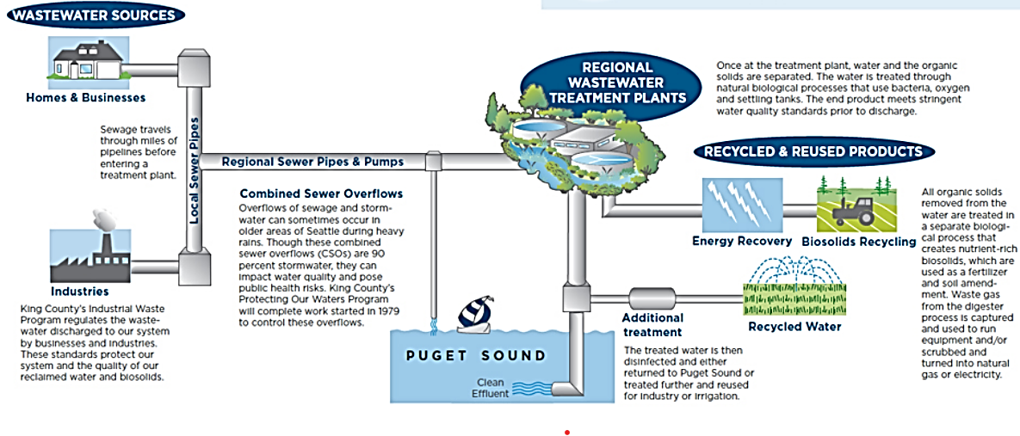

Summarized below are highlights of the strategic plans of the Biosolids, Energy, and Recycled Water programs. It is noted that these plan documents may have been completed a number of years ago; certain references quoted below may appear dated.

Biosolids

The Biosolids 2018-2037 Strategic Plan speaks to both program commitments and challenges.

“…WTD is committed to producing a King County-owned Class A biosolids product by 2023 and expanding the market for its Class B Biosolids Program. Producing Class A and B products in a diversified market will increase WTD’s adaptive capacity to consistently and beneficially use 100% of its biosolids. The specific Class A production method used by the Biosolids Program will be determined as part of the implementation of this strategic plan.
…with a reduction in forestry application and a decline in compost production…the program has become reliant on farmers in Douglas County to manage approximately 90 percent of WTD biosolids production. …Having only one reliable biosolids management approach leaves WTD vulnerable and with few options when highway passes close, fields are inaccessible, biosolids production increases, or farming practices change…

Figrure 2 below depicts the volumes of biosolids production at the three regional wastewater plants—Brightwater (in blue), South Plant (in red) and West Point (in green).

Figure 2. Biosolids Production
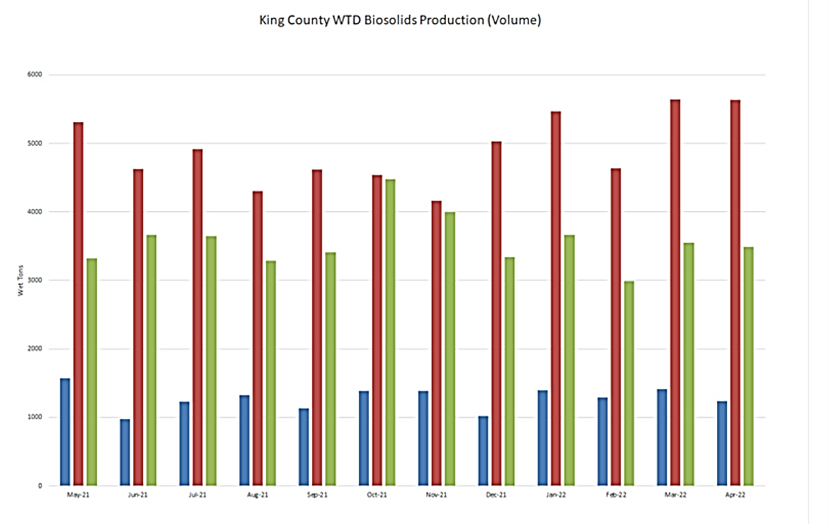

Energy

The Wastewater Treatment Division Energy Plan (February 2018) establishes direction for the Division’s energy and climate strategies. The Plan notes both the extent of the wastewater system’s use of energy, and the targets for agency efforts to limit carbon emissions.

“WTD is the largest facility energy user in King County government. The Division has a long history of energy conservation, innovative energy management and renewable energy generation. Implementing energy efficiency measures is part of WTD’s core business and ethos. WTD recognizes it can do more and understands the urgency and the significant role it has to play to help reduce or offset the County’s greenhouse gas emissions and reduce energy costs.
…the Strategic Climate Action Plan…reinforces county legislation that states the Wastewater Treatment and Solid Waste divisions independently achieve carbon-neutral operations and purchasing by 2025.”

Figure 3 below depicts the proportion of county government facility energy use by wastewater facilities.

Figure 3. Comparative Energy Use for Wastewater Treatment

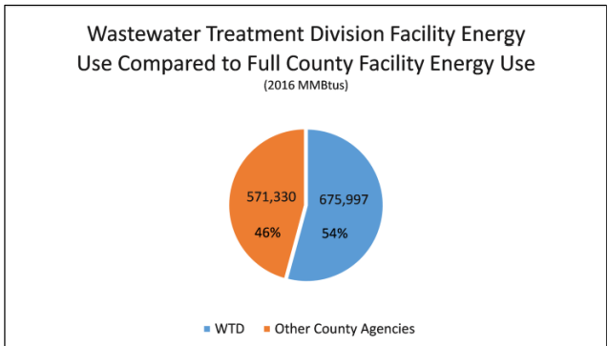

Figure 4 below describes the levels of energy usage at the county’s regional wastewater processing facilities.

Figure 4. Electricity Use at Regional Processing Facilities

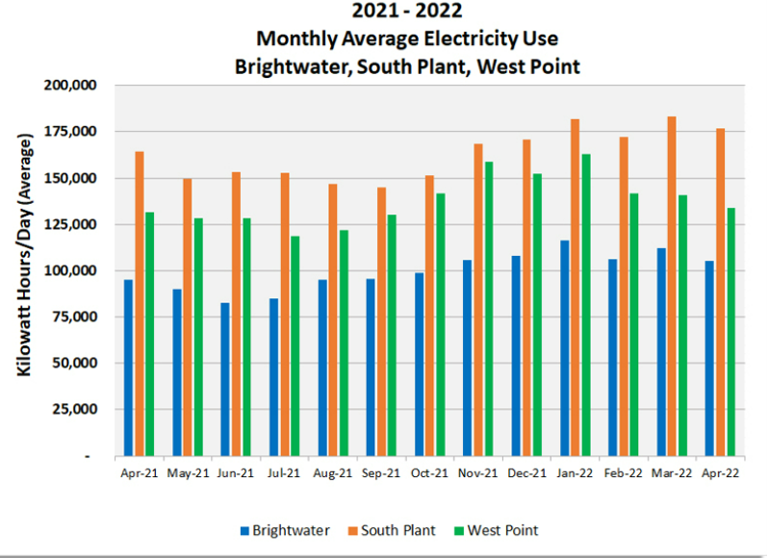

Figure 5 illustrates the wastewater system’s progress towards meeting goals for reduction of energy usage.

Figure 5. Energy Use Reduction

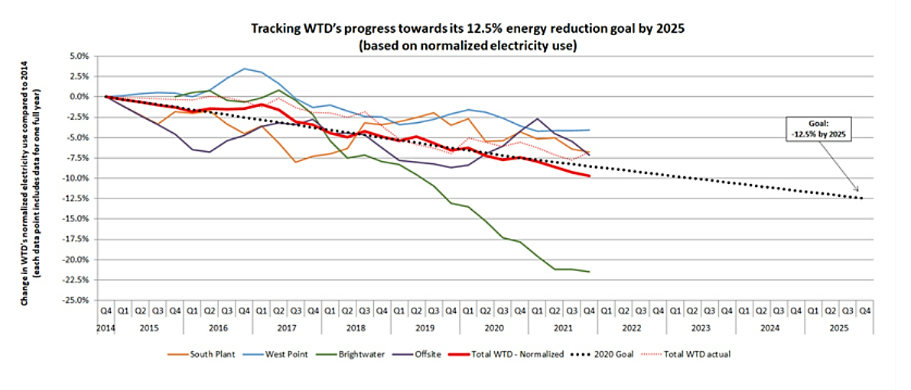

Recycled Water

The King County Recycled Water Program Strategic Plan notes both the benefits and the challenges of the Recycled Water Program.

Recycled water has many benefits for the Puget Sound region. These include creating options for managing wastewater effluent, helping the region respond to drought and climate change, and saving drinking water. Recycled water is also an important resource for King County to mitigate current and future discharge limits and regulations. In 2015, for instance, when the Pacific Northwest experienced significant drought, recycled water provided irrigation for local customers, preserving water in rivers and streams for natural habitats and people. As climate change exacerbates drought conditions, recycled water will become increasingly important to the region’s resiliency and sustainability.

Program Challenges
Despite the achievements of the Recycled Water Program and the benefits of recycled water use in general, WTD faces significant internal and external challenges to expanding recycled water use…the recycled water distribution system at Brightwater Treatment Plant, in particular, needs infrastructure improvements to reliably serve water—a factor that has inhibited customer development. Additionally, recycled water use is not as common in the Pacific Northwest as it is in water-limited areas of the United States, and there is currently not a strong demand for additional municipal water supplies. This makes it hard to establish water supply partnerships with drinking water utilities and creates political and economic hurdles because many drinking water utilities perceive recycled water as a duplicative, competing water supply.

INVITED

- Rebecca Singer, Resource Recovery Section Manager, Wastewater Treatment Division

ATTACHMENT

1. Resource Recovery Briefing PowerPoint presentation

Ratepayer Report 2015 (kingcounty.gov)
Biosolids 2018-2037 Strategic Plan (kingcounty.gov)
Operational performance metrics - King County
1802_KC-WTD-Energy-Plan.ashx (kingcounty.gov)
1802_KC-WTD-Energy-Plan.ashx (kingcounty.gov)
Operational performance metrics - King County
Operational performance metrics - King County
Recycled Water 2018-2037 Strategic Plan (kingcounty.gov)

