Legislative Review Form
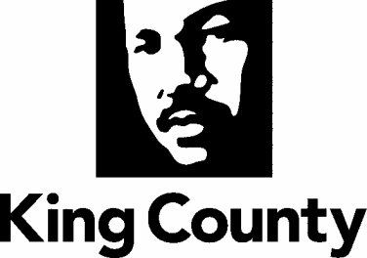

Agency: EXEC Office Contact person Rick Ybarra Phone 206-263-9651

Ordinance Motion Proviso Report Other

Civil Division Prosecuting Attorney Review

Name John Gerberding Version Final Date 2/24/2022 @ 2:38pm

Dept. Director or Designee Review

Name April Putney Version Final Date 2/17/2022 @ 3:30pm

Performance Strategy & Budget Office Review

Name Version Date

Technical Form/Code Reviser Review – Confirm adherence to legislative format

Name Bruce Ritzen, Council Staff Version Final Date 2/24/2022 @ 8:09am

Executive Office Review & Transmittal Approval

Name Shannon Braddock Version Final Date 2/17/2022 @ 3:30pm

ENTRANCE CRITERIA REVIEW
EXEC OFFICE (initials) KCC CLERK
Fiscal note? Y NA Y NA
KC Strategic Plan reference in letter? Y NA Y NA
Proof read for spelling and grammar? Y NA Y NA
All pertinent attachments listed/labeled? Y NA Y NA
Costs identified/described in letter Y NA Y NO
Regulatory Note Required and Complete? Y NA Y NO
Formatted/Delivered in word-searchable doc format? Y NA Y NA
Potential Annexation Area (PAA) impacts identified? Y NA Y NO
Advertising required? if yes, cite all pertinent code/laws. Y NA Y NO
Any special circumstances affecting processing time? Y NA Y NO

