STAFF REPORT

Agenda Items: | 8, 9 | Name: | Terra Rose
Proposed No.: | 2022-0175  2022-0176 | Date: | July 26, 2022

SUBJECT

Proposed Ordinances 2022-0175 and 2022-0176 would authorize the execution of franchise agreements with the City of Redmond for the use of King County road rights-of-way to construct and maintain water and sewer system facilities.

SUMMARY

King County Code Chapter 6.27 requires private or municipal corporations to obtain a franchise for the use of King County road rights-of-way (ROW) by submitting an application to the Facilities Management Division (FMD) and receiving approval from the Council. Proposed Ordinances (PO) 2022-0175 and 2022-0176 would authorize the Executive to execute the nonexclusive, negotiated franchise agreements with the City of Redmond for use of ROWs within two areas referred to as the Redmond City Franchise Area and the Novelty Hill Franchise Area, respectively. Executive staff indicate that through these proposed franchise agreements, the City's existing four sewer and three water franchises, one of each which is expired, would be combined into two franchises. The proposed agreements would have an initial term of ten years

Ordinance 18403, adopted by the Council in 2016, required that franchisees provide the County "reasonable compensation" in return for the right to use the ROW for utility facilities and outlines the factors and process to be used to determine the compensation amount. The proposed agreements would set the compensation at the following amounts, which would accrue to the general fund:

- $4,630.00 per year for the Redmond City Franchise Area (PO 2022-0175), beginning in 2021, with an additional one-time payment of $11,740.00 in exchange for use and occupation of the ROW between 2018 and 2020;
- $22,515.00 per year for the Novelty Hill Franchise Area (PO 2022-0175), beginning in 2021, with an additional one-time payment of $62,860.00 in exchange for use and occupation of the ROW between 2018 and 2020.

Executive staff indicate that Redmond will not be the first to pay franchise compensation to the County, but that these agreements are the first to come in front of the Council that include set compensation in exchange for the right to use and occupy the County ROW.
BACKGROUND

King County has the authority through state law (RCW 36.55.010) to grant franchises for the use of the rights-of-way (ROW) of county roads for the construction and maintenance of utilities, including waterworks, gas pipes, telephone, telegraph, and electric light lines, sewers, and any such facilities.

King County Code (K.C.C.) Chapter 6.27 requires private or municipal corporations to obtain a franchise for the use of the ROW, which must be consistent with the specific criteria laid out in that chapter of code. The application must be submitted to and negotiated with the Facilities Management Division (FMD) and approved by the Council. Water districts and distributors must also obtain approval of franchise applications from the utilities technical review committee prior to submittal to FMD.

K.C.C. 4A.675, together with K.C.C. 6.27.054, sets forth fees and charges to be paid for by the franchise applicant for the application. These fees include:

- A franchise application fee of $2,500;
- An advertising fee, which includes the full advertising costs associated with the application; and
- A surcharge to recover the actual costs incurred by the County in reviewing and processing an application.

The above fees include only those related to the franchise application. Throughout the life of the agreement, additional fees may be charged, including for permit applications for work in the ROW. Annual compensation is discussed later in this staff report.

Ordinance 18403, adopted by the Council in 2016, added a section to the K.C.C. requiring franchise agreements to include a requirement that the grantee of the franchise provide the County "reasonable compensation in return for the right to use the right-of-way for the purposes of constructing, operating, maintaining and repairing utility facilities and related appurtenances." K.C.C. 6.27.080 states that compensation shall be determined through consideration of the following relevant factors, not all of which must be applied to each franchise:

- The land value of right-of-way within the applicant's service area;
- The approximate amount of area within the right-of-way that will be needed to accommodate the applicant's use;
- A reasonable rate of return to King County for the applicant's use of the right-of-way;
- The business opportunity made available to the applicant;
- Density of households served;
- A reasonable annual adjustment; and
- Other factors that are reasonably related to the value of the franchise or the cost to King County of negotiating the franchise.

K.C.C. 6.27.080 also authorizes FMD to establish policies that create a process for the determination of franchise compensation, which may include different processes for the determination of franchise compensation depending on the size and complexity of the franchise. FMD adopted Public Rule RPM 9-2, Rules for Determining Franchise Compensation under K.C.C. 6.27.080, that further outlines how the previous factors will be used to generate the compensation amount, and which went into effect on January 29, 2018.

In January 2018, King County filed an action for declaratory relief in King County Superior Court against various water and sewer districts in King County regarding the legality of this provision. In September 2018, the Washington State Superior Court ruled in favor of the water and sewer districts and dismissed King County's compliant with prejudice. King County appealed to the Washington State Supreme Court. In December 2019, the Supreme Court ruled that King County has the authority to impose a franchise compensation charge for the use of ROW by private and public utilities. The Court also ruled that water and sewer districts do not have a general right to use county ROW without a franchise.

According to the recitals in the proposed agreements, on April 24, 2019, the City of Redmond (Franchisee; City) applied for a franchise for the right to use County ROWs for water and sewer system facilities and to update and combine portions of the previously approved franchise areas into two new franchise areas – the Redmond City Franchise Area and the Novelty Hill Franchise Area. Executive staff indicate that King County began discussions to address two expired franchises early in 2020 but suspended the negotiations while both sides responded to the COVID-19 pandemic. Negotiations resumed later in 2020 and in 2021 began detailed discussions about the franchise compensation after the State Supreme Court issued its opinion upholding the validity of Ordinance 18403.

ANALYSIS

Proposed Ordinances (PO) 2022-0175 and 2022-0176 would authorize the Executive to execute the nonexclusive, negotiated franchise agreements with the City of Redmond for use of King County road ROW within two areas referred to as the Redmond City Franchise Area and the Novelty Hill Franchise Area, respectively. Attachment A to each ordinance outlines the terms and conditions.

Council staff compared both the proposed Redmond City Franchise Area agreement (PO 2022-0175) and the proposed Novelty Hill Franchise Area agreement (PO 2022-0176). Staff found the language and terms to be the same except for the geographical references to the franchise locations, compensation amounts, and the required general liability insurance coverage levels. All differences between the two proposed agreements are specifically called out in the staff report.

Process and Approval Criteria. K.C.C. Chapter 6.27 identifies the criteria for franchise approval and requires each franchise application to be reviewed by the King County Department of Executive Services (DES) and Department of Local Services (DLS), as well as approved by the Utilities Technical Review Committee (UTRC). For background, Attachment 10 to the staff report provides an Executive staff generated document listing each franchise requirement and the appropriate reviewing agency.

Executive staff indicate that Road Services Division confirmation was received on December 10, 2021, UTRC confirmation received on December 15, 2021, and DES confirmation received on April 6, 2022.

According to Executive staff, the Redmond City Council approved the terms and conditions contained in the franchise agreement on March 1, 2022.

Duration of Agreements. The proposed agreements each have an initial term of ten years with an option for the FMD Director to approve an extension of up to fifteen years. If the County does not issue an extension beyond the initial ten-year term, the proposed agreements would provide the Franchisee with the opportunity to file an application for renewal of the franchise agreements and upon receipt, both parties shall commence good faith negotiations on renewal terms.

Locations of Franchise Areas. Executive staff indicate that through these proposed franchise agreements, the City's existing four sewer and three water franchises, one of each which is expired, are being combined into two franchises., The franchise areas covered by each of the proposed franchise agreements are depicted in the following figures.

Figure 1.
Redmond City Franchise Area Map (Proposed Ordinance 2022-0175)
(Located in Council Districts 3 and 6)

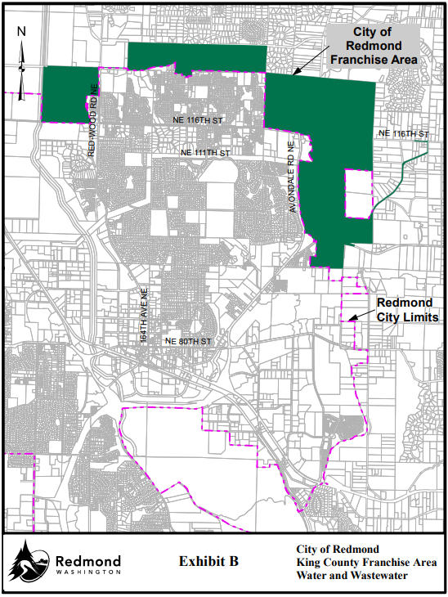

Figure 2.
Novelty Hill Franchise Area Map (Proposed Ordinance 2022-0176)
(Located in Council District 3)

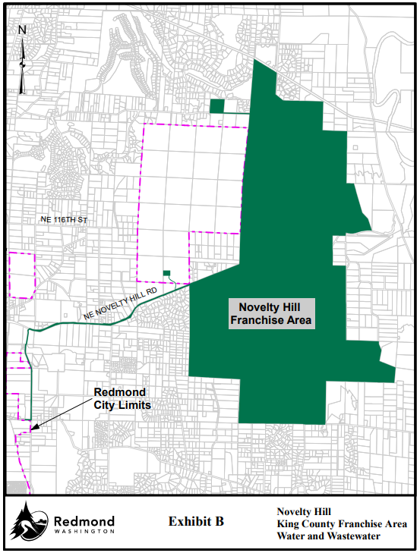

Franchise Compensation. Section 15 in each proposed agreement would require the Franchisee to pay the County franchise compensation in the nature of rent (referred to in the agreements as "Consideration") in exchange for the right to use and occupy the County ROW to place its facilities, as provided in KCC 6.27.080. The application fee paid by the City will be credited against the first franchise compensation payment.

Executive staff indicate that Redmond will not be the first to pay franchise compensation to the County and that addenda for franchise compensation were completed with the following utilities that were interested in discussing franchise compensation: Soos Creek Water & Sewer District; Lake Washington School District; and Puget Sound Energy. However, these franchise agreements are the first to come in front of the Council that include set compensation amounts.

The agreement for the Redmond City Franchise Area (PO 2022-0175) would set the Consideration at $4,630.00 per year, beginning in 2021, which includes a credit for fire suppression water facilities and services required by applicable law. Additionally, the parties have negotiated and agreed that the Franchisee shall pay the County an additional $11,740.00 of Consideration with the first invoice following the effective date in exchange for use and occupation of the ROW between 2018 through 2020.

The agreement for the Novelty Hill Franchise Area (PO 2022-0175) would set the Consideration at $22,515.00 per year, beginning in 2021, which also includes a credit for fire suppression water facilities and services. Additionally, for use and occupation of the ROW between 2018 through 2020, the parties have negotiated and agreed that the Franchisee shall pay the County an additional $62,860.00 in Consideration with the first invoice.

The revenues from compensation are accruable to the general fund. Executive staff indicate that an estimate of annual franchise compensation for each requested franchise area was created in accordance with Public Rule RPM 9-2. Specifically, Executive staff state that the City provided GIS data to verify the ROW occupied by City water and sewer facilities and that GIS data was used by King County GIS to identify the location-specific data that is used to create the annual estimate. Further, Executive staff indicate that the annual Consideration for the Novelty Hill Franchise Area was adjusted under the Financial Impact Limiting Factor provision of the Public Rule RPM 9-2, which is intended to evaluate the reasonableness of the estimate of annual franchise compensation. According to Executive staff, the estimate generated for the Novelty Hill franchise exceeded the Financial Impact Limiting Factor (currently $5 per customer per month) for its 3,471 customers, so the estimate was recalculated as described in Section 2.4.3 of the Public Rule.

Both proposed agreements would require the Consideration to be adjusted annually based on the Consumer Price Index at the end of the preceding year. Further, beginning in 2025, and thereafter in each fifth year throughout the agreement term, Consideration would be reevaluated with the purpose of capturing changes in the Franchise Area or changes in the assessed land values of parcels adjacent to the ROW. Both agreements also would reserve the right to impose a utility tax on the Franchisee if such taxing authority is granted by the State. The terms for Consideration shall survive the expiration, revocation, or termination of the franchise until such time as all facilities have been removed or have been decommissioned in place in accordance with the proposed agreements.

Council staff asked Executive staff if there was any indication on whether the City of Redmond would pass along these franchise costs on to its customers and if so, how that might be done. Executive staff indicate that whether and to what extent the City would do so was not a part of the franchise negotiation.

Construction and Maintenance in the ROW. Under the proposed agreements, the Franchisee would be required to apply for and receive ROW construction permits from the Real Estate Services section for any construction or maintenance, unless an emergency is present at which point the Franchisee may take corrective action immediately. The need to take immediate corrective action in an emergency, however, does not relieve the Franchisee from its obligation to obtain a ROW construction permit or any other permits necessary for the corrective action. Any activities performed by the Franchisee shall be performed in accordance with all applicable County standards and upon completion of construction or maintenance, the site and any adjacent affected areas must be restored to as good or better than its previous condition.

Roadside Management Program. Section 10 of each proposed agreement would require the Franchisee to submit a Roadside Management Assessment within ninety days after the effective date that includes an assessment of whether any of its facilities are located above ground and if the above ground facilities comply with the Road Standards. If the Franchisee concludes that it has above ground facilities not in compliance with Road Standards, the Franchisee shall submit a Roadside Management Program (RMP) within one hundred twenty days following the effective date for County approval. The Franchisee would submit an annual RMP Work Plan identifying specific remediation projects to be accomplished during that year and an annual RMP Work Report that shows the progress of remediation projects accomplished during the preceding year. Both the RMP Work Plan and RMP Work Report would be submitted annually until the facilities identified in the RMP are remediated and brought into compliance with the Road Standards.

Indemnification and Insurance. The proposed agreements require the Franchisee to agree to release, indemnify, defend (at the County's option and using counsel reasonably acceptable to the County), and hold harmless the County from and against claims to the extent caused by, arising out of, incidental to, or related to the acts or omissions of the Franchisee in connection with Franchisee's exercise of rights and obligations under this franchise. Indemnification terms are outlined in Section 16 of each agreement.

Section 18 of each agreement outlines the insurance requirements and would allow for the County Risk Manager to review and reasonably adjust the insurance section with each amendment and at the end of every five years. The language in each proposed agreement is the same, however as noted previously, the agreements have different general liability insurance coverage requirements. Specifically, the Novelty Hill Franchise Area agreement requires $5 million per occurrence and $5 million in the aggregate for general liability insurance and the Redmond City Franchise Area agreement requires $1 million per occurrence and $1 million in the aggregate.

Default and Dispute Resolution. Under each proposed agreement, the County could revoke or terminate the franchise if the Franchisee defaults on any term or condition of the franchise. Section 23.2 would establish the notification requirements and process for curing the default. Upon revocation or termination, all rights of the Franchisee granted by the franchise shall cease, and the County may suspend or withdraw approval of any active ROW construction permits.

Additionally, if the County finds that the Franchisee is not in substantial compliance with the terms and conditions of the proposed franchises, the County may require the Franchisee to furnish a performance bond up to $250,000 to ensure performance of Franchisee's obligations under the franchise. Under the Default section, the County may satisfy any remaining financial obligations of the Franchisee by utilizing any funds available under the performance bond.

In the case of disputes that may arise throughout the duration of the proposed agreements, Section 24 would set up a dispute resolution process wherein the Franchisee and the County would be required to meet within thirty days to make a "good-faith effort" to achieve resolution. If resolution is not reached, the Franchisee and the County would enter into mediation with any expenses incidental to mediation borne equally by the parties unless otherwise agreed. If mediation fails to resolve the dispute within thirty days, then either party may then pursue any remedy under the franchise or under applicable laws.

Amendments and Modifications to the Agreements. Council approval would be required for most amendments to both franchise agreements, with the following exceptions:

- The Franchise Area could be changed. Additionally, if during the term of the proposed agreements, any portion of the ROW is incorporated or annexed into a city or vacated, the affected portions of the ROW would be removed from the Franchise Area;
- The FMD Director could extend the term of the agreements for up to fifteen years beyond the original expiration date;
- The amount of the Consideration shall be adjusted and reevaluated as provided in Section 15;
- The County Risk Manager could amend the insurance section of the proposed agreements at every amendment or at the end of every five years of the agreements; and
- Minor technical corrections or updates.

Legal. The Council's legal counsel has reviewed the proposed agreements and identified no issues that require revisions to the agreements.

Timing and Consequences of Inaction. As noted earlier, Executive staff indicate that the Redmond City Council approved the terms and conditions in the franchise agreements earlier in 2022. According to Executive staff, King County cannot collect the negotiated franchise compensation until the franchises are approved by the King County Council and executed by the parties.

Additionally, if the proposed agreements are ultimately not approved by the Council, Executive staff indicate that the City would continue to operate under the five franchises that are current, but without franchise compensation. Depending on the circumstances, the City may not be eligible for ROW construction permits for construction or maintenance in the areas covered under the two expired franchises.

In accordance with RCW 36.55.040 and KCC 6.27.050, fifteen days public notice before the Council hearing is required.

INVITED

- Anthony Wright, Division Director, Facilities Management Division
- Terri Hansen, Franchise Project Manager, Facilities Management Division

ATTACHMENTS

- Proposed Ordinance 2022-0175 (and its attachments)
- Proposed Ordinance 2022-0176 (and its attachments)
- Transmittal Letter for PO 2022-0175
- Transmittal Letter for PO 2022-0176
- Fiscal Note for PO 2022-0175
- Fiscal Note for PO 2022-0176
- Updated Fiscal Note for PO 2022-0176
- Franchise Summary for PO 2022-0175
- Franchise Summary for PO 2022-0176
- Executive Staff Matrix for Franchise Approval Criteria

https://kingcounty.gov/about/policies/aep/propertyaep/rpm92dp.aspx
The franchise agreement for PO 2022-0175 combines the following King County Franchises (with the year granted and expiration year in parenthesis): 9036 (granted in 1993 with expiration on 6/23/2018); 9090 (granted in 1993 with expiration on 8/18/2018); 13683 (granted in 1999 with expiration on 8/31/2024); and 16637 (granted in 2009 with expiration on 8/31/2034).
The franchise agreement for PO 2022-0176 combines the following King County Franchises (with the year granted and expiration year in parenthesis): 12967 (granted in 1998 with expiration on 1/5/2023); 12968 (granted in 1998 with expiration on 1/5/2023); and 14307 (granted in 2009 with expiration on 3/25/2027).
Executive staff indicate that the City paid a $1,000 application fee in 2001 when it filed an application to amend the franchise area of King County Franchise No. 12967. Since the City's payment, the Code has been amended to increase the application fee to $2,500, changed the time of payment, and credited the application fee against any franchise compensation. Executive staff are not planning to require the City to adjust the application fee it paid in 2001.
The last franchise agreement for a water or sewer district that was adopted by the Council was in December 2020 for King County Water District 123 (Ordinance 19220). This Franchise Agreement reserved the right to receive compensation and outlined a process for negotiating the amount but did not set a specific amount within the agreement approved by the Council.
Executive staff indicate that the transmitted fiscal note for 2022-0176 contains an error and that all revenues accrue to the general fund and not as indicated on the fiscal note to Real Estate Services. An updated fiscal note is provided in Attachment 7.
https://kingcounty.gov/about/policies/aep/propertyaep/rpm92dp.aspx
U.S. Department of Labor, Bureau of Labor Statistics Consumer January through December Price Index for All Urban Consumers for the Seattle-Tacoma-Bellevue Statistical Metropolitan Area

