2015/2016 Biennial Budget Ordinance, Ordinance 17941, Section 129, as amended by Ordinance 18289, Section 2, Proviso P16
DES BRC Business Intelligence (BI) Project Training Strategy Report
EXECUTIVE SERVICES - ADMINISTRATION

Caroline Whalen - County Administrative Officer
Dwight Dively - Director, Office of Performance, Strategy and Budget

September 1, 2016

Table of Contents

Council Proviso | p. 3
Section A: Specific Training Goals and Strategies | p. 4
Section B: Training Implementation Plan | p. 6
Section C: Matrix of Project Tasks and Responsibilities  I. Training Methods and Media;  2. Proposed Curricula;  3. Training Development Tasks and Estimated Effort;  4. Baseline Metrics and Targets;  5. Training Delivery Schedule. | p. 8

COUNCIL PROVISO

For reference, the proviso in Ordinance 17941, Section 129, was amended by Ordinance 18289, Section 3, which added a proviso P16 is excerpted below:

For capital project 1126545, DES BRC Business Intelligence (BI) Project, this proviso requires that the BRC deliver a Training Strategy for the overall project. The executive shall transmit a report to outline specific training goals and strategies; a training implementation plan; a matrix of project task and responsibilities and a motion accepting that report. The motion shall reference the subject matter, the proviso's ordinance, ordinance section and proviso number in both the title and body of the motion. The report shall include, but not be limited to:
A. Identification of specific training goals and strategies;
B. A training implementation plan that includes information on the training approach and specific roles of those involved;
C. A matrix of the project tasks and responsibilities that identifies those who are responsible for each task, those who approve the task and those who will be consulted and informed on the process. The matrix includes high level tasks that shall include but not be limited to;
1. Identifying desired training methods and specific media;
2. Identifying specific training curricula;
3. An estimate of training development tasks and efforts;
4. Identifying program baseline metrics and targets; and
5. Identifying a schedule to deliver user training.

The executive must file the report and motion required by this proviso prior to or concurrent with the transmittal of any future appropriation requests for capital project 1126545, in the form of a paper original and an electronic copy with the clerk of the council, who shall retain the original and provide an electronic copy to all councilmembers, the council chief of staff, the policy staff director and the lead staff for the budget and fiscal committee or its successor.

DEPARTMENT OF EXECUTIVE SERVICES (DES) BUSINESS RESOURCE CENTER (BRC) BUSINESS INTELLIGENCE PROJECT

- Specific Training Goals and Strategies

The Oracle Business Intelligence Enterprise Edition (OBIEE) is a comprehensive business intelligence and analytics platform that is capable of delivering a range of financial and operational reporting. The overall goal of the BI Project training program is to provide effective and timely education to ensure that King County staff are prepared to use the Oracle Business Intelligence (BI) data warehouse and reporting tools. The BI Project team will also establish a Business Intelligence Competency Center (BICC) framework across the County to grow and mature BI skills, competencies and governance that go beyond the systems implementation.

As a first step, and to ensure adoption of the BI system, the BI Project team will target training toward two user groups: BI Consumers and Power Users. BI Consumers, are users who will login and view the prebuilt dashboards and report content. For example, Executives, Division Managers and Project Managers would use the system to monitor business performance. Power Users, who will receive more in-depth training, will learn how to build dashboards and reports for the BI Consumers. Over time the Power Users will develop the knowledge and skills necessary to support their agencies and help develop the County’s growing BI User Community.

BI End User Segmentation by Skill

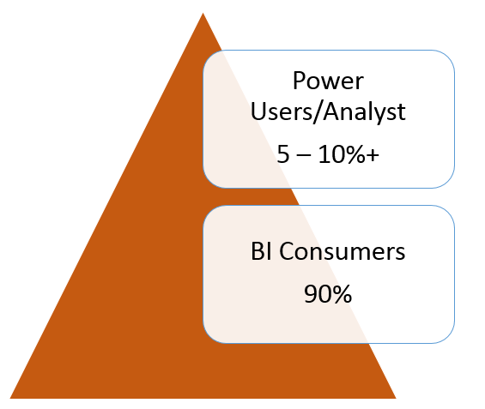

To achieve our training goals the Project training program will:

- Perform a Training Needs Assessment (TNA) to identify the agencies, users and training needs, relevant to the subject areas being released.
- Develop a training implementation plan that will scale over time, targeting approximately 1200 users across King County.
- Develop a training program that will address users with diverse training needs (i.e. BI Consumers; Power Users).
- Customize a course curriculum that will facilitate the release of new content as it becomes available.
- Develop reusable training materials (tools and collateral)
- Deliver the training using proven methods (i.e. instructor led training, computer-based and video).

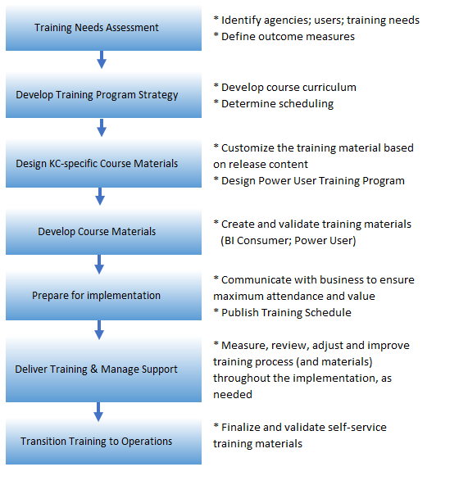

Training Implementation Plan

Training Implementation Plan

The Training Implementation Plan is intended to guide the process of developing and conducting BI training. The activities laid out in the training plan are a necessary part of the implementation and will maximize its effectiveness.
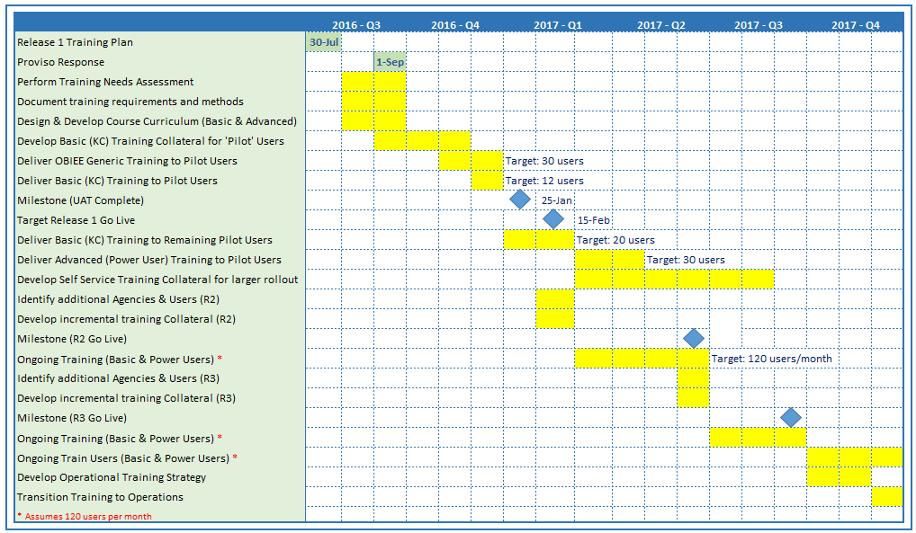

Training Approach

The BI Project team will assume responsibility for developing training materials and delivering end user training. In conjunction with the Release 1 ‘Pilot’, the Project team will deliver training to a ‘pilot’ group who will assist in a support role throughout the project. A subset of the pilot group will participate in User Acceptance Testing, and will be the first group to participate in the training. The BI Project team will prototype the implementation training materials with this pilot group of users.

The implementation approach is iterative, meaning that new content will be released throughout the project lifecycle. The project plan includes 3 major releases. The BI Project Rollout Strategy has identified the following agencies to participate in Release 1 (Agency Finance Managers will select the users who will participate in training):
Finance and Business Operations Division (FBOD)
Dept. of Natural Resources & Parks (DNRP)
Dept. of Public Health (DPH)
Dept. of Transportation (DOT)
Dept. of Public Defense (DPD)
KC Sheriff’s Office (KCSO)
KC Information Technology (KCIT)

In each subsequent Release, we will be guided by the BI Project Rollout Strategy to determine the agencies and users to be trained. Once the system is released in Production, we expect to train approximately 120 users per month (BI Consumers and Power Users).

Proposed Training Deployment Plan

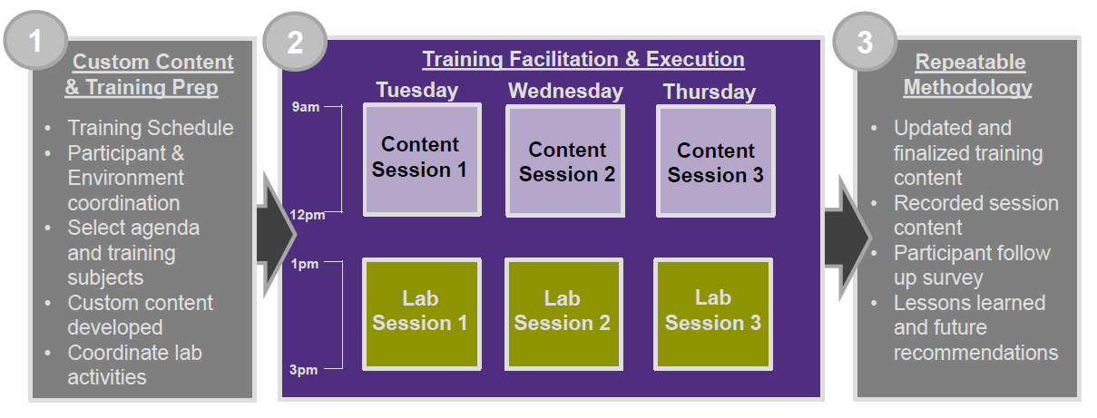

Power User Training

As part of the overall training strategy, we will develop a comprehensive Power User training program. Power Users will play an important role on the project and will work closely with the project team; validating the design, reviewing deliverables, and assisting with report development for the BI Consumers. Prior to the start of the formal training program the Project team will deliver Power User Training to the pilot group of users. Throughout the project, we will continue to train and develop the Power User community.

C. Matrix of the Training Tasks and Responsibilities
Legend | R Responsible for task | A Approves | S Support | C Consulted | I Informed

Task | Task Description | BI  Team | Agency  Mgmt. | BI Project Steering Committee | CBSC
Identify BI Consumers (agencies & central services) | - Review population from workshops  - Identify users (approximately 30 BI Consumers, Release 1) | R | C, S | A | I
Conduct Training Needs Assessment (interview users, identify training needs and methods; make recommendations) | - Conduct interviews  - Analyze needs and methods  - Identify desired methods/media  - Define outcome measures  - Identify business, governance or policy decisions required  - Document findings and recommendation | R | C, S | A | I
Design BI Consumer training methods and schedule | - Select desired methods, approach  - Develop training curriculum  - Estimate training tasks and effort | R | C | A | I
Design Power Users training methods and schedule | - Select desired methods, approach  - Develop training curriculum; Power User Forums; Security  - Estimate training development tasks and effort  - Design Power User Certification process  - Identify program baseline metrics & targets | R | I | I | I

Task | Task Description | BI  Team | Agency  Mgmt. | BI Project Steering Committee | CBSC
Develop BI training media; BI classes | - Develop BI Consumer classes and online assets  - Develop Power Users training sessions; Forums; security access;  - Validate training environment | R | I | I | I
Prototype training process with Proof Of Concept (POC) content and small set of users (post Go-No Go decision) | - Schedule and deliver BI Consumer training sessions  - Schedule and deliver Power User training sessions | R | I, S | I | I
Quantify & gather feedback/adjust for long term implementation | - Conduct post- Prototype survey  - Analyze feedback  - Adjust Reporting program for long term | R | I, S | I | I
Deliver training | - Conduct training: provide a mix of training classes (both Report Consumer and Power User training), train approximately 120 users/month  - Measure, review and adjust | R | I | I | I
Transition Training to Ongoing Support | - Document the transition strategy  - Transition training | R | I | I | I

- Training Methods and Media

The scope of training for the BI Project will involve a variety of methods, such as:

Instructor-led training: Formal classroom training; supported by instructor presentation, business process and procedures, work instructions, and exercises. Instructor shows County users how the software works and how to perform their required tasks, with users performing the tasks themselves in a classroom/lab setting. Each user has a computer on which to practice. Classes will be limited in size to 15 to 20 students.

Computer Based Training (CBT): Some of this training may be administered via individual desktops where end-users complete the training on their own and at their own pace. Facilitated CBT may also be offered where end-users complete the training at their own pace, but in a classroom setting with a facilitator in the room available to provide guidance as necessary.

Quick Reference Cards (QRC’s): Some functions may not require any formal instruction, but rather just a reference card showing end-users how to perform particular functions.

The BI project team will assume responsibility for developing training materials and delivering end user training. The goal is to conduct training on a prototype environment, using County data, as new content is released. At this time, we are evaluating training tools to determine the best fit for the County.
An example of tools under consideration are:
Camtasia - software that is used to record onscreen activity, audio and video content which is then deployed for self-paced learning
Oracle’s User Productivity Kit (UPK) - a content development platform that creates standardized documentation and simulations, such as:
- Computer-based, interactive training
- Instructor-led training (ILT) documents
- Business process documents
- User acceptance test scripts
- Job aids

All training materials and methods will be available for use after the implementation is complete.

2. Proposed Curricula

The Oracle Business Intelligence Enterprise Edition (OBIEE) is a comprehensive business intelligence and analytics platform that is capable of delivering a range of financial and operational reporting. The Getting Started with OBIEE course will introduce students to the fundamentals of OBIEE, on topics such as interactive dashboards, ad hoc & interactive reporting.
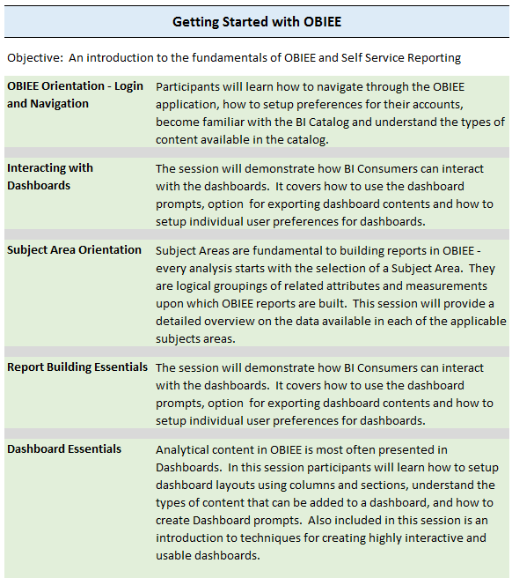

The Advanced Reporting courses will focus on developing the report building skills of the Power User community.
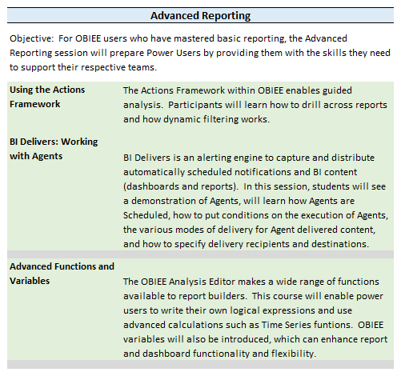

- Training Development Tasks and Estimated Effort

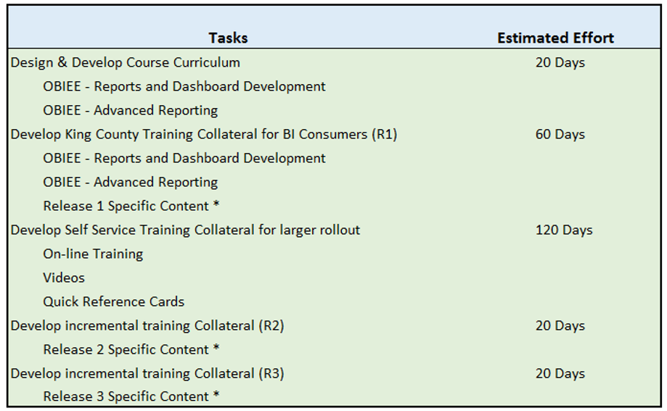
*
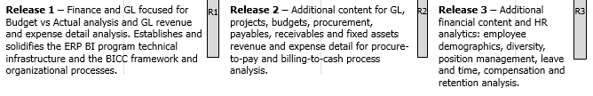

4. Baseline Metrics and Targets

The BI Training Program will support the following goals and objectives outlined in the Project Benefits and Achievement Plan:

Benefit #1

Faster, more accurate answers with better quality data for improved visibility and productivity. Improve and automate the existing very manual data manipulation and report production processes to eliminate the errors in the current agency produced excel reports.

Management will have improved visibility into material events and financial and budget performance across the agencies. Data transparency and more timely, accurate and consistent information will support proactive decisions, increase the speed to respond to emerging situations, and mitigate the risk of inaccurate compliance reporting to external agencies.

Baseline:
Larger agencies spend over 120-150 hours per agency to prepare their SSFA/SEFA and go through an average of 5 error correction cycles with central finance. Central Finance spends a minimum of approximately 320 - 400 hours/year on SSFA/SEFA preparation, review, error correction, technical assistance and internal audit issues coordination of SSFA/SEFA review processes.

Target:
The target for determining if the quality and accuracy of the data from the agencies has improved will be if the response to the survey questions from the agency financial analysts and Central finance indicate: 80% of the responses were positive that the quality of the data in the agency produced reports had improved; there was a reduction of at least 80% in the number of error-correction cycles they had to execute when producing the SSFA/SEFA financial reports; and there was a reduction of at least 75% in the number of internal audit issues identified.

Benefit #2

Improve operational efficiencies by reducing and removing the need for business analysts to manually extract and manipulate information from the three ERP systems to produce their regular operational and performance exception reports and their mission critical reports.

Provide a user friendly, self-service reporting solution that will provide unified data for EBS, PeopleSoft and Hyperion. There is no reporting solution that unifies data from these systems today. Currently King County Financial, HR and Budget analysts spend over 10,000 hours per month just preparing their own data silos by manually extracting and manipulating information from these systems. Reports are then manually produced, formatted and distributed from these data silos.

Baseline:
Currently King County Financial, HR and Budget analysts spend over 10,000 hours per month manually extracting, manipulating information from these systems.
Target:
Reduce the manual effort required to produce EBS, PeopleSoft & Hyperion data related to operating, management and executive reports by 50%.

Benefit #3

Improve diversity hiring in the county. HRD’s experience is that currently, it is very challenging and time consuming for managers to pull data showing where diversity falls off in the recruitment process. In a recent example, it took several weeks. Because managers are pulling from various sources and have varying degrees of skills with our systems, this also leads to inconsistent reporting across agencies. BI will enable automatic query of this information, at any time, for reporting from individual departments.

Baseline:
The current King County rate of diversity is 34.3%. Manual creation of the diversity report takes several weeks. Diversity fall off reason analysis is, currently, very limited.
Target:
Providing automated diversity reports on demand and analysts performing research on the agencies’ information showing where diversity falls off in the recruitment process will help improve the diversity hiring rate. It is expected that with this proactive oversight that the diversity rate can be increased to achieve the 38.5% target set by HRD.

Measuring Training Program Success

The BI training program is intended to provide education to the BI Consumers and Power Users to ensure a successful change management process and is key to meeting the Benefit Achievement Plan (BAP) goals.
Surveys will be administered at the close of each class, and after 6 months of product use, to measure the success of the BI training program. Surveys will allow for feedback and requests for additional support if needed. Questions will focus on the quality of the training material, the skills of the trainer, and especially on the perceived results of the training. Users will be asked questions like: “did the training deliver the skills necessary to become self-sufficient in the use of the BI Tools”.

The following is an estimate of the number of users to be trained during each Release:
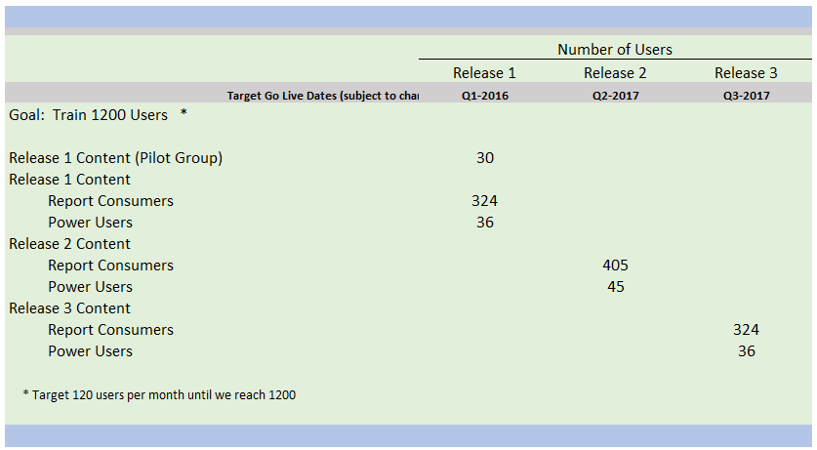

5. Proposed Training Delivery Schedule

The following chart represents the anticipated training delivery schedule for the project, followed by a proposed class schedule. Training will be ongoing, once development is complete, with a mix of BI Consumers and Power Users being training concurrently.

Delivery Schedule
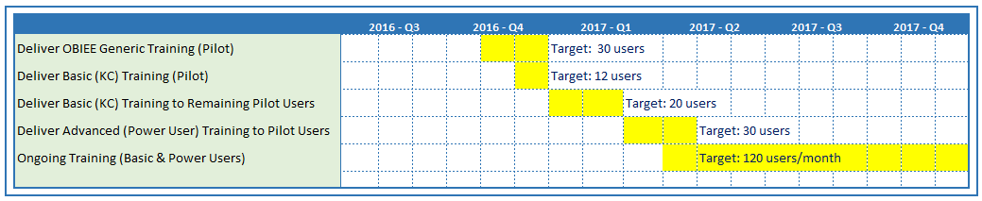

Class Schedule
