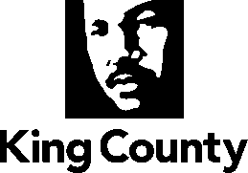
Metropolitan King County Council

News Release
Contact: NEED
Date: DATE

Public hearing planned on proposal to sell county land to the City of Sammamish

The Metropolitan King County Council will hold a hearing on DAY/DATE at 1:30 pm to gather public comment on a proposed ordinance that would allow the county to sell parcels of land to the City of Sammamish.

The property includes parcels 1524069062 and 1524069069 located at Issaquah-Pine Lake Road SE, Sammamish, WA.

Copies of the proposed ordinance are available upon request from the Clerk of the King County Council, Room 1200, King County Courthouse, 516 Third Ave., Seattle, WA 98104, or by calling 206-296-1020. The ordinance is also available online at www.kingcounty.gov/council/clerk.aspx by searching for proposed ordinance number 2021-XXXX.

A public hearing on the proposal to transfer will be held before the full Council at the King County Courthouse, Room 1001, on DAY/DATE at TIME.

# # #

King County provides regional and local services to two million residents, including 250,000 people living in unincorporated areas. Regional services include Metro transit, public health, wastewater treatment, courts, jails, prosecutors, public defenders, community and social services, and the King County International Airport. Local services include police protection, roads services, and solid waste transfer station and landfill services. King County also manages more than 26,000 acres of parks and natural lands, and 175 miles of regional trails. King County is the 14th largest county in the nation by population, and covers 2,134 square miles, 39 cities, 760 lakes and reservoirs, and six major river systems with 3,000 miles of streams.

