Purchase Property Summary
Photo of Property

Address 8531 East Marginal Way, Tukwila, WA
Sale Price $53,792,134.57
Sale Area 20.58 Acres
Assessor's Parcel 000160-0023
Zoning MIC/H” Manufacturing Industrial Center/Heavy District
Council District Eight
Funding Source Bond Funded Purchase
Template Status: County template with changes
Offer Expiration: Ordinance to be Effective by February 14, 2020

In August 2019, King County entered into a Real Estate Purchase and Sale Agreement (REPSA) with Star Forge to purchase the Star Forge property (the Property).
Property Information

The Property is a large industrial site covering approximately 20.58 acres. The Property is in a topographically flat area and is bordered to the east by East Marginal Way, to the north by the Boeing Plant 2 facility and south by the Boeing-Isaacson facility, and to the west by the Lower Duwamish Waterway. It is situated west of King County International Airport, bisected by East Marginal Way.

The Property was first developed by Isaacson Iron Works (Isaacson) for the U.S. Navy in 1942 to produce propeller shafts and other naval equipment. Between 1945 and 1965, Isaacson fabricated custom steel and aluminum parts. Operations included forging, heat treating and machining. Between 1949 and the early 1960s, Bethlehem Steel operated a steel distribution center on the northwestern portion of the Property. Earle M. Jorgensen (EMJ) purchased the Property in 1965 and continued forging steel and aluminum. EMJ owned the Property until 1992 when it was sold to The Jorgensen Forge Corporation (JFC). Forge operations continued until 2016 when JFC filed bankruptcy under Chapter 11. Star Forge, the current owner/seller, acquired the property in bankruptcy in 2016.

The Property is situated immediately adjacent to, and west of, the Lower Duwamish Waterway (LDW) Superfund site. The Environmental Protection Agency (EPA) is managing the sediment investigation and remediation for the LDW Superfund Site under the Comprehensive Environmental Response Compensation Act (CERCLA). The Washington Department of Ecology (Ecology) is responsible for managing source controls on the upland areas under the Model Toxics Control Act (MTCA).

In August 2016, the bankruptcy court entered an order approving, among other things, a July 2016 asset purchase agreement pursuant to which Star Forge agreed to purchase JFC and the Property. The agreement conditioned Star Forge’s purchase obligation on resolution of JFC’s environmental liabilities under both CERCLA and MTCA. In November 2016, the bankruptcy court entered an order approving a settlement agreement between Star Forge, JFC, EMJ, the United States, the State of Washington, Associated Indemnity Corporation (AIC) and Chubb insurance companies and Boeing to resolve the scope of environmental liabilities among the parties related to CERCLA and MTCA for the Property. Star Forge, EMJ and JFC have completed a portion of the remediation work on the Property required by the EPA under CERCLA, and are obligated to complete the remainder of the work. EMJ is liable for the MTCA liability on the Property pursuant to an Agreed Order with Ecology. As a requirement of the bankruptcy settlement agreement, Star Forge and EMJ also entered into a site access agreement that provides EMJ access to the Property and obligates EMJ to perform the remediation work required by the Agreed Order with Ecology. The site access agreement will be assigned to King County at closing. EMJ will perform the remediation work on the Property after it is purchased by King County.

In April 2018, Star Forge began decommissioning the plant and equipment and implementing clean closure requirements pursuant to the Facility Resource Conservation and Recovery Act (RCRA). As part of its clean closure requirements, and pursuant to the REPSA, Star Forge will demolish the structures on the Property after closing and prior to King County occupancy.

Context

Rationale for transaction: The rationale for the purchase of the Property is to secure land adjacent to the King County International Airport (KCIA). Increasing property values and the demand for warehouse and industrial space in the vicinity of KCIA has reduced the availability of land around an already landlocked airport. As land is acquired and redeveloped it reduces the opportunity to expand the economic footprint of KCIA and also creates additional obstacles within regulated airspace, further complicating an already complicated aeronautical situation at KCIA. The combination of industrial zoning, demand for warehouse and fulfillment center space relating to air cargo and the close proximity to KCIA makes the Property a desirable acquisition for King County.

Policy considerations: The most recent year for which economic data exists at KCIA is 2013. At that time the economic impact of KCIA was $3.5 billion in local business sales, supporting 16,336 jobs and $1.08 billion in labor income. In addition $78 million in sales and business and occupation taxes were generated for the State of Washington and in the local area, 5,209 people employed at the airport earning $495 million in labor income, direct sales by businesses at the airport were $2.2 billion. KCIA is a hub for exports from the region, contributing significantly to the regional economy. Export sales alone were $1.9 billion in 2013. Exports from KCIA generated $3 billion in sales for King County businesses, generating 13,205 jobs and $872 million in labor income in King County. KCIA has recently experienced strong demand for additional space, including from air cargo handlers. The economic activity at KCIA, like much of the rest of King County, has experienced strong growth since 2013. The location of the Property makes it a suitable spot for warehouse, sortation and fulfillment center activities. Even without the close proximity to KCIA, the Property is a unique investment opportunity for King County and an opportunity to help create jobs in the Georgetown-South Park neighborhoods.

Political considerations: None known at this time.

Due Diligence: A comprehensive due diligence process was completed prior to the submittal of the appropriation ordinance authorizing this purchase.

Community considerations
or partnerships: N/A

Fiscal considerations: The purchase price of the property is $53,792,134.57 and includes demolition of the current, contaminated improvements by the seller prior to County occupancy.

Other considerations: N/A

CIP/operational impacts None

Change in property use: No change in use at this time.

SEPA Review Required yes/no: No

King County Strategic Plan impact: Approval of this ordinance supports the strategic plan guiding principle of financial sustainability and goal of mobility by increasing the county footprint in the vicinity of the King County International Airport (KCIA) and planning for the long-term sustainability of county services.

Equity and Social Justice impact: In accordance with Real Property Asset Management Plan (RAMP) Strategy 2.0 and 24.0, the Facilities Management Division reviewed this legislation for Equity and Social Justice (ESJ) impacts. This location is in the Duwamish neighborhood of Tukwila, adjacent to Georgetown and South Park, this neighborhood includes industrial use properties and the KCIA. King County would control the redevelopment and future use of the Property, which would potentially benefit the local community by creating potentially living wage jobs and improving the economic vitality of the community.
Approving the appropriation for this legislation, increasing the county footprint in this neighborhood, is not anticipated to have an equity and social justice impact.

Appraisal Process

Summary: The appraisal was performed by Ken Barnes, MAI of McKee Appraisal. The appraisal report was prepared with several hypothetical assumptions at the direction of King County. The value was determined as if the Property were demolished, clean, and ready for development within normal time frames for permit/entitlements.

Date of valuation: August 21, 2019
Appraised by: McKee Appraisal
Appraisal factors: The appraisal used several hypothetical assumptions.
Comps analysis: Four recent sales were used in the analysis. All sales were recent and involved similar locations along the Duwamish
Estimated FMV: $58,000,000
Appraisal Summary Chart

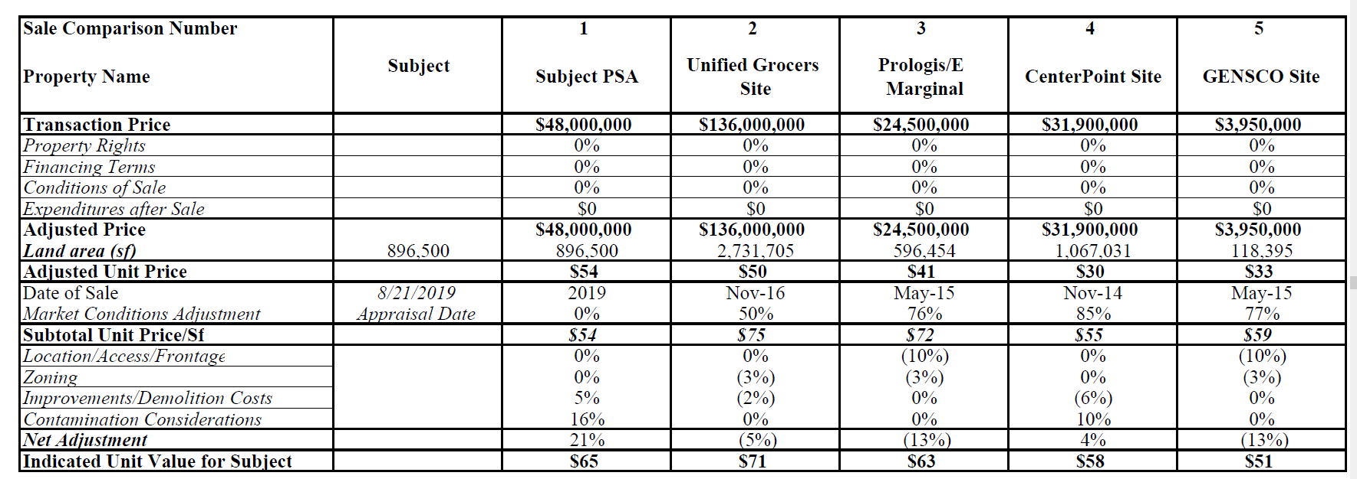

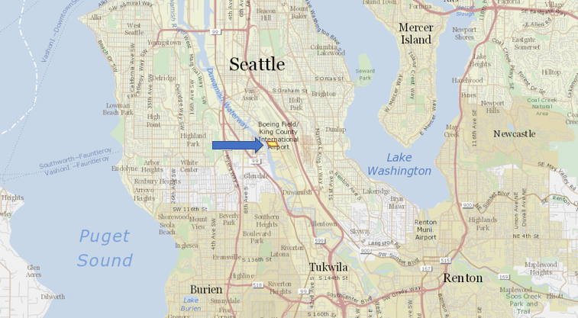
Vicinity View Map

Parcel Map
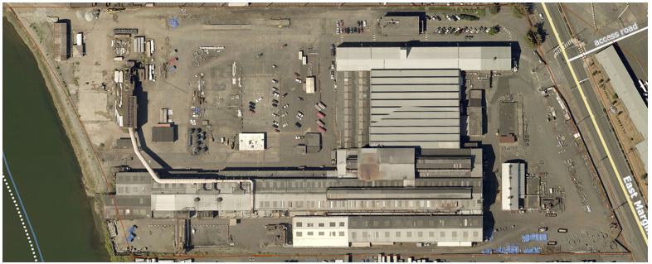

King County may have owned all or a portion of the Property prior to 1941, possibly acquiring it through a tax title foreclosure. Because Isaacson was the first to develop the Property for industrial use, The County’s possible prior ownership was not investigated.
As for liability relating to the LDW Superfund Site and the ongoing LDW Allocation process, the bankruptcy settlement agreement resolved only the liability of JFC as debtor
As part of its obligation under the Agreed Order with Ecology and the site access agreement, EMJ submitted a draft remedial investigation work plan to Ecology in January 2019 for review and approval.
King County International Airport Economic Impact Study (2013).

