Department of Adult and Juvenile Detention

Hiring Incentives Pilot Project Report

November 1, 2019

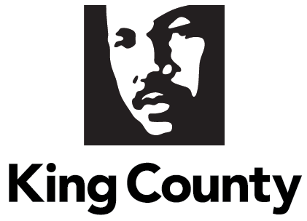

Table of Contents

**Executive Summary 4**

**Overview 4**

**Methodology 5**

**Proviso Requirements5**

Description of the Incentive Program5

Advertising and Recruiting7

Incentives Paid in 201911

2018 Incentives11

2018 Employee Referrals11

Performance Metrics12

Recommendation of Continuation14

**Conclusion 14**

**Proviso Text**

*Page 41-42, Section 52 – Adult and Juvenile Detention, P3 of the 2019-20 King County signed budget Ordinance 18835:*

*Of this appropriation, $100,000 shall not be expended or encumbered until the executive transmits a report evaluating the department of adult and juvenile detention's corrections and juvenile detention officer hiring incentive pilot program for new corrections and juvenile detention officers and a motion that should acknowledge receipt of the report and reference the subject matter, the proviso's ordinance, ordinance section and proviso number in both the title and body of the motion, and a motion acknowledging receipt of the report is passed by the council.*

*The report shall include, but not be limited to:*

*A. A description of the incentives provided through the program, to include "lateral hires," "new hires" and referral bonuses, and how the department identified those individuals who were eligible for the program incentives;*

*B. A description of how the department advertised the program;*

*C. For January 1, 2019, through September 30, 2019, the number of people who received each incentive, broken down to show laterals, new hires and referral bonuses;*

*D. To the extent possible, data for January 1, 2018, through December 31, 2018, showing the number of applicants who had previous corrections or law enforcement experience and would have been considered "lateral hires," the number of applicants who would have been be considered "new hires" and the number from each group who reached the benchmarks that would have made them eligible for incentives had the program been in place;*

*E. To the extent possible, data for January 1, 2018, through December 31, 2018, showing the number of applicants who were referred by a department employee, and the number from each group who reached the benchmarks that would have made the referring department employee eligible for incentives had the program been in place;*

*F. A description of the metrics that the department used to evaluate program performance for the report. The measures shall include, but not be limited to, an evaluation of program cost-effectiveness to include: the program cost per participant; the department's estimate of the impact of the program on department's vacancy rate and use of regular and mandatory overtime for the same time period based on a comparison to 2018 data; and an evaluation of any other potential avoided system costs resulting from hiring individuals eligible for the program incentives; and*

*G. The executive's recommendation of whether the program should continue in 2020. If the program is recommended to be continued, the report shall provide a program cost estimate for 2020 and any recommended changes to make the program more effective.*

*The executive should file the report and a motion required by this proviso by November 1, 2019, in the form of a paper original and an electronic copy with the clerk of the council, who shall retain the original and provide an electronic copy to all councilmembers, the council chief of staff and the lead staff for the budget and fiscal management committee, or its successor.*

1. **Executive Summary**

Beginning in January of 2019, the Department of Adult and Juvenile Detention (DAJD) started offering hiring incentives to both new hires and to existing employees who have referred quality applicants for Corrections and Juvenile Detention Officer positions. The department is offering three different types of incentives: lateral hires, no prior experience, and employee referrals. Details of each type of incentive are discussed below.

DAJD has developed updated advertising materials that highlight the department’s hiring incentives that were implemented in January of 2019. The department has also increased recruiting resources. These new hiring incentives and recruiting resources, coupled with updated advertising materials, have helped the department hire more Corrections and Juvenile Detention Officers through September 2019 than in the entire calendar year of 2018.

Due to long timelines required to recruit, hire and train new officers, the department is just beginning to distribute incentive payments to officers as they complete the academy and probation, which are key milestones of the incentives program. The Executive recommends continuing the incentives program in 2020 as DAJD continues to work to fill vacancies and meet the demands of attrition. The hiring incentives are another tool in the recruiting and hiring toolbox crucial to success in hiring and reducing overtime worked for DAJD employees.

1. **Overview**

DAJD operates one of the largest detention systems in the Pacific Northwest. The department is responsible for the operation of two adult detention facilities, the King County Correctional Facility (KCCF) in Seattle and the Maleng Regional Justice Center (MRJC) in Kent, with over 35,000 bookings a year and an average daily population of more than 2100 pre- and post-adjudicated felons and misdemeanants every day[1]. DAJD also operates a juvenile facility with an average daily population of approximately 40 youth under the age of 18, and a Community Corrections Division that supervises adults in the community.

DAJD staffs its detention facilities in large part with Corrections Officers (CO) in the two adult facilities and Juvenile Detention Officers (JDO) at the juvenile facility. Each facility is staffed 24/7 with staffing levels largely a function of the facilities’ designs, operational uses, and contractual labor agreements governing work practices. The department reviews staffing levels regularly to project staffing needs based on the type and number of inmates, staffing policies, a relief factor, and other criteria.

Each year, DAJD plans for some level of overtime hours. Overtime can be worked voluntarily or may be mandatorily assigned based on staffing needs on shift. DAJD has documented in several reports that there are various factors that drive overtime, including higher needs for hospital guarding, unanticipated leave, and high Corrections Officer and Juvenile Detention Officer vacancies. In early 2019, DAJD had nearly 50 Corrections Officer vacancies, representing nearly 10 percent of its budgeted Corrections Officer FTEs. The juvenile facility, while smaller in budgeted FTEs, has also struggled to fill Juvenile Detention Officer vacancies. In early 2019, the juvenile facility had nearly 10 vacancies, representing nearly 10 percent of its budgeted JDO positions. In response to these challenges, the innovative hiring incentive program was included in the 2019-2020 biennial budget to increase rate and pace of hiring and to reduce officer vacancies.

1. **Methodology**

DAJD Human Resources (HR) staff, analysts, and policy team members contributed to this report. The majority of the data was collected by DAJD’s HR team over the course of 2019 and is focused primarily on recruitment metrics. Additional data came from DAJD finance and Roster Management data systems. Some advertising and marketing data is provided by external vendors as indicated in the report.

1. **Proviso Requirements**
2. **Description of the Incentive Program**

DAJD has struggled over the past few years to fill vacant Corrections Officer and Juvenile Detention Officer positions. Officer vacancies have consistently been identified as a contributor to high levels of overtime.[2] With historically low unemployment in the Puget Sound Region and nationwide challenges to public safety sector hiring, the Executive was searching for creative ways to fill vacant officer positions. One proposed solution was to offer hiring incentives, similar to those offered in other local law enforcement agencies. In the department’s review of hiring incentives offered at other local law enforcement agencies within King, Snohomish and Pierce County, the hiring incentives have ranged from $10,000 to $20,000 per hire.

A hiring incentive pilot program was included in the adopted 2019-2020 biennial budget enabling hiring incentives for Corrections and Juvenile Detention Officers. The 2019-2020 biennial budget allocated $269,000 to DAJD for the hiring incentive program. In addition, the 2019 First Quarter Supplemental added an additional $250,000 to continue the incentives. After adoption of the budget, DAJD developed three tiers of incentives and the criteria for each tier. The three tiers for incentives are 1) Lateral Hires, 2) Employee Referrals, and, 3) No Previous Experience. New recruitments for both Corrections and Juvenile Detention Officers opened on January 14, 2019, at which point the new incentives were also implemented.

Lateral Hires

To be included in the lateral hire incentive tier, new officers must have at least 12 months of combined corrections, law enforcement, or juvenile detention experience with any agency within the three years prior to application with DAJD. Lateral hires are a benefit to DAJD because their professional experience shortens the amount of initial training time required before they are capable of working independently.

Applicants with recognized lateral experiences are eligible for up to a $10,000 in hiring incentive payment, allocated in three amounts linked to meeting three distinct milestones:

* Milestone one - $2,500 at hiring;
* Milestone two - $2,500 upon successful completion of the state training academy; and
* Milestone three - $5,000 upon completion of the 12-month probationary period.

If lateral hires are separated from DAJD employment for non-medical reasons prior to completing three years of service, they are required to reimburse the $5,000 payment that they receive upon completion of probation.

DAJD HR staff, as part of their routine review of job applications, flag applicants who have the requisite experience to be considered a lateral hire for hiring incentives. Once an individual is determined to be eligible for the lateral hire incentive payment, DAJD’s HR manager reviews the necessary documentation and makes the final approval for payment.

Employee Referrals

DAJD recognizes that current employees are often its best recruiters. To that end, the employee referral hiring incentives were developed to further encourage DAJD employees to reach out to job seekers they may know. DAJD employees can receive up to $2,500 in incentive payments for successful recruitment of a new Corrections or Juvenile Detention Officers, divided into two payments; the first incentive payment of $1,250 is made when the new employee begins work with DAJD, and the second $1,250 payment is disbursed after the new employee successfully completes the 12-month probationary period. In order to encourage DAJD employees to continue to successfully refer candidates, there is no limit on the number of applicants that an employee can refer, nor a limit on the number of referral incentives they can receive. However, only one current employee can receive the incentive for referring a single new hire. The employee referral incentive is open only to members of the King County Corrections Guild, the King County Juvenile Detention Guild and the Washington State Council of County and City Employees.

To facilitate tracking of employee referrals, a “referred by” field was added to the applications for Corrections Officers and Juvenile Detention Officers beginning with the January 14, 2019 recruitment. Applicants are required to provide the full name of the current DAJD employee that referred them to the position on the application, allowing DAJD HR staff to track both current employees and new hires for incentives. Current DAJD employees who have referred a candidate are notified via email by HR approximately 10 days before the new hire begins employment. Current employees are also told that their referral incentive payment will appear on the same paycheck that the new employee receives their first paycheck. As with lateral hires, the DAJD HR Manager makes the final approval of incentive payments for the referral incentive as well.

To date, for Corrections Officer recruiting, applicants have indicated an employee referral 182 times between January 14, 2019 and September 30, 2019, reflecting approximately 17 percent of all applicants for the time period. For Juvenile Detention Officer recruiting, applicants have indicated an employee referral 52 times in the same period. For the same time period, DAJD has received 998 applications for Juvenile Detention Officers, which reflects an employee referral rate of approximately 5 percent of all applicants. As of September 30, 2019, none of the new employees that have been referred by an existing employee have completed the 12-month probationary period, therefore no incentives for the probation completion milestone have yet been paid.

No Prior Experience

The third incentive type offered by DAJD through the incentive pilot program is available to new Corrections and Juvenile Detention Officers who have no prior public safety experience. Applicants in this group are eligible for up to $5,000 in hiring incentives, and similar to the lateral hires, the disbursement of the incentives happens after successful completion of three employment milestones:

* Milestone one - $1,250 is distributed at the time of hire;
* Milestone two - $1,250 is distributed upon successful completion of the state training academy, and;
* Milestone three - $2,500 is distributed upon successful completion of a 12-month probationary period.

If new hires are separated from employment for non-medical reasons prior to completing three years of service, they are required to reimburse the $2,500 payment that they receive upon completion of probation.

1. **Advertising of the Program**

Advertising Materials and Efforts

In 2019, DAJD developed new advertising materials and implemented new advertising campaigns highlighting the incentive programs. DAJD has developed two new printed pieces that can be used for recruiting. The DAJD recruiting team distributes the printed materials at recruitment events and career fairs[3]. The materials are essential pieces of DAJD’s recruiting strategy because they include important information about pay, hiring incentives, working conditions, and benefits of employment with DAJD. The materials also contain contact information for our recruitment team so prospective candidates know who to contact with questions regarding employment or the application process.

One improvement to facilitate the employee referral process, is the development of a small card that existing employees can provide to prospective applicants. The recruitment cards contain contact information, a quick response (QR code) with a link to the DAJD application page, and a space for the existing employee to write their name for the employee referral hiring incentive. A visual representation of both the front and the back of the card is included below.

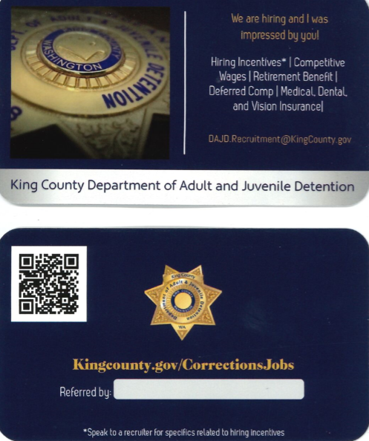

The department created a new recruiting flyer that includes updated wage information, resulting from the June 2019 King County Corrections Guild interest arbitration award, and adjustments to the minimum qualifications for the officers’ recruitment. The flyer is a full color, tri-fold handout, a copy of which is included in Appendix A.

In addition to developing new marketing materials, the department is now equipped with marketing tools such as banners and tents as well as branded promotional materials that are distributed at events. These items add to the impact of the DAJD recruiting at events, and provide a tangible object that interested job seekers can take with them.

DAJD has engaged in some novel advertising campaigns throughout 2019 in an effort to reach new pools of job seekers. On August 27, 2019 the department went live with an advertising campaign with Pandora music streaming service. In this campaign, audio advertisements are placed between streaming songs in the Pandora application. A visual display accompanies the audio advertisement; a screenshot of which is included below. The advertisements reach listeners in King, Snohomish, Franklin, Mason, Pierce, Thurston and Walla Walla Counties in Washington State. The campaign targets counties with large correctional and detention facilities with the goal of attracting additional lateral hires as well as new officers. Also targeted are counties outside of the Puget Sound region where normal in-person recruiting efforts may not always reach.



To date, the Pandora campaign has run 15,371 display advertisements and 153,238 audio advertisements. The display advertising only broadcast if someone is in front of a computer screen or phone, and these are considered ‘not guaranteed’ to be seen. The goal for the audio advertisements is 416,666 presentations before the end of October 2019. At the conclusion of the campaign, Pandora will be able to share key metrics with the department, such as how many times the advertising has resulted in follow-up by listeners. While it may be difficult to determine whether the audio or display advertising ultimately drives new candidates to the department, the campaign will be heard and displayed to a wide audience; the estimated weekly audience is 230,394 people.

DAJD is also developing a 12-month advertising campaign to be placed at the Angel of the Winds Arena in Everett, Washington. The campaign will utilize large dasher boards (the boards surrounding a hockey rink that regularly hold advertising), signage in the restrooms of the arena, and live LED advertisements during events such as open skate sessions and Everett Silvertips games. The printed material in this campaign will specifically mention hiring incentives but due to size constraints, the other materials will have basic hiring and contact information only. An example of some of the materials that will be used at Angel of the Winds Arena is shown in Appendix B. The department is also exploring a similar advertising campaign with another local arena.

DAJD also will be placing advertising materials on a select fleet of Washington State Ferries. The plan is yet to be finalized, but is expected to include 15 second advertisements that will be displayed on monitors around the decks while the ferry is in operation. DAJD is targeting the Seattle to Bainbridge, Seattle to Bremerton, Seattle to Vashon, Edmonds to Kingston, and Mukilteo to Clinton ferry routes. It is anticipated that the advertisements will be implemented close to the end of 2019.

Finally, DAJD is pursuing placement of audio advertisements with a media partner with multiple Spanish language radio stations within Washington State, with the intention of attracting diverse, bilingual candidates.

Recruiting

As detailed above, DAJD is actively doing more to recruit new officers, including advertising the incentives program. DAJD has spent the last year engaging in many more recruiting and outreach activities, including searching for new and innovative places to reach job seekers. The department has focused on broad advertising and outreach efforts that can be utilized for years to come, regardless of whether the hiring incentives continue into 2020. However, DAJD’s recruiting team has used the hiring incentives as another tool to build interest in employment with DAJD.

The 2019/2020 biennial budget added two FTE to the Department of Human Resources (DHR) to be assigned to DAJD to assist in recruiting. The two FTEs were hired, and then loaned to DAJD in April of 2019. With this additional staffing, DAJD has been able to attend many more recruitment events over the spring and summer of 2019, and continue to reach into new areas. One of the staff has focused primarily on the Juvenile Detention Officer recruitments. The other brings a strong marketing background and outreach experience that DAJD does not have in-house. Table 1 below details the recruiting events that DAJD has attended during 2019, and events that DAJD plans to attend through early 2020.

DAJD currently employs a significant number of military veterans. Historically, veterans transitioning from active service to civilian life have been an excellent source of new hires for the department. DAJD has continued to actively recruit at military recruitment events and career fairs in areas with large active and former military populations. Additional staffing has allowed the department to increase its presence at these events. The events that DAJD attended in 2019, or plan to attend in 2020 are included in Table One below.

**TABLE 1: PREVIOUSLY ATTENDED AND PLANNED RECRUITING EVENTS**

|  |  |
| --- | --- |
| **Events Attended or Planned** | **Date** |
| Snohomish County Regional Job and Resource Fair | March 27, 2019 |
| Hire GI Recruiting Event - JBLM | March 28, 2019 |
| Everett Community College Public Safety Career Fair | April 15, 2019 |
| Green River Community College Criminal Justice Career Fair | April 17, 2019 |
| Snohomish County Career Fair | April 23, 2019 |
| Women in Trades Career Fair | May 10, 2019 |
| Now Hiring Career Fair (WSU - Vancouver, WA) | June 15, 2019 |
| Auburn Kids Days | June 25, 2019 |
| Seattle PrideFest | June 30, 2019 |
| **Events Attended or Planned** | **Date** |
| Lucerne SeaFair Milk Carton Derby | July 13, 2019 |
| Diversity Employment Day | July 17, 2019 |
| SeaFair Indian PowWow | July 19, 2019 |
| Recruit Military – Hiring Event | July 25, 2019 |
| Alaska Airlines SeaFair Torchlight Parade | July 27, 2019 |
| SeaFair – Pista Sa Navon | August 2-4, 2019 |
| Othello Park International Festival | August 11, 2019 |
| Hire GI – Military Recruitment Event | August 22, 2019 |
| Pacific NW Public Sector Diversity Career Fair | September 10, 2019 |
| Seattle Fiestas Patrias | September 15, 2019 |
| Department of Navy Veterans Job Fair | September 21, 2019 |
| JBLM Military Transition Summit | September 25, 2019 |
| University of Puget Sound Fall Career Fair | September 26, 2019 |
| University of Idaho Fall Career Fair | October 2, 2019 |
| WSU Tri-Cities Career Fair | October 3, 2019 |
| YWCA Job Fair / Greenbridge Job and Resource Fair | October 10, 2019 |
| University of Washington Bothell All Industries Career Fair | October 16, 2019 |
| Snohomish County Regional Job and Resource Fair | October 17, 2019 |
| Recruit Military Hiring Event (JBLM) | October 17, 2019 |
| Central Washington University Fall Career, Internship, and Graduate School Fair | October 23, 2019 |
| Multicultural Job Fair (Burien, WA) | October 24, 2019 |
| Hire GI - Coast Guard | November 6, 2019 |
| Hire GI – JBLM | November 7, 2019 |
| Goodwill Military and Veteran Networking Event | November 20, 2019 |
| Recruit Military Hiring Event | December 5, 2019 |
| Evergreen State College – Community Opportunities and Internship Fair | January 29, 2020 |
| University of Washington Diversity Career Fair | January 30, 2020 |
| Fuse Career Fair (Gonzaga, Whitworth, Eastern WA University, WSU Health Sciences) | February 27, 2020 |
| So Northwest Women’s Show | February 29, 2020 |
| University of Puget Sound Spring Career Fair | March 5, 2020 |
| Big Bend Community College Job and Career Fair | March 5, 2020 |
| Northwest Indian College Spring Career Fair | Spring 2020 |

The ideal qualifications for a Juvenile Detention Officer include a Bachelor’s degree in Criminal Justice, Psychology, Sociology, Social Work or a related field of study, along with one year of full-time experience working with youth. The department has focused significant effort in the past year on establishing and developing new relationships with colleges and universities in the region and statewide. To this end, DAJD has networked with colleges and universities with the ultimate goal of being on campuses, and at higher education hiring events. DAJD has acquired accounts and permissions that enable the department to post job announcements at almost all public colleges and universities within Washington State. For the balance of 2019 and into 2020, the department plans to include regional private colleges and universities in its outreach efforts.

Looking ahead, the department’s longer-term outreach plans include developing out of state recruitment campaigns where the department could conduct “On the Spot Hiring Events”. These events would allow the department to complete the entire recruitment and selection process for officers at an offsite location within a three to five-day period, which could result in a contingent offer of employment for qualified candidates. Some of the attributes of an area that would be appropriate for an on the spot event are:

* Proximity to military bases;
* Diverse demographics, including access to larger bilingual populations;
* Challenging local labor market conditions that might drive individuals to seek employment elsewhere; and,
* Proximity to large correctional and detention facilities

DAJD is exploring broader outreach efforts in the Midwest and Southeast regions of the United States. As of the end of September 2019, the department is still working to determine the specific location or locations of these on the spot hiring events and assessing the return on investment for such outreach.

DAJD was recently made aware that the City and County of San Francisco is planning to close its juvenile detention facility in 2021. DAJD has been working to engage with the Bay Area office of Economic and Workforce Development to develop a recruitment campaign focused primarily on the recruitment of skilled detention staff affected by the closure of the juvenile detention facility.

1. **Incentives Paid in 2019**

When the hiring incentives program was initiated, the department determined that hiring incentives would begin with the Corrections and Juvenile Detention Officer recruitments that opened on January 14, 2019; individuals who applied or was hired prior to that time period would not be eligible for incentives. Through the first nine months of 2019, DAJD has hired 43 new Corrections Officers and 17 new Juvenile Detention Officers. In total for the same period of time, the department has paid $50,000 in incentives in 2019, starting in the 2nd quarter:

* $20,000 paid to juvenile detention officers;
* $21,250 paid to new corrections officers; and,
* $8,750 paid to employees for successful employee referrals.

The average hiring process timeline for new Corrections Officers is 85 days, and the hiring process for new Juvenile Detention Officers averages 100 days. Coupled with the incentives only being available to officers who applied for hire after January 14, 2019, DAJD is just beginning to see the incentive eligible officers be hired and begin the academy, which are the first milestones toward incentive pay.

1. **2018 Incentives**

In 2018, DAJD hired 25 new Corrections Officers and 14 new Juvenile Detention Officers. None of the officers hired in 2018 would have been eligible for the lateral incentives due to the absence of prior experience necessary to qualify as a lateral hire. To qualify as a lateral hire, an officer must have at least 12 months of combined corrections, law enforcement or juvenile detention experience within the three years prior to applying with DAJD. All of the new hires in 2018 would have been eligible for the no prior experience incentives. None would have reached the final retention milestone in 2018 due to the timing of their hire.

1. **2018 Employee Referrals**

Beginning with the January 14, 2019 recruitments for Corrections and Juvenile Detention Officers, DAJD added a “referred by” field to the job application where applicants can identify referral source by name. Prior to adding this data element, DAJD did not gather referral data and is therefore unable to determine how many referral bonuses would have been paid if the program was in place in 2018. In 2019, there have been 234 applications that indicated a referral by a current DAJD employee.

1. **Program Performance Metrics**

The goals of the hiring incentives program are to increase hiring and retention of officers while reducing vacancies and the use of overtime. To measure progress toward achieving these goals, the department is tracking and evaluating a number of performance measures, including:

Cost per participant

This measure is expected to vary through 2020 when newly hired officers begin to complete training milestones that trigger subsequent incentive payments. Data to date finds:

* As of September 30, 2019, DAJD has hired 43 new Correctional officers and paid $21,250 in incentives for an average cost per hire of approximately $494.
* As of September 30, 2019, DAJD has hired 17 new Juvenile Detention officers and paid $20,000 in incentives for an average cost per new hire of approximately $1,176.

Impact on officer vacancies, overtime hours and mandatory overtime hours

The overall goals of offering hiring incentives is to reduce the number of vacant officer positions, which in turn should ease the pressure of high numbers of overtime hours. As noted earlier, conditions that contribute to high levels of overtime include high use of leave, hospital transports, and other scheduling and staffing complexities involved in operating a secure, 24/7 facility.

For year to date 2019, the following tables provide data on vacancies, overtime and mandatory overtime hours. Please note that the number of officer vacancies in the table below reflect what is documented in DAJD’s Roster Management System (RMS) on the first day of each month. Additions and separations can happen on any day of the month, and therefore is a constantly changing number.

**TABLE 2: 2019 VACANCIES AND OVERTIME BY DIVISION**





The table below provides a year-over-year comparison of DAJD’s Corrections and Juvenile Detention Officer vacancies. DAJD has made significant gains in its hiring of new officers in 2019. In 2018, the department hired 25 new Corrections Officers and is on track to more than double that in 2019. As of September 30, 2019, the department has also hired 17 Juvenile Detention Officers compared to 14 in all of 2018. Please note that 13 additional Juvenile Detention Officer positions were added to DAJD at the end of 2018. So, while new hires exceed 2018 hires, there are still a large number of vacant Juvenile Detention Officer positions. Month by month vacancies are displayed in the Table three below.

**TABLE 3: OFFICER VACANCIES 2018-2019**



With regard to other potential avoided system costs that result from hiring individuals eligible for program incentives, this report recognizes that it is difficult to know all avoided system costs, the anticipated major avoided cost would be reduced overtime expenses attributable to lower staff vacancies and more officers available to work shifts. While somewhat intangible and not easily measured, by bringing on more officers DAJD is able to better support employees to avoid burnout and experience increased employee satisfaction. In turn, it is expected that decreased officer burnout and better job satisfaction outcomes for DAJD staff will likely lead to greater officer retention as well. The impact of reducing mandatory overtime in particular could greatly improve employee morale.

1. **Recommendation of Continuation**

Based on DAJD’s hiring successes to date and the key role that the hiring incentive program has played in recruitment and hiring of new officers, the Executive recommends continuing the hiring incentives program through 2020.

The loaned DHR staff is a pivotal element to the hiring incentive program’s success, as DAJD does not have current HR staffing resources to conduct the robust recruitment outreach. Moreover, DAJD HR does not have the in-house marketing and outreach skillset brought by the additional DHR staff. Without the additional DHR staff, the pilot would not be as successful. Therefore, the Executive recommends continuing the loan of DHR staff to DAJD to support the department’s increased recruiting efforts.

It is anticipated that a higher number of incentives in all categories will be paid in 2020 as new hires begin to move through the milestones of academy training and completing probation. The department estimates that it will need to hire at least 40-50 new Corrections and Juvenile Detention Officers in 2020 to fill vacancies, including vacancies due to attrition. The department estimates that it will pay a total of $275,000 for the costs of incentive payments in 2020, based on hiring as follows:

* $25,000 for existing employee referral incentives (10 referrals at $2,500 per new hire)
* $100,000 for lateral hires (10 lateral hires at $10,000 per hire)
* $150,000 for no prior experience incentives (30 new hires at $5,000 per hire)

To date, DAJD has not identified any changes needed for the pilot. Assessment is ongoing and program adjustments will be made as needed and possible.

1. **Conclusion**

The Executive and DAJD are committed to making King County a welcoming community where every person can thrive. DAJD’s specific role in this vision is to provide safe and humane detention facilities that deliver services to the people served in those facilities. DAJD cannot achieve these goals without sufficient, highly trained staff who are well rested and satisfied with their work.

DAJD remains optimistic that it will be able to reduce its officer vacancies to single digits in 2020, particularly if its current employees continue to refer candidates for hire at a high rate, and that it is successful in attracting lateral and new hire officers at a high rate throughout the remainder of 2019 and 2020.

This report fulfills the requirements of Ordinance 18835, Section 52, Proviso P3.

**APPENDIX A: TRI-FOLD RECRUITING FLYER**

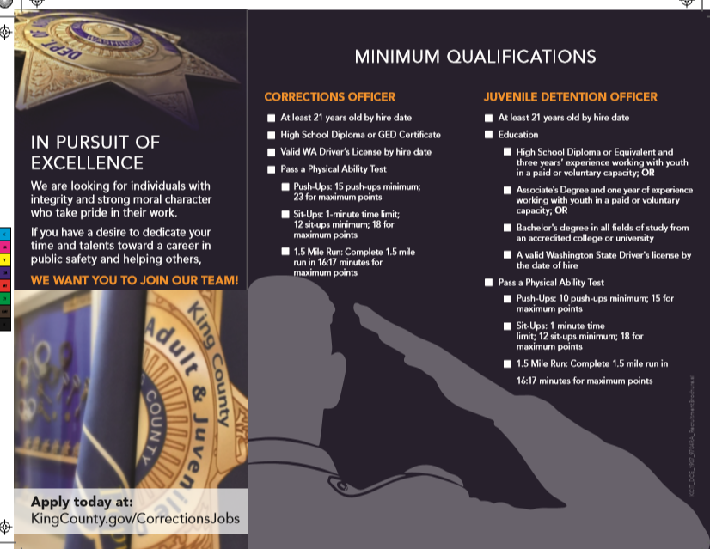

**APPENDIX B: ARENA ADVERTISING**



1. King County Department of Adult and Juvenile Detention, Detention and Alternatives Report, August 2019.
2. See DAJD [Report “Detailing the Causes of Mandatory Overtime and Recommendations for How to Reduce Mandatory Overtime.”](https://mkcclegisearch.kingcounty.gov/LegislationDetail.aspx?ID=3970937&GUID=FB39A6C8-4D63-4A8E-B508-EC54EBDE7EF1&Options=&Search=)
3. To date, 25 career fairs/recruitment events have been attended by DAJD staff with the updated materials