

EXECUTIVE RECOMMENDED PLAN

**Carnation Potential Annexation Area**

**Area Zoning and Land Use Study**

# I. OVERVIEW

On February 27, 2019, the King County Council adopted Motion 15329 directing the Executive to:

Work with the City of Carnation to identify options, processes and timelines for potential land use changes to facilitate annexation.

# II. BACKGROUND

The City of Carnation is located northeast of the confluence of the Snoqualmie and Tolt Rivers. The incorporated area includes approximately 1.1 square miles, or 730 acres of land. The City is responsible for all municipal services within city limits, and either provides the services directly, or through agreements with other public agencies or private parties. Other agencies with limited jurisdiction in Carnation include: the Riverview School District #407, Eastside Fire & Rescue, King County Sherriff, the Seattle and King County Public Health Department, the King County Library System and all state and federal agencies.

The City has accomplished important milestones in creating a thoughtful Comprehensive Plan and accompanying zoning. The City’s vision is a vibrant, active downtown with a central gathering are, thriving businesses, outdoor recreation and sustainable, attractive development. The City has been working to create the infrastructure, community amenities and services appropriate to serve the needs of residents and businesses while planning for future growth. The City’s 2015 Comprehensive Plan states that it is expected that within the 20-year timeframe of the City’s Comprehensive Plan that the City may annex portions of the City’s PAA’s, and provide municipal urban services to those areas including utilities, streets and other infrastructure.

Carnations Potential Annexation Areas (PAA) constitute the City’s future growth area, and includes the lands to which Carnation may feasibly provide urban services and those surrounding areas which directly impact conditions within the City limits. The City’s PAA’s consist of approximately 178 acres, or 0.31 square miles. The City’s Comprehensive Plan states the City’s PAA boundaries are based on 20 year population forecasts, environmental constraints, concentrations of existing development, locations of existing infrastructure and services, the location of existing and/or planned transportation corridors and where the City could logically and economically provide urban services.

The City of Carnation has four Potential Annexation Areas (PAA’s):

* **Southwest at NR 40th PAA** – 25 acre area located on the southwestern edge of Carnation adjacent to Tolt River John McDonald Park and near the confluence of the Tolt and Snoqualmie Rivers.
* **331st Ave PAA** – 1 acre area located on the southeastern edge of Carnation, adjacent to the Tolt River.
* **East Carnation PAA** – 21 acre area located on the eastern edge of Carnation between the Tolt River and Tolt River Road NE.
* **Tolt Home Tracts (Garden Tracts) PAA** – 123 acre area located on the northern edge of Carnation near the Snoqualmie River and adjacent to agriculture lands between the Tolt River and Tolt River Road NE.

# III. POLICY CONTEXT

The following policies inform analysis of this area study:

U-201 In order to meet the Growth Management Act and the regionally adopted Countywide Planning Policies goal of becoming a regional service provider for all county residents and a local service provider in the Rural Area and Natural Resource Lands, King County shall encourage annexation of the remaining urban unincorporated area. The county may also act as a contract service provider where mutually beneficial.

U-203 The Potential Annexation Areas Map adopted by the Growth Management Planning Council illustrates city-designated potential annexation areas (PAAs), contested areas (where more than one city claims a PAA), and those few areas that are unclaimed by any city. For contested areas, the county should attempt to help resolve the matter, or to enter into an interlocal agreement with each city for the purpose of bringing the question of annexation before voters. For unclaimed areas, King County should work with adjacent cities and service providers to develop a mutually agreeable strategy and time frame for annexation. For areas affiliated with a city for annexation, King County should proactively support annexations.

U-204 King County shall support annexation proposals that are consistent with the Countywide Planning Policies and the Washington State Growth Management Act, when the area proposed for annexation is wholly within the annexing city’s officially adopted PAA, and when the area is not part of a contested area.

U-207 King County shall work with cities to develop pre-annexation or annexation interlocal agreements to address the transition of services from the county to the annexing cities. The development of such agreements should include a public outreach process to include but not be limited to residents and property owners in the Potential Annexation Areas, as well as residents and property owners in the surrounding areas. Such agreements may address a range of considerations, including but not limited to:

a. Establishing a financing partnership between the county, city and other service providers to address needed infrastructure;

b. Providing reciprocal notification of development proposals in Potential Annexation Areas, and opportunities to identify and/or provide mitigation associated with such development;

c. Supporting the city’s desire, to the extent possible, to be the designated sewer or water service provider within the Potential Annexation Area, where this can be done without harm to the integrity of existing systems and without significantly increasing rates;

d. Assessing the feasibility and/or desirability of reverse contracting in order for the city to provide local services on the county’s behalf prior to annexation, as well as the feasibility and/or desirability of the county continuing to provide some local services on a contract basis after annexation;

e. Exploring the feasibility of modifying development, concurrency and infrastructure design standards prior to annexation, when a specific and aggressive annexation timeline is being pursued;

f. Assessing which county-owned properties and facilities should be transferred to city control, and the conditions under which such transfers should take place;

g. Transitioning county employees to city employment where appropriate;

h. Ensuring that land use plans for the annexation area are consistent with the Countywide Planning Policies with respect to planning for urban densities and efficient land use patterns; provision of urban services, affordable housing, and transportation; the protection of critical areas; and the long-term protection of urban separators;

i. Continuing equivalent protection of cultural resources, and county landmarks and historic resources listed on the King County Historic Resource Inventory;

j. Maintaining existing equestrian facilities and establishing equestrian linkages; and

k. Establishing a timeline for service transitions and for the annexation.

U-208 King County should engage in joint planning processes for the urban unincorporated areas with the area’s designated annexation city. Alternatively, upon a commitment from the city to annex through an interlocal agreement, King County will engage in joint planning processes for the urban unincorporated areas in tandem with the annexing city. Such planning may consider land use tools such as: a. traditional subarea plans, subarea studies or area rezoning; b. allowing additional commercial and high-density residential development through the application of new zoning; c. Transfers of Development Rights that add units to new development projects; and d. application of collaborative and innovative development approaches, such as design standards. King County will work through the Growth Management Planning Council to develop a plan to move the remaining unincorporated urban Potential Annexation Areas towards annexation.

DP-24 Allow cities to annex territory only within their designated Potential Annexation Area as shown in the Potential Annexation Areas Map in Appendix 2. Phase annexations to coincide with the ability of cities to coordinate the provision of a full range of urban services to areas to be annexed.

# IV. BACKGROUND INFORMATION

## A. Maps

### Vicinity

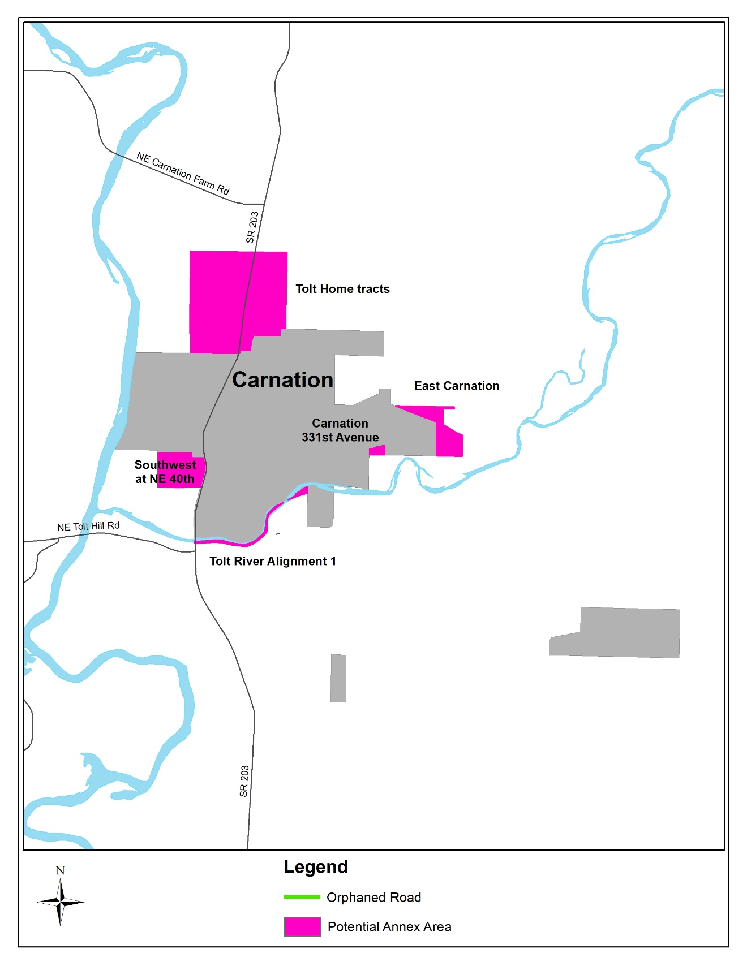

### Zoning



## B. Parcel Information / Land Use Information

There are approximately 108 parcels in Carnations PAA’s. All of the parcels are zoned RA-5, rural area, one unit per 5 acres, or Urban Reserve (UR) one unit per 5 acres.

The purpose of the rural zone (RA) is to provide for an area-wide long-term rural character and to minimize land use conflicts with nearby agricultural or forest production districts or mineral extraction sites.  These purposes are accomplished by:

1. Limiting residential densities and permitted uses to those that are compatible with rural character and nearby resource production districts and sites and are able to be adequately supported by rural service levels;
2. Allowing small scale farming and forestry activities and tourism and recreation uses that can be supported by rural service levels and that are compatible with rural character;
3. Increasing required setbacks to minimize conflicts with adjacent agriculture, forest or mineral zones; and
4. Requiring tracts created through cluster development to be designated as permanent open space or as permanent resource use.

Use of the RA-5 zone is appropriate in rural areas designated by the Comprehensive Plan as follows: rural areas where the predominant lot pattern is five acres or greater but less than ten acres in size and the area is generally environmentally unconstrained.

The purpose of the urban reserve zone (UR) is to phase growth and demand for urban services, and to reserve large tracts of land for possible future urban growth and development when a city is ready, while allowing reasonable interim uses of property.

These purposes are accomplished by:

1. Allowing for rural, agricultural and other low-density uses;
2. Allowing for limited residential growth, either contiguous to existing urban public facilities, or at a density supportable by existing rural public service levels; and
3. Requiring clustered residential developments where feasible, to prevent establishment of uses and lot patterns which may foreclose future alternatives and impede efficient later development at urban densities.

Use of this zone is appropriate in urban areas, rural towns or in rural city expansion areas designated by the Comprehensive Plan, when such areas do not have adequate public facilities and services or are not yet needed to accommodate planned growth, do not yet have detailed land use plans for urban uses and densities, or are designated as sites for a potential urban planned development or new fully contained communities.

## C. Environmental

About 6 parcels located in the Tolt Home (Garden Tracts) PAA are designated as environmentally sensitive areas. The Southwest at NE 40th PAA and the Tolt Home PAA are impacted by flood water issues.

# V. CONCLUSION & RECOMMENDATION

County staff met with City of Carnation staff multiple times over the spring of 2019 and discussed the city’s growth and development plans, as well as the goals for their Potential Annexation Areas and the timing of future annexations. The City has no current plans to annex their PAAs and did not request any changes to the development regulations, land use or zoning within those areas. Therefore, no changes are proposed in this Comprehensive Plan Update.

The City’s immediate concerns relate to the siting of new development and redevelopment within the Tolt Home (Garden Tracts) PAA, for which the City has requested notification from the County. The Permitting Division of the Department of Local Services has agreed to send monthly reports to the City informing them of all permit applications within this PAA. This will enable the City to better coordinate current and future planned infrastructure projects in the area.

Executive staff will continue discussions with Carnation and with all cities affiliated with annexation areas as work on the Annexation Plan continues.