March 2016 University Link Bus Integration Service Changes

Title VI Service Equity Analysis

August 2015

KCLogo-Black

Introduction

Federal Transit Administration (FTA) Circular 4702.1B, Chapter V, Section 7 requires transit agencies serving large urbanized areas to evaluate major service changes and to determine whether proposed changes would have a discriminatory impact as defined in the United States Department of Transportation’s Title VI regulations.

In accordance with these FTA regulations, this report summarizes Metro’s service equity analysis of service improvements planned for the March 2016 service change, submitted to the King County Council for approval, that are associated with the Link Connections project. The proposed changes are intended to integrate Metro bus service with the extension of Sound Transit’s Link light rail to Capitol Hill and the University of Washington. The proposal includes changes to 33 existing routes, primarily in Northeast Seattle, the SR-522 corridor, Capitol Hill, First Hill and the Central Area.

Equity and social justice are key priorities for the King County Executive and the King County Council. In addition to assuring compliance with federal Title VI regulations, the service equity analysis also helps to ensure consistency with King County’s goals related to equity and social justice. Identifying the relative impacts of proposed changes to low-income and minority communities is an important step in applying the “fair and just” principle as stated in the King County Strategic Plan 2010-2014. This analysis is part of an integrated effort throughout King County to achieve equitable opportunities for all people and communities.

The service change proposal for Link Connections was shaped by input received during three rounds of public engagement conducted between November 2014 and June 2015. Metro received over 16,000 comments and survey responses through these efforts. In addition to general public outreach, Metro formed a 24-member community advisory group, or “sounding board,” comprised of bus riders from the project areas. These outreach activities and the feedback generated will be summarized in a public engagement report, which will be submitted to the King County Council along with the service change ordinance for the Link Connections project.

Service Guidelines Overview

The 2013 update to King County Metro’s *Strategic Plan for Public Transportation, 2011-2021* and related service guidelines outline the methodology Metro uses to evaluate service changes, consistent with FTA Title VI requirements (FTA Circular 4702.1B). The most relevant excerpts from the service guidelines are included below.

Implementation

Starting in 2016 Metro will be revising service two times each year in the spring and fall, per King County Council Ordinance 18041 adopting the most recent Local 587 Union contract. In cases of emergency or time-critical construction projects, Metro may make changes at times other than the regularly scheduled service changes. However, these situations are rare and are kept to a minimum because of the high level of disruption and difficulty they create. Metro will identify and discuss service changes that address performance-related issues in its annual route performance report.

Any proposed changes to routes are subject to approval by the Metropolitan King County Council except as follows (per King County code 28.94.020):

* Any single change or cumulative changes in a service schedule which affect the established weekly service hours for a route by 25 percent or less.
* Any change in route location which does not move the location of any route stop by more than one-half mile.
* Any changes in route numbers.

Adverse Effect of a Major Service Change

An adverse effect of a major service change is defined as a reduction of 25 percent or more of the transit trips serving a census tract, or 25 percent or more of the service hours on a route.

Disparate Impact Threshold

A disparate impact occurs when a major service change results in adverse effects that are significantly greater for minority populations than for non-minority populations. Metro’s threshold for determining whether adverse effects are significantly greater for minority compared with non-minority populations is 10 percent. Should Metro find a disparate impact, Metro will consider modifying the proposed changes in order to avoid, minimize or mitigate the disparate impacts of the proposed changes.

Metro will measure disparate impacts by comparing changes in the number of trips serving minority or non-minority census tracts, or by comparing changes in the number of service hours on minority or non-minority routes. Metro defines a minority census tract as one in which the percentage of minority population is greater than that of the county as a whole. For regular fixed route service, Metro defines a minority route as one for which the percentage of inbound weekday boardings in minority census tracts is greater than the average percentage of inbound weekday boardings in minority census tracts for all Metro routes.

Disproportionate Burden Threshold

A disproportionate burden occurs when a major service change results in adverse effects that are significantly greater for low-income populations than for non-low-income populations. Metro’s threshold for determining whether adverse effects are significantly greater for low-income compared with non-low-income populations is 10 percent. Should Metro find a disproportionate burden, Metro will consider modifying the proposed changes in order to avoid, minimize or mitigate the disproportionate burden of the proposed changes.

Metro will measure disproportionate burden by comparing changes in the number of trips serving low-income or non-low-income census tracts, or by comparing changes in the number of service hours on low-income or non-low-income routes. Metro defines a low-income census tract as one in which the percentage of low-income population is greater than that of the county as a whole. For regular fixed route service, Metro defines a low-income route as one for which the percentage of inbound weekday boardings in low-income census tracts is greater than the average percentage of inbound weekday boardings in low-income census tracts for all Metro routes.

I. Service Change Area and Routes

*Affected Areas*

The project area includes a total of 119 census tracts with about 560,000 residents.

*Affected Routes*

Metro provides approximately 813,000 annual service hours on routes with proposed changes associated with the Link Connections project. Cumulatively, these routes generate approximately 36 million annual rides based on spring 2015 ridership data. Annual service hour and ridership data are shown in Appendix A for affected routes.

II. Threshold 1: Is this a Major Service Change? YES

For the purposes of complying with FTA Circular 4702.1B, Chapter IV, Metro defines any change in service as “major” if King County Council approval of the change is required pursuant to KCC 28.94.020.

The proposed changes meet all criteria for a major service change by Metro and FTA definitions. Appendix B lists the specific routes being changed in March 2016.

III. Threshold 2: Are Minority or Low-Income Census Tracts Affected? YES

*Classifying minority and low income census tracts*

Metro classifies census tracts as minority tracts if the percentage of the population that is minority within a tract is greater than the percentage for King County as a whole. Based on the American Community Survey five-year average for 2009-2013 data, 35.8 percent of the population is classified as minority within the county as a whole. Similarly, Metro classifies census tracts as low-income tracts if the percentage of the population classified as low-income (living at or below the poverty threshold) within a tract is greater than the percentage for King County as a whole. Based on the American Community Survey five-year average for 2009-2013, 11.5 percent of the population is classified as low-income within the county as a whole.

The service improvements and route alignment changes of the Link Connections project addressed in this report will affect the level of service provided to 119 King County census tracts currently served by Metro. The low-income and minority characteristics of affected census tracts are provided in Table 1 below.

Table 1. Low-Income and Minority Characteristics of Affected Census Tracts

|  |  |  |  |  |
| --- | --- | --- | --- | --- |
|  | Census Tract Classification | | | |
| Total Census Tracts Affected | Minority & Low-income | Minority ONLY | Low-income ONLY | Neither Minority nor Low-income |
| 119 | 31 | 8 | 21 | 59 |

IV. Threshold 3: Is there a Disproportionate Burden on Low-Income Populations or a Disparate Impact on Minority Populations? YES

The determination as to whether the proposed changes resulting in a reduction in service would have a disparate impact on minority populations was made by comparing changes in the number of Metro bus trips serving minority and non-minority census tracts. Similarly, the determination as to whether the proposed changes resulting in a reduction in service would have a disproportionate burden on low-income populations was made by comparing changes in the number of Metro bus trips serving low-income and non-low-income census tracts. The fall 2015 service change was used as the baseline for calculating the change in trips.

Impacts are summarized in Tables 3 and 4 below and in Figures 1 and 2. Adverse effects of the project were limited to a single census tract, Tract 45, which straddles I-5 and includes portions of the Wallingford and University District neighborhoods. This tract is classified as non-minority and low-income. Because no minority census tracts were adversely affected, Metro’s analysis indicates that the impacts of the project would not have a disparate impact on minority populations. However, because the only census tract with adverse effects is classified as a low-income tract, the analysis indicates that low-income populations would have a disproportionate burden.

A detailed description of the impacts to residents in Tract 45 is provided in Section 5, along with the alternatives available to riders in this area.

Notes for Tables 3 and 4

1. An adverse effect is defined as a reduction of 25 percent or more in trips per week.

Tracts are classified as low-income or minority when the percentage of low-income or minority persons in the tract is greater than the percentage of low-income or minority persons in the county as a whole.

A disproportionate burden occurs when the percentage of low-income tracts with adverse effects is more than 10 percentage points greater than the county-wide percentage of low-income tracts.

1. A disparate impact occurs when the percentage of minority tracts with adverse effects is more than 10 percentage points greater than the county-wide percentage of minority tracts.

Impacts of Link Connections – University Link Extension Project

Table 3. Impacts of the March 2016 Service Change on Low-Income Populations

|  |  |  |  |  |  |
| --- | --- | --- | --- | --- | --- |
| Category2 | Tracts with Adverse Effects1 | % of tracts adversely affected | % of tracts system-wide | Difference | Disproportionate Burden3? |
| Low-Income | 1 | 100% | 37% | 63% | YES |
| Non-Low-Income | 0 | N/A | 63% |  |  |
| Total | 1 | 100% | 100% |  |  |

Table 4. Impacts of the March 2016 Service Change on Minority Populations

|  |  |  |  |  |  |
| --- | --- | --- | --- | --- | --- |
| Category2 | Tracts with Adverse Effects1 | % of tracts adversely affected | % of tracts system-wide | Difference | Disparate Impact4? |
| Minority | 0 | N/A | 45% | N/A | NO |
| Non-Minority | 0 | N/A | 55% |  |  |
| Total | 0 | N/A | 100% |  |  |

Figure 1. Impact of proposed changes on minority census tracts.

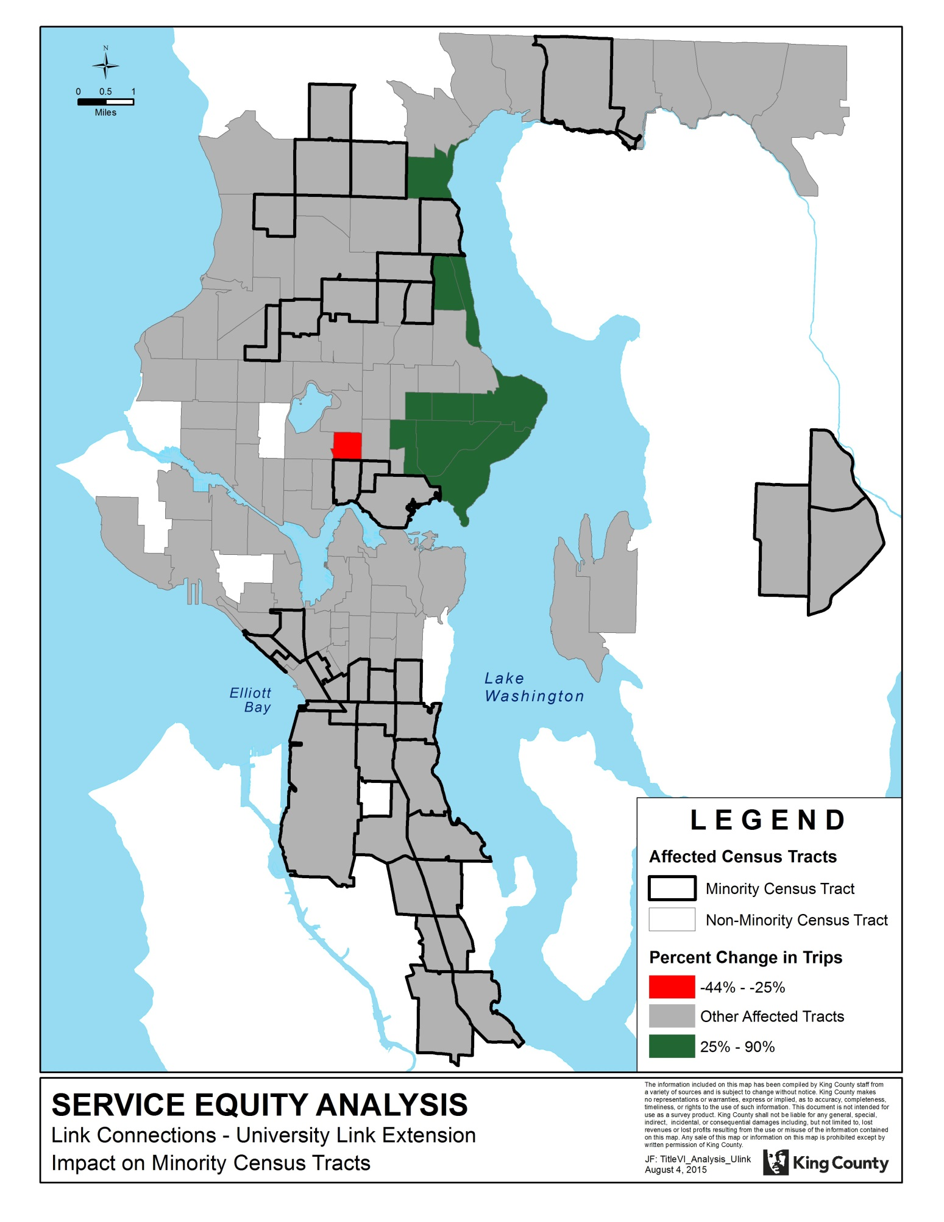

Figure 2. Impact of proposed changes on low-income census tracts.

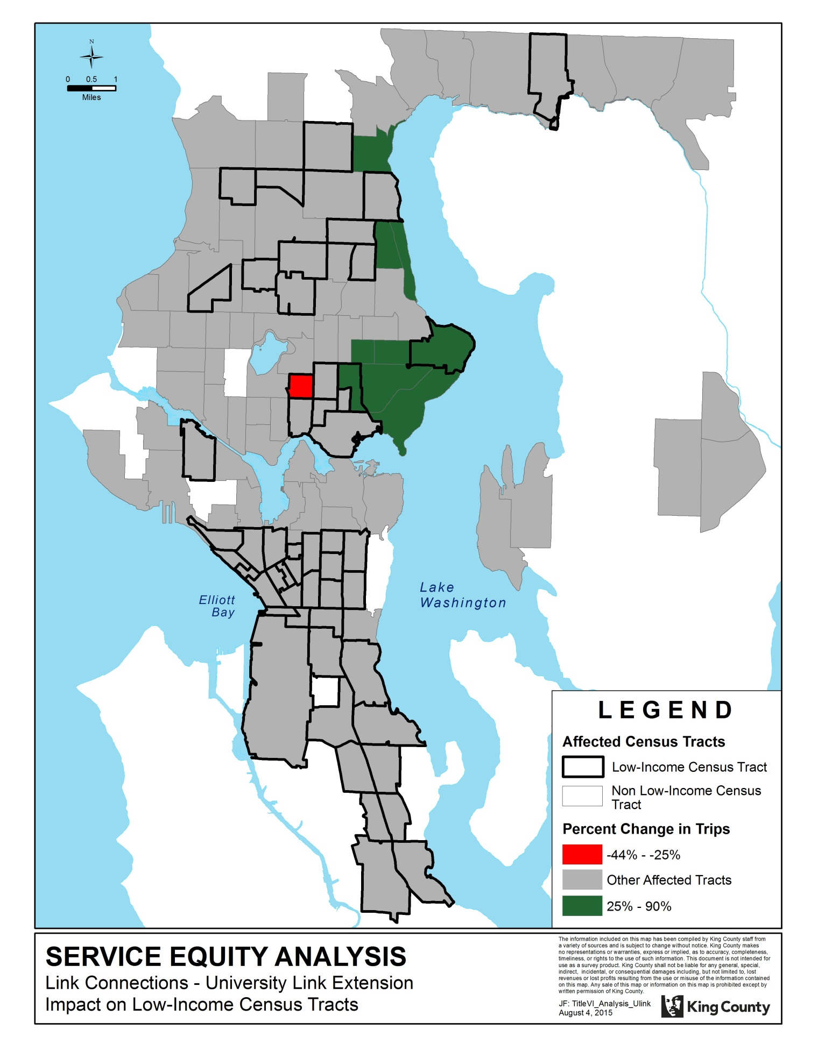

V. Threshold 4: Alternatives and Mitigation

As stated in Section IV, adverse effects of the Link Connections – University Link Extension project are limited to Census Tract 45, a low-income census tract. As shown in Figure 3, Census Tract 45 straddles I-5 and includes portions of the Wallingford and University District neighborhoods. Impacts to each of these distinct portions of Tract 45 are summarized below. Overall, the proposed changes will result in an estimated 44 percent reduction in the number of trips per week.

Wallingford

Latona Avenue Northeast runs north-south through the western portion of Tract 45 in the Wallingford neighborhood. Service along Latona Avenue Northeast is currently provided by Routes 26 local and 26 Express. The consolidation of the local and express variants of Route 26 into an all-day, two-way revised Route 26 Express will result in an estimated 12 percent reduction in the number of trips per week. A reduction of this magnitude does not meet Metro’s definition of an adverse effect.

University District

Roosevelt Way Northeast runs north-south along the eastern periphery of Tract 45 in the University District neighborhood. Roosevelt Way is currently served by Routes 66 Express and 67, which combine to provide service every 15 minutes for most of the day on weekdays. Route 66 Express provides service every 30 minutes for most of the day on weekends. Route 67 does not currently provide weekend service; however, Route 67 will begin providing 30 minute service on Saturdays in fall 2015, an improvement funded through the Community Mobility Contract with the City of Seattle.

Metro’s proposal would eliminate Route 66 Express and shift Route 67 from Roosevelt Way to University Way NE (located about 0.2 mile east of Roosevelt Way) south of Ravenna Boulevard. South of Ravenna Boulevard, service on Roosevelt Way would be replaced by a revised Route 73, which would provide half-hourly service on weekdays only. The proposed changes will result in an estimated 64 percent reduction in the number of trips per week in Census Tract 45, which meets Metro’s definition of an adverse effect.

During the second round of public engagement for the Link Connections project, Metro solicited feedback on two alternative integration networks: Alternative 1, which aimed to create a consolidated, frequent network; and Alternative 2, which involved more modest changes and preserved more geographic coverage. In Alternative 1, service on Roosevelt Way was eliminated entirely, whereas in Alternative 2, Route 48 was revised to provide frequent all-day service along this pathway.

Route 73 was incorporated into the final proposal to address concerns about the loss of coverage on Roosevelt Way associated with Alternative 1, among other concerns. Route 73 will provide more service to Roosevelt Way than was proposed in Alternative 1, but less than was proposed in Alternative 2.

The inclusion of Route 73 in the final proposed network would enable Metro to shift Route 67 to University Way south of Ravenna Boulevard, where it would combine with Route 45 to provide service every four to eight minutes through the center of the University District commercial area on University Way NE, connecting to Link light rail at the new University of Washington Station. Routes 45 and 67 would serve a stop on Roosevelt Way about 120 feet north of Ravenna Boulevard, which bounds Tract 45 along its northeast corner. However, because the routes only touch the corner of the tract, it is not physically possible to locate a stop for the routes *within* the tract, so the trips they would provide were not included in the total for the tract. If these trips were included in the total, the result would be a 160 percent increase in the University District portion of the tract, and a 93 percent increase for the tract overall.

South of Ravenna Boulevard, routes 45 and 67 will serve University Way, which is located about 0.2 miles east of Roosevelt Way. Riders along Roosevelt Way would have the choice between walking to access very frequent service on University Way or using closer service that is less frequent. Over 90 percent of respondents to a survey conducted during the first round of public engagement for Link Connections indicated willingness to travel five or more minutes to access service operating every 10 minutes or better. Again, Routes 45 and 67 will combine to provide service every four to eight minutes. The walk between Roosevelt Way and University Way could be accomplished in less than five minutes, assuming an average walk speed of three miles per hour, so it is likely that many of the current riders along Roosevelt Way will choose to walk to University Way, which will have more service than is provided on Roosevelt Way today.

Figure 3. Proposed changes to service in Census Tract 45.

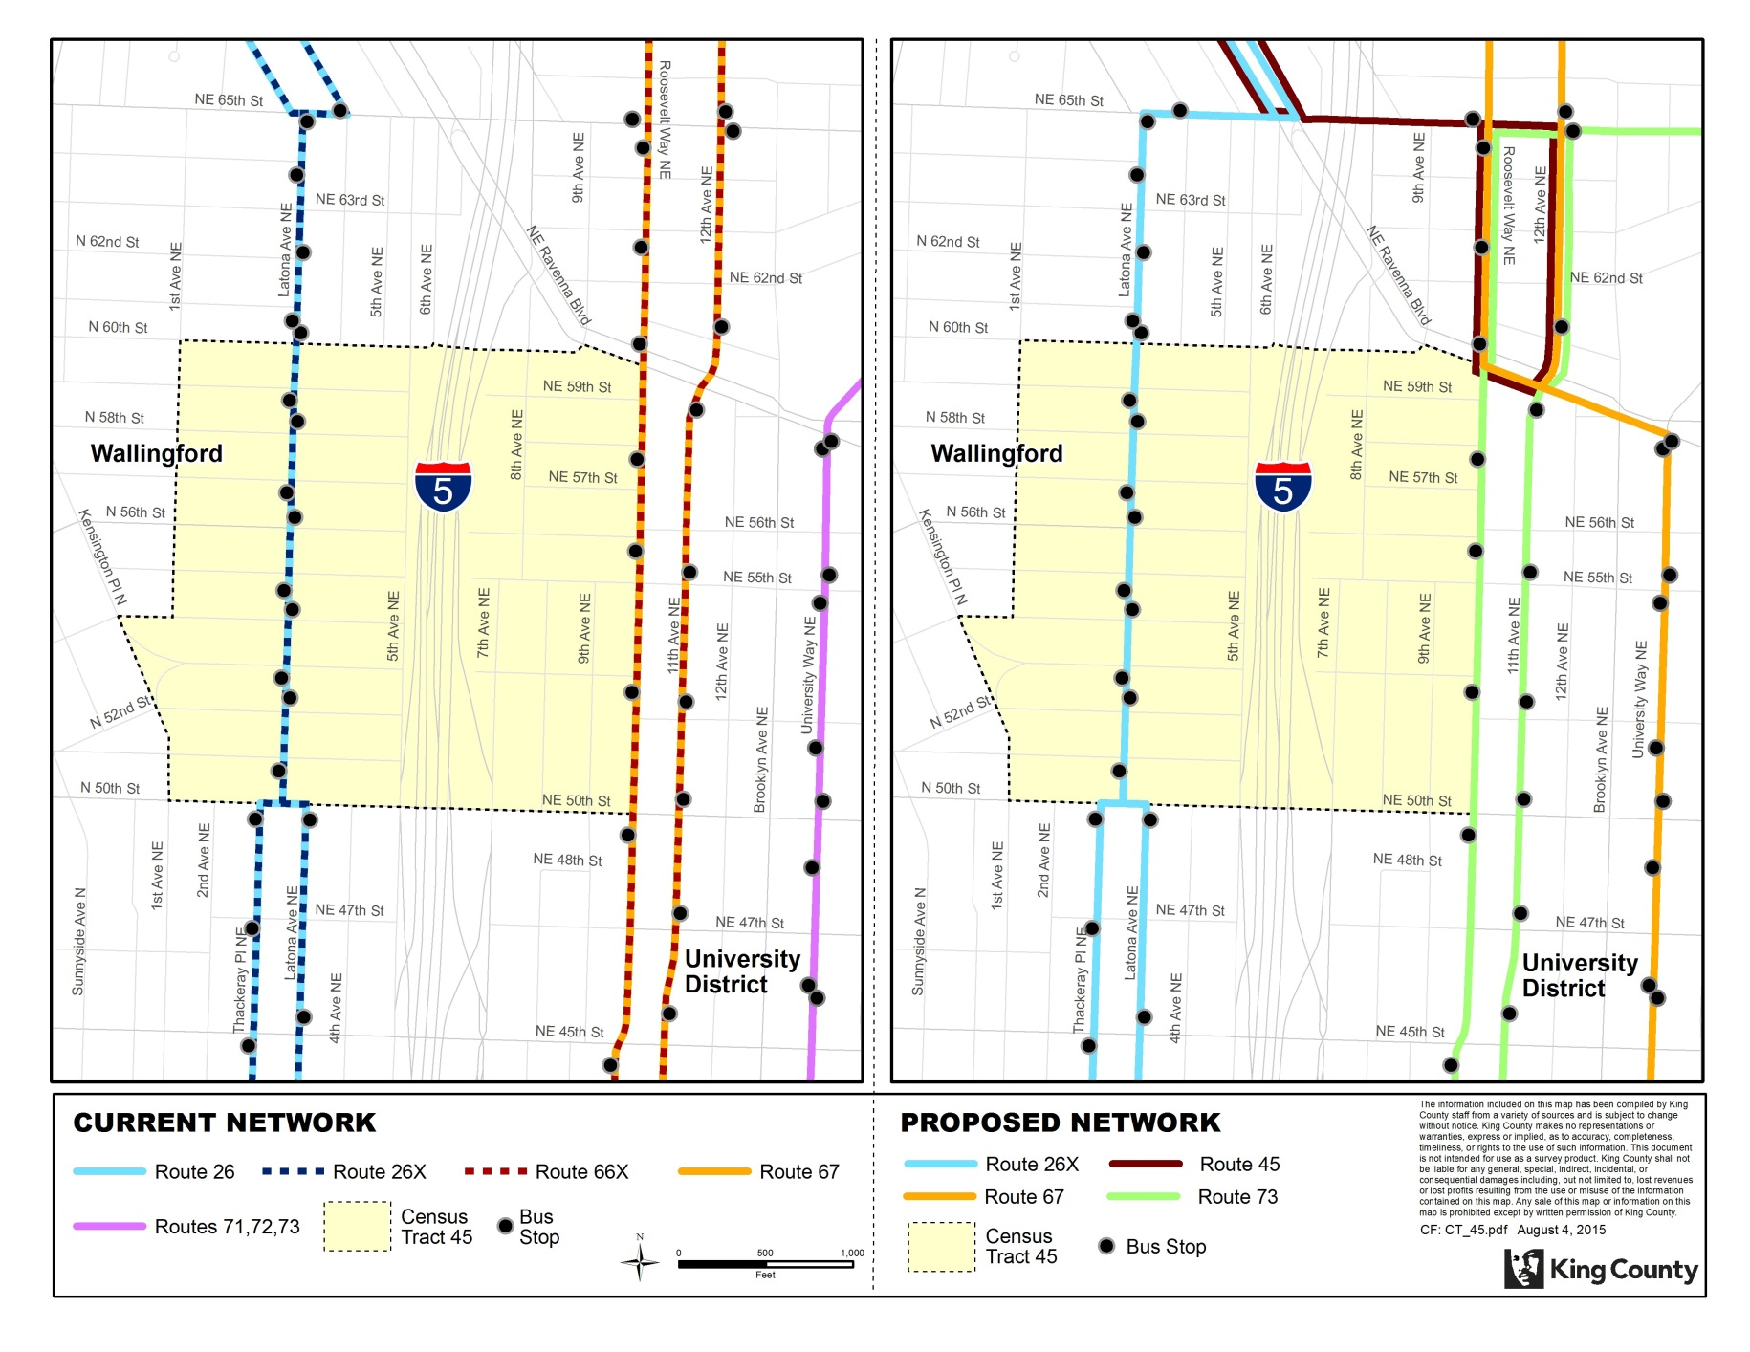

APPENDIX A: Service Hour and Ridership Data for Affected Routes

|  |  |  |
| --- | --- | --- |
| Route | Spring 2015 Annualized Platform Hours | Spring 2015 Annualized Rides |
| 8 | 69,000 | 3,139,000 |
| 10 | 27,000 | 1,425,000 |
| 11 | 20,000 | 1,069,000 |
| 12 | 23,000 | 997,000 |
| 16 | 54,000 | 1,534,000 |
| 25 | 7,000 | 135,000 |
| 26 | 24,000 | 925,000 |
| 26X | 4,000 | 187,000 |
| 28 | 24,000 | 905,000 |
| 28X | 7,000 | 308,000 |
| 30 | 6,000 | 114,000 |
| 31 | 15,000 | 521,000 |
| 32 | 24,000 | 910,000 |
| 43 | 48,000 | 2,362,000 |
| 44 | 45,000 | 2,361,000 |
| 48 | 73,000 | 3,442,000 |
| 49 | 44,000 | 2,532,000 |
| 64X | 6,000 | 202,000 |
| 65 | 25,000 | 876,000 |
| 66X | 30,000 | 1,049,000 |
| 67 | 9,000 | 391,000 |
| 68 | 11,000 | 523,000 |
| 70 | 28,000 | 1,259,000 |
| 71 | 32,000 | 1,690,000 |
| 72 | 27,000 | 1,533,000 |
| 73 | 34,000 | 1,898,000 |
| 74 | 6,000 | 329,000 |
| 75 | 29,000 | 1,367,000 |
| 76 | 5,000 | 303,000 |
| 238 | 19,000 | 215,000 |
| 242 | 6,000 | 101,000 |
| 316 | 4,000 | 254,000 |
| 372X | 28,000 | 1,094,000 |
| TOTAL | 813,000 | 35,950,000 |

APPENDIX B: Affected Routes and Alternatives

| Route | Action | Alternatives |
| --- | --- | --- |
| 8 | Shorten Route 8 to run between Mont Baker and Seattle Center to improve reliability. Buses would come more often on weekdays. | Between Rainier Beach and Mount Baker, use new Route 38 or Link light rail. |
| 11 | Revise to provide a new connection to Capitol Hill light rail station via John St and Thomas St. Buses would come more often on weekdays and Saturdays. | Between downtown Seattle and 15th Ave E, use Route 10. Between 15th Ave E and 19th Ave E, use Route 12. |
| 12 | Improve evening frequency on weekdays. | N/A |
| 16 | Delete route. | North of NE 92nd St, use routes 40, 345 or 346. Between Northgate and Green Lake, use revised Route 26X. Between Green Lake, Wallingford and Fremont, use new Route 62. On Aurora Ave, use Route 5, RapidRide E Line or revised routes 26X or 28X. |
| 25 | Delete route. | In Laurelhurst, use new Route 78 or walk to Sand Point Way to reach routes 65 and 75. |
| 26 | Combine routes 26 and 26X to make the system more efficient. | Along N 40th St, use Route 26X. Along Wallingford Ave N and N 35th St, use routes 31 and 32. Between Fremont and downtown Seattle, use new Route 62 (via Dexter Ave) or route 40 (via Westlake). |
| 26X | Combine routes 26 and 26X to make the system more efficient. Extend route 26X from Green Lake to Northgate. Operate all day on weekdays and weekends. | N/A |
| 28 | Combine routes 28 and 28X to make the system more efficient. | Between Fremont and downtown Seattle, use new Route 62 (via Dexter Ave) or route 40 (via Westlake Ave). |
| 28X | Combine routes 28 and 28X to make the system more efficient. Follow a revised express pathway to downtown Seattle via N 39th St and Aurora Ave N. Operate all day on weekdays and weekends. Continue providing service between Broadview and Carkeek Park during peak periods only. | N/A |
| 30 | Delete route. | Use routes 65, 74, 75, 78 or 372X. |
| 31 | Replace Route 26 service on Wallingford Ave N and N 35th St. | Along Stone Way N, use new Route 62. |
| 32 | Replace Route 26 service on Wallingford Ave N and N 35th St. | Along Stone Way N, use new Route 62. |
| 43 | Delete route. | Along 23rd Ave E and 24th Ave E, use routes 12 or 48. Along E Thomas St and E John St, use routes 8, 10, 11 or 12. On Pike St and Pine St, use routes 10, 11, 47 or 49. |
| 44 | Buses would come more often during peak periods. | N/A |
| 48 | Shorten to operate between Mount Baker and the University District. Improve frequency on weekdays and weekends. | Between Loyal Heights and the University District, use new Route 45. |
| 49 | Buses would come more often on weekdays and Saturdays. | N/A |
| 64X | Revise Route 64X to provide a new direct connection to South Lake Union. Would no longer serve 4th Ave or 5th Ave in downtown Seattle. | To reach 4th Ave or 5th Ave, use routes 76 or 316. |
| 65 | Route 65 buses would no longer continue as Route 31 or 32 (and vice versa). Instead, Route 65 would loop through the University of Washington campus and connect with Link at University of Washington Station. Buses would come more often on weekdays. | To Fremont, Magnolia, or Seattle Center, transfer to routes 31 or 32 on the UW campus. |
| 66X | Delete route. | North of the University District, use new Route 63 or revised Route 67. Within the University District, use revised Route 73. South of the University District, use Route 70. |
| 67 | Revise Route 67 to serve Roosevelt Way NE north of NE 80th St and University Way NE south of NE Ravenna Blvd. Buses would come more often on weekdays. | North of the University District, use new Route 63 or revised route 67. Within the University District, use revised Route 73. |
| 68 | Delete to reduce duplication. | North of NE 75th St, use routes 67 or 373.  South of NE 75th St, use Route 372X. |
| 70 | Operate all day on weekdays and weekends to replace night and Sunday service provided by routes 66, 71, 72, and 73. | N/A |
| 71 | Delete to reduce duplication and improve reliability. | Along University Way, use routes 45 or 67. Along NE 65th St, use routes 62, 65, 75, 76, 78 or 372X. North of NE 65th St, use routes 65, 76 or 78. For service between the University District and downtown Seattle, use Link light rail or route 74 (peak periods only). |
| 72 | Delete to reduce duplication and improve reliability. | North of NE 80th St, use Route 372X. Between NE 80th St and the University District, use routes 45, 67, 73 or 373.  On University Way, use routes 45 and 67. For service between the University District and downtown Seattle, use Link light rail or route 74 (peak periods only). |
| 73 | Operate Route 73 on weekdays between Jackson Park and the University of Washington campus. Between NE 65th St and NE Campus Parkway, revise to serve 11th Ave NE and Roosevelt Way NE to replace routes 66X and 67. | Along University Way, use routes 45 and 67.  For service between the University District and downtown Seattle, use Link light rail or route 74 (peak periods only). |
| 74 | Revise to serve 11th Ave NE and Roosevelt Way NE south of N 50th St. | Along University Way, use routes 45 or 67 to connect with Link light rail or access Route 74 on its new routing. |
| 75 | Buses would come more often during weekday peak periods and in midday on weekdays and Saturdays. | N/A |
| 76 | Add trips during peak periods. | N/A |
| 238 | Extend to Woodinville on weekdays to replace service currently provided by Route 372. | N/A |
| 242 | Delete to reduce duplication. | North of Northgate Transit Center, use routes 41 or 347.  Between Northgate and Green Lake Park-and-Ride, use new Route 62. To get to Overlake, transfer to Route 542 at Green Lake Park-and-Ride. |
| 316 | Add trips to replace service on Route 64 between Green Lake Park-and-Ride and downtown Seattle. | N/A |
| 372X | Between the University District and the University of Washington Bothell campus, buses would come more often and the period or service would be longer every day. Add weekend service between Lake City and U District only. Route 372X would no longer operate east of UW Bothell. | East of the University of Washington Bothell campus, use revised Route 238 or Route 522. |