**Swan**

**Lease Property Summary**



**Property Owner:** The City of Seattle - Seattle Public Utilities Department

**Address:** 39025 NE North Fork Road, Duvall, Washington

**Parcel Number:** 2926089004

**Rent (initial):**  $20,000 per year

**Improvements:** $573,000

**Lease Template** Seattle

**Operational Costs (initial):** $750 per year

**Term:** Twenty-five (25) years plus the option to renew for an additional three (3) periods of five (5) years each

**Square Footage:**  Approximately 8,008 square feet of ground space

**Council District:**  Three

**Funding Source:** Puget Sound Emergency Radio Network Capital Fund, Fund 3361

**Previous Location:** N/A

**Construction Start Date:** Immediately after lease is fully executed

**Synopsis:**

This 25 year ground lease with The City of Seattle Public Utilities Department (SPU) is for use of a portion of a parcel within the Tolt Water Corridor, referred to as the Swan site, for the new Puget Sound Emergency Radio Network (PSERN). The parcel is located on the SPU Tolt Water Treatment Facility site, east of Duvall. The PSERN Project (Project) is leasing the ground, and will install a new tower, shelter with generator, and fuel tank on the leased site. Construction of the improvements is scheduled to begin immediately after the lease is fully executed.

**Context**

*Rationale for transaction:* The PSERN vendor identified this site as part of its system design as required in their contract with King County. The contract requires the vendor to meet specific performance criteria, including coverage and signal strength. Sites are placed in order for the PSERN to meet those requirements.

*Policy considerations*: Council approved the Project: Ordinances 17993, 18074 and 18075, and PSERN capital fund 3361. There is urgency in completing the PSERN. The current King County Emergency Radio Communication System (KCERCS) is aging and the vendor will stop supporting the system at the end of 2018.

*Political considerations:* The PSERN Levy, in 2015, was supported by 65% of voters, and will improve public safety communications. The site owner, the City of Seattle, is a party to the Project’s Interlocal Agreement.

*Community considerations* *or partnerships:* We are not aware of anycommunity opposition to this site. The site will provide better coverage and increased capacity to areas of Duvall, Carnation, and unincorporated King County.

A number of police and fire agencies in the service area have actively supported the Project because it will enable seamless communications with other police and fire departments providing mutual aid, and because of the increased risk of failure after the vendor withdraws support for the current KCERCS.

*Fiscal considerations:*  The Project’s improvements at the site will total approximately $573,000 consisting of: 235 foot Tower - $130,000; 12 foot by 30 foot prefabricated Shelter & Generator - $127,000; 1,000 gallon fuel tank - $65,000; and Site Construction including civil improvements - $251,000.

The initial rent will be $20,000 per year, which includes electricity usage. The rent will increase annually by 1.5% on the first day of January after the first full calendar year of the term. Utilities are estimated to initially cost $750 annually, consisting only of diesel fuel for the generator. For purposes of the fiscal note, we estimate that utilities will increase 3% annually on the first day of January. The money for these improvements has been appropriated.

*Other considerations*: The PSERN project anticipates the City of Seattle’s Council reviewing and approving the lease in the fourth quarter of 2017.

*CIP/operational impacts:* PSERN will improve public safety and other public agency communications by covering a greater share of the County, increasing system capacity and reliability, and adding beneficial features, such as encryption. Installation and construction at this site will not affect the watershed.

*King County Strategic Plan impact:* This transaction supports the King County Strategic Plan guiding principles of Financial Sustainability and Regional Collaboration. Construction and operation of the PSERN supports the Strategic Plan goal of providing for safe communities. PSERN will be used to dispatch police, fire, and medical services to emergency locations where they are needed and will allow responders to communicate at those locations. It will also be used to coordinate the activities of water, sewer, and electricity utilities in restoring service after natural disasters.

*Equity and Social Justice Impact:* In accordance with Real Property Asset Management Plan (RAMP) Strategy 2.0 and 24.0, the Facilities Management Division and Project staff evaluated this location for Equity and Social Justice (ESJ) considerations. PSERN is an emergency radio network and will serve a larger share of the County than the current KCERCS, which was completed in 1997. This communications site is located in the North Fork neighborhood of Duvall and will serve a larger area of the County than the current network, allowing the program to add this location without any new ESJ impacts. A majority of the newly-served areas are rural parts of King County, some with lower average incomes than more urban areas.

*Energy Efficiency Impact:* Most of the electronic components in today’s network are twenty years old; the equipment the Project is buying is significantly more energy efficient. In addition, the shelters being installed for the Project must meet the State’s Labor and Industries Gold Seal certification and, therefore, are significantly more energy efficient than those currently being used.

**Alternatives Site Analysis**

The key factors Project staff considered in making this siting decision were coverage, capital and operational costs, vendor contract requirements, and schedule impacts associated with locating on a different site. The PSERN vendor and the Project staff discussed alternative sites, however this site was the only site that best met the established criteria. The Project is not aware of any reason it should reject the vendor’s selection.

**Vicinity View Map**

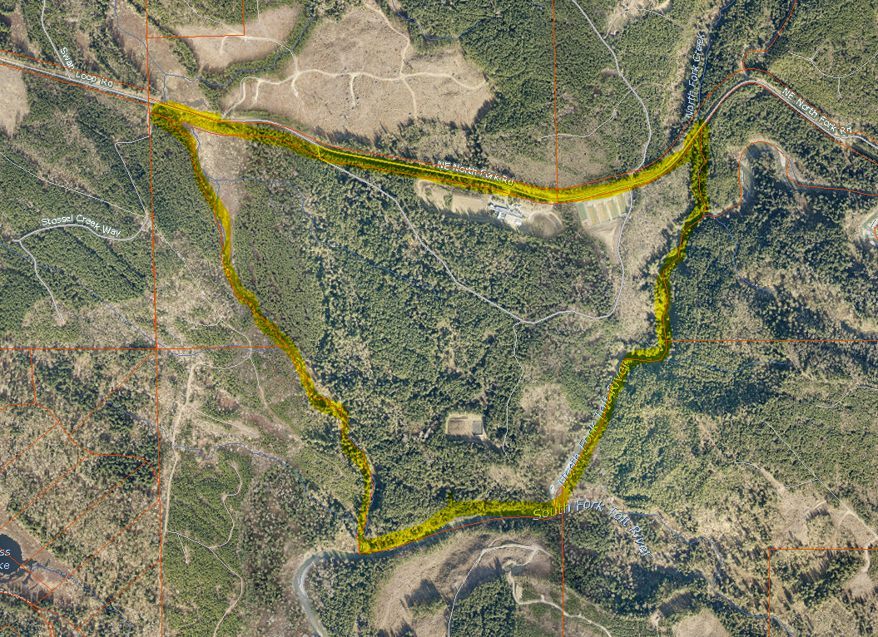

**Parcel Map**

