September 2016 Public Transportation Service Changes

Title VI Service Equity Analysis

March 2016

KCLogo-Black

Introduction

Federal Transit Administration (FTA) Circular 4702.1B, Chapter V, Section 7 requires transit agencies serving large urbanized areas to evaluate major service changes and to determine whether proposed changes would have a discriminatory impact as defined in the United States Department of Transportation’s Title VI regulations.

In accordance with these FTA regulations, this report summarizes Metro’s service equity analysis of service changes proposed for the September 2016 service change submitted to the King County Council for approval. Metro is proposing changes to service in Southeast Seattle, as well as a new peak only route in East King County.

Equity and social justice are key priorities for the King County Executive and the King County Council. In addition to assuring compliance with federal Title VI regulations, the service equity analysis also helps to ensure consistency with King County’s goals related to equity and social justice. Identifying the relative impacts of proposed changes to low-income and minority communities is an important step in applying the “fair and just” principle as stated in the King County Strategic Plan 2010-2014. This analysis is part of an integrated effort throughout King County to achieve equitable opportunities for all people and communities.

Metro’s proposed changes in Southeast Seattle were informed by a public engagement effort in late 2015 and early 2016 which included but was not limited to a survey, public meetings, information tables and posting of rider alerts at bus stops. These outreach activities and the feedback generated will be summarized in a public engagement report, which will be submitted to the King County Council along with the service change ordinance.

Service Guidelines Overview

The 2013 update to King County Metro’s *Strategic Plan for Public Transportation, 2011-2021* and related service guidelines outline the methodology Metro uses to evaluate service changes, consistent with FTA Title VI requirements (FTA Circular 4702.1B). The most relevant excerpts from the service guidelines are included below.

Implementation

Metro revises service three times each year—in spring, summer, and fall. The summer service change coordinates with the summer schedule for the University of Washington, because service is adjusted each summer on routes serving the UW. In cases of emergency or time-critical construction projects, Metro may make changes at times other than the three regularly scheduled service changes. However, these situations are rare and are kept to a minimum because of the high level of disruption and difficulty they create. Metro will identify and discuss service changes that address performance-related issues in its annual route performance report.[1]

Any proposed changes to routes are subject to approval by the Metropolitan King County Council except as follows (per King County code 28.94.020):

* Any single change or cumulative changes in a service schedule which affect the established weekly service hours for a route by 25 percent or less.
* Any change in route location which does not move the location of any route stop by more than one-half mile.
* Any changes in route numbers.

Adverse Effect of a Major Service Change

An adverse effect of a major service change is defined as a reduction of 25 percent or more of the transit trips serving a census tract, or 25 percent or more of the service hours on a route.

Disparate Impact Threshold

A disparate impact occurs when a major service change results in adverse effects that are significantly greater for minority populations than for non-minority populations. Metro’s threshold for determining whether adverse effects are significantly greater for minority compared with non-minority populations is 10 percent. Should Metro find a disparate impact, Metro will consider modifying the proposed changes in order to avoid, minimize or mitigate the disparate impacts of the proposed changes.

Metro will measure disparate impacts by comparing changes in the number of trips serving minority or non-minority census tracts, or by comparing changes in the number of service hours on minority or non-minority routes. Metro defines a minority census tract as one in which the percentage of minority population is greater than that of the county as a whole. For regular fixed route service, Metro defines a minority route as one for which the percentage of inbound weekday boardings in minority census tracts is greater than the average percentage of inbound weekday boardings in minority census tracts for all Metro routes.

Disproportionate Burden Threshold

A disproportionate burden occurs when a major service change results in adverse effects that are significantly greater for low-income populations than for non-low-income populations. Metro’s threshold for determining whether adverse effects are significantly greater for low-income compared with non-low-income populations is 10 percent. Should Metro find a disproportionate burden, Metro will consider modifying the proposed changes in order to avoid, minimize or mitigate the disproportionate burden of the proposed changes.

Metro will measure disproportionate burden by comparing changes in the number of trips serving low-income or non-low-income census tracts, or by comparing changes in the number of service hours on low-income or non-low-income routes. Metro defines a low-income census tract as one in which the percentage of low-income population is greater than that of the county as a whole. For regular fixed route service, Metro defines a low-income route as one for which the percentage of inbound weekday boardings in low-income census tracts is greater than the average percentage of inbound weekday boardings in low-income census tracts for all Metro routes.

I. Service Change Area and Routes

*Affected Areas*

The proposed changes will affect 27 census tracts with a total population of about 137,000 residents.

*Affected Routes*

Metro is proposing changes to two routes in Southeast Seattle - Route 9 Express, and Route 38 – and a new route in East King County (Route 243). On Route 9 Express, Metro provides approximately 16,400 annual service hours, and the route generates about 740,000 annual rides based on spring 2015 ridership data. Route 38 is a new route Metro will be implementing in March 2016, so ridership data for this route are not yet available.

II. Threshold 1: Is this a Major Service Change? YES

For the purposes of complying with FTA Circular 4702.1B, Chapter IV, Metro defines any change in service as “major” if King County Council approval of the change is required pursuant to KCC 28.94.020.

The proposed changes meet all criteria for a major service change by Metro and FTA definitions. Appendix A lists the specific routes being changed in September 2016.

III. Threshold 2: Are Minority or Low-Income Census Tracts Affected? YES

*Classifying minority and low income census tracts*

Metro classifies census tracts as minority tracts if the percentage of the population that is minority within a tract is greater than the percentage for King County as a whole. Based on the American Community Survey five-year average for 2009-2013 data, 35.8 percent of the population is classified as minority within the county as a whole. Similarly, Metro classifies census tracts as low-income tracts if the percentage of the population classified as low-income (living at or below the poverty threshold) within a tract is greater than the percentage for King County as a whole. Based on the American Community Survey five-year average for 2009-2013, 11.5 percent of the population is classified as low-income within the county as a whole.

The proposed service changes addressed in this report will affect the level of service provided to 27 King County census tracts currently served by Metro. The low-income and minority characteristics of affected census tracts are provided in Table 1 below.

Table 1. Low-Income and Minority Characteristics of Affected Census Tracts

|  |  |  |  |  |
| --- | --- | --- | --- | --- |
|  | Census Tract Classification | | | |
| Total Census Tracts Affected | Minority & Low-income | Minority ONLY | Low-income ONLY | Neither Minority nor Low-income |
| 27 | 14 | 5 | 3 | 5 |

IV. Threshold 3: Is there a Disproportionate Burden on Low-Income Populations or a Disparate Impact on Minority Populations? NO

The determination as to whether the proposed changes resulting in a reduction in service would have a disparate impact on minority populations was made by comparing changes in the number of Metro bus trips serving minority and non-minority census tracts. Similarly, the determination as to whether the proposed changes resulting in a reduction in service would have a disproportionate burden on low-income populations was made by comparing changes in the number of Metro bus trips serving low-income and non-low-income census tracts. The March 2016 service change was used as the baseline for calculating the change in trips.

Impacts are summarized in Tables 2 and 3 below and in Figures 1 and 2. No census tracts will be adversely affected by proposed changes to Metro bus service. Because no minority census tracts were adversely affected, Metro’s analysis indicates that the impacts of the project would not have a disparate impact on minority populations. Likewise, because no low-income census tracts were adversely affected, Metro’s analysis indicates that the impacts of the project would not place a disproportionate burden on minority populations.

Notes for Tables 2 and 3

1. An adverse effect is defined as a reduction of 25 percent or more in trips per week.

Tracts are classified as low-income or minority when the percentage of low-income or minority persons in the tract is greater than the percentage of low-income or minority persons in the county as a whole.

A disproportionate burden occurs when the percentage of low-income tracts with adverse effects is more than 10 percentage points greater than the county-wide percentage of low-income tracts.

1. A disparate impact occurs when the percentage of minority tracts with adverse effects is more than 10 percentage points greater than the county-wide percentage of minority tracts.

Impacts of Proposed Changes for September 2016

Table 2. Impacts of the September 2016 Service Change on Low-Income Populations

|  |  |  |  |  |  |
| --- | --- | --- | --- | --- | --- |
| Category2 | Tracts with Adverse Effects1 | % of tracts adversely affected | % of tracts system-wide | Difference | Disproportionate Burden3? |
| Low-Income | 0 | N/A | 37% | N/A | NO |
| Non-Low-Income | 0 | N/A | 63% |  |  |
| Total | 0 | N/A | 100% |  |  |

Table 3. Impacts of the September 2016 Service Change on Minority Populations

|  |  |  |  |  |  |
| --- | --- | --- | --- | --- | --- |
| Category2 | Tracts with Adverse Effects1 | % of tracts adversely affected | % of tracts system-wide | Difference | Disparate Impact4? |
| Minority | 0 | N/A | 45% | N/A | NO |
| Non-Minority | 0 | N/A | 55% |  |  |
| Total | 0 | N/A | 100% |  |  |

Figure 1. Impact of proposed changes on minority census tracts.

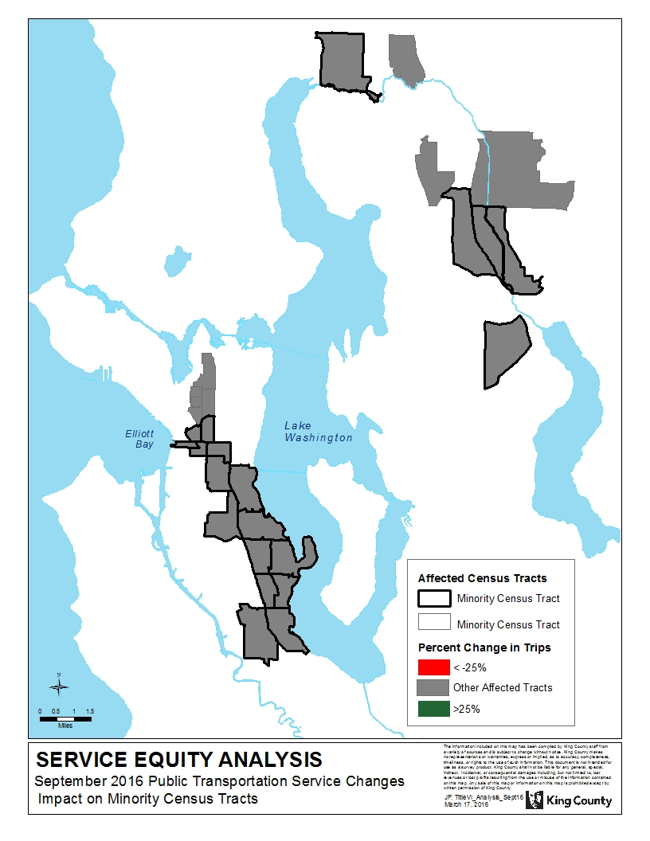

Figure 2. Impact of proposed changes on low-income census tracts.

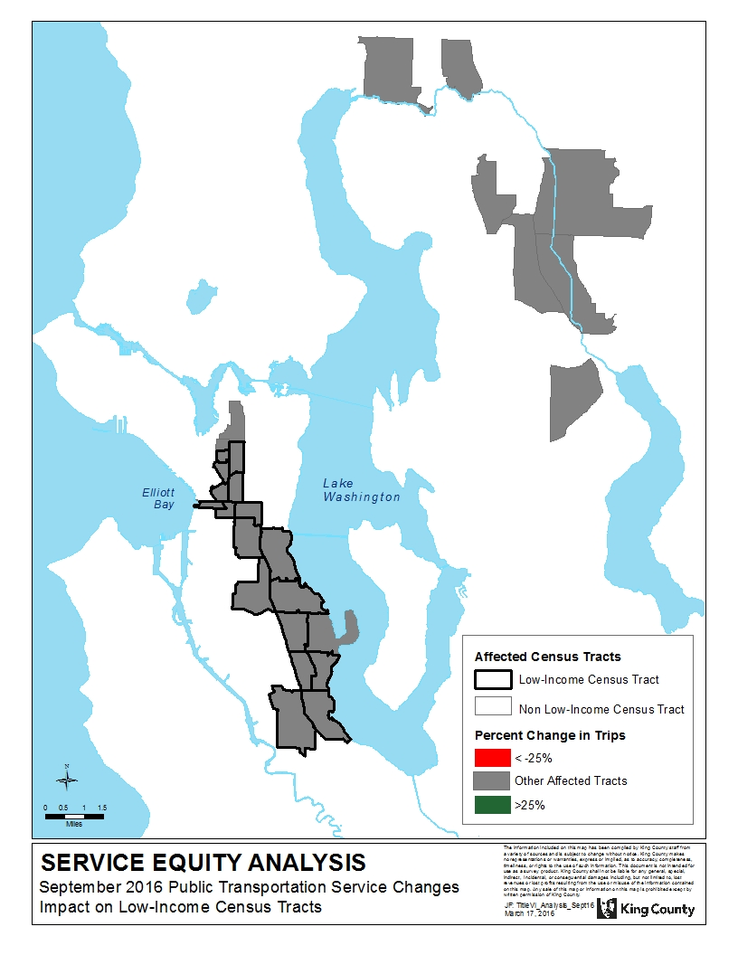

APPENDIX A: Affected Routes and Alternatives

| Route | Action | Alternatives |
| --- | --- | --- |
| 9X | Delete midday service on Route 9X and use the resources to extend Route 38 to the International District on weekdays. | Alternative service is available on Route 7 between Rainier Beach and South Jackson Street/12th Avenue South. Alternate service is available on Route 60 and also the First Hill Streetcar between South Jackson Street/12th Avenue South and Broadway. Alternate service is available on Link Light Rail between Rainier Avenue South at the Mount Baker Link Station and the Capitol Hill Station. |
| 38 | Extend Route 38 on weekdays, during the peak and midday, to serve Rainier Avenue South and South Jackson Street between the Mount Baker Transit Center and the International District. All weekday peak and midday trips would be extended, while weekday evening and weekend service will continue to operate between Rainier Beach and the Mount Baker Mount Baker Transit Center, following the current alignment via South Henderson Street and Martin Luther King Jr. Way South. The extended trips would operate as express service, with limited stops along the routing between Mount Baker Transit Center and South Jackson Street/12th Avenue South. | N/A |
| 243 | Implement new Route 243 Express. Provide about four northbound trips to Kenmore in the AM, and about four southbound trips in the PM on weekdays. | N/A |

1. The proposed 2016 Service Guidelines update will reflect that Metro has two service changes per year; Spring and Fall.