## Waste-to Energy Studies Cost Comparison

October 24, 2019

## Introduction

The purpose of this report is to explain the differences in financial impact results between two recent studies that both covered the topic of Waste to Energy (WTE) feasibility:

1. The Waste to Energy Feasibility Study transmitted to the King County Council as required by Ordinance 18835, Section 19, Proviso P4 on October 4, 2019. This report was completed by Arcadis U.S. Inc, and is referred to as the 2019 Arcadis Study for the purposes of this report.
2. The Waste to Energy Options and Solid Waste Export Considerations report dated September 28, 2017, which Council was briefed about on November 1, 2017, and the results of which were used in the 2019 Comprehensive Solid Waste Management Plan. This report was completed by Normandeau Associates, Inc., and is referred to as the 2017 Normandeau Study for the purposes of this report.

The 2019 Comprehensive Solid Waste Management Plan also included an analysis of Waste Export by Rail (WEBR) costs, estimated by King County Solid Waste Division (KCSWD).

Each of these reports included an analysis of the cost per ton for implementing WTE as a disposal option and WEBR as a disposal option to manage the region’s solid waste in the future.

The resulting cost per ton estimates are different between the two studies, and this report describes the assumptions and methodology differences between the two studies that resulted in each calculation.

## Background

KCSWD provides comprehensive municipal solid waste transfer, disposal, recycling, and waste prevention services for approximately 1.3 million residents and 660,000 employees in King County, Washington. The solid waste system serves unincorporated King County and 37 of the 39 cities within the county - all of the cities in the county except Seattle and Milton. KCSWD provides waste disposal through landfilling at Cedar Hills Regional Landfill, which the County owns and operates. KCSWD’s interlocal agreements with its partner cities obligate the division to provide waste disposal through 2040. Cedar Hills Regional Landfill is estimated to reach capacity before 2040. Prior to reaching capacity, the County will need to identify an alternative waste disposal strategy.

The two studies discussed above were both designed to analyze potential future alternatives for managing the region’s waste stream. The studies covered many types of impacts, including financial, environmental, and operational considerations. This report only compares the results of the financial impact analysis.

## Cost Per Ton Comparative Analysis

#### Waste to Energy

The table below contains a high level comparison of the disposal cost per ton figures for a WTE plant between the 2019 Arcadis and 2017 Normandeau studies. The numbers below are based on a 4,000 tons per day scenario and show costs in the year 2028.

The Normandeau Study estimated a cost per ton $24 higher than the Arcadis Study:

  
*1 2028 was chosen as a comparison year because it is the earliest year that is present in both studies. Summary tables in each report focus on multiple different time periods. Numbers for this analysis were taken from appendices or backup financial documentation.*

#### Waste Export by Rail

The table below contains a high level comparison of the disposal cost per ton figures for Waste Export by Rail between the 2019 Arcadis Study and KCSWD’s Comprehensive Plan analysis.

The Comprehensive Plan estimated a cost per ton $41 less than the Arcadis Study:

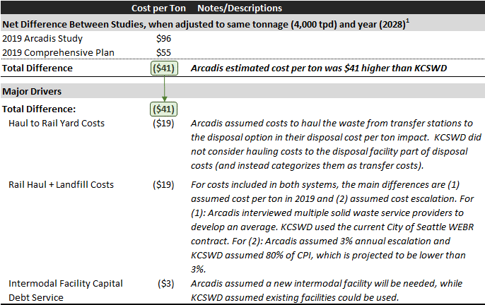

## Conclusion

The two studies compared in this report were completed by independent consultants, and the differences in their analysis reflect each company’s professional judgment about the appropriate assumptions to use in the analyses with which they were tasked. There is an inherent amount of uncertainty in long-term projections of this type, which necessitate making assumptions and projections on imperfect information.

Report prepared by King County Solid Waste Division and Office of Performance, Strategy and Budget.