King County Metro Transit

Response to Ordinance 17941 Section 113:   
2015-16 Transit Budget Proviso P6

Evaluating the Results of Capital Project 1116944: Mobile

Ticketing Pilot Project

**October 2017**

***Prepared for:***

**King County Council**

***Prepared by:***

KCLogo-Black

**Department of Transportation**

**Metro Transit Division**

King Street Center, KSC-TR-0415

201 S Jackson St.

Seattle, WA 98104  
www.kingcounty.gov/metro

Alternative Formats Available

206-477-3832 TTY Relay: 711

**Evaluating the Results of Capital Project 1116944:   
Mobile Ticketing Pilot Project**

# Executive Summary

Transit GO Ticket (capital project #1116944), the Puget Sound region’s first mobile ticket app, was launched in November 2016 as a twelve-month pilot project is a partnership between King County Metro, Sound Transit, the City of Seattle, and King County Marine Division to offer riders an alternative to cash fare payments. The app allows riders to buy and redeem tickets to ride King County Metro, King County Water Taxi, Seattle Streetcar, and Sound Transit Link and Sounder trains from their mobile device. This app is designed to be more convenient for cash-paying riders — including visitors, sports fans, or those who do not use ORCA and would otherwise pay cash.

Mobile ticketing is an innovative emerging technology that enables customers to pay their transit fares using smartphones instead of cash. The goals of the project were to better understand the technology’s feasibility and effectiveness in improving customer and operator satisfaction, reducing cash payment (especially for occasional riders), increasing safety for customers and operators, and speeding boarding in order to help customers get to their destination on time.

Over the course of the pilot project mobile ticket sales and the number of accounts have grown steadily, to 24,253 tickets sold and 20,716 accounts as of July 2017. Of the approximately 2,000 users who responded to a customer survey, 77 percent said they are satisfied with Transit GO Ticket and are likely to continue using the application. A majority of transit operators surveyed said mobile ticketing is faster and more efficient than cash payment. Operators also provided feedback that indicated a need for continued education and training about the Transit GO Ticket product, which Metro is committed to conducting on an ongoing basis. So far, it appears that Transit GO Ticket has not captured a significant portion of market share from any single fare option and has had a negligible impact on the ORCA market share.

Metro’s believes that the mobile ticketing demonstration has been successful in achieving its goals. With the positive results of the pilot project Metro intends to transition mobile ticketing from pilot project status to ongoing status at the beginning of December 2017. As part of the transition Metro will also focus on increasing education for operators, fare enforcement officers, and customers about what Transit GO Ticket is and how it works.

# Introduction

This report presents the results of the Mobile Ticketing Pilot Project that was the subject of a proviso during the adoption of the 2015-2016 budget. Ordinance 17941, Section 113, Proviso 6 states:

*Of this appropriation, $500,000 shall not be expended or encumbered until the executive transmits a final report evaluating the results of capital project 1116944, mobile ticketing pilot project, and a motion that accepts the final report and the motion is passed by the council. The motion shall reference the subject matter, the proviso's ordinance, ordinance section and proviso number in both the title and body of the motion.   
  
The final report shall include, but not be limited to:*

1. *A summary of the pilot project results;*
2. *A comparison of projected mobile ticket transaction costs and ORCA transaction costs;*
3. *A discussion of the project's potential impact on ORCA card usage and market share;*
4. *Identification of the project impact on transit division participation in the ORCA Replacement regional project;*
5. *A discussion of potential operating and capital program changes resulting from the pilot; and*
6. *A discussion of equity and social justice impacts of the project and approaches to mitigation of impacts.*

*The executive must file the final report and motion required by this proviso in the form of a paper original and an electronic copy with the clerk of the council, who shall retain the original and provide an electronic copy to all councilmembers, the council chief of staff, the policy staff director and the lead staff for the transportation, economy and environment committee, or its successor.*

# Background

Mobile ticketing is an emerging technology that allows customers to pay their transit fares using their smartphones instead of cash. The pilot project sought to explore the potential of mobile ticketing to provide a convenient method of pre-paying fares and assess how such technology can improve customer satisfaction and speed boarding and increase operator safety by reducing cash collection on the bus.

King County Metro Transit prepared a request for proposals (RFP) and selected Bytemark as its mobile ticketing provider in a competitive procurement. In coordination with the City of Seattle and Sound Transit, the mobile ticketing application, called Transit GO Ticket, was launched in November 2016. It allows customers to download an app for Android, iPhone and Windows mobile devices and to buy tickets for Metro bus, Link light rail, Sounder train, Seattle Streetcar and King County Water Taxi services using their credit or debit cards.

Tickets are the same price as cash and are stored on the device until the customer activates the ticket and boards transit. The ticket then stays active for the duration of the transfer period. The customer shows their activated ticket on their mobile device screen to the driver or fare enforcement officer as required, depending on how they are traveling.

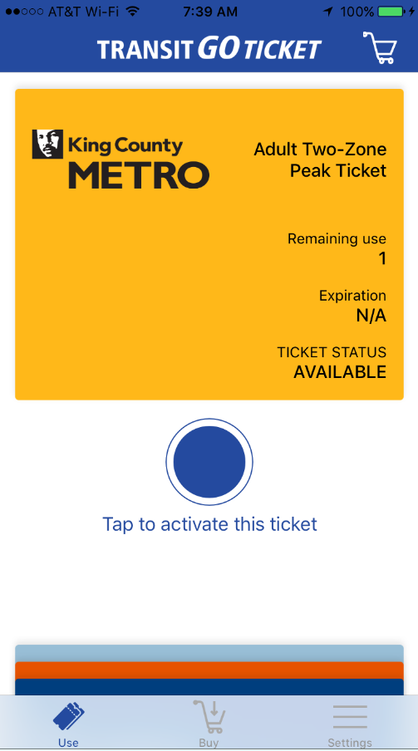 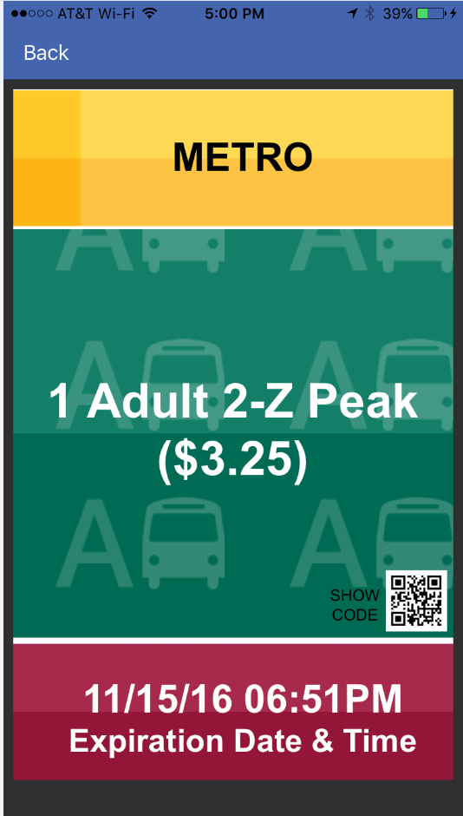

A Transit GO ticket prior to activation

A Transit GO ticket post-activation

The primary goals of the pilot project were to understand the effectiveness of mobile ticketing in Metro’s fare and operational environment and to assess how it complements other products Metro offers today. The project was designed to help Metro decide if and how to provide and use mobile ticketing as part of its overall suite of fare products.

Secondary goals included to reduction in cash fare payment by speeding up boarding and reducing the amount of time buses spend at bus zones. Metro ultimately prefers for customers to use an ORCA card to pay their fare, which facilitiates transfers, among other benefits. A key purpose of the pilot project was to see if Transit GO Ticket would be downloaded and used by cash-paying customers or would divert customers from using ORCA to pay their fares.

# Response to Proviso 6

## Summary of pilot project results

The objective of the Mobile Ticketing Pilot Project was to determine whether a mobile ticketing app can give infrequent riders a convenient alternative to cash fare payment that meets a number of business requirements, including customer and operator satisfaction, cost effectiveness, and limited “poaching” of market share from ORCA. The following are the observed results of the pilot project.

Customer satisfaction and support for the system, including potential for wide market penetration

In a survey of approximately 2,000 users, 77 percent said they are satisfied overall with Transit GO Ticket, and 77 percent said they are likely to continue using the application. The primary source of dissatisfaction among respondents was the limited categories of tickets to purchase. As the project moves to full production, participating agencies will expand the categories of tickets customers may purchase.

Ticket sales increased steadily over the course of the pilot project, from 3,153 in the first full month of operations (December 2016) to 24,253 in July 2017. Accounts grew from 2,600 to 20,716 over the same time period.

Impacts on cash fares and the use of other fare options such as ORCA

To date, fares paid with Transit GO Ticket have accounted for roughly a 10th of a percent of boardings. It does not appear that Transit GO Ticket is capturing a significant portion of market share from any single fare option. Most customers who responded to Metro’s Transit GO Ticket user survey indicated that they use multiple fare media. Customer research found that Transit GO Ticket is being used primarily as a backup fare payment method for customers who do not have cash or are unable to use their ORCA card.

Ease of recognition for operators and fare enforcement officers

In a survey of 377 Metro operators who had experienced customers paying with Transit GO Ticket, satisfaction with ease of recognition was mixed. Approximately 42 percent were somewhat or very dissatisfied with the ease of visual validation for a single ticket, and 57 percent were somewhat or very dissatisfied with the ease of visual validation for multiple tickets. It may be noted that nearly half (47 percent) of respondents had encountered Transit GO Ticket only one to five times, so some of the dissatisfaction may be due to lack of familiarity or a need for additional training (training was provided as part of the vendor’s contract).

Securitas Fare Enforcement reports that they encounter customers paying with Transit GO Ticket about two to three times per week. It was noted that it was “very common” to observe customers waiting to activate their Transit Go Ticket until they saw a fare enforcement officer approaching.

Metro will continue operator education about Transit GO Ticket to ensure a high level of familiarity with the product. Metro will also send reminders and educational materials to customers who use Transit GO Ticket that they should allow sufficient time for an operator to recognize and acknowledge their Transit GO Ticket as valid fare payment when they board.

Effectiveness of automated inspection and validation technologies

Automated inspection and/or validation technologies were not part of this pilot project; however, the vendor has recently demonstrated new automated ticket scanning and validation functionality that they are developing that could potentially address operator concerns about ease of recognition. Such automated identification would require separate pieces of equipment that need to be installed on the bus. Metro does not know the cost of such equipment as some of it represents emerging technology that still needs to mature.

Impacts on boarding times using this fare payment technology

About two-thirds (64 percent) of the operators who responded to the operator survey said that the mobile ticketing process is faster and more efficient than payment with cash. No quantitative data is available at this time to measure time savings due to Transit GO Ticket.

Potential for fare evasion and methods to mitigate

The potential for fare evasion identified during the pilot project:

* Customers not activating their mobile ticket until approached by a Fare Enforcement Officer. This scenario was observed several times by Securitas Fare Enforcement officers.
* Customers using a screenshot of a Mobile Ticket.

Methods to mitigate this types of fare evasion identified include:

* Moblile tickets, once activitated, display a red bar on the bottom of the screen for two minutes after activation, providing a visual indicator of a “recent” activation. This allows Fare Enforcement Officers a visual check to determine when the ticket was activiated.
* When a customer activates a Transit GO Ticket, the image on the screen displays the day’s cash transfer color and letter in a moving background. This display confirms the ticket is not a static screenshot.

During the 12 month pilot period Metro Transit Police did not report any fare evasion incidents related to Transit GO Ticket.

The mobile application demonstrates the ability to comply with the Americans with Disabilities Act and Section 508 of the Rehabilitation Act of 1974

The Transit GO Ticket solution is contractually required to comply with the Americans with Disabilities Act and Section 508 of the Rehabilitation Act of 1974. The vendor has demonstrated that they designed their system with accessibility in mind and to utilize native accessibility features provided by each mobile platform. These features include voice-over (or similar features) compliance on all screens and audio instructions in place of visual tutorials. The interface was also reviewed for usability by visually impaired users as part of the vendor’s internal design process.

The viability of deploying the technology across multiple modes and agencies, and supporting new fare options and alternative transit services such as vanpool and paratransit

The technology has been deployed across Metro bus, Link light rail, Sounder commuter rail, the King County Water Taxi, and Seattle Streetcar for selected fare products.

In September 2017, Access paratransit customers began engaging in a demonstration to purchase tickets through Transit GO Ticket. Full rollout of mobile ticketing for Access customers is anticipated in the near future, offering a new and potentially easier way for these customers to pay.

Value-added features and the ability to support new and emerging technologies and consumer applications

In June 2017, the vendor held a series of workshops demonstrating enhancements to the Transit GO Ticket system that they were developing and that Metro could consider implementing. Many of these enhancements were intended to address issues with validating tickets, preventing fraud, and expanding the range of fare products offered through the app.

The overall feasibility of mobile devices as a new sales channel for fare media

To date, the pilot project has demonstrated that fare media sales via mobile device are technologically and operationally feasible. To improve the user experience and viability of the project, two improvements will be considered when the project moves beyond the pilot phase:

* Steps to improve operator satisfaction with Transit GO Ticket, whether through technology improvements or additional training, and
* Seek to increase ticket sales (and thus reduce cost to Metro as measured on a per-ticket basis) by promoting Transit GO Ticket and adding other transit agency partners in the region.

## B. Comparison of projected mobile ticket transaction costs and ORCA

## transaction costs

Once the mobile ticketing pilot project expires in December 2017, and the project moves into regular implementation, the recurring operational costs would include a fixed monthly cost of $10,500 per month for hosting and service fees, and a variable charge of 1.5 percent of the value of each transaction, plus credit card processing fees.

For 42,000 tickets per month (current projected sales for December 2017) at an average cost of $2.75, this monthly fee would equate to a per-ticket cost of $.25, plus $.04 in transaction charges, for a total per-ticket cost to Metro of $.29plus credit card fees. Credit card fees for merchant acquirer banks generally average 2.25% of the gross purchase cost.

For comparison, Metro estimates that ORCA fees cost the agency approximately $.37 per tap, including all fees. The cost incurred by Metro per Transit GO Ticket appears to be less than an ORCA tap.

Metro also looked at the cost of Transit GO Ticket compared to the cost of cash fare collection. The annual operating cost components of cash fare collection are:

* Revenue Processing Center - $1,530,800
* Fare collection equipment repair and maintenance - $830,500
* Transfers - $250,500
* Indirect costs - $49,600

These operating costs total $2,661,400 annually. With roughly 35 million annual cash boardings, the per-boarding cost to collect cash is about $0.076cents per boarding, excluding any amortization of the capital cost of the fareboxes themselves.

This calculation does not attempt to estimate bus operational savings due to reduced dwell times.

Therefore, for Transit GO Ticket’s monthly hosting and transaction fees to be roughly on par with the cost of cash fare collection, the number of mobile tickets sold would need to be around160,000 per month.

## C. Discussion of the project’s potential impact on ORCA card usage and market share

Customer research has found that the impact of Transit GO Ticket on ORCA card usage and market share is negligible. The average number of boardings on Metro, Link, and Seattle Streetcar was more than 11.8 million for the first six months of 2017. When compared to the roughly 24,000 Transit GO Ticket products sold in July 2017, Transit GO Ticket fares are used for approximately a 10th of a percent of boardings.

The customer survey of users found that Transit GO Ticket is not currently the primary fare media for most of the respondents. Approximately 40 percent of the trips respondents took in the past month were paid with Transit GO Ticket. As shown in Fig. 1, two-thirds (66 percent) of respondents who used other fare media in the last month said they used ORCA, 38 percent paid cash, and 22 percent used a ticket vending machine (multiple responses were allowed).

Figure 1. How Customers Paid Their Fares in Past Month

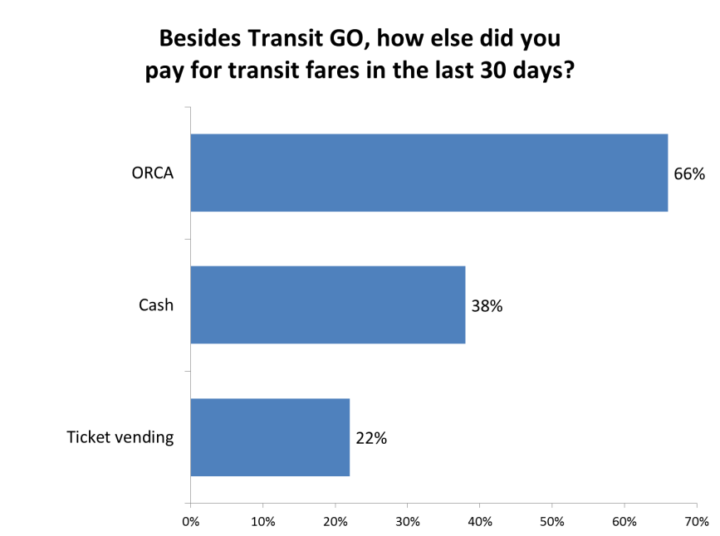

Prior to mobile ticketing, about equal numbers of respondents said they paid with cash (30 percent) as said they used pre-paid media: ORCA (25 percent) or a ticket vending machine (9 percent). However, about one-third (34 percent) said they didn’t ride before at all.

|  |  |
| --- | --- |
| Table 1:  Why Customers Use Mobile Ticket Over ORCA | |
| Why do you choose to use mobile ticketing instead of an ORCA card? | |
| Backup if ORCA lost, forgotten, out of funds | 8% |
| Used prior to getting ORCA | 3% |
| Purchase for guests, other people | 2% |
| Easier to load value (or thought it was) | 1% |
| Convenient, easy (general) | 1% |
| Try it out | 1% |
| Convenient to carry | 1% |

While a rate of 40 percent of respondants paid with Transit GO Ticket may seem like a relatively extensive use of the technology, it appears that many Transit GO Ticket customers are infrequent riders, so the number of rides this measure is based on is considerably lower than the number taken by most commuters. Nearly one-third of the Transit GO Ticket customers did not ride transit in the 30 days prior to responding to the survey. Additionally, when looking at the number of tickets sold per month compared to the number of accounts, the ratio is only 1.2 per rider, indicating a low amount of activity on the average account. The median number of tickets purchased per customer for the period of July and August 2017 was 5.7 per customer. The highest number of tickets purchased in July 2017 was 57 and in August 2017 it was 84 tickets.

Finally, customers report that Transit GO Ticket is a good backup for when ORCA cards are lost, forgotten, or out of funds. For a few respondents, Transit GO Ticket was a stopgap before getting an ORCA Card, and a few respondents purchased the mobile tickets for guests or family members who don’t ride often. Results are summarized in Table 1.

Overall, Metro does not see negative impacts on the ORCA market share through the use of Transit GO Ticket. Transit GO Ticket appears to be reaching its target market of infrequent riders, with the added benefit of providing a backup method of fare payment to ORCA and cash riders.

## D. Identification of the project impact on transit division participation in the ORCA Replacement regional project

The Transit GO Ticket project has no impact on Metro’s participation in the next generation ORCA project. Metro continues to participate as a full partner in the replacement effort. Next generation ORCA is expected to include a regional mobile ticketing application when it launches in 2021, at which point it is expected that Transit GO Ticket will be phased out and customers transitioned to the next generation ORCA system. In the meantime, Transit GO Ticket provides Metro, Sound Transit, WaterTaxi and other partners information on mobile ticketing use that can inform next generation ORCA and serves as a means of introducing mobile ticketing technology to the region’s transit riders.

## E. A discussion of potential operating and capital program changes resulting

## from the pilot

The primary capital cost of continuing the pilot project into full implementation is a one-time migration cost of $100,000 for Metro and Sound Transit, with an additional $45,000 per additional new partner agency (it is assumed this cost would be paid by the partner agency). The costs include the migration from temporary servers to dedicated production servers located on the cloud, and the fees associated with such services from cloud storage providers (like Amazon). Also included in this migration cost are the upgrades of current and future versions of the application.  This migration cost was included in the contract signed with Bytemark at the beginning of the pilot. The $100,000 will be covered by existing funds and will not require any capital program changes.

Operational program changes will include the ongoing fixed monthly hosting and service fee of $10,500 as well as the per-transaction processing fees, which would vary by volume.

During the pilot project, Metro absorbed these fees internally.

Metro is working to resolve several issues around budgeting and management of these fees as mobile ticketing moves to full implementation. Metro will work with King County Finance to determine the feasibility of using the Point-and-Pay system for credit card processing and will also have to determine how to budget for any volume of fees that exceed current resources before the start of the 2019-2020 budget cycle. Metro will work with participating agencies to cover their share of the costs based on ticket sales and redemptions, with specifics to be documented in a memorandum of understanding.

A Mobile Ticketing Pilot Continuation was identified as an anticipated initiative for the 2019-2021 biennium in the Strategic Technology Roadmap for Transit developed in 2016 under a separate proviso.

## F. A discussion of equity and social justice impacts of the project and approaches

## to mitigation of impacts

Mobile ticketing technology offers an additional option for fare payment and does not take away or reduce other services. Metro did not identify negative impacts on equity and social justice that require mitigation.

It was identified that low income and other historically disadvantaged populations may lack access to mobile technology or credit and banking services that are required to use Transit GO Ticket. Though Transit GO Ticket is not adversely impacting low-income riders, minorities, refugees, and English language learners, demographic data about users from the Transit GO Ticket Customer survey suggests it is not providing as much benefit to those populations as it is to higher income customers, who are using the application more.

As Metro continues this program, we will use the opportunity to increase awareness and usage among low-income, minority, and English-language-learner populations by increasing the transcreation of mobile ticketing materials into other languages to make them more accessible. Transcreation is a process of adapting a message from one language to another while making extra effort to preserve the tone and meaning of the original message. We will also explore the possibility of incorporating messaging around mobile ticketing into ORCA LIFT outreach to increase usage of the program among low-income populations. Finally, Metro will explore with the vendor how to add Regional Reduced Fare Permits to Transit GO Ticket for customers who have already applied and been approved for the reduced fare.

Looking to the future, the next generation ORCA system will allow customers without bank accounts to purchase products, including mobile tickets, at any agency or retail provider location. It is anticipated that the number of retail providers in next generation ORCA will increase four-fold over today’s 130 locations.

The Transit GO Ticket customer survey, to which 1,981 users responded, provided some valuable demographic information. The response rate for the survey was 15%, which is typical for an online survey of this type. One-third (35 percent) of the respondents are between 25 and 34 years old. One quarter (24 percent) live outside the Seattle metro area. Eighty-four percent are employed. One in seven (14 percent) have household incomes below 200 percent of the poverty level and would qualify for ORCA LIFT, while nearly half (46 percent) have household incomes above $100,000. Table 2, on the following page, illustrates the survey results in more detail.

|  |  |  |  |  |
| --- | --- | --- | --- | --- |
| Table 2: Summary of the Transit GO Ticket User Demographics | | | | |
| **Gender** |  |  | **Age** |  |
| Male | 52% |  | Under 18 | 1% |
| Female | 47% |  | 18-24 | 11% |
| Other | 1% |  | 25-34 | 35% |
|  |  |  | 35-44 | 23% |
| **Employment** |  |  | 45-54 | 17% |
| Employed | 84% |  | 55-64 | 11% |
| Student | 12% |  | 65+ | 3% |
| Retired | 4% |  |  |  |
| Homemaker | 4% |  | **Residence** |  |
| Not employed | 3% |  | Seattle | 43% |
|  |  |  | Other King County | 25% |
| **Household Income** |  |  | Other Seattle Metro* | 7% |
| Below $25K | 8% |  | Non Seattle Metro** | 24% |
| $25-34K | 6% |  |  |  |
| $35-54K | 10% |  | **Ethnicity** |  |
| $55-74K | 13% |  | White | 75% |
| $75-99K | 17% |  | Asian | 13% |
| $100-149K | 22% |  | Black | 2% |
| $150K + | 24% |  | Other/Multi | 10% |
| Below 200% poverty level | 14% |  | Hispanic/Latino | 8% |

*\*i.e. Pierce, Snohomish, Kitsap*

*\*\*i.e. visitors from out of the area*

Additionally, the 2015 Rider/Non-Rider survey provides some information on smartphone usage among Metro riders overall, though the data is limited and not necessarily representative of all riders. According to that survey, 84 percent of Metro’s riders own a smartphone, and 62 percent of all riders use a smartphone to get information about transit. Smartphones are the most frequently used source of information about Metro for all riders. The 2015 Rider/Non-Rider survey also showed a relationship between income and use of smartphones to get information about transit. Sixty-eight percent of respondents with household incomes of less than $35,000 owned a smartphone, compared to 98 percent of respondents with household incomes above $100,000. Forty-five percent of riders with household incomes of less than $35,000 got their information via smartphone, compared to 78 percent of riders with incomes of $100,000 or more.

However, outreach conducted with community-based organizations in spring 2017 suggests there could be growing opportunity for Metro to use smartphones to increase access to transit among people with low incomes, English language learners, and other historically disadvantaged populations. Metro contracted with World Relief, White Center Community Development Association (WCCDA), and Hopelink to learn more about the needs of the individuals they serve. Together, those organizations reached 311 participants. Eighty percent of participants own a smartphone, and 60 percent use their phone to get information about transit. Forty-nine percent of respondents rate their comfort with technology to pay their transit fares at a score of seven or higher (out of 10, the most comfortable).

Ages, languages spoken, race and ethnicity, and incomes vary greatly across questionnaire audiences. For example, World Relief’s questionnaire participants largely reported being unemployed, while some from WCCDA and Hopelink reported annual household incomes of over $60,000, and as high as $150,000. Though the results reflected here are not a statistically valid representation of Metro ridership or King County constituents as a whole, they do suggest that mobile ticketing could be an effective way to reach lower-income and minority communities and increase their access to transit. Metro will work to increase usage of mobile ticketing among low-income, minority, refugee, and English-language learner populations through the ways outlined above.

# Conclusion

Metro’s mobile ticketing demonstration has been successful in achieving its goals and will transition Transit GO Ticket from pilot to full operational status in December 2017.

Metro is confident that the vendor has delivered a quality product that the majority of users find to be a useful alternative to paying cash. In the coming months and years leading to the transition to the next generation ORCA system, Metro and its partners will focus on making more options available to customers and serving more passenger types. Metro will also focus on increasing education for operators, fare enforcement officers, and customers about what Transit GO Ticket is and how it works.