Dow Constantine
King County Executive

401 Fifth Avenue, Suite 800
Seattle, WA 98104

206-296-9600 Fax 206-296-0194
TTY Relay: 711
www.kingcounty.gov

July 19, 2018

The Honorable Joe McDermott
Chair, King County Council
Room 1200
C O U R T H O U S E

Dear Councilmember McDermott:

In accordance with Ordinance 18684, Section 19, the King County Executive and King County Council, in coordination with 4Culture, are to convene a 4Culture Task Force. The task force will conduct the community stakeholder process and the task force should use the results of the assessment and evaluation to make a report of recommendations to 4Culture’s practices, governance and oversight structure to promote geographic, social and racial equity in the allocation of funding and to promote development of cultural infrastructure across King County to improve accessibility to both patrons and practitioners of arts, cultural, heritage and historic preservation programs countywide. The report is to be transmitted to the King County Council and the King County Executive by April 1, 2019

The 4Culture Task Force will be composed of at least 14 members appointed by the executive and confirmed by the council. The 4Culture Task Force membership shall include, but not be limited to:
- One representative for the King County Council;
- One representative for the King County Executive;
- One representative for the cultural development authority;
- One representative for Cultural Access Washington;
- One representative for the Sound Cities Association; and
- At least nine representatives of organizations supporting underrepresented populations or smaller arts, culture, heritage and historic preservation organizations in King County.

Enclosed for consideration and approval by the King County Council are motions confirming the appointment of the following individuals to the King County 4Culture Task Force:

- Dominica Meyers | - Sharon Williams | - Janelle Johnson
- Julie Ziegler | - Josef Krebs | - Kelly Dylla
- Jeanne Burbidge | - Tera Beach | - Scott Gray
- Jennifer Meisner | - Brian Carter | - Dwight Gee
- Ronda Billerbeck | - Shannon Halberstadt | - Mari Horita
- Manny Cawaling | - Patricia Cosgrove | - Kji Kelly
- Laura Reynolds | - Marie McCaffrey | - Tim Lennon
- Julianna Ross | - Latha Sambamurti | - Cassie Chin
- Carolyn Busch | - Matias Valenzuela | - Lawrence Ellis (SCA Alternate)

The appointments of the 4Culture Task Force members listed above will expire on September 30, 2019. A board profile and group appointment letter are enclosed for your information. This appointment request supports the King County Strategic Plan goal of public engagement by expanding opportunities to seek input, listen and respond to residents.

If you have any questions about this appointment, please have your staff contact Shannon Braddock, Deputy Chief of Staff, at 206-477-0982.

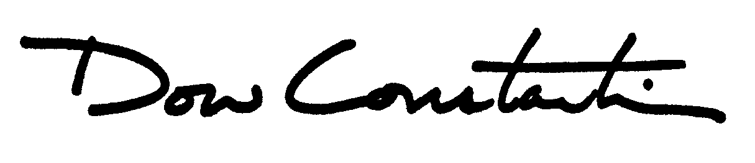
Sincerely,

Dow Constantine
King County Executive

Enclosures

cc: King County Councilmembers
ATTN: Carolyn Busch, Chief of Staff
Melani Pedroza, Clerk of the Council
Dwight Dively, Director, Office of Performance, Strategy and Budget
Rick Ybarra, Liaison for Boards & Commissions

