revised STAFF REPORT

Agenda Item: | 7 | Name: | Leah Krekel-Zoppi
Proposed No.: | 2019-0410 | Date: | November 5, 2019

COMMITTEE ACTION

Proposed Substitute Ordinance 2019-0410.2 establishing the alignment and station locations for Metro Transit’s RapidRide G Line serving the Madison Street corridor in Seattle, passed out of committee on November 5, 2019, with a “Do Pass” recommendation. The Ordinance was amended in committee with Amendment 1 to authorize the Executive to enter into a project agreement that requires a defined service level commitment to operate the G Line for up to five years after the line opens.

SUBJECT

An ordinance establishing the alignment and station locations for Metro Transit’s RapidRide G Line serving the Madison Street corridor in Seattle.

SUMMARY

The proposed RapidRide G Line, serving the Madison Street corridor in Seattle, was identified in Seattle’s Transit Master Plan, and later as part of an extended RapidRide network envisioned in King County’s Metro Connects Long-Range Plan. Seattle will be providing the majority of funding for the $121.4 million capital costs of the project; Seattle’s share of funding includes several secured grants and there is a pending application to the Federal Transit Administration (FTA) for a $60 million federal Small Starts grant. King County’s portion of funding for RapidRide G Line design and construction was appropriated in the 2019-2020 Biennial Budget. Proposed Ordinance 2019-0410 would establish the alignment and station locations for the G Line, allowing the project to move forward with the federal grant application and construction in order for service to begin in 2022.

The proposed alignment for the G Line was established through a process conducted by the City of Seattle to identify a locally preferred alternative. The public outreach process for selection and design of the corridor was carried out in a manner consistent with Seattle’s Race and Social Justice Initiative, according to Seattle staff. The proposed G Line alignment and design is estimated to provide bus riders with a 5-7 minute improvement in travel time compared to current conditions.

King County would own and operate the G Line. As a condition of receiving federal Small Starts grant funding, King County would be required to enter into an agreement committing to operate service on the G Line at a specified level for up to five years.

BACKGROUND

RapidRide Implementation 2006 - Present

The first RapidRide lines were proposed as part of the successful 2006 King County Transit Now ballot measure, which added 0.1 percent to the King County Metro dedicated sales tax. Transit Now included a commitment to implement the first RapidRide lines (Lines A-E) and described RapidRide as including:

- High frequency operation
- Faster, more reliable trip times through exclusive, HOV or Business Access and Transit (BAT) lanes and/or priority at intersections through transit signal priority or queue jumps;
- Improved shelter waiting areas with real-time information at major stops;
- Low emission hybrid diesel-electric buses; and
- Branded buses and facilities with a unique ride and feel.

The RapidRide alignments were established by ordinance, and each line’s bus service start date and frequency were defined by a service change ordinance. At the Council’s direction, the RapidRide F Line was added. Table 1 summarizes these changes.

Table 1. RapidRide Lines A-F Alignment and Service Change Ordinances

Line | Alignment Ordinance | Service Change Ordinance | Service Start
A | 16725 (12/14/2009) | 16844 (5/24/2010) | October 2010
B | 16725 (12/14/2009) | 17100 (5/31/2011) | October 2011
C | 16725 (12/14/2009) | 17320 (5/7/2012) | September 2012
D | 16725 (12/14/2009) | 17320 (5/7/2012) | September 2012
E | 17391 (7/30/2012) | 17584 (5/13/2013) | February 2014
F | 17391 (7/30/2012) | 17584 (5/13/2013) | June 2014
Note: Ordinance 18132, adopted 10-19-2015, revised the C and D Line alignments; the City of Seattle picked up the costs of the added service hours.

As implemented, RapidRide features include well-spaced stops, on-board WIFI, larger and well-lit branded shelters, real time bus arrival signs, One Regional Card for All (ORCA) readers that let card holders pay at some bus stops and board through any of the distinctive red buses’ three doors, and a variety of “intelligent transportation systems” (ITS) to help keep buses moving quickly.

Metro states that rider satisfaction surveys indicate that RapidRide is recognized by riders as a higher quality service, and that ridership growth has outpaced regular Metro service. As of 2018, combined ridership on the six active RapidRide lines had grown 75 percent relative to the pre-RapidRide ridership.

RapidRide Expansion and METRO CONNECTS

In 2015-2016, King County Metro worked with cities and other transportation agencies to develop the METRO CONNECTS Long Range Plan service network. To implement the vision of an extensive, frequent service network, Metro included additional RapidRide lines in various parts of the county, proposing 13 new RapidRide Lines by 2025, with a total of 26 by 2040. Seven of the lines would be Move Seattle RapidRide Lines that were included in the 2015 Move Seattle ballot measure approved by Seattle voters for development in partnership with Metro.

Appendix G to the METRO CONNECTS Long Range Plan explains the process for evaluating potential new RapidRide lines. Current and future productivity, social equity, and geographic value measures are used to identify candidate corridors.

Though building on the foundation of the current RapidRide Lines A-F, future RapidRide Lines are expected to require large investments to feature more Bus Rapid Transit (BRT) characteristics, as described in the METRO CONNECTS plan:

“METRO CONNECTS envisions RapidRide service with much more investment in speed and reliability improvements to achieve more robust BRT. We would target operating 50 percent of RapidRide service in transit-only lanes, and would make additional improvements to reduce delays caused by major bottlenecks, traffic signals, boarding, and other sources.”

Since adoption of Metro Connects, Metro has revised the timeline, with the 2019-2020 Biennial Budget showing plans for implementing seven new RapidRide lines by 2027, with the additional 13 to be delivered at a later time. Table 2 lists the proposed new RapidRide lines and target implementation dates as of October 2019. The Move Seattle RapidRide lines are in italics.

Table 2. RapidRide Implementation Schedule, 2021-2027

Assigned Letter | To / via / from | Target opening
G | Madison:  Madison Valley/E Madison St/ Seattle Central Business District (CBD) | 2022
H | Delridge:  Burien TC/ Westwood Village/ Seattle CBD | 2021
I | Renton/ Kent/ Auburn | 2023
R | Rainier:  Seattle CBD/ Mt. Baker/ Rainier Beach | 2024
J | Roosevelt:  Seattle CBD/ Eastlake/ Roosevelt | 2024
K | Totem Lake/ Bellevue/ Eastgate | 2025
TBD | East or South King County Line (TBD) | 2027

The Council approved the alignment and station locations for the RapidRide H Line, which will serve Burien, Delridge, and Downtown Seattle, in May 2019.

RapidRide G Line Implementation and Funding

Figure 1 shows the typical process and timeline for implementing a RapidRide line, which includes identifying capital funding through a budget ordinance, establishing the alignment, and adopting a service plan for the route.

Figure 1. Typical RapidRide Ordinance Timeline

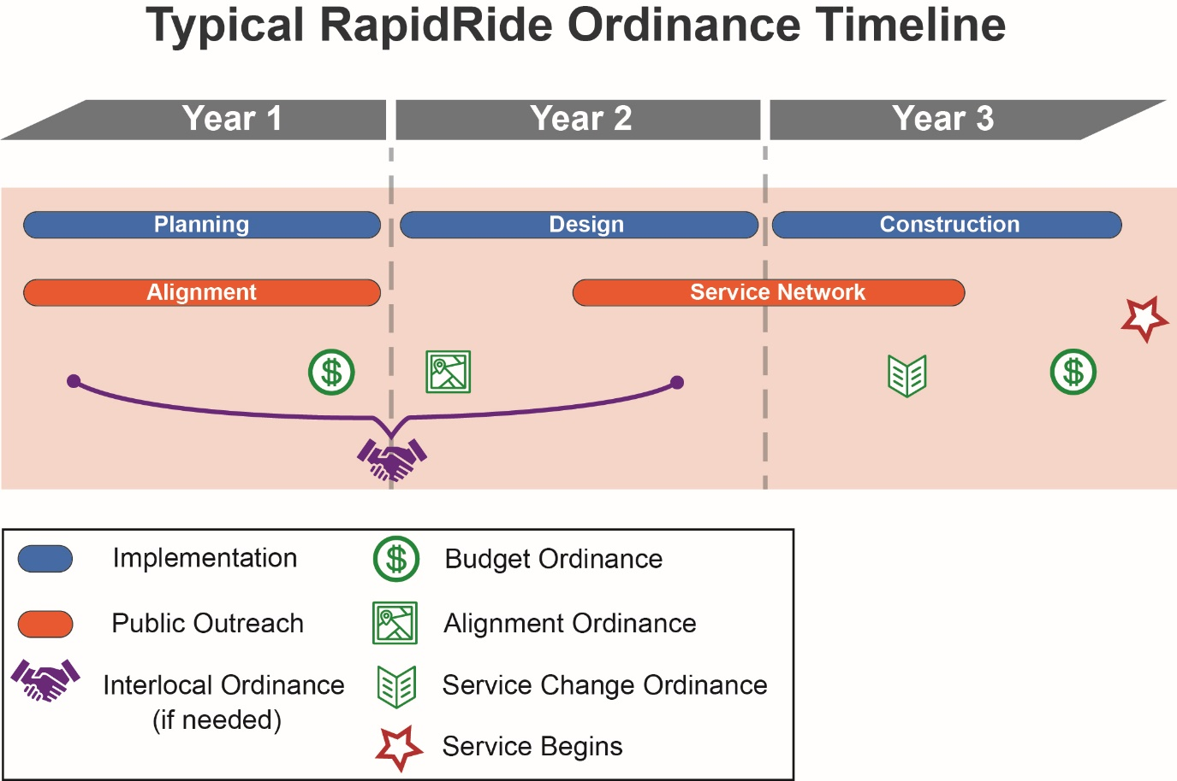

In the case of the G Line, the budget ordinance and proposed alignment ordinance are occurring later than typical in the design phase because the project was initiated by Seattle in 2014 and not determined to be a RapidRide partnership with King County Metro until Metro Connects was developed in 2016.

In the 2017-2018 Biennial Budget, the Council included provisos requiring Metro to submit reports describing the process for implementing new RapidRide lines. In response, the Executive transmitted a report titled “Implementation of New RapidRide Lines/METRO CONNECTS RapidRide Expansion,” which identified the G Line as one of the first two next generation RapidRide lines to be implemented, with specific routing to be determined by the Council. The Council approved the report in September 2017.

Seattle has been the lead of the G Line project, with a planned contribution of up to $118 million towards the estimated $121.4 million capital costs for the project. Portions of Seattle’s contributions include $28.5 million from Sound Transit, $2.5 million from the state, $9.7 million from the Federal Highway Administration, and applying for a $60 Federal Transit Administration (FTA) Small Starts grant.

Metro’s capital funding contributions of $10.5 million for RapidRide G Line implementation and $3.4 million for fleet were included in the adopted 2019-2020 Biennial Budget. The County’s funding is for Metro staff time to plan, design, and implement the project, and to install Metro-owned assets in the corridor, such as shelters, real time information signs, trash bins, and ORCA fare collection equipment; some of these costs are anticipated to be reimbursed by Seattle through funding received from the Small Starts grant.

Other capital improvements in the corridor, funded by partnership dollars, will involve major reconfiguration of the corridor to provide improvements in speed and reliability, safety, and connectivity. Such improvements would include:
- Stations with passenger amenities, including branded RapidRide shelters, off-board fare payment, and real-time arrival information.
- New pavement, dedicated transit lanes, and new bike lanes.
- Transit signal priority at intersections.
- Reconfigured intersections with new crosswalk and bike box markings, separation between pedestrian and bicycle paths, expanded sidewalk space, and restricted turn movements to facilitate pedestrian and bicycle safety.

The County will also be providing the fleet of RapidRide vehicles for the G Line, which will operate with 13 RapidRide branded five-door sixty foot diesel-electric hybrid buses. Using buses with doors on both sides of the vehicle will allow the buses to use the three center platform stations proposed for the alignment.

ANALYSIS

Proposed RapidRide G Line Alignment

Proposed Ordinance 2019-0410 would establish the alignment and station locations for the G Line. Approval of the alignment and station locations would allow Metro to complete design of the capital elements of the G Line and move forward with the FTA Small Starts grant application and construction. The service for RapidRide G Line would be established by the Council through a service change ordinance in 2021 or 2022.

As proposed, the G Line would replace service on Metro’s Routes 11 and 12 along the Madison Street corridor and would travel 2.3 miles from 1st Avenue near the Downtown Seattle waterfront to Martin Luther King, Jr. Way E in the Central District of Seattle, serving Downtown, First Hill, Capitol Hill, Madison Valley, and the Central District.

Figure 2 shows the proposed G Line alignment, and Attachment 6 shows a comparison between existing routes and stops in the area, and the proposed G Line alignment and stations. The proposed RapidRide G Line alignment would connect to dozens of bus routes, the First Hill Streetcar, and ferry service at the Colman Dock Ferry Terminal.

Figure 2: Proposed RapideRide G Line Alignment and Stations
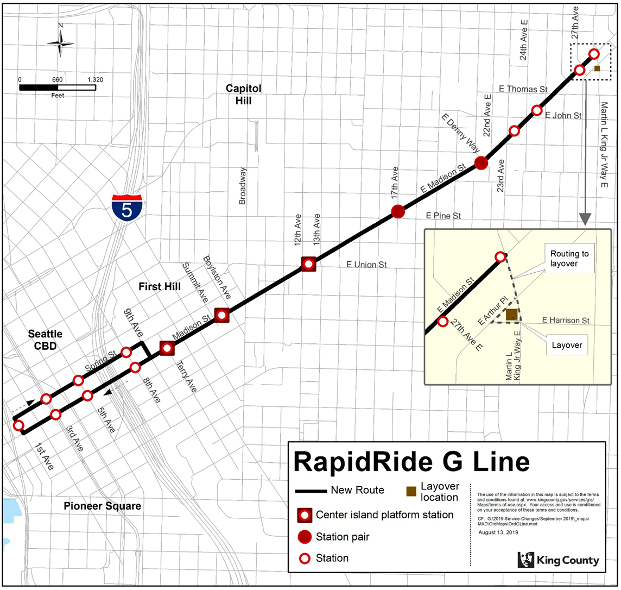

The proposed G Line alignment was developed through a local planning process conducted by the City of Seattle as a component of positioning the project for federal funding. In 2016, Seattle selected a locally preferred alternative (LPA) that was approved by the Mayor and City Council. Proposed Ordinance 2019-0410 is consistent with the LPA adopted by Seattle.

The G Line is proposed to have 21 stations, including three center island platform stations, located an average of less than one‐quarter of a mile apart. The proposed station locations for the G Line are:
- 1st Ave and Spring Street (eastbound)
- Madison Street and 3rd Ave (westbound)
- Spring Street and 3rd Ave (eastbound)
- Madison Street and 5th Ave (westbound)
- Spring Street and 5th Ave (eastbound)
- Madison Street and 8th Ave (westbound)
- Spring Street and 8th Ave (eastbound)
- Madison Street and Terry St (center platform both directions)
- Madison Street between Summit Avenue and Boylston Avenue (center platform both directions)
- Madison Street between 12th Avenue and 13th Avenue (center platform both directions)
- Madison Street and 17th Ave (both directions)
- Madison Street and E Denny Way/22nd Ave (both directions)
- Madison Street and 24th Ave (both directions)
- Madison Street and 27th Ave (eastbound)
- Madison Street and Martin Luther King Jr Way E (westbound)

Approximately 85 percent of the people boarding at existing stops in the proposed G Line corridor would have no more than a block to travel to reach a proposed G Line stop.

Public Engagement

The G Line corridor along Madison Street is home to a diverse community, with census tracks directly south of Madison Street containing a percentages of people of color of 36 – 57 percent; and several major employers and destinations, including Virginia Mason Hospital, Kaiser Permanente Capitol Hill Campus, Swedish Medical Center, Seattle University, and Seattle Central College.

The City of Seattle identified the Madison Street corridor as a priority for high-capacity transit in the 2012 Seattle Transit Master Plan, and began public engagement for the corridor in 2014, before Metro’s participation in the project was identified. Thus the City of Seattle has conducted the public engagement for the corridor. Seattle’s public engagement efforts related to Madison Street bus rapid transit began in September 2014 and have continued through fall of 2019 in several phases:
- September 2014 – Fall 2015: A local planning process to determine the LPA
- August 2016 – August 2019: Three rounds of outreach on various design phases, including 90 percent design in 2019

Seattle’s outreach efforts have included the following:
- Open houses, including an online open house
- Design workshops
- Community meetings
- Online surveys
- Door-to-door outreach to businesses on or near the corridor

For the local planning process, Seattle solicited participation in outreach efforts through mailers, email, the Seattle Transit Blog, the Capitol Hill blog, the First Hill Improvement Association, and Seattle Department of Transportation website. According to Seattle, public and stakeholder input during the local planning process helped inform development of project design priorities and alignment alternatives. Project decisions informed by this phase of design were: the configuration of bus lanes (including having center-running bus lanes), stations, and street design; the eastern and western terminals of the line; and the eastbound alignment in Downtown Seattle.

For the design process, Seattle solicited public engagement participation through email notifications and mailers translated into six languages, web and print advertisements in local media outlets including translated advertisements in ethnic media outlets, and door-to-door outreach to businesses on or near Madison Street. Public feedback during the design phase helped refine the design related to sidewalk and pedestrian access, parking and loading zones, station design, and the bus layover area. Feedback from business and property owners along the corridor also influenced the construction phasing plan for the project.

According to Seattle, staff led the G Line outreach in a manner consistent with the Seattle Race and Social Justice Initiative. In fall of 2015, after the public engagement process for the LPA had concluded but prior to outreach on the project design, Seattle staff conducted a Racial Equity Toolkit for the project, laying out strategies and considerations to address the impacts of the project on racial equity. Public outreach for the design phase was conducted by a project team with experience doing inclusive outreach to traditionally underrepresented populations.

The City of Seattle provided a letter of support for the G Line alignment, available as Attachment 7 to this staff report.

Consistency with METRO CONNECTS and Travel Time Improvements

METRO CONNECTS identified an enhanced RapidRide network to be built out by 2040. The RapidRide G Line is consistent with line 1059 included in the METRO CONNECTS enhanced RapidRide network.

METRO CONNECTS envisions RapidRide service operating 50 percent in transit-only lanes, with additional improvements to reduce delays. With planned dedicated bus lanes through most of the corridor, including center-running bus lanes in the center portion of the corridor, and other planned speed and reliability enhancements at stations and intersections, the proposed G Line alignment is consistent with the METRO CONNECTS vision for RapidRide design. See Attachment 8 for a detailed depiction of the planned G Line design.

The proposed G Line would have an average travel time reduction of 32-46 percent compared to bus travel in the Madison Street corridor today, which equates to a 5-7 minute improvement.

Federal Grant Requirements and Operating Costs

Although Seattle and other partners are funding the majority of the capital improvements for the RapidRide G Line, King County Metro would own and operate the service. While a service change ordinance establishing G Line service levels wouldn’t be adopted by the Council until 2021 or 2022, Metro estimates the G Line would operate with approximately 35,700 service hours, at a cost of approximately $16.5 million in the 2023-2024 biennium (the first full biennium of service). Operation of the RapidRide G Line would also trigger the need to restructure service in the Madison Street corridor, as the main route that would be replaced by the G Line, Route 12, currently serves 19th Avenue, and the G Line would not.

Metro currently operates Route 12 with 27,249 annual service hours. For a rough comparison between current and future service hours in the corridor, operating the RapidRide G Line would require approximately 8,450 more service hours than are currently operated in the corridor. However, that is with the caveat that transit service in the Madison Street corridor would be restructured in concert with G Line service, providing some flexibility in how many total net service hours are distributed in the area.

Currently, Seattle provides 3,560 annual service hours towards the operation of Route 12 through its Transportation Benefit District (TBD) and partnership with Metro. However, the potential for Seattle making future operating contributions towards the G Line cannot be assumed at this time due to the uncertainty around Seattle’s TBD as a funding source, which expires in 2020 and would be impacted if Initiative 976 were to pass in November 2019.

As a requirement for the receipt of an FTA Small Starts grant, which would provide $60 million of the project’s $121.4 million capital cost, King County would need to enter into an agreement with the FTA committing to operate service on the G Line at a specified level for a period of five years. The Executive transmitted Proposed Ordinance 2019-0411 to change county code to allow the Executive to enter into RapidRide project agreements that require defined service level commitments as a prescribed condition of receiving federal financial assistance.

In order to stay on track with the FTA Small Starts grant application timeline, the Executive would need authority to enter into a project agreement for the G Line by the end of 2019.

A policy consideration for entering into a service commitment for the G Line is how such a service commitment would comply with the policies established in Metro’s Service Guidelines for prioritizing service investments. The Service Guidelines recognize that service investments expand and contract according to the availability of resources, but a service commitment implies a static investment in G Line service levels regardless of the availability of resources.

According to Metro, FTA project agreements typically include language allowing FTA to grant a waiver to all or a portion of the service requirement at FTA’s discretion. Metro states that if the agency were in a scenario of needing to cut service and the process of using the Service Guidelines identified a need to cut RapidRide service, Metro would enter into discussions with the FTA and Seattle (the primary grant recipient) about seeking a waiver to comply with the service guidelines. If the waiver were not granted, Metro would not be able to reduce service on the G Line during the term of the service commitment.

However, since the G Line would be a highly productive route serving an area with a high concentration of population and jobs, and a higher than average concentration of people of color, it would be unlikely to be identified for service cuts under the criteria of the Service Guidelines.

Future RapidRide lines that receive FTA Small Start grants would also have service commitments. RapidRide Lines A-F received federal capital grants under different FTA rules, and did not have comparable service commitments. Seattle and Metro did not apply for a Small Starts grant for the H Line.

amendment

Because it is uncertain whether the Mobility and Environment Committee will have adequate time to consider 2019-0411 within the timeline needed for the G Line project, the Chair instructed staff to draft Amendment 1.

Amendment 1 would amend Proposed Ordinance 2019-0410 to authorize the Executive to enter into a project agreement that requires a defined service level commitment to operate the G Line for up to five years after the line opens. The fiscal and policy impacts of this amendment are discussed in the previous section of this staff report.

Ordinance 18449 and http://metro.kingcounty.gov/planning/long-range-plan/
METRO CONNECTS Long Range Plan, page 22
Ordinance 18894
Ordinance 18409, Section 132, Provisos P4 and P5
Motion 14956
According to information provided by Metro during adoption of King County’s 2019-2020 Biennial Budget.
Ordinance 18835, capital project 1132324
According to the Amended and Restated Agreement between the City of Seattle and King County Concerning Fleet Purchase for the Madison Street Bus Rapid Transit Project, RapidRide G Line fleet funding would be divided between the federal Small Starts grant, which would provide funding to purchase nine coaches, and King County, which would provide funding to purchase the additional four coaches.
As the service in the Madison Street corridor is currently provided through a combination of electric trolley buses and diesel-electric hybrid buses, utilization of all-electric buses was explored for the G Line, but according to Metro, bus manufacturers were not able to deliver all-electric buses meeting the specifications needed for the corridor.
Seattle Department of Transportation RapidRide G Line Alignment Public Engagement Summary
Seattle Department of Transportation RapidRide G Line Alignment Public Engagement Summary
METRO CONNECTS Long Range Plan, page 22

