Access Paratransit Service Update

August 31, 2021

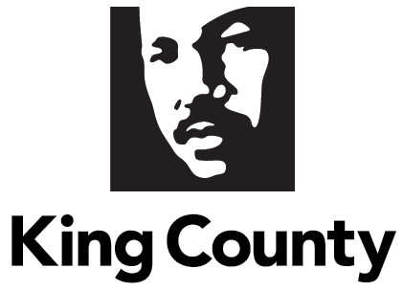

Content
s
Executive Summary 3
Background 6
Contractor’s Compliance with Terms 11
Performance Metrics and Trends 12
Key Findings 13
On-time Performance 13
Pick-up Window 15
Missed Trips 17
Drop-off Window 18
On Board Time, Excessively Long Trips, Will Call 20
Maintenance 22
Control Center Hold Time, Control Center Call Chaining 24
Cost Per Boarding 25
Ongoing Access Rider Survey 26
Areas of Deficiency or Improvement 27
Key Findings 27
On Time Performance 28
Pickup Window 28
Missed Trips 28
Drop off window 28
Control Center 29
Cost Per Boarding 29
Potential Service Improvements 29
E-Faring 29
Online booking 29
Conclusion 31
Next Steps 32
Appendix A: Proviso Text 34
Appendix B: Performance Metrics Tables 36
Appendix C: Performance Standard Tier Chart 39
Appendix D: Average On-Board Times Access May 2020 – April 2021 41

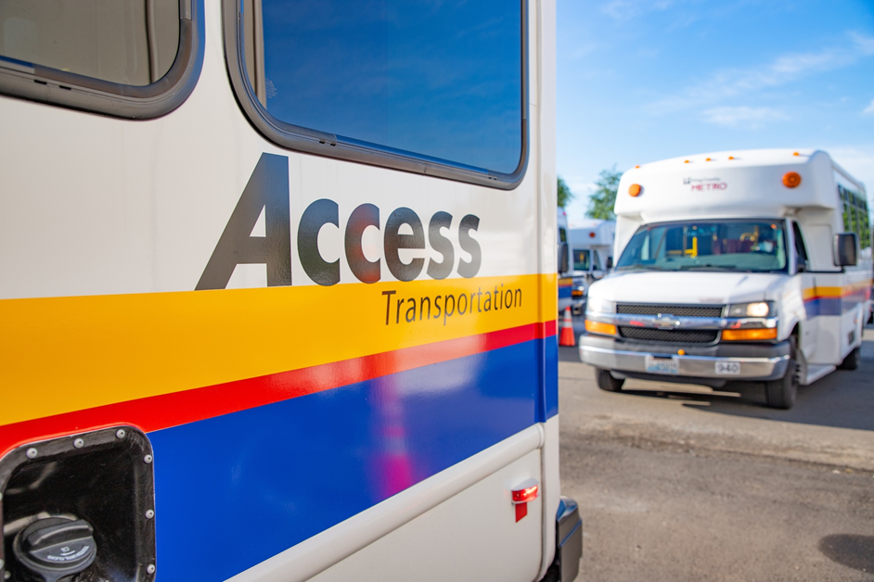

Executive Summary
This is the Phase One response to the adopted King County 2021-2022 Biennial Budget Ordinance 19210, Section 113, Proviso P2. This report documents the performance of the Access Paratransit Service from May 2020 – April 2021, including the COVID-19 response and impacts, final phase of the service transition to a new contractor, contractor’s compliance with contract terms, performance metrics, areas of deficiency, potential service improvements, and potential service innovations.

COVID-19
The COVID-19 pandemic dramatically impacted King County Metro and the Access Program during this reporting period. This included Access experiencing a significant initial decrease in ridership and sustained lower ridership that continued throughout this reporting period. In May 2020 the first month of the reporting period there were 25,673 boardings on Access, which equates to 26% of ridership from May 2019. Ridership fluctuated throughout the next 9 months before stabilizing at 43,000 boardings per month in the final two months and ending the reporting period with a total of 447,640 boardings, 42% of the total from the previous year. To ensure the safety of riders, employees and members of the community, Access made policy and procedure changes to promote social distancing, decrease rider density on vehicles, and increase vehicle cleanings; as such, the service operated outside of normal conditions during the entire reporting period. The policy and procedure changes made on Access were similar to and consistent with changes made on other Metro services such as bus and water taxi to focus on providing safe service consistent with guidance from King County Public Health. However, Access has maintained a higher percentage of riders than other modes.

In the months immediately prior to this reporting period, King County Metro and MV Transportation responded to the pandemic with innovative mobility options to support King County’s transportation needs during the COVID-19 pandemic. This included supporting nutritional assistance programs by delivering 33,544 hot meals and 6,873 food boxes, partnering with King County Public Health to transport COVID-19 positive and presumptive persons, and supporting the County’s essential workers and persons with disabilities who were not certified Access riders but who were impacted by reductions in fixed route service. These efforts continued during this reporting period and included additional innovative solutions King County Metro and local partners developed, such as vaccine transportation, which provided trips for riders to vaccine distribution sites. Due to the effects of COVID-19 on the service, all performance metrics for Access have been significantly impacted for the entire reporting period.

Service Transition
This reporting period began with the continuation of the Service Improvement and System Optimization phase, the third phase of the transition of the Access program from the former service model with multiple contractors to the current service model with MV Transportation as the sole contractor responsible for the service. The two previous phases of the transition included a Planning and Implementation Phase and a Service Stabilization Phase. The Planning and Implementation Phase included preparation and transition of all aspects of the Access program, including facilities, equipment, and staff. This took place from May 29th to November 10th, 2019. The Service Stabilization phase included stabilization of operations under the new service model and MV Transportation and took place from November 11th, 2019 to January 31st, 2020. Successful completion of the first two phases of the transition was key in allowing Access to move forward with the third and final phase of the transition.

The Service Improvement and System Optimization phase began in February 2020 and was scheduled to last until December 31, 2020. The primary goal of the third phase of the transition was to introduce service improvements while continuing to optimize the system. The service improvements scheduled for implementation included online booking, E-Faring, and same day service for Access customers. Shortly after moving into the third phase of the transition, the COVID-19 pandemic significantly impacted service conditions for the Access program and many of the optimization and improvements were halted or delayed.

Compliance with Contract Terms
Items of relevance during this reporting period include the contractor’s compliance with software maintenance and service availability policies. Implementation of some new features and other items agreed to in the contract were delayed or postponed during transition. These delays were a result of additional challenges King County Metro and MV Transportation faced during the COVID-19 pandemic response. Waivers for the monthly performance incentives and disincentives that were started prior to this reporting period were continued through June 2020 due to the pandemic’s impacts on the system. Incentives and disincentives were restored for all KPI’s in July 2020, with the exception of cost per boarding and the subcontracted/NDS usage mix which was waived for the entire reporting period due to a significant decrease in ridership and the continuation of COVID-19 response policies and procedures which significantly increased the cost per trip. Metro will continue to work with MV Transportation to determine when these elements will be restored.

Performance Metrics Improvements and Deficiencies
Of the 18 Key Performance Indicators (KPIs) listed in this report, 12 have defined performance standards, of which 9 reached the standard during this reporting period. Of the 3 that did not reach the performance standard during the reporting period, 2 have a performance standard of 0 allowable instances in a month, a significantly more challenging KPI to achieve. Other significant findings for this report include the following:

- On-time Performance Appointment showed improvement between the first and fourth quarter of the reporting period and met the performance standard for the final 8 months.
- The KPI associated with On-Time Performance Pick-Up performed above the performance standard for all 12 months of the reporting period.
- Of the 3 KPIs associated with the Pick-Up Window, Early Pick-up and Late Pick-up showed a decrease in performance between the first and fourth quarter of the reporting period. Excessively Late Pick-up showed improvement between the first and fourth quarter of the reporting period.
- Of the 2 KPIs associated with Missed Trips, one saw improvement between the first and fourth quarter of the reporting period and one did not. Both did not reach the performance standard of 0 instances during a month.
- Of the 2 KPIs associated with the Drop-Off Window, one saw improvement between the first and fourth quarter of the reporting period and one did not.
- Average On-Board Times for Access were shorter than comparable fixed route On-Board times for the entire reporting period.
- Excessively Long Trips performed above the performance standard the entire reporting period.
- Will Call Trip response times fluctuated during the reporting period, ending with a marginal decrease in response time.
- For Maintenance, all three KPIs performed above standard for most of the reporting period, with 2 performing above standard for the full reporting period.
- Of the 2 KPIs associated with the Control Center, one performed above standard the entire reporting period and one for six months during the reporting period.
- Cost per boarding showed improvement between the first and fourth quarter but performed below standard for the entire reporting period.

Next steps
Access is currently undergoing a multi-phased approach towards the restoration of normal service parameters and resumption of full system capacity. This plan is based on the Governor’s phased approach to reopening, King County and Metro policies and guidance along with federal regulations. Washington State implemented full reopening of the state on June 30, 2021, King County Metro and the Access program planned and implemented full restoration of vehicle capacity on July 3, 2021. Access riders along with all of Metro riders will continue to be required to wear masks on public transit as part of the Transportation Security Administration’s (TSA) mask mandate which is currently in effect through September 13th, 2021. King County Metro and the Access program anticipate ridership to slowly return, though much demand will be dependent on when locations such as senior and community centers, along with places of employment, return to normal operations. A large component of preparing for resumption of normal service demand includes recruiting and hiring of drivers and other staff. MV Transportation continues to recruit, train, and hire drivers and staff as ridership allows.

As King County Metro looks towards the future, budget and ridership impacts of COVID-19 remain significant concerns. Metro will resume the implementation of service innovation and improvements such as same day service in 2022. Access will also analyze service conditions to optimize efficiencies while delivering high quality service to meet the expectations of riders, stakeholders, and those set forth in the Access contract. This includes reviewing current leases and future facilities plans. Most recently, King County Metro purchased the long-standing site of the South Park Access operations facility. Purchasing this facility secured operations capacity in the central Seattle area, as suitable locations for operations bases become increasingly scarce in the future. The purchase of the South Park Access operations facility also provides a potential base for fleet electrification. Electrification of the Access fleet is a key component of the program’s efforts towards Reducing Greenhouse Gas Emissions, a core component of the County’s Strategic Climate Action Plan (SCAP).

Background

Department Overview
King County Metro is the largest public transportation agency in the Puget Sound region, and under normal service conditions delivers more than 130 million rides per year through a variety of mobility options, including: fixed route services (bus, rail, streetcar, and water taxi), contracted services (Dial-A-Ride Transit and Access paratransit service), and shared and connected services (Vanpool, Vanshare, Rideshare, and Community Access Transportation). Metro was recognized as the number one transit agency in North America in 2018 by the American Public Transportation Association.

Key Historical Conditions
The Americans with Disabilities Act (ADA) requires transit agencies like King County Metro ensure their transportation systems are accessible for people with disabilities. The ADA also mandates that transit systems have a complementary paratransit service for when riders can’t take the bus or rail because of barriers they face due to their disability. Access Paratransit is the ADA complementary paratransit service provided by King County Metro and is designed to meet the eligibility and service criteria established by the Federal Transportation Administration (FTA). Under normal service conditions, Access provides approximately 1,000,000 trips for upwards of 12,000 registered users annually.

ADA paratransit has specific eligibility and service criteria set forth by the Federal Transportation Administration. The FTA mandates that paratransit must be comparable to fixed route in regards to: service area (at least ¾-mile on either side of a fixed route); fares (not more than twice the regular fixed route fare for a comparable trip); no restrictions on trip purpose, hours, and days of service (at least the same as fixed route); and no capacity constraints. Access Paratransit adheres to these criteria and at King County Council direction, provides service that goes above and beyond FTA minimum requirements through an expanded service area (providing service outside ¾ mile from fixed route) and increased hours of service in select areas.

Historically, Access service has been provided by private companies and non-profits who contract with King County Metro, overseeing day-to-day operations and staffing to include operators, supervisors, maintenance, control center, and reservation staff and support. The current Contractor, MV Transportation, has been solely responsible for service of the Access program since November 2019.

Current Conditions
Access Transportation consistently strives to achieve the goals and objectives of the King County Strategic Plan, by providing Mobility options that, “deliver a safe, reliable and seamless network of transportation options to get people and goods where they need to go.” As King County Metro continues to explore transportation projects and services that complement the Access program, mobility options such as a same day service program for Access riders will, “Increase integration between transportation modes and all service providers,” a key objective of King County’s Mobility goal.

During this reporting period, King County Metro and the Access program continued to make efforts to, “Provide more equitable mobility access and reduce historic gaps,” a key objective of the County’s Mobility goal. King County Metro has made progress in developing next steps and allocating funding to implement the findings of the recent Equity Impact Review (EIR) published in January 2020. Findings of the EIR includes increased and focused outreach to communities where English is a second language and piloting a cultural navigator’s program to support possible applicants through the robust eligibility program. Though the COVID-19 pandemic halted many of the community outreach opportunities planned or in place, Metro increased engagement with current riders by developing and disseminating brochures for online booking, launching a new post trip customer survey, and creating a rider newsletter. As the pandemic subsides and conditions return to normal, Metro will seek to resume or implement community outreach efforts.

Metro and MV Transportation continued to work together to carry out the goals and objectives of the King County Metro Strategic Plan. Metro’s implementation of updated contract management and quality assurance processes that focus on all aspects of the service, coupled with increased rider engagement, align with the strategic goal of providing service excellence through robust customer support, reliable operations, and innovative mobility options that are responsive to the needs of the community. The Access program demonstrated improvement in several key performance indicators, including on-time performance for appointment, excessively late pick-up, missed trip pick-up, early drop-off appointment, will call response times, miles between road calls, control center hold times, call chaining, and cost per boarding.

Metro continues to develop and implement diverse customer feedback and engagement opportunities for Access customers. During this reporting period, Metro launched the Access Paratransit Advisory Committee (APAC), a Mystery Rider program, and a post-trip survey program and continued implementation of the ongoing Access customer survey. These efforts support Access’s commitment to public engagement and transparency by promoting diverse public engagement that informs, involves, and empowers people and communities served by the program. The information gained from the rider survey and the mystery rider program have been used to inform Metro of the customer experience and present opportunities for operational improvements, thus increasing rider satisfaction. Metro will continue to engage its customers through surveys and the Access Paratransit Advisory Committee and will seek out rider engagement whenever the opportunity arises.

Transition of service

Phase 3: Service Enhancements and System Optimization, February 1, 2020 – December 31, 2020
The third and final phase of the transition of the Access program focused on implementing system enhancements while increasingly optimizing the system. Service enhancements with planned implementation included: online booking, E-Faring, and a same-day service pilot. As detailed below, there have been significant impacts to this phase of the transition. Increased resources and attention have been reallocated to respond to the pandemic, while impacts on ridership and current system parameters have delayed further optimization efforts. As the Access program recovers from COVID-19, service enhancements and optimization efforts that have been delayed or paused will resume.

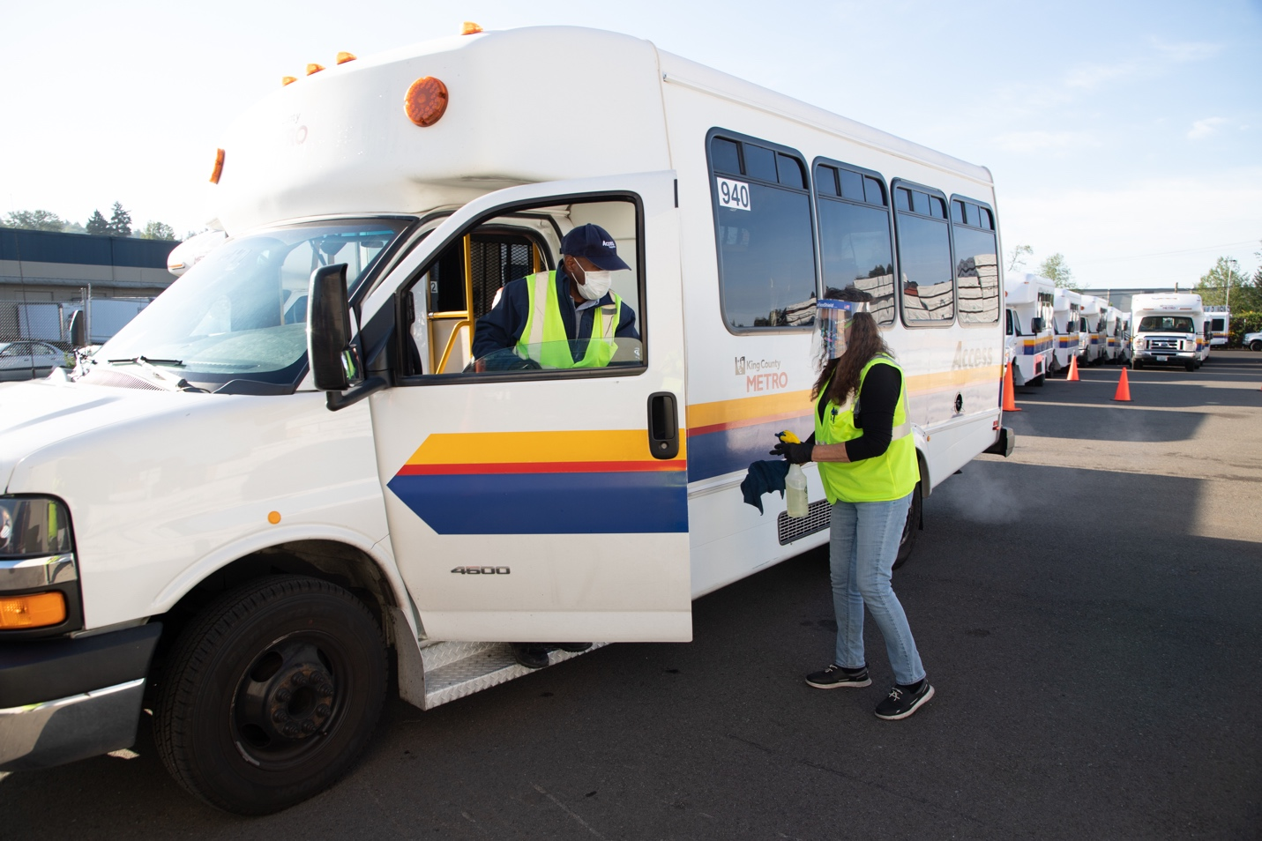

COVID-19
COVID-19 dramatically impacted Access Transportation and public transportation at large during this report period. Access began the reporting period in May 2020 with 25,673 boardings, a 73.5% decrease from the previous year. Ridership fluctuated throughout the entire reporting period, before finishing at 447,640 boardings, 42% of the previous year. Ridership levels were not the only significant change for the program. King County Metro enacted large scale changes across the program and all Metro services in the months preceding and during this reporting period, these changes, aimed at safeguarding employees and riders, impacted all aspects of system performance. The most significant policy and procedures changes are summarized below.
Figure 1: Monthly Ridership on Access 2019 vs 2020-2021

- Enhanced Cleaning and Sanitizing: Continuation of additional cleanings of all Access vehicles were accomplished through the creation of enhanced sanitizing procedures. Cleaning stations were deployed at Access bases across the County and aimed at preventing the potential spread of COVID-19 to riders and employees via increased cleaning of high touch surfaces.
- Social Distancing and Decreased Capacity: Continuation of social distancing by decreasing the density of riders on Access vehicles and closing down seats to maintain distance between riders and employees. To provide additional protective measures for riders, plastic shields were installed on Access vehicles and procedures developed that increased ventilation of vehicles.
- Fare Collection: Continuation of the no fare collection policy during a portion of the reporting period. From March to October 2020, fares were not collected on Access or other Metro services.
- Contact Tracing: Access continued implementation of procedures to conduct contact tracing when notified by staff or riders that they have been exposed to COVID-19. An example of Metro successfully using contact tracing and additional mobility options to Meet the Transportation Needs of the Community included when Metro was notified by a local dialysis center that an Access rider became infected, Metro alerted potentially impacted riders while the COVID-19 positive rider utilized the Transportation for Pandemic Response (TPR) service to be safely and appropriately transported.
- Staffing: As ridership for Access decreased, Vehicle Revenue Hours (VRH), the primary compensation method for MV’s provision of Access service, was also reduced. MV Transportation subsequently made the business decision to furlough employees.

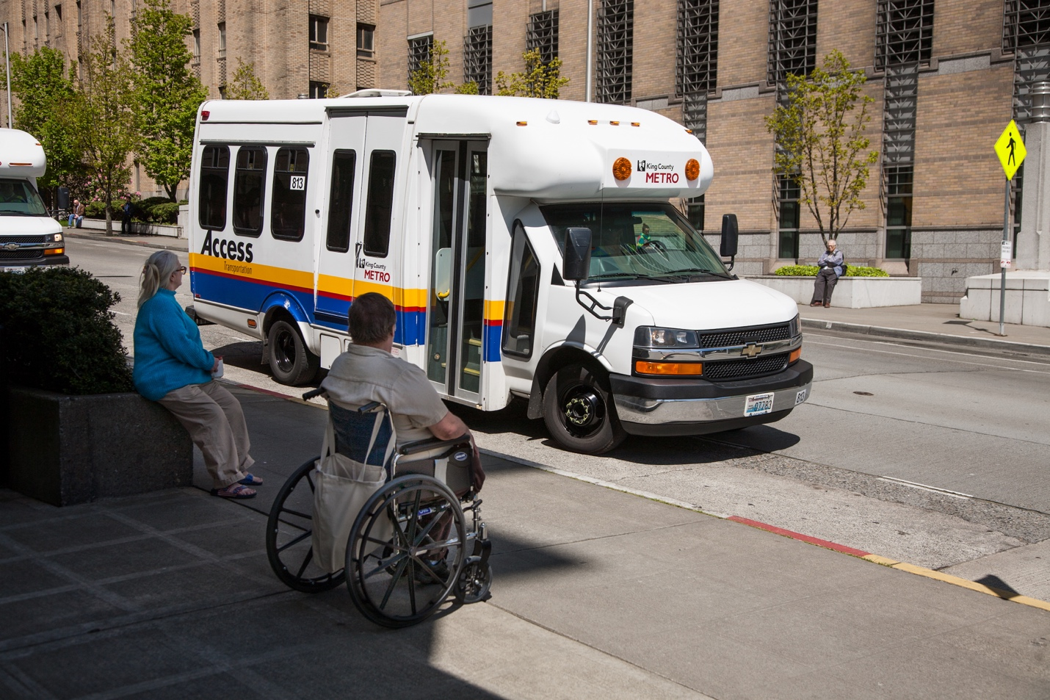

Meeting the Transportation Needs of the Community
During the initial response to COVID-19, King County Metro and MV Transportation sought ways to implement the mobility goals of the County’s strategic plan, delivering safe and reliable transportation. Throughout the COVID pandemic Access staff regularly coordinated with groups such as the King County Senior Centers and the Developmental Disabilities and Early Childhood Supports Division. These collaborations bolstered outreach efforts to ensure that the community is aware of the services provided by Access. This led to the development of unique mobility solutions to the county’s transportation needs during this public health crisis. These efforts were established prior to the period covered by this report and continued during this reporting period.

Transportation for Pandemic Response (TPR)
In the months prior to this reporting period, a partnership was created between King County Public Health, social human service agencies and area medical providers to meet the increasing need for transportation for confirmed COVID-19 patients and symptomatic, test-pending individuals. Transportation for Pandemic Response (TPR) utilizes King County Metro Access vehicles with partitions that were specially designed by King County Metro Vehicle Maintenance and vehicle operators, call center, and maintenance support staff from MV Transportation to provide this service. Due to the continued need for this service, it was continued throughout the entire reporting period. From May 2020 through April 2021, the TPR service provided 4,474 trips.

Transportation for Nutrition Support
Many local foodbanks and community-based organizations remained closed for on-site food pantries and hot meals and continued with a delivery only service model that was implemented prior to this reporting period. As such, Access continued its collaboration with these organizations to deliver food boxes and hot meals in a safe manner. Access partnered with United Way, Northwest Harvest, and Seattle YWCA, among numerous other foodbanks, nonprofits, and community-based organizations, to deliver 33,544 hot meals and 6,873 food boxes from May 2020 – April 2021.

Transportation for Non-Access Riders/Special Rider Requests
As a response to the temporary service reductions made to fixed route service, Access began transporting non-paratransit certified persons with disabilities to their essential destinations as well as other riders impacted by service changes. Continuation of the program was tied to the state’s phased approach to reopening. As King County entered phase 3 of the reopening process, this triggered an eight week phase out of the program. From inception until completion in June 2021, the Special Rider Request program provided 12,000 trips on Access.

Transportation for Vaccines
King County Metro was involved in efforts to ensure that all King County residents had access to the vaccine for the COVID-19 virus. Access was a founding member of the COVID Vaccine Mobility Task Force, which brought together transportation providers, Public Health, Aging and Disability Services, and others. Together the Task Force identified transportation barriers to receiving vaccinations (availability, accessibility, information gaps, as well as actual transportation) and systematically addressed them. Access was a “trusted voice” that shared communication, encouraging customers to become vaccinated and telling them about opportunities to be vaccinated. Transportation was provided to vaccination appointments for members of the public regardless of Access eligibility. From the first trip, which took place in January 2021, until the end of this reporting period in April 2021, the service provided 1,703 trips to registered Access riders and 186 trips to nonregistered riders.

Report Methodology
To produce this report, King County Metro staff queried internal data systems and reviewed monthly and quarterly performance reports. The data represented in this report was developed in collaboration between MV Transportation and King County Metro, as part of monthly performance reviews and other established reporting and monitoring processes. King County Metro Accessible Services staff completed the data queries, collection, and analysis. The report was developed by King County Metro Accessible Services staff with assistance from King County Metro’s Communications Team.

Contractor’s Compliance with Terms

This section of the report covers King County Council’s request for an update on the Access contractor’s compliance with the contract terms.

Items with significance this reporting period include the following.
- Service Level Agreement: Service availability was within the performance standard for the reporting period. No issues of non-compliance were identified during this reporting period.
- Software Maintenance Policy: The contractor has been compliant with the Software Maintenance Agreement. No issues of non-compliance were identified during this reporting period.
- Pricing: The contractor has been compliant with the pricing agreed to in the Access Contract. In response to the unique service conditions that arose as a result of the COVID-19 pandemic, King County Metro and MV Transportation agreed to an emergency pricing plan to ensure continuity of operations throughout the COVID-19 pandemic.
- Contract Amendment: During this reporting period, King County Metro and MV Transportation agreed to two Contract Amendments. These amendments focused on the continuity of operations during the COVID-19 pandemic as well as the Transportation for Pandemic Response (TPR) program.
- Changed Requirements: Due to the COVID-19 pandemic, local and state orders regarding social distancing have impacted the service requiring significant policy and procedures changes. Federal directives regarding mask usage on public transportation required updates to policies and procedures as well. King County Metro and MV Transportation worked together to respond to these orders and directives.
- Audits: The contractor provided access for Metro staff to conduct audits of records, as part of contract oversight. There have been no issues of noncompliance with audit access identified during this reporting period.
- Contract Incentives and Disincentives: As a result of impacts of COVID-19 on the system performance, all contract incentives and disincentives were waived for the months of March through June 2020. Incentives and disincentives were restored for all KPI’s in July 2020, with the exception of cost per boarding and the subcontracted/NDS service mix, which remained in abeyance for the entire reporting period due to the significant impacts that social distancing and other policy and procedures changes.
- Implementation Date Changes: As a result of the impacts of COVID-19, some of the implementation dates for new features and components associated with this contract were delayed or postponed during this reporting period. Some of the delayed features include online booking or “E-faring,” which is scheduled for launch in 4th quarter 2021, and implementation of a same day service pilot, which has a planned launch in 2022.

Performance Metrics and Trends

This section provides performance metrics and trends for the Key Performance Indicators (KPI) requested by County Council for the reporting period of May 2020 through April 2021. Included in this section are KPIs related to: On-time Performance, Pick-up Window, Missed Trips, Drop-off window, On-board times, Will Call, Maintenance and Control Center, and Cost Per Boarding. As part of the monthly performance review process, King County Metro and MV Transportation review all KPIs and discuss issues and challenges. Areas of deficiency or where performance does not meet the standard are given increased attention and action plans developed to improve performance.

Key Findings
- Of the 18 performance metrics listed in this report, 11 performed the same or better over the course of the reporting period.
- Of the 12 KPIs with defined performance standards, 9 met the performance standard at some time during the reporting period.
- Of the 3 that did not meet the standard, 2 had a performance standard of 0 instances allowed in the month.
As mentioned previously, the COVID-19 pandemic has had dramatic impacts on the Access program, including: decreased ridership, changes in road conditions, rider transportation patterns, and closure of common locations (e.g., adult day and community centers, places of work), along with policy and system changes put in place by King County Metro for social distancing purposes. As a result, virtually all performance metrics for the Access program have been impacted for this reporting period, with continued impacts likely to be felt for the near to mid-term future.

Within the Access contract there are three different tier levels of performance. The current funding for Access is for Tier Level One. All performance standards listed within this report are from Tier Level One. Appendix C: KPI Definitions Tier Chart contains all tier levels as defined within the contract. Additional tables with performance metrics are included in Appendix B: Performance Metrics Tables.

On-time Performance
On-time Performance includes two associated performance metrics: On-time Performance Appointment (OTP-A) and On-time Performance Pick-up (OTP-P). On-Time Performance Appointment (OTP-A) is a relatively new KPI for Access, being established for the first time in November 2019.

Figure 2: On-time Performance Appointment, May 2020 – April 2021
On-time Performance Appointment (OTP-A) is defined as the percentage of total appointment-based trips (including No-shows and Cancel at Door appointments) where the vehicle arrived between zero and 30 minutes before the customer’s scheduled appointment time. Riders who would like to arrive early for their appointment are able to opt out of this requirement via the Rider’s Choice program. The performance standard for OTP-A is 92 percent.
- Access began the reporting period with an OTP-A of 90.5 percent for the month of May. This was the third lowest performance rating for the entire period.
- Performance improved over the course of the reporting period, experiencing a low of 90.1 percent in June and a high of 96.1 percent in March.
- After performing below standard for the first 4 months, OTP-A was above standard for the final 8 months of the reporting period.

Figure 2: On-time Performance Pick-up May 2020 – April 2021
On-time Performance Pick-up (OTP-P) is defined as the percentage of total trips (including No Shows and Cancel at Door appointments) where the vehicle arrived between zero and 30 minutes in relation to the beginning of the pickup window. The standard performance range for OTP-P is 92 percent. OTP-P may operate in a range of 91.5 to 92.5 percent before incentives or disincentives are applied.
- Access began the reporting period with an OTP-P of 96.1 percent for the month of May, the third highest performance for this time.
- Performance fluctuated between a high of 96.5 percent in August and a low of 94.6 percent in April.
- OTP-P was above the performance standard for the entire reporting period.

Pick-up Window
The Pick-up window refers to the 30-minute time period when a rider is scheduled to be picked up by the Access vehicle. There are three KPIs associated with the Pick-up Window: Early Pick-up, Late Pick-up and Excessively Late Pick-up. Early Pick-up and Excessively Late Pick-up were established for the first time in November 2019.

Figure 3: Early Pick-up May 2020 - April 2021
Early Pick-up is defined as when the vehicle arrives before the beginning of the pick-up window. This practice is discouraged, but these trips are counted as on-time. It is Access policy that riders are not required to board until the window opens. There is no performance standard for Early Pick-up, but the trips are tracked and reported by the contractor and monitored by Access for excessive Early Pick-up activity.
- Access began the reporting period with 1,812 instances of Early Pick-up in May, the fourth lowest amount during this time.
- Early Pick-up fluctuated between a high of 2,362 in July and a low of 1,635 in December, ending with 2,281 instances in April.
- The majority of Early Pick-ups occurred when the trip was assigned to a non-dedicated service provider.

Figure 4: Late Pick-up May 2020 - April 2021
Late Pick-up is defined as a trip in which the vehicle arrived between zero and 30 minutes after the pick-up window, and the rider chooses to still take the trip. There is no performance standard for Late Pick-up. This KPI is tracked and reported by the contractor and monitored by Access for excessive instances.
- Access began the reporting period with 735 instances of Late Pick-Up in May, a low number for the reporting period.
- Late Pick-up fluctuated from a low of 735 instances in May, 1,731 instances in October, and ending a high of 1,877 instances in April.
- Late Pick-up saw an increase in occurrences for the final two months of the reporting period.

Figure 5: Excessively Late Pick-up May 2020 - April 2021
Excessively Late Pick-up is defined as a trip where the vehicle arrived between 30 and 60 minutes past the end of the pick-up window and the rider chooses to still take the trip. There is no performance standard for Excessively Late Pick-up, but this KPI is tracked and reported by the contractor and monitored by Metro.
- Access began the reporting period with 92 instances of Excessively Late Pick-ups in May, the fourth lowest amount during this time period.
- Performance fluctuated throughout the reporting period, experiencing a high of 160 instances in June, and a low of 55 occurrences in January before increasing to 125 in April.

Missed Trips
There are two KPIs associated with missed trips: Missed Trip Pick-up (MT-P) and Missed Trip Appointment (MT-A). Missed Trip Appointment was established for the first time in November 2019. Missed Trip Pick-up has seen no changes in recent time.

Figure 6: Missed Trip Pick-up May 2020 - April 2021
Missed Trip Pick-up (MT-P) is defined as a trip in which the vehicle arrived more than 60 minutes after the pick-up window, regardless of whether the rider chooses to take the trip. The performance standard for Missed Trip Pick-up is zero Missed Trip Pick-ups per month.
- Access began the reporting period in May with 28 instances of Missed Trip Pick-ups, the third highest number for the reporting period.
- Missed Trip Pick-up performance fluctuated between a high of 53 instances in July, to a low of 10 instances in February, before increasing for the final two months ending with 18 in April.
- Access did not meet the performance standard of zero Missed Trip Pick-ups during this period.
Figure 7: Missed Trip Appointment May 2020 - April 2021
Missed Trip Appointment (MT-A) is defined as a trip in which the vehicle arrives more than ten minutes late for the customer’s scheduled appointment time. The performance standard for Missed Trip Appointments is zero Missed Trip Appointments per month.
- Access began the reporting period with 30 instances of Missed Trip Appointments in May, a low for the reporting period and best performance during this time.
- Missed Trip Appointments fluctuated to 126 instances in October before decreasing to 77 in February and ending with a reporting period high of 145 in April.
- Access did not meet the performance standard during this reporting period.

Drop-off Window
The Drop-off Window refers to the 30-minute window riders are given prior to their appointment. KPIs for this section include Early Drop-off and Late Drop-off. Both KPIs were implemented for the first time in November 2019.
Figure 8: Early Drop-off May 2020 - April 2021
Early Drop-off is a trip in which the vehicle arrives at a drop-off more than 60 minutes prior to the customer’s scheduled appointment time, excluding trips where the customer has agreed to arrive early. The Rider’s Choice program, which provides riders the opportunity to approve to arrive early for an appointment early, was developed after listening to customer feedback. There is no performance standard for Early Drop-offs, but this KPI is tracked and reported by the contractor and monitored by Metro.
- Access began the reporting period with 103 instances of Early Drop-off in May, the lowest amount and best performance for the reporting period.
- July brought 360 instances of Early Drop-off, resulting in the highest number and lowest performance during this period, performance fluctuated for the rest of the report period ending with 209 instances in April.
Figure 9: Late Drop-off May 2020 - April 2021
Late Drop-off is a trip in which the vehicle arrived between zero and 10 minutes late in relation to the customer’s scheduled appointment time. There is no performance standard for Late Drop-offs, but this KPI is tracked and reported by the contractor and monitored by Metro.
- Access began the reporting period with a high of 34 instances of Late Drop-offs in May, the lowest number and best performance for this reporting period.
- Late Drop-offs increased through November which had 203 instances, before fluctuating and ending with 224 instances in April, a high for the period.

On Board Time, Excessively Long Trips, Will Call
On Board Time and Excessively Long Trip KPIs are associated with the amount of time a rider is on the Access vehicle during their trip. The Will Call response time is the amount of time it takes for the vehicle to arrive after a rider requests a Will Call Trip.

Figure 10: Average On-board Travel Time Access vs. Fixed Route May 2020 – April 2021
On-Board Time (OBT) is the amount of time a rider spends on the Access vehicle. Excessively Long Trip is the KPI used to measure On-Board Time.

- Average OBT slightly decreased from the first quarter to the fourth quarter, Appendix D highlights the average monthly travel for Access time based on mileage.
- Average travel times on Access were roughly one third the travel time on similar length fixed route trips.

Figure 12: Excessively Long Trip May 2020 – April 2021
Excessively Long Trip is defined as a trip where the customer’s on-vehicle time from origin to destination is greater than an equivalent fixed route travel time (as defined by the ADA) plus 15 minutes. The performance standard for Excessively Long Trip is the total percentage of excessively long trips that are longer than the defined value are not more than 3 percent of all trips delivered.

- Access began the reporting period with a low of .04 percent Excessive Long Trips in May, the lowest percentage and best performance.
- Performance fluctuated throughout the reporting period with a high of .51 percent in Sep and Oct, before ending the period with .42 percent in April.
- The performance standard for this KPI was met for the entire reporting period.

Figure 13: Average Will Call Response Time May 2020 - April 2021
Will Call is defined as a same day trip that is scheduled for a rider that is not ready at the time of his or her original request. There currently is no performance standard for Will Call response times, but Access has a No Strand policy for riders, meaning Access guarantees a rider a ride back from their destination. Access will negotiate a Will Call ride home for customers as schedule permits. Though not required by FTA for ADA paratransit, Access’s No Strand policy provides riders a piece of mind should they experience a delay in their regularly planned trip.

- Access began the reporting period in May with the fourth highest Will Call response time of 123 minutes.
- Performance fluctuated between a high of 130 minutes in August, to a low of 102 minutes in March.

Maintenance
There are three KPIs associated with vehicle maintenance for the Access program: Miles Between Road Calls, Preventative Maintenance, Random Inspection.
Figure 14: Miles Between Road Calls May 2020 - April 2021
Miles Between Road Calls is calculated by dividing the number of mechanical roads calls by the total mileage of revenue fleet Vehicles traveled in a period. The performance standard for miles between road calls is 25,000 for mechanical issues. A Road Call or “Vehicle Road Call” is defined as, “Mechanical failures of a Vehicle in revenue service that causes a delay to service, and necessitates repair or adjustment in the field or removing the Vehicle from service until repairs are made.” Higher Miles Between Road Calls is indicative of a higher performing maintenance system.

- Access began the reporting period with 65,490 Miles Between Road Calls in May, this was the sixth best performance for the reporting period.
- Performance fluctuated during the reporting period with a best of 616,169 Miles Between Road calls in December and low of 39,185 Miles Between Road Calls in April.
- Access performed above the performance standard for the entire reporting period.

Figure 15: Preventative Maintenance Performance May 2020 - April 2021
Preventative Maintenance focuses on the performance of necessary maintenance on Access vehicles as specified by the manufacturer or within an accepted preventative maintenance plan. The performance standard is 98 percent of all preventative maintenance performed on-time and per plan.

- Access began the reporting period with 100 percent Preventative Maintenance in May, one of the nine times this occurred during the performance review period.
- Performance fluctuated slightly, reaching 99.4 percent in December, before ending the reporting period with 99.2 percent in April.
- This KPI was above standard for all 12 months of the reporting period.

Random Vehicle Inspections is defined as random inspections of vehicles in revenue service. The performance standard for random vehicle inspections is all revenue service vehicles must meet standards specified for operational features and safety equipment when in service. MV Transportation inspects 15% of in-service vehicles monthly.

- During the month of November, 5 instances of vehicles not meeting operational or safety standards were found.
- Random vehicle inspections by King County Metro were postponed for the majority of the reporting period due to COVID-19 precautions.

Control Center Hold Time, Control Center Call Chaining
Figure 16: Control Center Hold Times May 2020 – April 2021
Control Center Hold Time is defined as the average time a call spends in queue before being answered by an employee. This applies to all public contact channels: reservations, ride check, rider services, etc. The performance standard for control center hold time is 90 percent of calls answered in less than 3 minutes and 95 percent of calls answered in less than 5 minutes per calendar month.

- Access began the reporting period with 99.2 percent of Control Center calls answered in 3 minutes and 99.7 percent of calls answered in 5 minutes.
- Both performance measures stayed above 99 percent for the entire reporting period.
- Both KPI’s saw performance above the performance standard for the entire reporting period.

Month | Call-Chaining
May-20 | 3
Jun-20 | 1
Jul-20 | 1
Aug-20 | 0
Sep-20 | 0
Oct-20 | 7
Nov-20 | 3
Dec-20 | 0
Jan-21 | 1
Feb-21 | 0
Mar-21 | 0
Apr-21 | 0
Table 1: Call Chaining May 2020 – April 2021
Call Chaining is defined as when a customer call is answered and then immediately put on hold in order to meet performance requirement metrics. The performance standard for call chaining is that call
chaining is prohibited or there are zero instances of call chaining.

- Access began the reporting period with 3 instances of call chaining in May, the second highest amount for the reporting period.
- Performance fluctuated from May through October, which saw a reporting period high of 7 instances before trending downwards the rest of the reporting period.
- Call Chaining met the performance goal of 0 instances per month for six of the twelve months of the reporting period, including the final three months.

Cost Per Boarding

Figure 17: Cost Per Boarding May 2020 - April 2021
Cost Per Boarding is a key performance metric and part of overall system performance monitoring. The target cost per boarding for the first year of the Access contract was $70.47. King County Metro and MV meet quarterly to review cost per boarding as part of the cost containment strategy.

- The monthly cost per boarding for the month of May was $134.30. This was the highest cost during this reporting period.
- Performance fluctuated throughout the reporting period, with cost per boarding reaching a high of $123.58 in September before ending at 103.73 in April. Increased cost per boarding was a direct result of the service impacts related to COVID-19.
- Of all KPI’s impacted by the COVID-19 pandemic, Cost Per Boarding was the most negatively impacted by the decrease in trip volume and implementation of social distancing requirements, with additional cost increases due to a decrease in passengers per vehicle, increased vehicle hours due to additional cleanings, and the emergency adjusted vehicle revenue hour rate.
- Despite the increased cost per boarding during the COVID-19 pandemic, overall costs for the services are lower than projected.
- Due to the impacts of COVID-19 on system performance, the cost per boarding disincentive was waived for the entire reporting period.

Ongoing Access Rider Survey
Service Attribute | Customer Satisfaction Scores
Service Attribute | Q3 2020 | Q4 2020 | Q1 2021 | Q2 2021
Value of Access | 95% | 91% | 96% | 94%
On-time performance | 87% | 91% | 95% | 95%
Access service area | 90% | 93% | 94% | 94%
Access overall | 88% | 93% | 93% | 93%
Scheduling overall | 86% | 88% | 92% | 92%
Total trip time | 83% | 91% | 92% | 92%
Rating of last trip* | 88% | 89% | 91% | 91%
Scheduling subscription trips | 82% | 88% | 91% | 91%
Application process | 82% | 85% | 89% | 89%
Taxi drivers | 85% | 83% | 89% | 89%
Payment methods | 86% | 87% | 88% | 88%
How kept informed | 87% | 88% | 86% | 86%
Real-time information | 86% | 86% | 85% | 85%
Table 2: Topline Survey Results, Access Ongoing Survey May 2020 – April 2021
The Ongoing Access Rider Survey began implementation in 2019 and surveys up to 200 Access riders each calendar quarter and 800 annually. The Access rider survey is used to measure customer satisfaction and is part of the quality assurance processes used to maintain and improve service quality. Other quality assurance processes used to measure rider satisfaction and experience include the post trip survey and the mystery rider program. There were four survey iterations during this reporting period.
In the most recent survey period in Q2 2021, the survey was made available in 16 different languages. These languages include Amharic, Arabic, English, Filipino, Hindi, Japanese, Korean, Mandarin Chinese, Punjabi, Romanian, Russian, Somali, Spanish, Tigrinya, Vietnamese and Yue Chinese. The majority of completed surveys were over the phone with 65% complete in that method and the remaining 35% completed online.
- Value of Access received the highest score of any attribute with 94 percent average satisfaction during the reporting period.
- 8 of the 13 key attributes scored over 90 percent in the final 2 survey periods.
- 10 of 13 key attributes improved between the first and final survey period.
- Total trip time and scheduling subscription trips showed most improvement between Q1 and Q4 of the reporting, increasing by 9 percent.

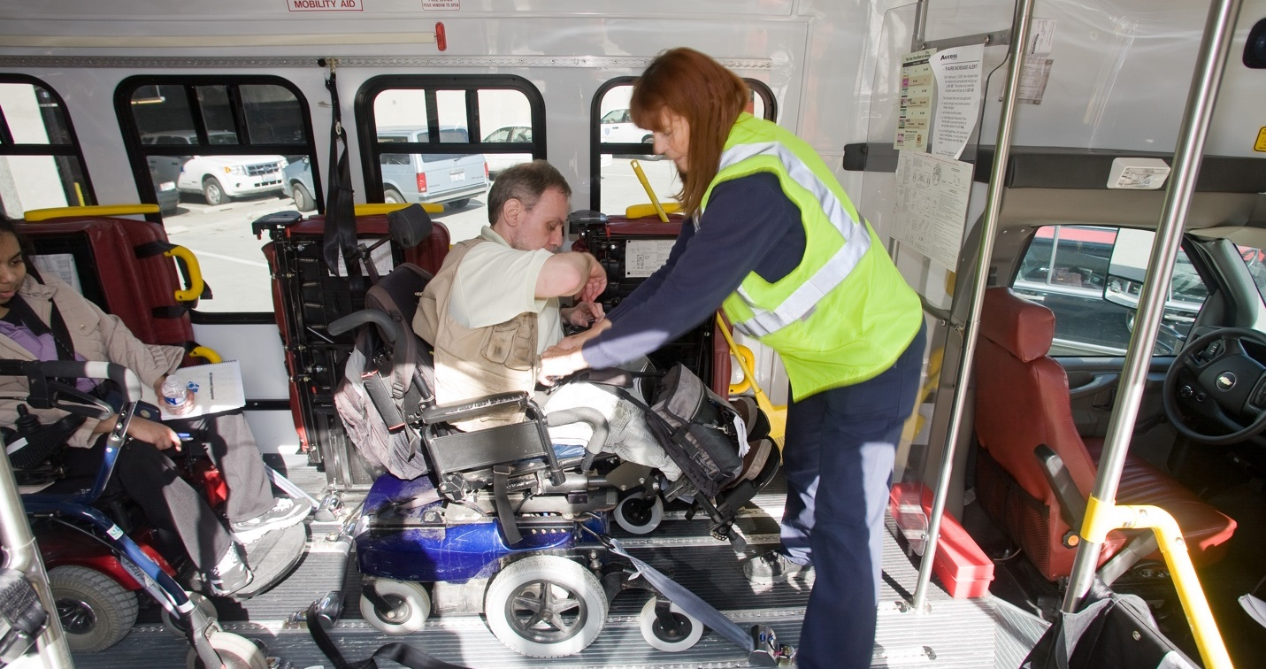

Areas of Deficiency or Improvement

This section contains the response for King County Council’s request for Areas of Deficiency or Improvement during each reporting period and covers the KPIs that either improved or failed to meet the performance standard during the reporting period. This information is also included in the Performance Metrics and Trends section.

Key Findings
- Of the 18 performance metrics covered in this report, 9 saw improvement during the reporting period, 7 saw performance decrease and 2 did not improve or decrease in performance.
- Missed Trip Pick-up saw the largest improvement of all KPI’s, with on average 27 less instances per month in the fourth quarter than the first quarter of the reporting period, a 65 percent decrease.
- Strong consideration should be given to the varying levels of ridership and the changes to policies and procedures that took place over the reporting period when comparing KPI performance from month to month.

Improving Areas of Deficiency
As part of regular performance monitoring processes King County Metro works closely with MV Transportation to improve service performance in areas where KPI’s are not performing to standard. To improve service performance regarding Excessively Late Pick-up, Missed Trip Pick-up, Missed Trip Appointment, Early Drop-off Appointment, and Late Drop-off Appointment KPI’s, the following actions have been taken:

- Increasing employee hiring, training, and coaching
- Increasing support tools for employees
- Reorganization of teams
- Improving internal communication
- Implementation of new schedules
- Increasing use of system optimization technology
- Increasing collaboration with subcontractors on performance issues
- Heightening operations planning, implementation and continued oversight

On Time Performance
On-Time Performance for Appointment saw improvement during this reporting period, the average number of trips arriving on time for appointment in the fourth quarter of this reporting period was 5 percentage points higher than the first quarter of the reporting period. OTP-A was above standard for the final 8 months of the reporting period.

Pickup Window
Excessively Late Pick-Up performance for the fourth quarter of the reporting period improved over the first quarter of the reporting period with a monthly average of 93.7 during the fourth quarter compared to a monthly average of 133.7 over the first quarter. The number of Excessively Late Pick-Ups per 1,000 boardings improved during the reporting period from an average of 4.17 per 1,000 boardings in Q1 to an average of 2.33 per 1,000 boardings in the fourth quarter.

Missed Trips
Missed Trip Pick-Up did not meet the performance standard of zero instances per month during this reporting period. The performance over the fourth quarter of the reporting period showed improvement over the first quarter of the reporting period with a monthly average of 14.7 missed trips during the fourth quarter and with a monthly average of 42 over the first quarter. The average rate of Missed Trip Pick-ups per 1,000 boardings decreased from 1.3 in Q1 of the reporting period to 0.4 in Q4 of the reporting period.

Missed Trip Appointment did not meet the performance standard of zero instances per month during this reporting period. The performance over the fourth quarter of the reporting period showed a decrease in performance over the first quarter of the reporting period with a monthly average of 110.3 missed trips for appointment during the fourth quarter, and with a monthly average of 53 over the first quarter. The average rate of Missed Trip Appointment’s per 1,000 boardings increased from 1.7 in Q1 of the reporting period to 2.7 in Q4.

Drop off window
Early Drop-Off Appointment performance for the fourth quarter of the reporting period showed an improvement in performance over the first quarter of the reporting period with a monthly average of 175.3 early drop-off for appointment during the fourth quarter and with a monthly average of 210.3 over the first quarter. The average rate of Early Drop-off Appointments per 1,000 boardings decreased from 6.6 in Q1 of the reporting period to 4.4 in Q4.

Late Drop-Off Appointment performance for the fourth quarter of the reporting period showed a decrease in performance over the first quarter of the reporting period with a monthly average of 175 late drop-off for appointment during the fourth quarter and with a monthly average of 64.3 over the first quarter of the reporting period. The average rate of Late Drop-off Appointments increased from 2.0 per 1,000 boardings in Q1 of the reporting period to 4.4 per 1,000 boardings in Q4.

Control Center
Call Chaining improved during this reporting period, with an average of 0 instances per month in the fourth quarter, down from an average of 1.7 per month in the first quarter. Six of the twelve months had 0 instances of call chaining including four of the final six months of the reporting period.

Cost Per Boarding
Cost Per Boarding did not meet the performance standard of $70.47 per quarter during this reporting period. Due to the significant decrease in ridership and the policies and procedures changes that were implemented to safeguard riders, staff, and members of the public, the cost per boarding KPI was waived for the entire reporting period. Cost per boarding did see a decrease of cost and improvement in performance between the fourth quarter and first quarter of the reporting period. The average cost per trip in the first three months of the reporting period was $116.37 and decreased to $105.56 during the fourth quarter, a decrease of over $10 per trip.

As ridership increases, pre-COVID-19 policies and procedures restored and the system parameters return to normal, King County Metro anticipates the Cost Per Boarding to move towards pre-pandemic levels.

Potential Service Improvements

This section provides response to County Council’s request for information on potential service improvements, including information about their budgetary requirements.

E-Faring
Once launched, E-Faring or EZ-WALLET will provide an online or phone payment option for Access customers to pay for their trips. This will include the option to load funds to their account via credit or debit card. The original timeline for implementation of E-Faring was July 2020. Due to impacts related to COVID-19 and unforeseen challenges establishing the necessary accounting policies and practices to accept and process credit card transactions, the current deployment timeline is scheduled for Q4 2021. Despite the delay in implementation, costs for the program are expected to be within budget.

Online booking
Online booking allows Access customers to manage their trips via a web portal accessible from computer or smart phone device by scheduling and canceling trips, viewing ride history, and getting real time vehicle location of their assigned Access vehicle. Other key functionalities include the following:
- Receive "Where's my ride?" alerts
- Book casual trips and view and cancel their casual and recurring or subscription trips
- View their profile and update their personal information
- Change their password
- View announcements and general information from transit agency
- Provide feedback

The annual maintenance fees for this software are included in the appropriation authority for the Access program. Online booking was originally launched in Q3 2020 and has seen modest growth in usage. King County Metro continues to market and promote this service improvement to all Access riders while incorporating user feedback into system improvements.

Potential Service Innovations

This section provides response to County Council’s request for an update on potential service innovations, such as increased opportunities for same-day service using taxicabs or transportation network companies, including information about their budgetary requirements.

Same day service pilot
Establishing a same day service program utilizing taxicabs or transportation network companies (TNC’s) will provide additional mobility options for Access riders while potentially increasing overall system efficiencies. Across the paratransit industry, there are a variety of service models and approaches that have been implemented, with each tailored to fit the unique characteristics of the transit system providing the service.

To date, King County Metro has researched pilot programs at numerous transit agencies, begun collaboration with the Access contractor on potential parameters for a same day pilot, implemented a test project utilizing a taxi provider, provided a targeted same day service to Access customers in select areas using Metro’s on-demand flexible services (Via to Transit and Crossroads Connect), and entered into a partnership with the University of Washington to conduct extensive research and data analysis on a same day service project.

Due to the impacts of COVID-19 on the private transportation industry and the Access program, King County Metro has delayed the launch of a same day service option. King County Metro will continue to explore the implementation of a same day service pilot project that is cost neutral or cost reducing for the overall Access program, with estimated program launch in 2022.

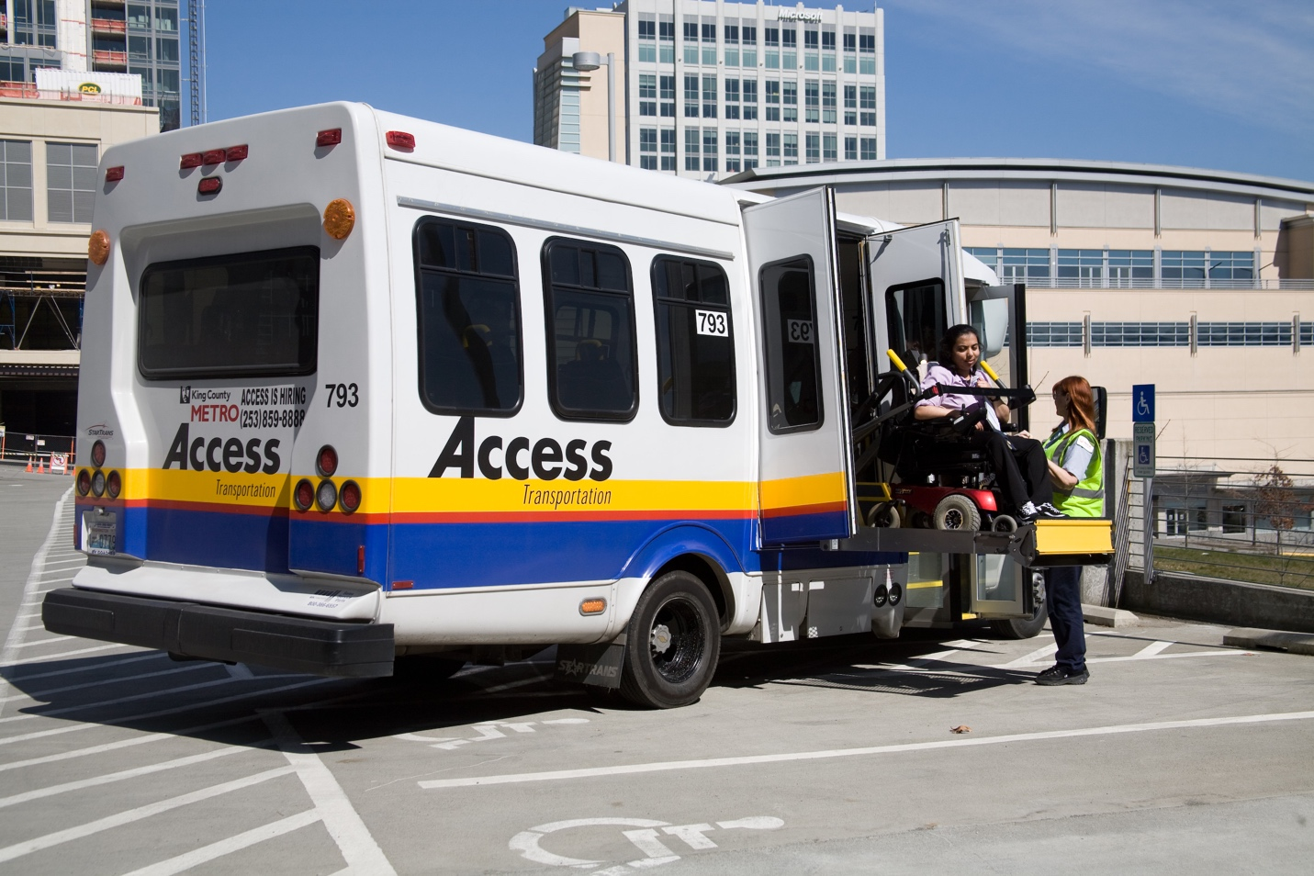

Conclusion

During this reporting period, Access Transportation quickly responded to the significant challenges of the COVID-19 pandemic, delivering safe, effective, and efficient transportation. Shortly after undergoing a transition of the entire program, including service provider and contract model, the pandemic required an unprecedented fundamental alteration of the service. During this time King County Metro and MV Transportation partnered to deliver the reliable, equitable, safe, and secure transportation service that our riders and community members expect.

- Due to the COVID-19 pandemic, ridership during this period decreased significantly to 447,640 boardings, less than 50 percent of ridership during 2019.
- Key Performance Indicators OTP-P and OTP-A performed above standard for most or all of the entire reporting period.
- A majority of the maintenance KPI’s performed above standard for the entire reporting period.
- A majority of the call center KPI’s performed above standard for the entire reporting period.
- Of the 12 KPIs listed in this report that have defined performance standards, 9 met the standard at some time during the reporting period. The 3 KPI’s that did not meet the standard include: Missed Trip Appointment, Missed Trip Pick-up, and Cost Per Boarding. Of those 2 have a standard of zero, a much more difficult target to achieve.
- Metro continued to provide innovated mobility solutions during the pandemic, delivering 33,544 hot meals along with 6,873 food boxes and 1,889 boarding’s for vaccine transportation.

After shifting from an initial response to service stabilization under pandemic conditions, MV and King County Metro continued to collaborate and respond to ever changing regulatory guidance and community needs. This included providing additional transportation services to King County including many of its most vulnerable residents, most recently with creating a new service option, providing reliable transportation for county residents to vaccine distribution sites. Due to the significantly decreased ridership and changing travel patterns of Access riders, system performance fluctuated throughout the reporting period. As ridership has increased, it has impacted service delivery and performance metrics.

Next Steps

As King County Metro looks to the future of the Access program, the following challenges and goals will be at the forefront.

- Continued service delivery during the COVID-19 pandemic and adjustments to system parameters, policies, and procedures in coordination with increased ridership and changing regulatory orders and guidance.
- Recovery and restoration of service post COVID-19, including the significant ridership and budget impacts.
- Continued exploration and implementation of service improvements and system optimization to further the King County Strategic Plan Mobility Objective to “Preserve and optimize the mobility system.” Planned Service Improvements and System Efficiencies include the implementation of E-Faring and further development and implementation of a Same Day Service pilot project as well as further integration of scheduling and trip management tools such as Trip Broker, a software tool that aids in analyzing and dispatching the most cost-effective service option, and Just-In-Time scheduling, a system wide real-time trip batching tool will further optimize the system through increased flexibility and innovation. Access will continue to collaborate with the Access Paratransit Advisory Committee (APAC) and MV Transportation to enact customer focused system efficiencies to reduce costs with a focus on continued quality service.

- Continued advancement of goals and principles of King County’s Strategic Plan.
- Implementation of language access recommendations proposed in the Equity Impact Review (EIR) to further the mobility objective to “Provide More Equitable Mobility Access and Reduce Historic Gaps.” Efforts will be made to conduct community outreach, perform training, translate documents, and create a pilot for “cultural navigators” to assist with the application process. This work will remain guided by the Equity and Social Justice (ESJ) shared values as the Access program continues to meet the needs of riders and stakeholders.
- Planning for fleet electrification, including testing of vehicles and continued research and development of infrastructure requirements. This work will move Metro and the Access program towards the core goals of King County’s Strategic Climate Action Plan.

At the time of this report, the COVID-19 pandemic appears to be subsiding, with Washington State fully reopening on June 30, 2021. It remains to be seen when Access will see a return to pre-COVID-19 trip volumes. Post COVID-19, King County Metro expects to face challenges related to funding new and improved services consistent with its long range vision contained in Metro Connects, resumption of normal staffing levels after possible long-term furloughs or layoffs, and the impacts that the pandemic has had on many of the organizations that serve Access riders, such as senior and community centers, places of employment, and recreation facilities.

All of this work will continue to be guided by the mobility goals and values set forth in King County’s Strategic Plan to, “Deliver a safe, reliable, and seamless network of transportation options to get people and goods where they need to go, when they need to get there”.

Appendix A: Proviso Text

P2 PROVIDED FURTHER THAT:
Of this appropriation, $1,000,000 shall not be expended or encumbered until the executive transmits two Access paratransit service updates and a motion that should acknowledge receipt of each Access paratransit service update and a motion acknowledging receipt of each Access paratransit service update is passed by the council. The motions should reference the subject matter, the proviso's ordinance number, ordinance section and proviso number in both the title and body of the motion.
A. In recognition of the importance of Access paratransit to the passengers it serves and to reflect the council's commitment to service excellence in Access paratransit operations, each Access paratransit service update shall include, but not be limited to:
1. The contractor's compliance with contract terms;
2. Performance metrics and trends over each reporting period, including, but not limited to:
a. on-time performance;
b. pickup window, including early pickups, late pickups and excessively late pickups;
c. missed trips;
d. drop-off window, including early drop-offs and late drop-offs;
e. onboard time and excessively long trips; and
f. will call;
3. Areas of deficiency or improvement during each reporting period;
4. Potential service improvements, including information about their budgetary requirements; and
5. Potential service innovations, such as increased opportunities for same-day service using taxicabs or transportation network companies, including information about their budgetary requirements.
B. The following Access paratransit service updates should be transmitted to the council:
1. An update report by August 31, 2021; and
2. An update report by August 31, 2022.
The executive should file each Access paratransit service update and the motions required by this proviso in electronic format with the clerk of the council, who shall retain the original and provide an electronic copy to all councilmembers, the council chief of staff and the lead staff for the mobility and environment committee, or its successor.

Appendix B: Performance Metrics Tables

Month | Access Monthly Ridership
May-20 | 25,673
June-20 | 31,987
Jul-20 | 38,577
Aug-20 | 38,939
Sep-20 | 40,721
Oct-20 | 42,209
Nov-20 | 36,949
Dec-20 | 36,643
Jan-21 | 35,376
Feb-21 | 33,881
Mar-21 | 42,790
Apr-21 | 43,895
Table 3: Access Monthly Ridership May 2020 – April 2021

Month | On-time Performance Appointment
May-20 | 90.5%
June-20 | 90%
Jul-20 | 90.4%
Aug-20 | 90.9%
Sep-20 | 93.3%
Oct-20 | 93.6%
Nov-20 | 93.2%
Dec-20 | 95.2%
Jan-21 | 94.6%
Feb-21 | 94.6%
Mar-21 | 96.1%
Apr-21 | 95.1%
Table 4: On-time Performance Appointment May 2020 – April 2021
Month | On-time Performance Pick-up
May-20 | 96.1%
June-20 | 94.9%
Jul-20 | 95.4%
Aug-20 | 96.5%
Sep-20 | 96.2%
Oct-20 | 94.9%
Nov-20 | 94.7%
Dec-20 | 95.1%
Jan-21 | 95.9%
Feb-21 | 95.6%
Mar-21 | 95.5%
Apr-21 | 94.6%
Table 5: On-time Performance Pick-up May 2020 – April 2021

Month | Late Pick-up
May-20 | 735
June-20 | 1,226
Jul-20 | 1,342
Aug-20 | 1,070
Sep-20 | 1,211
Oct-20 | 1,731
Nov-20 | 1,589
Dec-20 | 1,523
Jan-21 | 1,189
Feb-21 | 1,179
Mar-21 | 1,531
Apr-21 | 1,877
Table 7: Late Pick-up May 2020 – April 2021
Month | Early Pick-up
May-20 | 1,812
June-20 | 1,927
Jul-20 | 2,362
Aug-20 | 2,158
Sep-20 | 2,358
Oct-20 | 1,991
Nov-20 | 1,884
Dec-20 | 1,635
Jan-21 | 1,734
Feb-21 | 1,735
Mar-21 | 2,356
Apr-21 | 2,281
Table 6: Early Pick-up May 2020 – April 2021
Month | Excessively Late Pick-up
May-20 | 92
June-20 | 160
Jul-20 | 149
Aug-20 | 95
Sep-20 | 100
Oct-20 | 106
Nov-20 | 86
Dec-20 | 61
Jan-21 | 55
Feb-21 | 60
Mar-21 | 96
Apr-21 | 125
Table 8: Excessively Late Pick-up May 2020 – April 2021

Month | Missed Trip Appointment
May-20 | 30
June-20 | 52
Jul-20 | 77
Aug-20 | 67
Sep-20 | 71
Oct-20 | 126
Nov-20 | 100
Dec-20 | 93
Jan-21 | 81
Feb-21 | 77
Mar-21 | 109
Apr-21 | 145
Table 10: Missed Trip Appointment May 2020 – April 2021
Month | Missed Trip Pick-up
May-20 | 28
June-20 | 45
Jul-20 | 53
Aug-20 | 22
Sep-20 | 24
Oct-20 | 25
Nov-20 | 25
Dec-20 | 16
Jan-21 | 16
Feb-21 | 10
Mar-21 | 16
Apr-21 | 18
Table 9: Missed Trip Pick-up May 2020 – April 2021
Month | Early Drop-off Appointment
May-20 | 103
June-20 | 168
Jul-20 | 360
Aug-20 | 299
Sep-20 | 171
Oct-20 | 280
Nov-20 | 196
Dec-20 | 105
Jan-21 | 159
Feb-21 | 172
Mar-21 | 145
Apr-21 | 209
Table 11: Early Drop-off Appointment May 2020 – April 2021

Month | Excessively Long Trip
May-20 | .04%
June-20 | .16%
Jul-20 | .39%
Aug-20 | .49%
Sep-20 | .51%
Oct-20 | .51%
Nov-20 | .48%
Dec-20 | .44%
Jan-21 | .32%
Feb-21 | .35%
Mar-21 | .38%
Apr-21 | .42%
Table 14: Excessively Long Trip May 2020 – April 2021

Month | Late Drop-off Appointment
May-20 | 34
June-20 | 61
Jul-20 | 98
Aug-20 | 114
Sep-20 | 145
Oct-20 | 196
Nov-20 | 203
Dec-20 | 160
Jan-21 | 133
Feb-21 | 122
Mar-21 | 179
Apr-21 | 224
Table 12: Late Drop-off Appointment May 2020 – April 2021
Distance in Miles | Average Access vs. Fixed Route Travel Time
0 to 1.99 | 33%
2 to 3.99 | 34.4%
4 to 5.99 | 35.4%
6 to 7.99 | 35.2%
8 to 9.99 | 33.9%
10 to 11.99 | 33.5%
12 to 13.99 | 31.9%
14 to 15.99 | 32.9%
16 to 17.99 | 32.9%
18 to 19.99 | 35.6%
20 or greater | 31.9%
Table 13: Average Access vs. Fixed Route Travel Time May 2020 – April 2021

Month | Miles Between Road Calls
May-20 | 65,490
June-20 | 51,545
Jul-20 | 56,912
Aug-20 | 62,893
Sep-20 | 72,072
Oct-20 | 63,787
Nov-20 | 223,984
Dec-20 | 616,169
Jan-21 | 289,717
Feb-21 | 99,550
Mar-21 | 96,388
Apr-21 | 39,185
Table 16: Miles Between Road Calls May 2020 – April 2021
Month | Will Call Response Time
May-20 | 123
June-20 | 124
Jul-20 | 117
Aug-20 | 130
Sep-20 | 120
Oct-20 | 118
Nov-20 | 123
Dec-20 | 104
Jan-21 | 108
Feb-21 | 118
Mar-21 | 102
Apr-21 | 110
Table 15: Will Call Response Time May 2020 – April 2021
Month | Preventative Maintenance
May-20 | 100
June-20 | 100
Jul-20 | 100
Aug-20 | 100
Sep-20 | 100
Oct-20 | 100
Nov-20 | 99.8
Dec-20 | 99.38
Jan-21 | 100
Feb-21 | 100
Mar-21 | 100
Apr-21 | 99.21
Table 17: Preventative Maintenance May 2020 – April 2021

Month | Cost Per Boarding
May-20 | 134.30
June-20 | 118.50
Jul-20 | 96.33
Aug-20 | 100.29
Sep-20 | 123.58
Oct-20 | 96.41
Nov-20 | 96.62
Dec-20 | 112.90
Jan-21 | 109.60
Feb-21 | 110.06
Mar-21 | 102.81
Apr-21 | 103.73
Table 18: Cost Per Boarding May 2020 – April 2021

Appendix C: KPI Definition Tier Chart

Measure | Tier 1 | Tier 2 | Tier 3
On-Time Performance | A rider can expect to  be picked up and  dropped off within or  before the pick-up  and/or drop-off  window 92% of the  time (change from  past) | A rider can expect to  be picked up and  dropped off within or  before the pick-up  and/or drop-off  window 95% of the  time (change from  previous tier) | A rider can expect to  be picked up and  dropped off within the  respective window  96% of the time  (change from  Previous tier)
Pick-Up Window | A rider is given a 30-  minute pickup window | A rider is given a  pick-up window of 20  minutes for trips < 8  miles or 30 minutes  for trips > 8 miles  (change from  previous tier) | A rider is given a  pick-up window of 20  minutes (change from previous tier)
Early Pick-Up | Early pick-ups are  counted as on-time and monitored | Early pick-ups are  counted as on-time  and monitored | Early pick-ups are  allowed when the  rider pre-approves  them when booking  the trip (change from  previous tier)
Late Pick-Up | Pick-up is late if the  vehicle arrives >0.0  and <30 minutes  after the end of the  pick-up window | Pick-up is late if the  vehicle arrives >0.0  and <20minutes after  the end of the pick-up  window (change from  previous tier) | Pick-up is late if the  vehicle arrives >0.0  and <20 minutes  after the end of the  pick-up window
Excessively Late  Pick-Up | Pickup  is excessively late  if the vehicle arrives  >=30 and <=60  minutes after the end  of the pick-up window | Pickup  is excessively late  if the vehicle arrives  >=20.0 and <=60  minutes after the end  of the pick-up window  (change from  Previous tier) | Pickup  is excessively late  if the vehicle arrives  >=20.0 and <=40.0  minutes after the end  of the pick-up window  (change from  Previous tier)

Measure | Tier 1 | Tier 2 | Tier 3
Missed Trips | Trip is missed if the  vehicle arrives >60  minutes after the end  of the window | Trip is missed if the  vehicle arrives >60  minutes after the end  of the window | Trip is missed if the  vehicle arrives >40.0  minutes after the end  of the window  (change from  Previous tier)
Drop-Off Window | A rider is given a 30-  minute appointment  drop-off window | A rider is given an  appointment drop-off  window of 20 minutes  for trips < 8 miles or  30 minutes for trips >  8 miles (change from  Previous tier) | A rider is given an  appointment drop-off  window of 20 minutes  (change from  Previous tier)
Early Drop- Offs | Early drop-offs are  when a rider is  dropped off >=60  minutes before the  scheduled  appointment time  (change from past contract) | Early drop-offs are  when a rider is  dropped off >=20  minutes before the  start of the drop-off  window (change from  previous tier) | Early drop-offs are  when a rider is  dropped off >0.0 and  <20.0 minutes before  the drop-off window  begins (change from  previous tier)
Late Drop- Offs | Late drop-offs are  when a rider is  dropped off >0.0 and  <10.0 minutes after the end of the window (change from past) | Late drop-offs are  when a rider is  dropped off >0.0 and  <10.0 minutes after the end of the window | Late drop-offs are not  defined (change from  previous)
Missed Trips | Trip is missed when  a rider arrives >=10  minutes after  appointment time  (change from past) | Trip is missed when  a rider arrives >=10  minutes after  appointment time | Trip is missed when  a rider arrives  >=20.0 minutes  before the drop-off  window or >0.0  minutes after the  appointment time  (change from  previous)
On-Board Time | On-board time (OBT)  is fixed route travel  time plus 15 minutes | On-board time (OBT)  is fixed route travel  time plus 15 minutes | On-board time (OBT)  is fixed route travel  time plus 15 minutes
Excessively Long  Trips | Excessively long trips  are longer than OBT  no more than 3% of  the time | Excessively long trips  are longer than OBT  no more than 3% of  the time | Excessively long trips  are longer than OBT  no more than 2% of  the time (change  from previous)
Will Call | Access has a “no  strand policy” and  negotiates a will call  ride home for  customers as  schedule permits | Access has a “no  strand policy” and  negotiates a will call  ride home for  customers within 75  minutes (change  from previous) | Access has a “no  strand policy” and  negotiates a will call  ride home for  customers within 45  minutes (change  from previous)

Appendix D: Average On-Board Times Access May 2020 – April 2021

Mileage | May-20 | Jun-20 | Jul-20 | Aug-20 | Sep-20 | Oct-20 | Nov-20 | Dec-20 | Jan-21 | Feb-21 | Mar-21 | Apr-21 | Q1 Avg | Q2 Avg | Q3 Avg | Q4 Avg | CNG Q4 - Q1
0 | 7.43 | 7.53 | 8.06 | 7.93 | 7.96 | 8.86 | 8.75 | 8.77 | 8.25 | 8.09 | 7.96 | 8.22 | 7.67 | 8.25 | 8.59 | 8.09 | -0.50
1 | 10.26 | 10.2 | 11.2 | 11.5 | 12.5 | 12.2 | 11.7 | 11.9 | 11.7 | 11.2 | 10.51 | 11.3 | 10.55 | 12.1 | 11.76 | 11.00 | -0.76
2 | 12.69 | 12.4 | 14.3 | 14.9 | 15.1 | 15.2 | 15.3 | 15.6 | 14.6 | 15.1 | 15.1 | 14.9 | 13.11 | 15.1 | 15.17 | 15.02 | -0.15
3 | 15.1 | 14.9 | 16.6 | 17.1 | 17.6 | 18 | 18.5 | 17.9 | 17.4 | 17.6 | 17.87 | 17.4 | 15.54 | 17.5 | 17.94 | 17.62 | -0.32
4 | 17.38 | 17.1 | 19.5 | 20.7 | 20.9 | 21.8 | 22 | 21.2 | 21.3 | 20.9 | 21.01 | 21.3 | 17.99 | 21.1 | 21.50 | 21.06 | -0.43
5 | 19.48 | 19.2 | 21.8 | 23.5 | 23.8 | 25.4 | 24.6 | 24.2 | 23 | 23.3 | 24.45 | 24.3 | 20.16 | 24.2 | 23.96 | 24.01 | 0.05
6 | 20.99 | 22.1 | 24.6 | 26 | 26.6 | 27.5 | 26.9 | 27.3 | 26.1 | 26.9 | 26.48 | 27 | 22.54 | 26.7 | 26.75 | 26.81 | 0.06
7 | 22.6 | 23.5 | 26.1 | 28.4 | 28.5 | 29.3 | 29.4 | 27.9 | 27.2 | 27.6 | 27.69 | 27.9 | 24.04 | 28.7 | 28.17 | 27.70 | -0.46
8 | 23.22 | 23.7 | 28.1 | 29.2 | 30.2 | 32.6 | 31.4 | 30.2 | 29.2 | 28.8 | 28.84 | 29.7 | 24.98 | 30.6 | 30.27 | 29.10 | -1.17
9 | 25.24 | 25.4 | 29.5 | 30.8 | 31.2 | 31.3 | 32.5 | 32.2 | 30.2 | 32 | 30.98 | 32.9 | 26.72 | 31.1 | 31.67 | 31.95 | 0.28
10 | 23.91 | 23 | 28.4 | 32.6 | 32.3 | 33.7 | 34.3 | 34.5 | 33.7 | 33.1 | 32.72 | 33 | 25.09 | 32.9 | 34.18 | 32.93 | -1.25
11 | 26.25 | 25.7 | 31.2 | 34.9 | 34.5 | 37.6 | 36.2 | 36.5 | 36.4 | 35.7 | 35.6 | 36.2 | 27.70 | 35.7 | 36.35 | 35.83 | -0.53
12 | 28.31 | 29.1 | 33.1 | 34.8 | 37.7 | 36.5 | 36.8 | 36.2 | 35.3 | 34.7 | 35.38 | 37 | 30.19 | 36.3 | 36.07 | 35.70 | -0.37
13 | 28.29 | 30 | 33.7 | 37.1 | 39.6 | 40.2 | 38 | 37.9 | 36.7 | 36.2 | 38.89 | 37.8 | 30.65 | 38.9 | 37.52 | 37.62 | 0.10
14 | 32.15 | 34.4 | 37.7 | 40.6 | 33.3 | 42.7 | 41.5 | 41.6 | 41 | 40.5 | 40.66 | 40.6 | 34.76 | 38.9 | 41.37 | 40.59 | -0.78
15 | 30.68 | 30.5 | 38.6 | 40.7 | 43.8 | 42.6 | 44.5 | 41.1 | 39.8 | 38.2 | 40.67 | 38.6 | 33.26 | 42.4 | 41.82 | 39.16 | -2.66
16 | 32.34 | 34.5 | 37.4 | 41.6 | 43.2 | 43.5 | 47 | 45 | 42.5 | 43.3 | 41.38 | 44.4 | 34.73 | 42.8 | 44.85 | 43.02 | -1.83
17 | 33.98 | 35.3 | 40.2 | 44.6 | 46.9 | 49.3 | 48.5 | 47 | 47.3 | 45.1 | 46.56 | 45.9 | 36.48 | 46.9 | 47.60 | 45.84 | -1.76
18 | 36.05 | 35.7 | 41.2 | 42.2 | 45.5 | 44.5 | 43.5 | 47.6 | 48.1 | 44.5 | 42.73 | 45.1 | 37.64 | 44.1 | 46.39 | 44.11 | -2.28
19 | 36.74 | 39 | 42.7 | 45.8 | 47.1 | 42 | 48.9 | 50.1 | 46.3 | 42.4 | 45.74 | 49.1 | 39.48 | 45 | 48.40 | 45.74 | -2.66
20 | 37.02 | 42.2 | 46.3 | 47.9 | 51 | 51.8 | 57.1 | 49.9 | 45.9 | 53.6 | 48.09 | 47.3 | 41.82 | 50.2 | 50.96 | 49.67 | -1.29
21 | 40.17 | 15.3 | 44.2 | 48.9 | 42.6 | 51.6 | 53.7 | 50.7 | 49.3 | 49.9 | 50.77 | 48.8 | 33.22 | 47.7 | 51.23 | 49.81 | -1.42
22 | 40.36 | 42.9 | 46.5 | 48.2 | 52 | 54.3 | 56 | 51.3 | 47.5 | 52.5 | 52.17 | 50.2 | 43.24 | 51.5 | 51.63 | 51.62 | -0.01
23 | 40.14 | 43.3 | 45.3 | 50 | 52.8 | 58.5 | 56 | 50.9 | 56.4 | 53.6 | 50.11 | 51 | 42.91 | 53.7 | 54.44 | 51.55 | -2.89
24 | 43.39 | 43.9 | 47.7 | 48.3 | 57.5 | 55 | 65.1 | 56.1 | 59.1 | 51.4 | 50.27 | 49.1 | 44.99 | 53.6 | 60.07 | 50.25 | -9.82
25 | 42.92 | 47.6 | 52.2 | 54.4 | 53.7 | 53 | 81.9 | 58.8 | 45.5 | 61.3 | 60.13 | 54.1 | 47.55 | 53.7 | 62.06 | 58.49 | -3.57
26 | 41.4 | 47.2 | 59.5 | 71.9 | 62.6 | 58 | 61.2 | 56.7 | 61.3 | 69.8 | 57 | 71.2 | 49.37 | 64.2 | 59.74 | 66.01 | 6.27
27 | 44.4 | 48.4 | 66.3 | 57 | 57.9 | 56.2 | 48 | 52 | 48 | 34.5 | 50 | 56.6 | 53.06 | 57 | 49.33 | 47.02 | -2.31

Mileage | May-20 | Jun-20 | Jul-20 | Aug-20 | Sep-20 | Oct-20 | Nov-20 | Dec-20 | Jan-21 | Feb-21 | Mar-21 | Apr-21 | Q1 Avg | Q2 Avg | Q3 Avg | Q4 Avg | CNG Q4 - Q1
28 | 51.27 | 54.6 | 57.9 | 59.6 | 52.2 | 63 | 51.5 | 57.6 | 50.9 | 47.8 | 53.75 | 54.6 | 54.57 | 58.3 | 53.32 | 52.05 | -1.27
29 | 52 | 53 | 69.3 | 58.5 | 65.7 | 62.1 | 62.5 | 54.3 | 52.5 | 48.5 | 56.14 | 63.1 | 58.09 | 62.1 | 56.42 | 55.91 | -0.51
30 | 48 | 58.3 | 59.1 | 61.2 | 58.8 | 49 | 67.8 | 69.1 | 54.7 | 49.6 | 53 | 59.4 | 55.15 | 56.3 | 63.84 | 53.99 | -9.85
31 | 49.33 | 71.8 | 54.6 | 62.1 | 57.4 | 46.7 | 81.3 | 71.5 | 70.8 | 61.3 | 58.9 | 46 | 58.55 | 55.4 | 74.52 | 55.40 | -19.11
32 | 50 | 56.7 | 49.4 | 63.7 | 66.5 |  | 64.3 | 58.1 | 60 | 58.3 | 65.58 | 84.3 | 52.01 | 65.1 | 60.82 | 69.40 | 8.58
33 | 57.67 | 74.4 | 63.2 | 63.2 | 53.7 |  | 61.3 |  | 61 | 58 | 71.6 | 49.2 | 65.08 | 58.45 | 40.78 | 59.60 | 18.82
34 |  |  | 69.5 |  | 60 |  | 46 | 95 |  | 68 | 67.67 | 47 | 69.5 | 60 | 70.5 | 60.89 | 13.89
35 |  | 46 |  |  | 74.5 |  |  |  |  |  |  |  | 46 | 74.5 | N/A | N/A | N/A
36 |  |  |  |  |  |  |  |  |  |  | 47.33 | 74 | N/A | N/A | N/A | 60.67 | N/A
37 |  |  |  |  | 70.7 |  |  |  |  |  |  | 81.5 | N/A | 70.7 | N/A | 81.5 | N/A
38 |  |  |  |  |  | 62 | 83 | 124 | 68 | 72 | 96 | 81.7 | N/A | 62 | 91.66 | 83.22 | N/A
39 |  | 70 | 61.3 |  |  | 88 |  | 105 |  |  |  | 76 | 65.65 | 88 | 105 | 76 | -10.35
41 |  |  | 66 |  |  |  |  |  |  |  |  |  | 66 | N/A | N/A | N/A | N/A
48 |  |  |  |  |  |  |  |  |  |  | 95 | 75.5 | N/A | N/A | N/A | 85.25 | N/A
49 |  |  |  |  |  | 99 |  |  | 77 |  |  |  | N/A | 99 | 77 | N/A | N/A

TSA Extends Face Mask Requirement at Airports and Throughout the Transportation Network, https://www.tsa.gov/news/press/releases/2021/04/30/tsa-extends-face-mask-requirement-airports-and-throughout
King County 2020 Strategic Climate Action Plan, https://your.kingcounty.gov/dnrp/climate/documents/scap-2020-approved/2020-king-county-strategic-climate-action-plan.pdf
King County Strategic Plan, https://www.kingcounty.gov/depts/executive/performance-strategy-budget/performance-strategy/Strategic-Planning/2015-strategic-plan-update.aspx
King County Metro Access Paratransit Equity Impact Review, https://kingcounty.gov/~/media/depts/metro/accountability/reports/2020/metro-access-paratransit-equity-impact-review.pdf
Performance standard in this report refers to the performance standards defined in the Access Paratransit Contract, Statement of Work, pages 117-122.
King County Strategic Plan, https://kingcounty.gov/~/media/depts/executive/performance-strategy-budget/documents/2017StratPlan/2017KCStrategicPlan_v7.ashx?la=en
King County Strategic Plan, https://kingcounty.gov/~/media/depts/executive/performance-strategy-budget/documents/2017StratPlan/2017KCStrategicPlan_v7.ashx?la=en
King County Strategic Plan, https://kingcounty.gov/depts/executive/performance-strategy-budget/performance-strategy/Strategic-Planning/2015-strategic-plan-update.aspx

