April 20, 2021 |  |  | 2
CB1

 | Sponsor: | Balducci
[L. Krekel-Zoppi]
 | Proposed No.: | 2021-0288
AMENDMENT TO STRIKING AMENDMENT S1 TO PROPOSED MOTION 2021-0288, VERSION 1
On Attachment A, page 67, the 2020 Strategic Climate Action dated April 19, 2021, under the header "Priority Actions" after priority action GHG 2.1.1, insert:
"GHG 2.1.2 Identify and report on the level of additional transit investments needed to achieve the SCAP regional transit ridership and car trip reduction targets. Report on the gap between current Metro and service levels and costs and what would be needed to achieve the SCAP goals, including potential funding sources available at the time of reporting, and as part of future conversations about funding for Metro Connects identify funding levels to cover the gap in Metro transit service levels. Regularly update the transit service levels and cost modeling in future SCAP progress reports and updates to keep up with inflation and other changing conditions. (Metro)"
Insert King County Role: 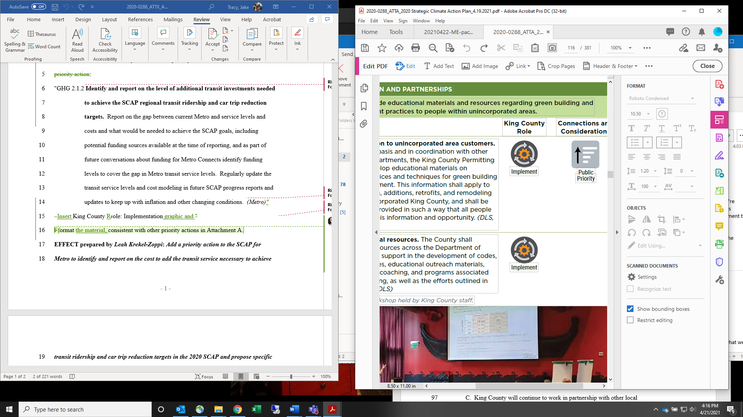and format the material, consistent with other priority actions in Attachment A.
EFFECT prepared by Leah Krekel-Zoppi: Add a priority action to the SCAP for Metro to identify and report on the cost to add the transit service necessary to achieve transit ridership and car trip reduction targets in the 2020 SCAP and propose specific funding levels needed to meet those needs.

