Lease Property Summary
Photo of Property:

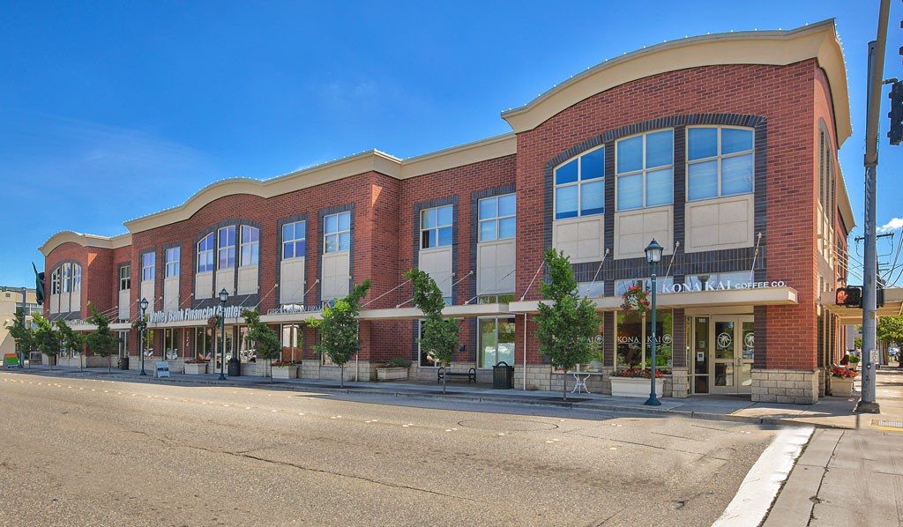

Property Owner: Kent Valley Professional Plaza, LLC
Address: 124 4th Ave S, Kent, WA 98032
Cost Per Sq. Ft.: $20.00 per rentable square foot
Operational Costs: The 2018 estimated operating costs are $9.11/RSF
Term: 10 Years
Square Footage: 4,896 rentable square feet
Council District: Five
Funding Source: General Fund
Previous Locations: This is an expansion space

Time Sensitive: This proposed lease has an approval deadline of August 1, 2018 as negotiated in a multi-offer situation. The Facilities Management Division (FMD) is interested in expediting the approval of this agreement in order to obtain this space.

Lease Synopsis:
On July 1, 2013 the Department of Public Defense (DPD) became a new department within the King County Executive branch. The DPD staff that supports the Kent Maleng Regional Justice Center (MRJC) is currently located in 24,370 square feet in the Meeker St. Law Building located across the street from this proposed expansion space. DPD does not have adequate space to serve their program needs and is seeking expansion space.

Context

Rationale for transaction: The purpose of this project is to temporarily address the space requirements of the four public defender divisions providing public defense services to the MRJC in Kent. The proposed lease at the Kent Valley Professional Center will include tenant improvements to the ground and 2nd floors to accommodate approximately 20 DPD Kent staff from the Northwest Defender Division (NDD).

Policy considerations: Acquiring more office space for the DPD in Kent has been a priority of the Department’s leadership since before the department was formally created in 2013. The caseloads in Kent have increased over the last six years and there is not adequate space for attorneys to handle the workload. The purpose of this expansion project is to allow the DPD to be able to adequately staff the divisions to provide legal counsel and representation to indigent individuals at MRJC.

Consistency with the RAMP: Leasing space for DPD is consistent with the current Real Property Asset Management Plan (RAMP) that was adopted by Council in 2016.

Political considerations: N/A

Community considerations
or partnerships: N/A

Fiscal considerations: The fully-serviced price per rentable square foot is $20.00 for year one and there is an increase of 3% annually. This is a NNN lease which means that the Tenant pays for its share of property taxes, insurance and common area maintenance in addition to the Base Rent. Controllable NNN charges are capped at five percent (5%) each year. The negotiated rental rate is a fair market rate and includes a one-time Landlord contribution of $75.00 per rentable square foot as a Tenant Improvement allowance or $367,200. The companion ordinance regarding tenant improvements is being transmitted under separate cover.

Other considerations: This lease includes five exclusive parking stalls at no additional costs.

CIP/operational impacts: Tenant Improvement modifications for the proposed lease are needed prior to DPD staff occupying this location. The capital appropriation request to fund the tenant improvements is being submitted under separate cover. This request combined with the Tenant Improvement allowance will pay for all phases of the project management, tenant improvements, and relocation of staff. The project involves demolition and construction to convert the previous retail space to offices for attorneys and workstations for staff. The basis of the budgetary estimate is on construction cost per square foot, number of staff, and data costs per square foot.

King County Strategic Plan impact: Leasing of this property furthers the King County Strategic Plan guiding principle of Financial Sustainability and goal of providing for a safe and just community through proactive law enforcement and an accessible and fair justice system.

Equity and Social Justice impact: In accordance with RAMP Strategy 2.0 and 24.0, FMD and the DPD reviewed this legislation for Equity and Social Justice (ESJ) impacts. This location, in the Scenic Hill neighborhood of Kent, is across the street from the existing office and will be a centralized services location for clients. DPD’s clients are indigent; many also need to use public transit in order to access DPD’s services. This location serves the MRJC and has convenient access to freeway and transit service. This proposed lease is not expected to negatively impact low income communities, communities of color or limited English proficient communities by expanding across the street from their current location.

Energy Efficiency impact: This tenant project is incorporating the following Strategic Climate Action Plan (SCAP) elements:
Energy Strategy A.11 – Landlord shall obtain an Energy Star or LEED Silver certification for the Building within twenty-four (24) months after mutual execution of the Lease (this requirement is included in the lease language);
Energy Strategy A.6 – this project will be designed to meet the Seattle Energy Code (most stringent city energy code within county);
Energy Strategy A.8 – technologies to be avoided; and,
Energy Strategy A.9 – purchase of Energy Star Appliances.

Lease Alternatives Analysis
Summary: The program scope required the expansion location to be within four (4) blocks of the MRJC. This proposed lease is the only suitable option for the DPD within the required boundary.

Vicinity View Map
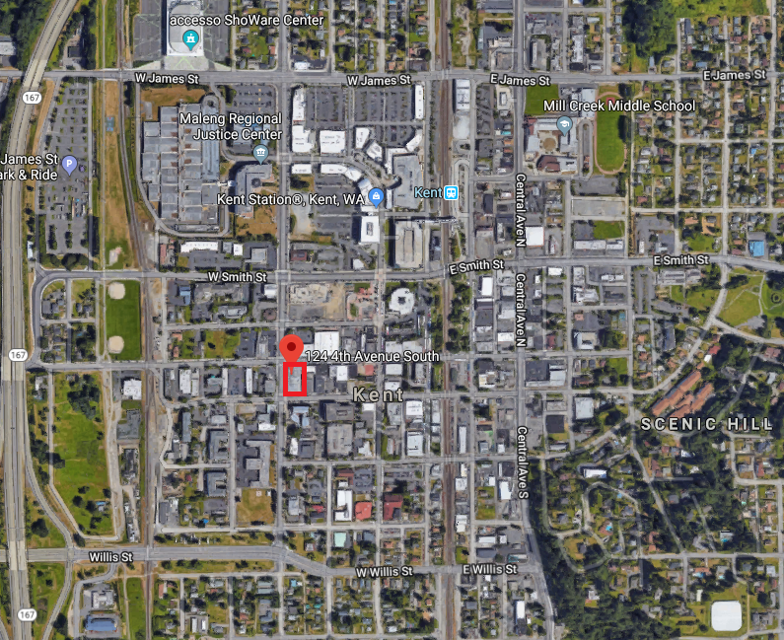

Parcel Map
