Attachment A - 15153

Facilities Management Division

Recommendations for Implementation of Hygiene Facilities

Proviso Response

Ordinance #18602

King County 2017/2018 Budget

Section 69, Proviso P2

Facilities Management Division
Recommendations for Implementation of Hygiene Facilities
Proviso Response

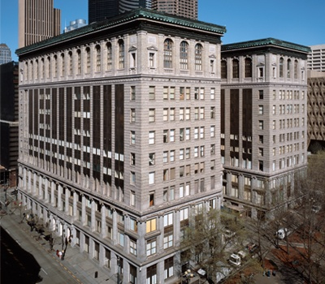

Table of Contents

Summary 4
The Proviso – Ordinance 18602, Section 69, Proviso P2 4
Response to Specific Budget Proviso Questions 4
Hygiene and security: Hygiene and security concerns 5
Description of the King County Courthouse Perimeter 5
Current Hygiene Facilities near the Courthouse Perimeter: 6
Signage - Hygiene Facility Location 6
Public Health Impact 6
Equity and Social Justice Issues Related to Hygiene Facilities 6
Status of City of Seattle efforts related to hygiene and toilet facilities in City Hall Park: 7
Recommendations for Implementation of Hygiene Facilities in Partnership with the City of Seattle: 8
Option #1 Portable single stall ADA Portable Toilet 8
Option #1A Portable single stall Portable single stall ADA Restroom Trailer 9
Option #2: Permanent restroom structure (a.k.a. Portland Loo) 11
Option #3: Hygiene Center 13
Risk Evaluation 15
Financial Evaluation: 16
Hygiene Facility Delivery Timeline 17
Recommendation 18
Appendix A: Courthouse Vicinity Improvement Committee Members 19
Appendix B: Map of Courthouse Perimeter 21
Appendix C: Map of Pioneer Square Preservation District 22
Appendix D: Pioneer Square Public Access Restroom Facilities 23
Appendix E –Reviewer Acknowledgement 24

Summary

In 2017, the King County Facilities Management Division (FMD) received additional funds and staffing approval to maintain the cleanliness of the King County Courthouse (KCCH) area (Ordinance 18602). A subsequent proviso requested that the Executive transmit a report providing recommendations for siting hygiene facilities in the KCCH vicinity. The goal of a hygiene facility, developed in partnership with the City of Seattle, would be to improve the cleanliness and safety of the courthouse perimeter and environs. This report includes a needs assessment, three hygiene facility options and one recommendation.

The Proviso – Ordinance 18602, Section 69, Proviso P2

Of this appropriation, $400,000 shall be expended or encumbered solely to implement strategies to maintain cleanliness and security of the immediate vicinity of the King County Courthouse building. Of the moneys restricted by Expenditure Restriction ER1 of this appropriation $100,000 shall not be expended or encumbered until the executive transmits a report providing recommendations for implementation of hygiene facilities in partnership with the City of Seattle in order to improve cleanliness of the exterior perimeter of the courthouse and a motion that should approve the report and reference the subject matter, the proviso’s ordinance, ordinance section and proviso number in both the title and body of the motion and a motion to approve the report is passed by the council.
The executive should file the report and the motion required by this proviso by March 1, 2018, in the form of a paper original and an electronic copy with the clerk of the council, who shall retain the original and provide an electronic copy to all councilmembers, the council chief of staff and the lead staff for the budget and fiscal management committee, or its successor.

Response to Specific Budget Proviso Questions

BACKGROUND AND NEED

A number of efforts are underway to address safety and hygiene issues in the Courthouse vicinity. A Courthouse Vicinity Improvement (CVI) Committee (see Appendix A), composed of King County, City of Seattle, and nonprofit partners has been meeting since January 2017 to stay informed on crime incidence, ensure ongoing information sharing and communication, and develop collaborative solutions to safety and hygiene issues in the courthouse vicinity. In addition, The Superior Court General Rule 36 Court Security Committee was created in late 2017 to address emerging security issues in courthouses across the state. Health Care for the Homeless Network provides healthcare services to people experiencing homelessness in King County has also been involved in issues related to safety and hygiene.

The CVI committee has supported a number of interjurisdictional accomplishments including:

- Increased cleaning of sidewalks and streets by the Facilities Management Division (FMD), the Seattle Metropolitan Improvement District (MID), Downtown Emergency Service Center (DESC) and Metro Transit;
- Increased security by FMD, MID, Seattle Police Department (SPD), King County Sheriff's Office (KCSO) and Metro Transit;
- Improved wayfinding for jurors through improved signage and directions; and
Increased funding (for sidewalk cleaning, Superior Court secure window replacement and limited 4th Avenue entrance operations)

The Superior Court General Rule 36 Court Security Committee was convened as mandated by WA State. Rule 36 requires drafting of a security plan, security training and reporting. The committee’s current goal is to improve incident reporting.

Hygiene and security: Hygiene and security concerns at the KCCH and adjoining geographical areas including City Hall Park and Prefontaine Fountain have been ongoing for many years, if not decades. The prevalence of garbage at City Hall Park and juror safety was raised during a July 11, 2017 Government Accountability and Oversight Committee panel discussion on Courthouse Perimeter Security (Briefing 2017-B0137).

Soon thereafter, FMD and the Seattle Police Department (SPD) increased security presence at the Third Ave. entrance to the Courthouse. In addition FMD increased exterior cleaning efforts, partnering with FMD Building Services Section (BSS) Utility Workers to pressure wash and remove garbage. Council subsequently approved funding for this effort as part of the 2017 Omnibus (Ordinance 18602) which approved three FTE’s (two Utility Worker II positions and one Security Officer). The budget for these additional cleaning and security efforts was subject to an expenditure restriction requesting recommendations for implementation of hygiene facilities in partnership with the City of Seattle and this report is being submitted in accordance with that proviso.

Description of the King County Courthouse Perimeter: The Courthouse, which is located at 516 3rd Avenue, is a twelve-story 500,000 square feet building. It is bounded by James Street to the north, Fourth Avenue to the east, Jefferson Street to the south and Third Avenue to the west. The courthouse parcel is 1.3 acres and has busy transit stops on the Third Avenue and James Street sides of the building (See Appendix B for a map). Directly south of the Courthouse is 1.3 acre City Hall Park (450 Third Avenue), established in 1916. City Hall Park is in the Pioneer Square Historic District (See Appendix C, map of the Pioneer Square Preservation District). Directly south of City Hall Park (across Third Avenue) is .05 acre Prefontaine Place Park (425 Third Avenue), open from 6 am to 10 pm daily. Also adjacent to the Courthouse perimeter is the downtown transit tunnel Pioneer Square Station, which has one entrance on Third Avenue and James Street (directly north of the Courthouse), a second entrance on Third Avenue and Jefferson Street (next to Prefontaine Park), and a third entrance on the west side of Third Avenue. Metro Transit reports that more than 4,700 riders use the station daily.

Need: There are 12,866 residents and 69,795 jobs within a half mile of the Courthouse according to data regarding Pioneer Square. The area is a busy government, business and retail center during the day and a vibrant neighborhood filled with nightlife once the workday ends. While government building restrooms are available during the day the number of restrooms decreases in the evening and the problem is made more challenging as most businesses only make bathrooms available to customers. Hygiene enhancements would improve this situation and benefit the broad range of people in this area including downtown workers, tourists, sports fans and persons experiencing homelessness.

Current Hygiene Facilities near the Courthouse Perimeter: FMD surveyed facilities and hours near the Courthouse perimeter. The area is served by at least a dozen restrooms in different locations during the day, but in the evening and night there are few available hygiene facilities (See Appendix D, list of restrooms in the nearby vicinity). Restrooms are available in the King County Courthouse, the King County Administration Building and Seattle City Hall during daytime hours. Restrooms are located in one of the nearby businesses, but these are normally customer-only restrooms and also are restricted to daylight hours. There are no hygiene facilities in the surrounding parks or in the Pioneer Square Station. The King County Administration Building, the Fourth and Jefferson Building (4JB) and Seattle City Hall all have secure homeless shelters open in the evening hours and the KCCH is restricted access afterhours.

Signage - Hygiene Facility Location: There is no signage regarding the location and hours of these facilities in the Courthouse area. The lack of signage makes it especially challenging for first time visitors to the area. Tourists, jurors and those using nearby transportation make up a large number of first time visitors.

Public Health Impact: Public health concerns exist due to individuals using the public outdoor areas to defecate and urinate. Lack of public restrooms was frequently cited as a contributing cause in San Diego’s recent hepatitis A outbreak and is likely a contributing factor to the increase in Shigella and Bartonella cases documented by the Public Health of Seattle and King County. The King County Board of Public Health is currently considering Resolution 18-06 regarding supporting efforts for sanitation and hygiene infrastructure for homeless and unsheltered populations.

Equity and Social Justice Issues Related to Hygiene Facilities: Many cities are facing the tough issues related to improving hygiene and criticism for laws that “restrict the ability of the homeless to engage in life sustaining activities in public, even when that person has no reasonable alternative.” Hygiene facilities near the courthouse perimeter would likely decrease the number of people being cited for civility charges in the area and reduce the chance of incarceration due to complications resulting from payment of fines. Local data provided by the “King County 2017 Point-in-Time Count of People Experiencing Homelessness” is 11,643 homeless persons countywide and 8,522 in Seattle. Laws that restrict people experiencing homelessness are known as “civility charges” or “quality of life ordinances” and disproportionately impact people of color, gender non-conforming people, those with mental illness and those previously incarcerated. Life sustaining activities that are threatened by laws include “laws that prohibit sitting, standing, sleeping, receiving food, going to the bathroom, asking for help and protecting one's self from the elements.” Denver, San Francisco and Portland, Oregon are three of the cities working to increase the availability of restrooms and reduce the criminalization of people experiencing homelessness. While City of Seattle data is available on civility charges, San Francisco research indicates the citations cost more to process than the revenue they bring in. The disproportionality of the citations to disadvantaged coupled with the negative fiscal effect on government finances, makes a strong argument for reducing tickets for these type of offenses.

Status of City of Seattle efforts related to hygiene and toilet facilities in City Hall Park: Neither City Hall Park or Prefontaine Place Park have restrooms or hygiene facilities. The park is well used and is open from 6 a.m. to 10 p.m. daily. City records document hygiene issues in the park.

City of Seattle staff have indicated that Park improvement planning is currently underway, but that a budget for City Hall Park would be part of the 2021-2026 Six Year Capital Improvement Program Plan. There is no current plan for restroom or hygiene facilities. If funds were to be included, the earliest implementation would be 2021-2022. For successful siting of hygiene facilities, the City of Seattle underscored the importance of implementing social changes to activate the site as community gathering place and a viable destination location. Because this site is within the Pioneer Square Historic District, any changes including construction, remodel and even signage require a Certificate of Approval to be issued by the Pioneer Square Preservation Board and the Director of the Department of Neighborhoods before the City will issue any permits (See Appendix C Pioneer Square Historic District requirements).

Recommendations for Implementation of Hygiene Facilities in Partnership with the City of Seattle:

FMD researched efforts that other jurisdictions have used to address this problem and evaluated three options. A detailed description of the options, operational and risk issues associated with the options, and costing information follows.

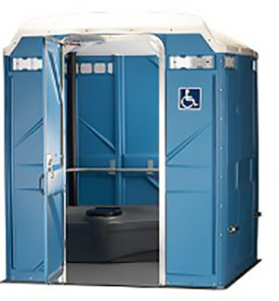
Figure 1: Option #1 - Single Stall ADA Portable Toilet

Option #1 Portable single stall ADA Portable Toilet

Scope: Vendor provided, delivered and installed standard ADA accessible Portable Toilet and provided once daily wipe down cleaning, removal of garbage from unit, graffiti removal and tank servicing. Vendor provided cleaning materials, toilet paper and hand sanitizer. Non-heated, no electrical lighting, standard latch lock.

Cost: Estimate rental cost plus daily cleaning service contract $1,000/week ($52,000/year) plus $70 initial delivery cost and $70 for pick up at end of contract. Though security staffing is recommended, it is not included in this cost estimate.

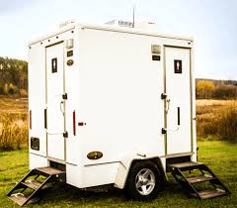
Figure 2: Option #1A – Portable Restroom Trailer

Option #1A Portable single stall Portable single stall ADA Restroom Trailer

Scope: Similar to #1-Vendor contract for rental and servicing of single stall ADA Accessible unit with a ramp to be installed with option to remove the Portable Restroom each evening and return in morning. A Portable Restroom on a trailer with an ADA ramp adds $200/day to Option #1 ($124,940 annually). Though security staff is recommended, it has not been included in this cost estimate. Portable ADA Restrooms with built in ramps are available for rent but these are designed for movie sets, weddings and special event rentals and are not built for use as public restrooms in an urban environment.

Option #1 and #1A Suitability: A portable toilet was located in City Hall Park about seven years ago but was removed due to concerns about criminal activity. Portable toilets have some hazards that permanent mounted restrooms do not. They are susceptible to vandalism including graffiti, tipping and fires. They also can be used for intravenous drug use, illegal sexual activity and occupied for housing (there have been substantial crime problems associated with their deployment in Los Angeles). Option #1 and #1A attempt to reduce these risks by engaging daily portable toilet maintenance. An additional advantage that this option has over Option #2 (the Portland Loo) is that the rental unit is easily discontinued; they can be removed in a day’s notice. Some cities such as San Francisco, Olympia and Duluth, have deployed Option #1, the Portable Toilet solution. It is chosen largely due to cost difference between this option and the Portland Loo. Others cities such as Los Angeles, and Anaheim have had crime issues with portable toilets that were deployed to serve people experiencing homelessness and protests once these toilets have been removed.

There was less research regarding portable trailered toilets (Option #1A). The one instance we did find was a staffed facility that is used by the Low Income Housing Institute (LiHi) at their Othello Station location. Many of portable trailered toilet models are more expensive and higher quality than traditional portable toilets and consequently have a higher incidence of damage or illegal activities – which is perhaps why there are few of them being deployed for this type of effort. There was one instance of a city using portable trailered toilets - the City of Austin recently announced a trailered portable restroom; it is transported to communities that need it the most. Maintenance and utility costs would need to be determined. A subsequent article described how four portable toilets in Austin were set on fire.

Suitability for Pioneer Square Historic District would need to be determined. The District boundaries include half of the Jefferson Street right-of-way and all of City Hall Park. Portable toilets are not a permanent structure but a review of whether they fall under the Pioneer Square Historic District would be needed if this option is selected for further consideration.

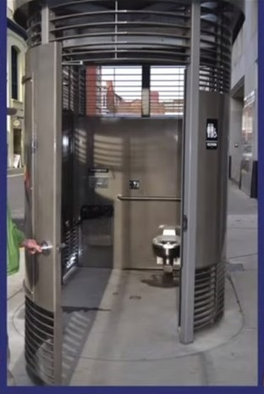
Figure 3: Portland Loo

Option #2: Permanent restroom structure (a.k.a. Portland Loo)

Scope: Year round facility; ADA accessible, single stall Unisex toilet facility, large enough to accommodate a bike, with locked utility storage and an outdoor sink. Two of these are currently installed at the City of Seattle’s Rainier Beach Playfield. Options available include solar power, security surveillances, and art work are at an additional cost. The loo fits in an average parking space (dimensions are: 10' 7” long x 6’ wide by 8’ 6” tall).

Costs:
- Initial purchase costs: start at $97,700 (2016 pricing) per loo plus tax =$107,470/unit (discounts available for multiple unit purchases)
- Installation cost: varies depending upon location and the availability of power, sanitary sewer and domestic water connections. Construction costs could include permit, design fees, construction costs for crane, utility connections, site work and project management additional. Other estimates are $65,000 (2014 in Texas) and $383,000 (2016 in San Diego, CA)
- Estimate Range of Initial Project Costs: $172,470 to $490,470
- Operational Cost: Recommend twice day cleaning (Non-King County Labor, TBD responsibility) and required security surveillance cost (still to be determined) plus annual water, sewage and power utility costs.

Suitability: There are eight Portland Loos installed in Portland but they are not universally well suited to locations. The two advantages that Portland Loos have over portable toilets include 1) the design has some exposure so that it is possible to detect if illegal activity is occurring (though a blind spot prohibits outsiders from viewing people making appropriate use of this facility); and 2) blue lighting makes it difficult for intravenous drug users to locate where to inject drugs into their body, they also have a graffiti proof coating. Portland has not had to remove any of the loos and they are very popular with city residents; they even have their own Facebook page. However, they don’t work everywhere; the City of San Diego removed one of their Portland Loos after fourteen months due to a 130% increase in crime at that location. Because a hygiene need still existed, the City contracted with St. Vincent DePaul to provide secure 24/7 restrooms one block from the former loo location (annual contract amount is estimated at $100,000). The Portland Loo located at San Diego’s Park Blvd and Market Street has not had a crime increase, so the City plans to keep the Loo installed at that location.

The City of Seattle has sited Portland Loos at the Rainier Beach Playfield and the City intends to install additional ones in Ballard, the University District, and possibly in the future, the Downtown corridor.

Suitability for Pioneer Square Historic District (the District) is another consideration of the location of this permanent structure. A Certificate of Approval would have to be issued by the District and the Director of the Department of Neighborhoods before a permit could be issued for construction. There is not a lot of research regarding Portland Loo and historic districts. The City of Portland has eighteen historic districts and a staff interview revealed they sometimes use historic photos on the door of the loo as a method of making them fit into the community they are serving.

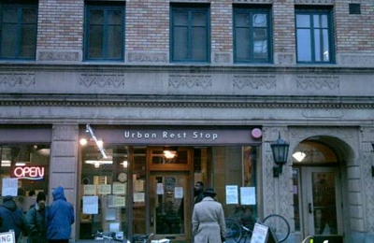
Figure 4: Hygiene Center

Option #3: Hygiene Center

Definition: A hygiene center includes restrooms, sinks for hand washing and can include other enhancements such as showers or laundry.

Cost: The estimated annual cost for this is $300,000.. Hygiene enters, run by non-profit groups, provide hygiene facilities in a clean, safe and dignified environment. As of this writing, the City of Seattle has recently restored funding for existing hygiene centers. A hygiene center might also benefit Metro Transit’s Pioneer Square Station and Prefontaine Place Park which is adjacent to the Courthouse; (the Station is open from 5 am to 1 am daily; Sundays 6 am to 1 am).

To determine if a hygiene center would be a good solution we first evaluated whether there were any nearby. The nearest hygiene center to the Courthouse is the Compass Housing Alliance hygiene center which is located at 77 S. Washington Street, in Pioneer Square (approximately eight blocks from the Courthouse). As of this writing, the Compass Center is funded through December 31, 2018. In order to further refine the cost estimate it would be necessary to determine which hygiene facilities would be offered; restrooms only would likely be less expensive than restrooms, laundry and showers.

Suitability: This option, while one of the more expensive, provides a safer solution with less liability to the City and County. In San Diego it has been successful in high crime areas, where the Portland Loo was not. Hygiene sites are typically staffed, which increases personal contact and reduces the incidence of crime and risk. Because they are staffed there is also the opportunity for additional resource referrals (food, medical care, and housing). The sites are inside an existing building and heated, so they have a higher comfort factor. Lastly, sites like this have gender option restrooms, which also increases the sense of safety. Depending on the site chosen, a Certificate of Approval may be necessary before a hygiene center could be opened. The one concern in using hygiene centers is their funding. Many have had their City of Seattle funding decreased due to a policy changes that focus on permanent housing.

Other options: Other options that were researched but have not been recommended include building and maintaining portable open-air urinals and pay toilets. The open air toilet option has several disadvantages and the pay toilets were also excluded from this analysis as state law effectively precludes their use.

Risk Evaluation

Each of the options was reviewed for security, maintenance, and risk components. These considerations are referenced in Table 1 and ratings for the different options are referenced in Table 2.

Table 1: Non-Financial Factors Used to Evaluations of Hygiene Improvements
Crime | Health Risk | Liability | Responsibility
Drug Use | Needles | City vs. County | Bargaining Unit
Prostitution | Chemicals | Insurance | Hours of Operation
Violence | Waste Handling | Permits Needed | Securing Facility
Harassment
Arson

Table 2: Hygiene Improvement Rated by Non-Financial Factor.
Option | Crime | Health Risk | Liability | Responsibility
1.Portable Toilet | High | High | High | Med
1.A. Portable Restroom Trailer | High | High | Med | Med
2.Portland Loo | Med | Low | Med | Med
3.Hygiene Center | Low | Low | Low | Low

Review of Non-Financial Factors: Hygiene centers had the lowest overall risk due to their being indoor facilities managed by professional staff. This model is followed by the Portland Loo which has lower health risks (the unit is plumbed and has handwashing facilities on the exterior of the structure). The Portland Loo also had lower crime ratings than the Portable Toilet, this is due to the totally enclosed nature of the portable toilets. The Portable Restroom Trailer had slightly lower ratings than the portable toilet because moving and securing the trailer nightly might mean less exposure to vandalism.

Financial Evaluation:

Table 3: Financial Evaluation of Hygiene Improvements

Option No. | Option Name | Annual Rental Cost | Purchase & Installation | Maint. & Utilities | Annual Operating Cost Subtotal | Five Year Cost | Ten Year Cost | Twenty Year Cost
1 | Portable Toilet with Daily Service | $52,000 | $ | - | $52,000 | $260,000 | $520,000 | $1,040,000
1.A | Removable Portable Toilet | $124,940 | $ - | - | $124,940 | $624,700 | $1,249,400 | $2,498,800
2 | Portland Loo* (2) | $ - | $460,000 | $163,050 | $623,050 | $1,275,251 | $2,090,501 | $3,721,002
3 | Hygiene Center** | - | $300,000 | - | $300,000 | $1,500,000 | $3,000,000 | $6,000,000

*City of Seattle Purchase and Maintenance Costs for two Portland Loos for City Hall Park were used for Purchase, Installation and Maintenance.
**Hygiene center costs assumes a professional service contract that includes funds for staff and leased space. Estimates based on Urban Rest Stop’s Ballard Location and 8.5 hours of service in the evening.

Table 3 contains information on the costs of the different options. On an annual cost basis, Option #1 – Portable Toilet with Daily Service is the least expensive ($52,000 annually). Option #1.A is more than double the cost of Option #2 on a yearly basis. Hygiene Center costs above are based on five year and ten-year scenarios. While it is possible that a hygiene center limited to restrooms might be considerably less expensive than a full-service center, specific cost information on this scenario wasn’t available.

The Portland Loo is the most expensive option for the first year because the purchase and construction costs frontload the costs. Portland Loos have a significant maintenance requirement to keep the facilities clean. Costs provided by the City of Seattle are for two Portland Loos; if only one Loo is maintained the staffing costs would need to be recalculated.

The two Loo estimate above assumes 1.84 laborer FTEs. The estimate assumes facilities cleaning three times daily year-round. Work performed as part of maintenance includes sweeping, power washing, trash removal and restocking of supplies. It also assumes $5,000 of preventative maintenance related to plumbing, painting metal and carpentry work but excludes cost related to vehicle purchase. Over ten and twenty-year periods, the Portland Loo is two thirds the cost of a hygiene center. The Portland Loo product has not been in existence for ten years, so it is difficult to anticipate the useful life span.

If a decision is made to install a Portland Loo near the Courthouse a more specialized cost estimate should be completed. One of the criticisms of some Portland Loo installations is the higher than anticipated construction costs. Site work and the closeness of utilities are two of the variables that seem to cause the construction costs to vary.

Further, it should be noted while the installation of hygiene improvements may reduce the need for pressure washing outside of the courthouse it may not eliminate the need. The improvements may not get 100% compliance and so pressure washing will need to be re-evaluated.

Hygiene Facility Delivery Timeline

Table 4: Delivery Timeline Comparison
Option No. | Option Name | Implementation Timeline | Assumptions
1 | Portable Toilet | 3 months | Permitting process is limited for this use.
1A | Portable Restroom Trailer | 3 months | Permitting process is limited for this use.
2 | Portland Loo | 3 years* | Budget, Design, Purchase and Construction
3 | Hygiene Center | 6 months | Negotiate with provider; pursue permits**

*This date is based on Seattle Parks and Recreation space activation requirement.
**Assumes Proclamation of Emergency can be used to expedite this process.

Table 4 contains information on the delivery timeline for each option. The Portable Toilet and the Portable Restroom Trailer options have implementation timelines of two months. These are readily available, and the timeline is mostly for communication and coordination efforts. If it is determined that a Certificate of Approval is needed from the Department of Neighborhoods and the Pioneer Square Historic District, the implementation would need to be extended.

The Portland Loo has the lengthiest timeline; this is due to the efforts needed to fund, design, purchase and construct the facility. This timeline assumes a Certificate of Approval is needed, bidding of the construction is required, utility coordination, construction, approval of occupancy and space activation requirement.

The hygiene center has a shorter timeline than the Portland Loo because there appears to be available leased space in the area for a program of this type. The delivery of this item also may able to be expedited due to the Homelessness Proclamation of Emergencies that have been issued by the Mayor of Seattle and the King County Executive. This schedule timeline assumes that a Certificate of Approval is needed but that it will not take a long as the approval for the Portland Loo.

Recommendation

A Hygiene Center is recommended. It can be implemented quickly and while it may have the highest cost, it has lower crime, health, liability and responsibility risks. The hygiene center provides a higher level of service to individuals needing restroom facilities. It has the added advantage of being more flexible than the Portland Loo which will be expensive to remove in the future if it is determined to be a poor fit for City Hall Park.

A decision regarding siting and funding restroom facilities should not wait until 2021. This report recommends that the City of Seattle contract for a non-profit operated hygiene center in the Courthouse vicinity in 2018 in accordance with the Proclamation of Emergency. A hybrid measure, whereby a hygiene center would operate only until a Portland Loo could be installed, could also be considered. The broader policy decision of whether the County would contribute towards services that are the responsibility of the City is beyond the scope of this report.

Final note: FMD staff evaluated risk, the financial impact and timeline as well as stakeholder input (see Appendix E, Reviewer Acknowledgement). Option #1 and #1A – Portable Toilets - were eliminated due to previous safety and crime problems at this location. Option #2, the Portland Loo, was a reasonable solution and at a lower price than Option 3, but it has a long delivery period and it has a higher risk than a hygiene center.

Appendix A: Courthouse Vicinity Improvement Committee Members

KING COUNTY
Executive Services (DES): Caroline Whalen, Director; Meg Goldman, Project Manager
Metro Transit: Rob Gannon, General Manager
Superior Court (KCCH): The Honorable Laura Inveen, Presiding Judge; Paul Sherfey, Chief Administrative Officer
Sheriff’s Office (KCSO): Undersheriff Scott Somers
Facilities Management Division (FMD): Anthony Wright, Director

CITY OF SEATTLE
Seattle Police Department (SPD): Assistant Chief Steve Wilske, Captain Tom Mahaffey (West Precinct)
Seattle Parks & Recreation (Parks): Robert Stowers, Director, Parks & Environment, Seattle Parks
City Attorney’s Office: Cherie Getchell, West Precinct Liaison Attorney
Department of Finance and Administrative Services: August Drake-Ericson, Program Manager, Encampment Response Team

COMMUNITY PARTNERS
DESC (The Morrison): Daniel Malone, Executive Director

ADDITIONAL CVI CONTACTS
Email distribution list
KING COUNTY
- Adrienne Quinn, Director, Community & Human Services (DCHS)
- Cristina Gonzalez, Interim Deputy Director, Facilities Management Division (FMD)
- Collin Sanders, Security Manager, FMD
- Maureen Thomas, Project Manager, FMD
- Leo Griffin, Operations Manager, FMD
- Cameron Satterfield, Communications Manager, Department of Executive Services (DES)
- Julie Long, Executive Assistant, DES
- Taryn Russo, Labor Management Partnership Program Manager, Office of Labor Relations
- Alina Tanzer, Power and Facilities Manager, Metro Transit, Department of Transportation

CITY OF SEATTLE / SEATTLE POLICE DEPARTMENT
- Lawrence Eichhorn, Emergency Management and Security, Seattle Department of Transportation (SDOT)
- Jon Jainga, Urban Forestry Manager, Seattle Parks and Recreation
- Victoria Schoenburg, Activation Team, Seattle Parks and Recreation
- Cynthia Thurmond, Enhanced Grounds Maintenance, Clean Project Seattle Manager, Seattle Parks and Recreation
- Gary Johnson, Center City Coordinator, Office of Planning and Community Development
- Peter Ahlstrom, Parking Enforcement Unit, SPD

Appendix B: Map of Courthouse Perimeter

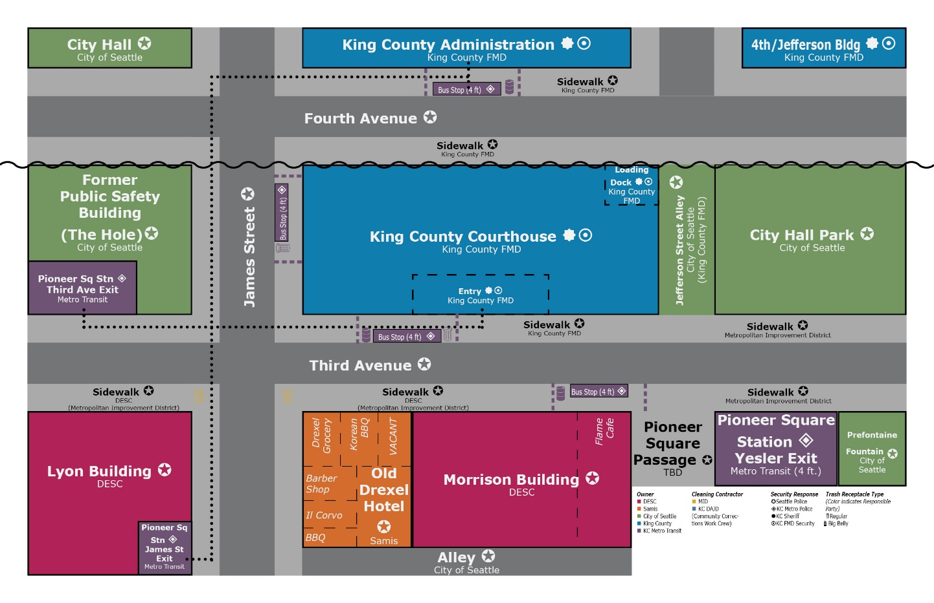

Appendix C: Map of Pioneer Square Preservation District

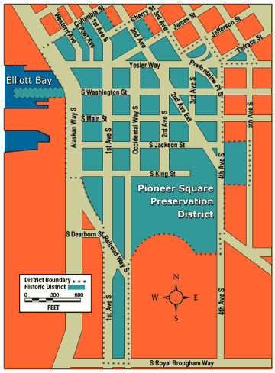

Source: http://www.seattle.gov/neighborhoods/programs-and-services/historic-preservation/historic-districts/pioneer-square#districtboundarymap

Appendix D: Pioneer Square Public Access Restroom Facilities

No. | Name | Owner | Address | Hours | Comments
1. | King Street Station | City of Seattle- leased to Amtrak | 303 S. Jackson St. | 6:00 a.m. – 11:00 p.m. every day
3. | Seattle City Hall | City of Seattle | 600 4th Ave. | 7:00 a.m. – 6:00 p.m. M - F
4.. | Klondike Gold Rush Museum | National Park Service | S. Jackson & 2nd Ave. S. | 9:00 a.m.- 5:00 p.m. every day
6. | King County Administration Bldg. | King County | 500 4th Ave. | 8:30 a.m. – 4:30 p.m. M - F
7. | King County Courthouse | King County | 516 3rd Ave. | 7:00 a.m. – 5:00 p.m. (3rd Ave. entrance) M – F | Must clear security
8. | Chinook Building | King County | 401 5th Ave. | 8:30 – 4:30 M - F
9. | Tashiro Kaplan Building | 4Culture | 101 Prefontaine Pl. S. | General Hours  9:00 am – 5:00 pm, M - F
10. | Ferry Terminal | WSDOT | 801 Alaskan Way- Pier 52 | 4:30 a.m. – 1:30 a.m.
11. | Compass Center | Compass Housing Alliance | 77 S. Washington St. | 7:00 a.m. – 2:30 p.m. M - F
12. | Chief Seattle Club | Chief Seattle Club | 410 2nd Ave. Extension |  | must prove native affiliation
13. | Lazarus Center | Catholic Community Services | 416 2nd Ave. Extension | 7:30 a.m. – 6:30 p.m. every day
14. | Qwest Field | Public Stadium Authority | 800 Occidental Ave. S. | 10:00 a.m. – 5:00 p.m. M – F/10:00 a.m. – 2:00 Sat. All day game day | Pro Shop entrance west side
15. | Union Gospel Mission | UGM | 318 2nd Ave. Extension | 24/7
Source: City of Seattle Office of Planning and Community Development and King County

Appendix E –Reviewer Acknowledgement

The Facilities Management Division, would like to thank staff in the following agencies who reviewed and provided comments on this report:

King County:
Department of Executive Services
Department of Community and Human Services
Department of Transportation
Executive Office
King County Prosecuting Attorney’s Office
King County Sheriff’s Office
King County Superior Court
Public Health – Seattle & King County

City of Seattle:
Department of Parks and Recreation
Office of Planning and Community Development
Budget Office

Elisa Hanh, “Concerns Grow over Attacks Outside King County Courthouse,” July 11, 2017, http://www.king5.com/mobile/article/news/crime/concerns-grow-over-attacks-outside-king-county-courthouse/455631065
City Hall Park, http://www.seattle.gov/parks/find/parks/city-hall-park
Pioneer-square district boundary map, February 20, 2018. http://www.seattle.gov/neighborhoods/programs-and-services/historic-preservation/historic-districts/pioneer-square#districtboundarymap,
Prefontaine Park, February 20, 2018, http://www.seattle.gov/parks/find/parks/prefontaine-place
“Pioneer Square,” https://web.archive.org/web/20160825190842/http://www.psrc.org/assets/10103/Pioneer_Square_SAP.pdf
Los Angeles: Soumya Karlamangla, "California's Deadly Hepatitis A Outbreak could last years", Los Angeles Times, http://www.latimes.com/local/california/la-me-ln-hepatitis-outbreaks-20171006-htmlstory.html
Public Health of Seattle & King County, “Health Advisory: Shigella and Bartonella quintana Infections in Persons Experiencing Homelessness in King County”, 23 Feb 2018.
Los Angeles Central Provider’s Collaborative et al, "No Place to Go: An Audit of the Public Toilet Crisis in Skid Row", http://clkrep.lacity.org/onlinedocs/2017/17-1092_misc_10-18-17.pdf
Sara Rankin, “The Criminalization of Visual Poverty”, JURIST - Academic Commentary, Dec. 2, 2016, http://jurist.org/forum/2016/11/Sara-Rankin-criminal-homelesness.php
All Home, "Count Us In” page 9, http://allhomekc.org/wp-content/uploads/2016/11/2017-Count-Us-In-PIT-Comprehensive-Report.pdf
Coalition on Homelessness, "Punishing the Poorest: How the Criminalization of Homelessness Perpetuates Poverty in San Francisco". pages 2-3"Punishing the Poorest: How the Criminalization of Homelessness Perpetuates Poverty in San Francisco". pages 2-3Coalition on Homelessness, "Punishing the Poorest: How the Criminalization of Homelessness Perpetuates Poverty in San Francisco," pages 2-3, http://www.cohsf.org/Punishing.pdf.
Colorado: Kieran Nicholson, "Criminalizing Homeless Chronicled In Colorado"| Denver Post, April 7, 2015.
San Francisco: "Punishing the Poorest"
Portland: Public Hygiene Let's Us Stay Human (PHLUSH)| February 20, 2018, ttp://www.phlush.org/public-restroom-planning/portland-public-restroom/portland-toilet-locato/
Portland: Ben Collins, ”Homeless People Have to Pee Too- Find A Place For Them Instead of complaining about it you monsters,” February 20, 2018, https://www.thedailybeast.com/homeless-people-have-to-pee-too-find-a-place-for-them-instead-of-complaining-about-it-you-monsters
https://www.seattle.gov/courts/about/data-and-publications/civility-charges
“Punishing the Poorest”, page 43.
“Criminalizing Homelessness Comes at Staggering Cost”, Colorado Independent, http://www.coloradoindependent.com/157780/criminalizing-homelessness-comes-at-staggering-cost.
City of Seattle Site Journal, ; it was inspected in July of 2017 by the homeless encampment team and during that time, was found to have 17 tents, garbage, human waste, open alcohol, and sharps (biomedical device waste which includes hypodermic needles, razor blades, etc.) This documented issues were promptly remedied by the City of Seattle’s Encampment Response Team http://www.seattle.gov/documents/departments/homelessness/cleanups/07-20-17-city-hall-park.pdf
Conversation with Robert Stowers, Seattle Parks District, February 23, 2018.
Email from Christopher Williams, October 20, 2017.
Making Changes to Buildings in the Pioneer Square Historic District, Making changes in the district
For information on San Diego Security Costs: Jeff McDonald, “County Spending Thousands of Dollars a day to Guard Temporary Toilets That Are Rarely Used” San Diego Union Tribune, January 16, 2018, http://www.sandiegouniontribune.com/news/watchdog/sd-me-porta-potty-20180116-story.html
Orange County: Jamie Lynn Fletcher, "Portable-toilet-explosion-destroyed-car-man-says" Orange County Register, March 12, 2009.
Los Angeles Portable Toilets: Richard Serrano and Leonard Bernstein, “Police Say Toilets for Homeless are Havens for Crime”| Los Angeles Times
San Francisco: Lee Romney, “San Francisco Porta Potty Program Offers Homeless Privacy, Normalcy”| Los Angeles Times, ttp://www.latimes.com/local/california/la-me-sf-mobile-toilets-20150127-story.html
Olympia Portable Toilets: Andy Hobbs, "Downtown Olympia Restrooms Get Greenlight from Divided City Council"| The Olympian, http://www.theolympian.com/news/local/article124516569.html
Duluth: Jimmy Lovrien, Duluth-improves-restroom-access-homeless| Duluth Tribune, December 29, 2017, http://www.duluthnewstribune.com/news/4380949-duluth-improves-restroom-access-homeless
Los Angeles: “"More Toilets for the Homeless", http://www.latimes.com/opinion/editorials/la-ed-public-toilets-20170713-story.html
Anaheim: Carla Green, "Anaheim-homeless-toilets-confiscated-public-health-crisis"| The Guardian, https://www.theguardian.com/us-news/2017/sep/08/anaheim-homeless-toilets-confiscated-public-health-crisis
Conversation with Sharon Lee, March 1, 2018.
Austin: Gigi Barnett, "Austin's-public-toilets-solving-public-urination-bacteria-problem"| KXAN, http://kxan.com/2018/01/18/austins-public-toilets-solving-public-urination-bacteria-problem/
Austin: Calily Bien, "Man accused of setting downtown public restroom on fire 4 times" | KXAN.com, http://kxan.com/2018/01/17/man-accused-of-setting-downtown-public-restroom-on-fire-4-times/
Seattle : Daniel Beekman, “After embarrassment, Seattle finds public toilet that’s just right,” https://www.seattletimes.com/seattle-news/politics/after-earlier-embarrassment-seattle-resumes-public-toilet-quest/,
http://theloo.biz/, February 24, 2018.
Portland Loo Locations: Portland-loo-perfect-public-toilet-2016-10, http://www.businessinsider.com/portland-loo-perfect-public-toilet-2016-10
Reducing Illegal Activities: Portland-loo-perfect-public-toilet-2016-10
San Diego: David Garrick, "San Diego Yanks Problem Portland Loo"| The San Diego Union-Tribune.
2017-2018 Seattle City Council Green Sheet, May 23, 2018, https://seattle.legistar.com/LegislationDetail.aspx?ID=2884365&GUID=538AC689-F33C-45FA-A83B-F0BACBC80231&Options=ID|Text|&Search=Portland+Loo
City of Portland Historic Districts, https://www.portlandoregon.gov/bps/article/133983
Voicemail from Bryan Aptekar, February, 22, 2018.
Urban Rest Stop - URS Funding Cut! Contact the City Council – Urban Rest Stop, https://urbanreststop.org/2017/11/28/urs-funding-cut-contact-the-city-council/
My Northwest, "Seattle Increases Funding In Homeless Hygiene Centers." My Northwest, February 20, 2018, http://mynorthwest.com/903168/seattle-2018-homeless-hygiene-services
Compass Hygiene Center « Compass Housing Alliance, ttp://www.compasshousingalliance.org/what-we-do-top/day-services/hygiene-center/
Hygiene Centers: $1M For Seattle-Homeless Restored", Seattle Times, https://www.seattletimes.com/seattle-news/homeless/money-for-hygiene-services-for-seattle-homeless-restored/
Hygiene Centers: Erica C. Barnett, "Critics warn sanitation hazards after cuts homeless hygiene enters downtown", http://seattlemag.com/news-and-features/critics-warn-sanitation-hazards-after-cuts-homeless-hygiene-centers-downtown
Hygiene Centers: Vianna Davila, "$1M For Seattle-Homeless Restored", Seattle Times, https://www.seattletimes.com/seattle-news/homeless/money-for-hygiene-services-for-seattle-homeless-restored/
Uritrottoirs in Paris: Dan Bilefsky, Paris Turns to Flower-Growing Toilet to Fight Public Urination, https://www.nytimes.com/2017/02/02/world/europe/paris-turns-to-flower-growing-toilet-to-fight-public-urination.html
San Francisco Open Air Urinals, Robin Abcarian, "Open-air urinal in San Francisco park has no designs on privacy", http://www.latimes.com/local/abcarian/la-me-abcarian-park-urinal-20160401-column.html
RCW 70.54.160, Public Facilities – Pay Facilities – Penalty.
Proclamation of Emergency, http://murray.seattle.gov/wp-content/uploads/2015/10/Proclamation-of-Civil-Emergency.pdf -

