STAFF REPORT

Agenda Item: | 6 | Name: | Mary Bourguignon
Proposed No.: | 2017-0050 | Date: | February 21, 2017

SUBJECT

Proposed Motion 2017-0050 would recognize the value of federal public lands to King County and state that it is the policy of King County to support continued federal ownership and management of existing federal public lands in King County.

SUMMARY

The 2016 Republican Platform states that, “Congress shall immediately pass universal legislation providing for a timely and orderly mechanism requiring the federal government to convey certain federally controlled public lands to states.”

Proposed Motion 2017-0050 would respond to that platform position by recognizing the value of federal public lands to King County and stating that it is the policy of King County to support continued federal ownership and management of existing federal public lands in King County.

The Proposed Motion states that the transfer of federal lands to Washington State would impose a financial burden on Washington residents, and would pose “increased risk of environmental degradation, profiteering and loss of public access to open areas.”

BACKGROUND

The 2016 Republican Platform includes a section on America’s Natural Resources: Agriculture, Energy and Environment. That section of the platform makes recommendations on the ownership and management of land currently held by the federal government:

“Federal ownership or management of land also places an economic burden on counties and local communities in terms of lost revenue to pay for things such as schools, police, and emergency services. It is absurd to think that all that acreage must remain under the absentee ownership or management of official Washington. Congress shall immediately pass universal legislation providing for a timely and orderly mechanism requiring the federal government to convey certain federally controlled public lands to states. We call upon all national and state leaders and representatives to exert their utmost power and influence to urge the transfer of those lands, identified in the review process, to all willing states for the benefit of the states and the nation as a whole.”

The federal government owns significant land holdings within King County. According to the Washington Public Lands Inventory, King County currently has 761,127 acres of public land out of 1,476,922 acres total. As Figure 1 shows, public holdings include:

Figure 1. Public Lands in King County

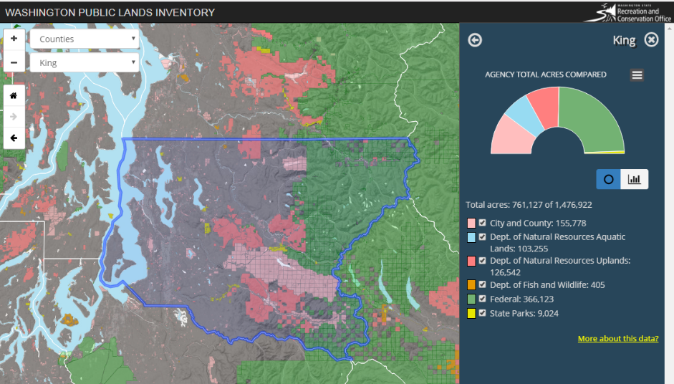
Source: State of Washington Public Lands Inventory

- City and County: 155,778 acres
- Washington Department of Natural Resources Aquatic Lands: 103,255 acres
- Washington Department of Natural Resources Uplands: 126,542 acres
- Washington Department of Fish and Wildlife: 405 acres
- State Parks: 9,024 acres
- Federal: 366,123 acres

Federal land across the country includes holdings managed by a variety of agencies, including the U.S. Bureau of Land Management, the Defense Installations Spatial Data Infrastructure, the U.S. Fish and Wildlife Service, the National Park Service, and the U.S. Forest Service. Each of these agencies manages land for a different purpose and has different authorizing legislation, regulatory authority, management practices, and stakeholders.

The Republican Platform does not identify which federal lands might be appropriate to be transferred to the states.

ANALYSIS

As Proposed Motion 2017-0050 notes, the federal government holds more than 366,000 acres of land in King County. Transfer of the management and/or ownership of some or all of this land could have significant fiscal and administrative implications for state and county government.

Although neither King County nor the State of Washington have commissioned analysis of the potential administrative or financial implications of the type of land transfer contemplated in the Republican Platform, there have been studies of the current economic benefits provided by public lands in Washington State. In addition, the State of Wyoming has studied the potential financial and administrative implications for transferring management (but not ownership) of federal lands to that state.

State of Washington Study of Economic Value of Public Lands. In 2015, the State of Washington Recreation and Conservation Office commissioned a study on the economic value of public lands within Washington. That study concluded that, overall, “there were a total of about 446 million participant days a year spent on outdoor recreation in Washington, resulting in $21.6 billion dollars in annual expenditures.” Of that total, the report estimates that federal lands in Washington state account for approximately 32.8 million participant days and $1.3 billion in annual expenditures.

The report also notes that:

“In addition to the monetary contribution of outdoor recreation to Washington's economy, there are a number of other benefits not accounted for within traditional economic analysis. These benefits include the satisfaction and increase in general quality of life people get from engaging in outdoor recreation and from the ecosystem services recreational lands provide. Trees, water, and animals provide ecosystem goods and services such as swimmable water, habitat, and aesthetic beauty. Washington’s 23 million acres of public land provide many of these benefits. The combined total estimated value of these nonmarket benefits is between $134 billion and $248 billion a year.”

Of this “combined ecosystem service value,” the report estimates that federal lands in the state provide a value between $81 and $154.9 billion a year. If the ratio from the state’s overall holding of federal lands to the county’s applies in the same way as with outdoor recreation benefits (the report does not attempt to break down ecosystem service value at the county level), King County potentially realizes between $4 and $7.75 billion a year from federal lands located within the county.

Mt. Baker-Snoqualmie National Forest Job and Income Contributions. In September 2016, the Mt. Baker-Snoqualmie National Forest produced a report on its job and income contributions for 2014. Although the Mt. Baker-Snoqualmie National Forest spans several counties, it accounts for the bulk of federal public lands within King County.

The report noted that, “In 2014, the Mt Baker-Snoqualmie NFs supported around 1,400 jobs annually in local communities and around $ 65,800,000 dollars of annual labor income for wage earners and business sole proprietors.” These estimates encompass recreation by local and non-local visitors, livestock grazing, forest products, minerals and energy production, as well as support to local states and counties (such as the Secure Rural Schools program and Payments in Lieu of Taxes).

State of Wyoming Study on Transfer of Land Management. In 2015, the State of Wyoming commissioned a study on the management (though not the ownership) of some of the federal public land within the state. That study noted that a key policy decision must be made before the feasibility of a transfer of land management could be considered: “Is the goal of the transfer to generate more revenue to financially support the state and/or to pay for the cost for the state to manage these lands, or is the goal to improve the management, condition, and access to the lands in question?”

The report notes that the administrative and legal issues involved in the mechanics of a transfer, “would take a considerable amount of time and resources for the state as well as the federal government,” and notes that the state, “would not be able to manage these [federal] lands in the same manner they manage the state School Trust lands without significant changes in federal law.” The report then quantifies the administrative, legal, environmental, and financial burdens that might fall to the State of Wyoming should it assume management for some or all of the federal land holdings within the state, and notes that, “No matter the mechanism—whether a fee or a share of revenue generated—the state would have to be compensated for managing federal public lands.”

The situation in Washington State is very different from that in Wyoming. As a result, this staff report does not provide great detail on the Wyoming numbers. However, it could be anticipated that Washington State, like Wyoming, would find it impossible to seamlessly transfer management and/or ownership of federal public lands to the state without incurring costs that would need to be recouped in some way. The policy questions about the purpose for which the land is to be managed and the level of priority on using the land to generate income – for public schools, for example – would need to be addressed.

LINKS

- Y2 Consultants, LLC. Study on Management of Public Lands in Wyoming. 0373-Z. Jackson, WY. 2016: http://slf-eb.state.wy.us/osli/News/FinalStudyFedLand.pdf

- State of Washington Public Lands Inventory: http://publiclandsinventory.wa.gov/#Map

- Briceno, T., Schundler, G. 2015. Economic Analysis of Outdoor Recreation in Washington State. Earth Economics, Tacoma, WA. http://www.rco.wa.gov/documents/ORTF/EconomicAnalysisOutdoorRec.pdf

- National Forest Service, “Mt. Baker-Snoqualmie NFs Job and Income Contributions for 2014 At a Glance,” Estimates as of September 2016, https://www.fs.fed.us/emc/economics/contributions/documents/at-a-glance/508/pacificnorthwest/AtaGlance-508-MtBakerSnoqualmie.pdf

ATTACHMENTS

- Proposed Motion 2017-0050

INVITED

- Chris Krupp, Public Lands Guardian, Wild Earth Guardians
- Paul Kundtz, Washington State Director, The Trust for Public Land
- Adres Orams, Backcountry Hunters and Anglers

Republic Platform: America’s Natural Resources: Agriculture, Energy and Environment (https://www.gop.com/platform/americas-natural-resources/)
State of Washington Public Lands Inventory (http://publiclandsinventory.wa.gov/#Map)
Briceno, T., Schundler, G. 2015. Economic Analysis of Outdoor Recreation in Washington State. Earth Economics, Tacoma, WA. http://www.rco.wa.gov/documents/ORTF/EconomicAnalysisOutdoorRec.pdf
Briceno, p. ix
Briceno, p. xi
Briceno, p. 46
National Forest Service, “Mt. Baker-Snoqualmie NFs Job and Income Contributions for 2014 At a Glance,” Estimates as of September 2016, https://www.fs.fed.us/emc/economics/contributions/documents/at-a-glance/508/pacificnorthwest/AtaGlance-508-MtBakerSnoqualmie.pdf
National Forest Service, p. 3
Y2 Consultants, LLC. Study on Management of Public Lands in Wyoming. 0373-Z. Jackson, WY. 2016, http://slf-web.state.wy.us/osli/News/FinalStudyFedLand.pdf
Y2 Consultants, page ii
Y2 Consultants, page iii
Y2 Consultants, page vii

