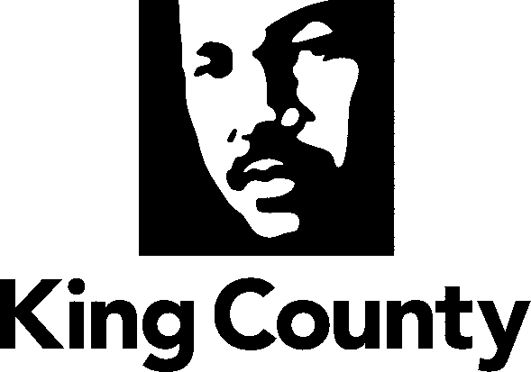

Checklist and Summary of Changes for the attached
Collective Bargaining Agreement

Name of Agreement
Joint Crafts Council, Construction Crafts and two Memoranda of Agreement

Labor Negotiator
Robert Railton

Prosecuting Attorney’s Review | Yes
Legislative Review Form; Motion or Ordinance | Yes
Executive Letter | Yes
Fiscal Note | Yes
Six Point Summary | Yes
King County Council Adopted Labor Policies Contract Summary | Yes
Ordinance | Yes
Original Signed Agreement(s) | Yes
Does transmittal include MOU/MOA? X2 | Yes

Six Point Summary of changes to the attached agreement:
1. Reflects the severance of some Teamsters’ bargaining units from the Joint Crafts Council and the establishment of a separate labor agreement covering the units (Joint Units Agreement).

2. Reflects the severance of a Teamsters’ bargaining unit representing Security Screeners from the Joint Crafts Council and transfer of the unit to the Sheriff’s Office and establishment of a separate labor agreement.

3. Reflects the severance from the Joint Crafts Council and change in representation of a Teamsters’ bargaining unit representing Security Officers, Security Officer-Dispatchers, and Security Sergeants who formed their own labor organization, King County Security Guild.

4. Adopts the cost-of-living Memorandum of Agreement agreed to by the vast majority of the County’s represented employees.

5. Provides for reopening the Agreement for the purpose of negotiating the standardization of pay practices.

6. Clarifies contract provisions and incorporates practices to reduce cause for grievances.

