STAFF REPORT

Agenda Item: | 9 | Name: | Sam Porter
Proposed No.: | 2023-0276 | Date: | May 7, 2024

SUBJECT

A motion accepting the 2022 Mental Illness and Drug Dependency annual report.

SUMMARY

The 2022 Mental Illness and Drug Dependency (MIDD) Annual Report is Attachment A to Proposed Motion 2023-0276 and covers MIDD activity during calendar year 2022. The requirements for the MIDD annual report are outlined in King County Code 4A.500.309 and include performance measurement statistics, utilization statistics, expenditure status updates, and progress reports on evaluation and implementation. The 2022 MIDD annual report appears to meet the requirements of K.C.C. 4A.500.309.

BACKGROUND

State Authorizes Sales Tax. In 2005, the Washington State Legislature authorized counties to implement a one-tenth of one percent sales and use tax to support new and expanded chemical dependency and mental health treatment programs and services, and for the operation of new or expanded therapeutic court programs and services.

King County Authorizes Sales Tax. In 2007, the King County Council adopted Ordinance 15949 authorizing the first MIDD sales tax. Ordinance 15949 established the expiration date of MIDD 1 as January 1, 2017. Subsequent ordinances established the MIDD Oversight Committee (April 2008) and the MIDD implementation Plan and MIDD Evaluation Plan (October 2008). Ordinance 18333 established MIDD 2 as a continuation of the MIDD sales tax established in Ordinance 15949, with an expiration date of January 1, 2026.

King County Council Approved Extension of the MIDD Sales Tax in August 2016. On August 22, 2016, the King County Council passed Ordinance 18333, extending collections of the MIDD sales tax through 2025. MIDD 2 became effective on January 1, 2017. According to the December 2023 MIDD financial plan, the sales tax generated approximately $172.2 million in the 2021-2022 biennium and is expected to generate approximately $192.1 million during the 2023-2024 biennium. Ordinance 18333 set forth the following five policy goals for the MIDD:
- Divert individuals with behavioral health needs from costly interventions such as jail, emergency rooms and hospitals.
- Reduce the number, length, and frequency of behavioral health crisis events.
- Increase culturally-appropriate, trauma-informed behavioral health services.
- Improve the health and wellness of individuals living with behavioral health conditions.
- Explicit linkage with, and furthering the work of, King County and community initiatives.

ANALYSIS

The 2022 MIDD annual report appears to meet the requirements of K.C.C. 4A.500.309. The services and programs funded by the MIDD are evaluated by staff in King County’s Department of Community and Human Services (DCHS) based on data submitted by providers. King County Code 4A.500.309.D.1 requires that the annual summary evaluation report shall include at a minimum the following:
A. Performance measurement statistics;
B. Program utilization statistics;
C. Request for proposal and expenditure status updates;
D. Progress reports on evaluation implementation;
E. Geographic distribution of the sales tax expenditures across the county, including collection of residential ZIP Code data for individuals served by the programs and strategies;
F. Updated performance measure targets for the following year of MIDD initiatives, programs and services;
G. Recommendations on either program changes or process changes, or both, to the funded programs based on the measurement and evaluation data; and
H. Summary of cumulative calendar year data.

The information listed above can be found throughout the report and linked to the web-based MIDD Data Dashboard at the following address: https://kingcounty.gov/en/legacy/depts/community-human-services/mental-health-substance-abuse/midd/reports.aspx

Figure 1 below provides the page numbers for specific sections of the report.

Figure 1. 2022 MIDD Annual Report Sections
Section | Page
2022 Highlights | 7
Strategy Areas | 9
Who MIDD Serves | 14
Geographic Distribution of Participants | 15
Results | 16-20
Evaluation and Performance Measurement Results | 21-26
Financial Report | 28

Items of note in the 2022 MIDD annual report:
- In 2022, total MIDD expenditures were approximately $76.16 million, roughly $22.9 million less than anticipated for the year.
- 19,281 people were served by MIDD programs in 2022; 374 more than the previous year. Of those, 64 percent were adults ages 18-54, nine percent were youth ages 0 to 17, and 22 percent were age 55 and over, virtually static distribution to the prior year.

Figure 2 provides information about the geographic distribution of people served in 2022, and Figure 3 provides information about additional demographics of those served.

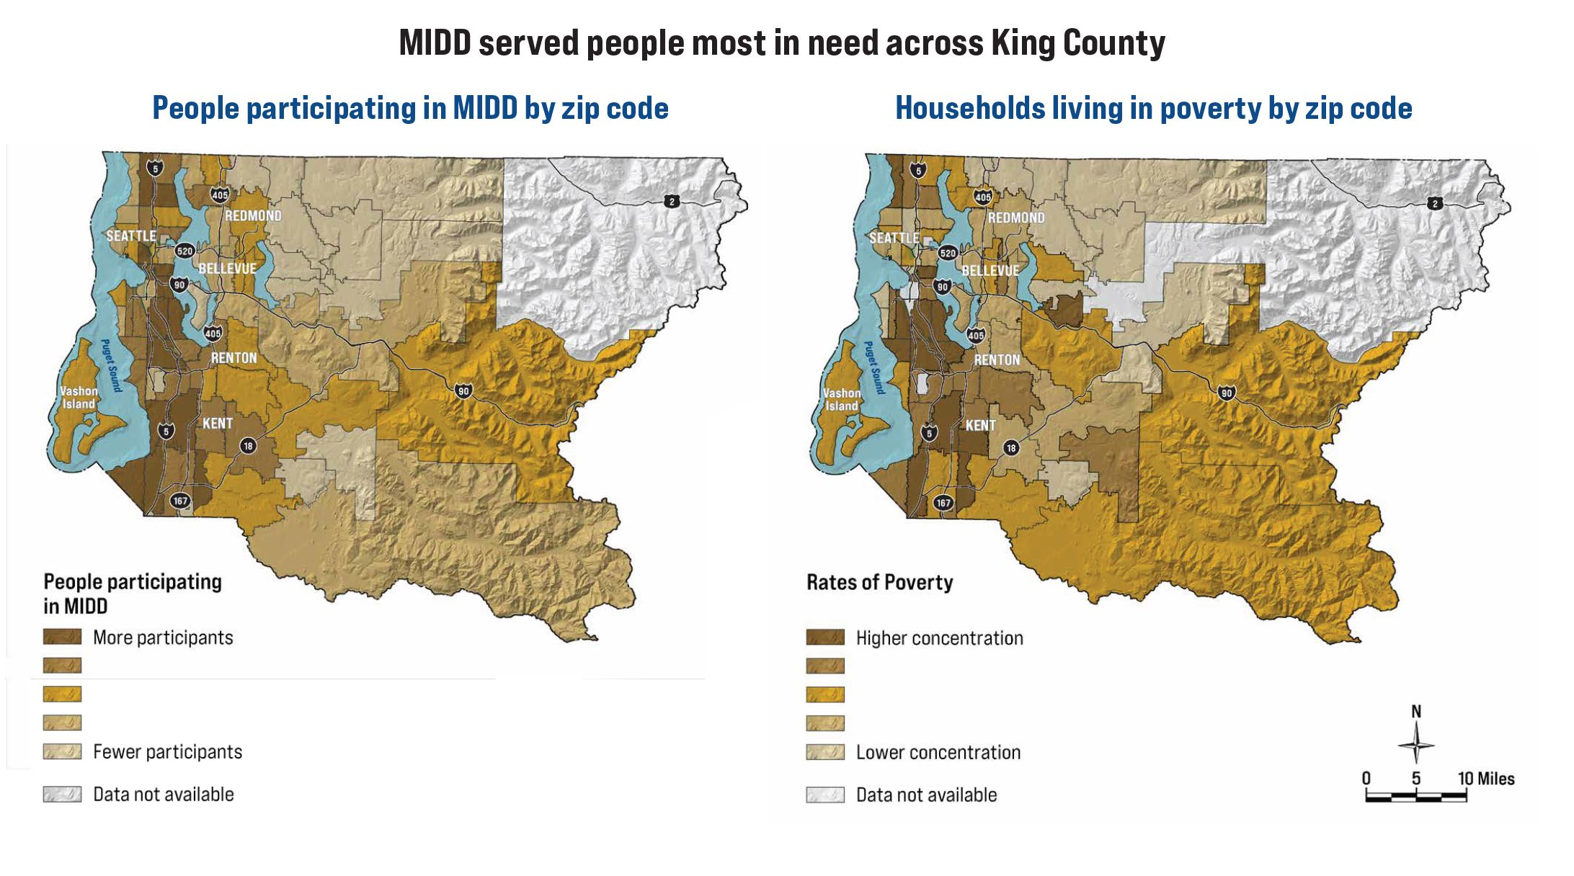
Figure 2. Geographic Distribution of People Served by MIDD, 2022

Figure 3. Additional Demographics of People Served by MIDD, 2022
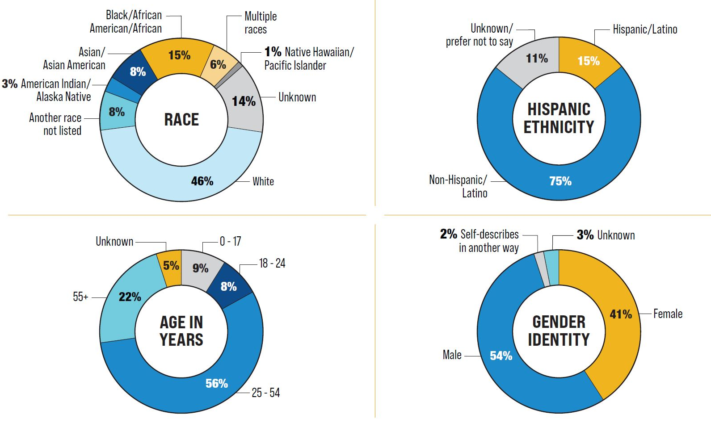

Details about the 2022 outcomes from the MIDD Policy Goal areas appear on pages 16 through 20 of the report and on the web-based data dashboard.

The MIDD Advisory Committee reviewed the 2022 MIDD annual report at their June 2023 meeting. The 2022 Annual Report was transmitted to Council in Fall 2023 with Proposed Motion 2023-0276 as a nonmandatory dual referral to both the Regional Policy and the Law, Justice, Health and Human Services (LJHHS) Committees, or its successor. Proposed Motion 2023-0276 was passed by the Regional Policy Committee on March 13, 2024, with a Do Pass recommendation. It was then referred to the Health and Human Services Committee as the relevant successor of the LJHHS Committee.

INVITED

- Susan McLaughlin, Director, Behavioral Health and Recovery Division (BHRD), Department of Community and Human Services (DCHS)
- Robin Pfohman, MIDD Coordinator, BHRD, DCHS

ATTACHMENTS:

- Proposed Motion 2023-0276 (and its attachments)
- Transmittal Letter
- 2022 MIDD Annual Report Presentation, HHS, May 7, 2024

In 2005, the Washington state legislature authorized counties to implement a one-tenth of one percent sales and use tax to support new or expanded chemical dependency or mental health treatment programs and services and for the operation of new or expanded therapeutic court programs and services.
The MIDD Oversight Committee was established in Ordinance 16077 and is an advisory body to the King County Executive and the Council. The purpose of the Oversight Committee is to ensure that the implementation and evaluation of the strategies and programs funded by the tax revenue are transparent, accountable, and collaborative.
In October 2008, the Council adopted the MIDD 1mplementation Plan and the MIDD Evaluation Plan via Ordinance 16261 and Ordinance 16262.
2022 MIDD Annual Report, page 15
2022 MIDD Annual Report, page 14
MIDD Advisory Committee, https://kingcounty.gov/depts/community-human-services/mental-health-substance-abuse/midd/midd-committees.aspx

