STAFF REPORT

Agenda Items: | 5 – 7 | Name: | Andrew Kim
Proposed No.: | 2023-0443  2023-0444  2023-0448 | Date: | February 20, 2024

SUBJECT

Motions confirming the executive's appointments to the King County Priority Hire Advisory Committee.

SUMMARY

In 2018, the County established the Priority Hire Program to prioritize recruitment, apprenticeship, and employment opportunities on county public works construction projects of $5 million or more. Eligible program participants include those who reside in “economically distressed areas” in the county. The program, operated by the Finance and Business Operations Division (FBOD), utilizes the Master Community Workforce Agreement, a pre-hire collective bargaining agreement signed by the county and labor organizations, to establish terms related to the program including targets for percentage of priority hire workers and apprenticeship and diversity goals. The Priority Hire Program’s annual reports show an increase in the number of program participants each year since inception, however, participation by women and minorities remain flat.

The Priority Hire Advisory Committee (PHAC) was established to advise on the following: (1) program's performance in serving economically disadvantaged communities; (2) program's impacts on minority- and women-owned business enterprises (MWBEs) and small contractors and suppliers (SCS); and (3) make recommendations on program adjustments.

The proposed motions would confirm the executive’s appointments of Young Sang Song, Drew Gibson, and Mary Lerdahl for partial terms to the PHAC. Council staff has not identified any issues with any of the transmitted appointments.

BACKGROUND

King County Priority Hire Program. In January 2015, the City of Seattle established a priority hire program to train and hire underrepresented workers in the construction trades for City of Seattle public works construction projects with the goal of ensuring equity and eliminating disparities in city construction projects.

In February 2015, by way of a supplemental appropriations ordinance, the county took similar action by establishing the Economic Opportunity and Empowerment Program (EOEP) to ensure that the Children and Family Justice Center capital project, a ballot initiative to build a new facility to replace the Youth Detention Center, would include a diverse workforce. The EOEP supported the county’s design-build contractor’s goals of hiring and training minorities, women, veterans and youth; and utilizing small contractors and suppliers. The supplemental appropriations ordinance also established a community advisory board that supported the development of an EOEP implementation plan.

In May 2016, the executive issued a directive to all county department directors to pilot a Priority Hire program for large capital construction projects. The EOEP implementation plan served as a guide for the pilot program.

In 2018, the County established the Priority Hire Program to prioritize recruitment, apprenticeship and employment opportunities on county public works construction projects of $5 million or more. Eligible program participants include those who reside in “economically distressed areas” in the county. “Economically distressed areas” means the top 30% of all zip codes in the county in terms of the concentration of individuals who meet at least two of the following three criteria:
- Have income at or below 200% of the federal poverty level;
- Are unemployed; and
- Are at least 25 years old without a college degree.

Zip codes in Pierce and Snohomish counties that have county wastewater construction projects may also be included for eligibility. Figure 1 below shows a map of zip codes of priority hire worker residences in 2022. The adjacent bar graph indicates the number of priority hire workers that reside in each of the zip codes.

The Priority Hire Program, operated by the Finance and Business Operations Division (FBOD) within the Department of Executive Services (DES), utilizes the Master Community Workforce Agreement, a pre-hire collective bargaining agreement signed by the county and labor organizations, to establish terms to support the program’s goals. These goals include percentage targets of priority hire workers for each construction project, apprenticeship goals, and diversity goals.

FIGURE 1.
Residential zip codes of priority hire workers in 2022.

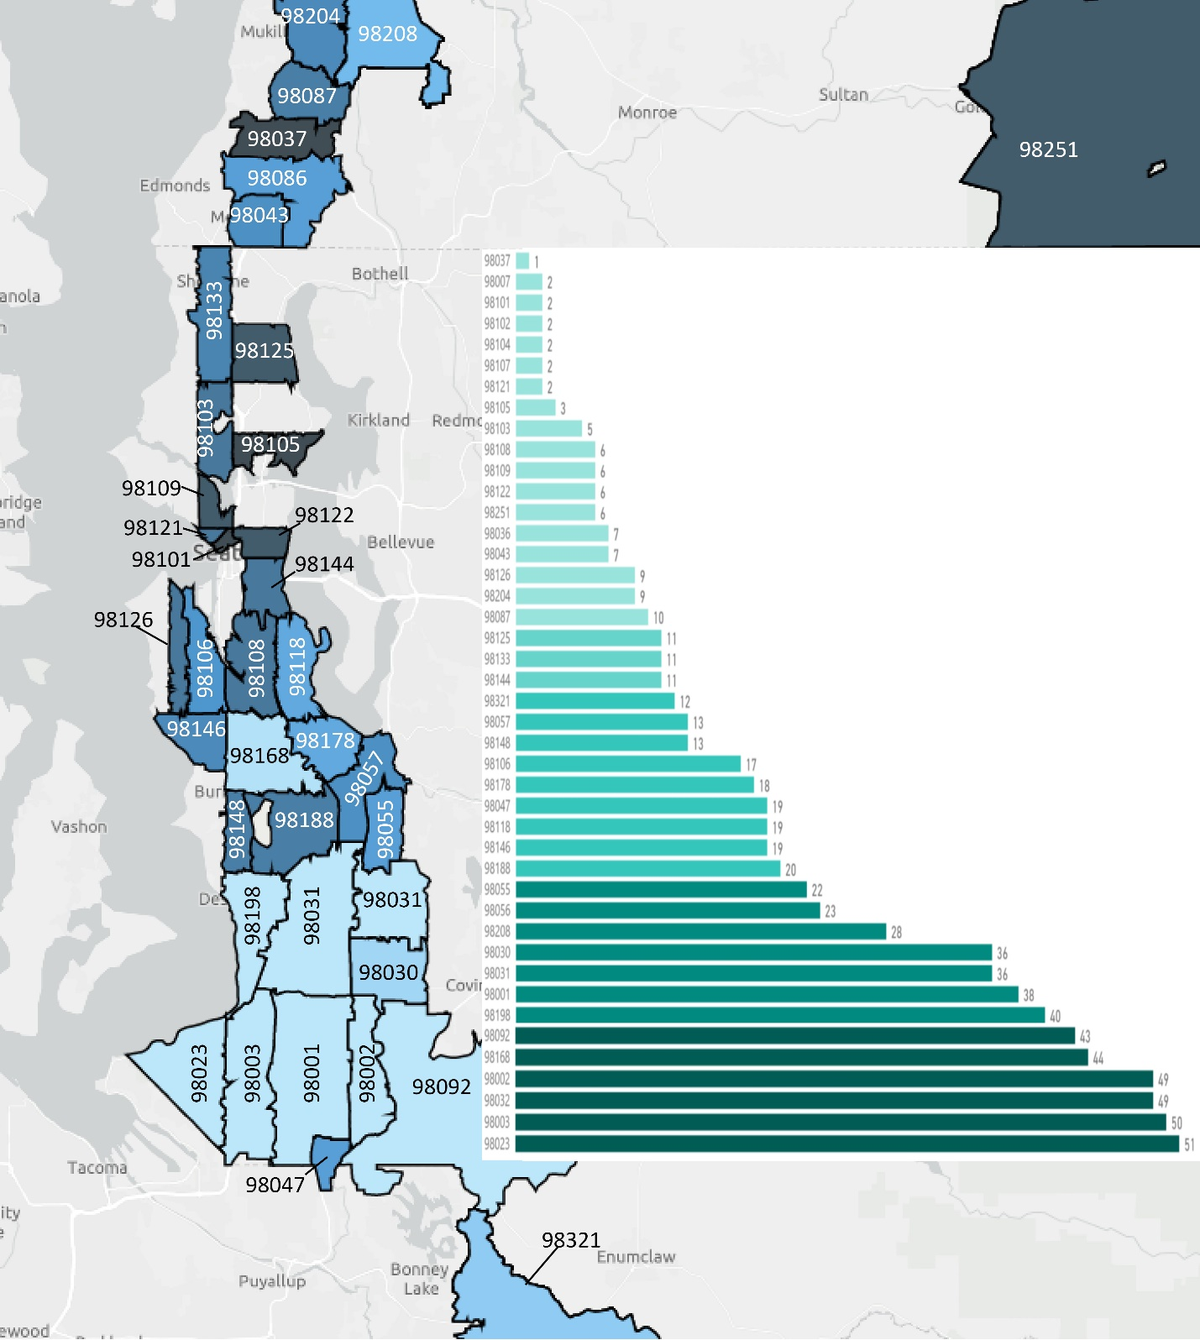

Priority Hire Program Performance. K.C.C. 12.18A.050.B. and K.C.C. 12.16.175 require the FBOD Director to submit an annual report to the executive detailing the performance of the Priority Hire program and forward the report to the council by April 30th each year. As shown in Figure 2 below, since inception, the program has shown an increase in the number of priority hire workers each year, which in effect has also increased the total earnings of the priority hire workers each year.

Figure 2 also shows that the percentage of women and minority priority hire workers has remained flat since inception of the program. According to the 2022 Apprenticeship and Priority Hire Program Annual Report, the lack of increase in the percentage of women and minority participants in the program are due to the following:
- All apprentices have the same classroom instruction, but women and minority apprentices have different on-the-job experiences, which is the primary method to foster interest in construction careers. The different experiences have resulted in lower retention rates for women and minority apprentices compared to their white male counterparts. In 2022, the County partnered with Apprenticeship & Non-Traditional Employment for Women (ANEW), the oldest continuously running pre-apprenticeship program in the nation, to facilitate RISE UP training for county employees involved in the management of capital construction projects or related areas. RISE UP training incorporates industry best practice workplace actions, knowledge, tools, and awareness to create and maintain a safe, inclusive, and productive environment that can lead to increase in worker retention rates. More than 150 county employees attended this training.
- The impacts from the COVID-19 pandemic in the construction industry is having an impact on job retention where previously laid-off workers are not returning to construction sites due to risk of occupational hazards, family demands and other issues. This issue has disproportionately impacted the Pacific Islander, Native American, and Black workers who were also disproportionately impacted by the pandemic.

The 2022 Annual Report also notes that the priority hire apprenticeship participation rate of 45.6% exceeded the required participation rate of 23.5%.

FIGURE 2.
Priority Hire Program Key Performance Metrics (2018 – 2022).

Priority Hire Advisory Committee (PHAC) Requirements. Per K.C.C. 12.18A.040.B., the PHAC was established to advise on the following: (1) program's performance in serving economically disadvantaged communities; (2) program's impacts on minority- and women-owned business enterprises and small contractors and suppliers; and (3) make recommendations on program adjustments. The PHAC was also required to provide input on the development of the Master Community Workforce Agreement.

K.C.C. 12.18A.040.A. requires that the PHAC consist of 8 to 12 members and a good faith effort be made to include representatives with experience in the construction industry from: contractors; the Associated General Contractors of Washington; labor union representatives; small contractor and supplier businesses; pre-apprentice and apprentice training providers; and local community or business organizations.

Lastly, K.C.C. 12.18A.040.B requires that the PHAC meet at least twice per year.

ANALYSIS

The proposed motions would confirm the executive’s appointments of Young Sang Song, Drew Gibson, and Mary Lerdahl for partial terms to the PHAC.

Per K.C.C. 2.28.010, PHAC board members are appointed for a 3-year term. However, all of the appointments in the proposed motions would be approved for partial terms as the appointees are fulfilling board positions that have been vacant for 1 or 2 years. PHAC members whose terms have expired continued to serve during those vacant years as allowed by K.C.C. 2.28.003.C. Due to the vacancies, executive staff state that the PHAC did not meet in 2023.

Table 1 below provides a description of the three executive transmitted appointments including the status of their financial disclosure forms and their professional background.

Table 2 below provides the current list of all 10 PHAC members, including the three executive transmitted appointments. Executive staff state that the current members whose terms have expired on September 30, 2023, are still serving and they are having conversations with the members to see if they wish to be reappointed.

Council staff has not identified any issues with any of the transmitted appointments.

TABLE 1.
Priority Hire Advisory Committee Board Appointees Needing Council Approval.
(Ordered by Proposed Motion number)

Proposed Motion |  | Appointee Name |  | District |  | Representing |  | Term Expiration |  | Financial Disclosure |  | Background
2023-0443 |  | Young Sang Song |  | 9 |  | Contractor, SCS |  | 09.30.2025 |  | No issues |  | 20+ years in construction experience; Owner of DBE certified business; UW Graduate;  National Association of Minority Contractors (NAMC) Vice President and Current Interim President; Washington State Capital Project Advisory Review Board (CPARB) Member
2023-0444 |  | Drew Gibson |  | 9 |  | Contractor |  | 09.30.2025 |  | No issues |  | Senior Superintendent of ASI Structures located in Seattle; Experience working with various trade partners and job performance in the field and promoting apprentices
2023-0448 |  | Mary Lerdahl |  | 9 |  | Contractor, SCS |  | 09.30.2024 |  | No issues |  | Electrical contractor for 23 years with DBE certified business; Washington State Department of Transportation DBE Advisory Board member for over 10 years; Provides consulting services through WSDOT, Tabor 100, etc.
TABLE 2.
Current Priority Hire Advisory Committee Board Members.
(Ordered by Board Positions)

Position |  | Board Member |  | District |  | Representing |  | Term Expiration |  | Notes
1 |  | Mary Lerdahl |  | 9 |  | Contractor, SCS |  | 09.30.2024 |  | Pending council confirmation (PM 2023-0448).
2 |  | Monty Anderson |  | 9 |  | Labor |  | 09.30.2023 |  | Term expired but continuing to serve.
3 |  | Young Sang Song |  | 9 |  | Contractor, SCS |  | 09.30.2025 |  | Pending council confirmation (PM 2023-0443).
4 |  | Dave Johnson |  | 3 |  | Contractor |  | 09.30.2024 |  | Council confirmed on 02.06.2024.
5 |  | Sonja Foster |  | 4 |  | AGC of WA |  | 09.30.2023 |  | Term expired but continuing to serve.
6 |  | Drew Gibson |  | 9 |  | Contractor |  | 09.30.2025 |  | Pending council confirmation (PM 2023-0444).
7 |  | Caroline Vidal |  | 7 |  | Labor |  | 09.30.2024 |  | Council confirmed on 02.06.2024.
8 |  | Karen Dove |  | 7 |  | Pre-Apprentice |  | 09.30.2023 |  | Term expired but continuing to serve.
9 |  | Leilanna Barrientes |  | 7 |  | Labor |  | 09.30.2024 |  | Council confirmed on 02.06.2024.
10 |  | Robin Strom |  | 5 |  | Contractor |  | 09.30.2024 |  | Council confirmed on 02.06.2024.
11 |  | VACANT |  |  |  |  |  | 09.30.2025
12 |  | VACANT |  |  |  |  |  | 09.30.2024

ATTACHMENTS

- Proposed Motion 2023-0443
- Proposed Motion 2023-0443 transmittal letter
- Proposed Motion 2023-0444
- Proposed Motion 2023-0444 transmittal letter
- Proposed Motion 2023-0448
- Proposed Motion 2023-0448 transmittal letter
- Priority Hire Advisory Committee – Board Profile

City of Seattle Ordinance 124690, enacted January 21, 2015. [LINK]
Ordinance 17973, enacted February 18, 2015. [LINK]
Renamed as Judge Patricia H. Clark Children and Family Justice Center via Ordinance 18961. [LINK]
Ordinance 17304, enacted April 26, 2012. [LINK]
Report 2016-RPT0028. [LINK]
Executive Dow Constantine’s Memorandum to Department Directors, dated May 10, 2016. [LINK]
Ordinance 18672, adopted March 5, 2018. [LINK]
K.C.C. 12.18A.010.G. [LINK]
Master Community Workforce Agreement Between King County and Seattle/King County Building and Construction Trades Council and Northwest National Construction Alliance II, signed October 5, 2020. [LINK]
2023-RPT0038 (2022 Apprenticeship and Priority Hire Program Annual Report) Figure 7. [LINK]
2023-RPT0038 (2022 Apprenticeship and Priority Hire Program Annual Report). [LINK]; 2022-RPT0052 (2021 Apprenticeship and Priority Hire Program Annual Report). [LINK]; 2021-RPT0056 (2020 Apprenticeship and Priority Hire Program Annual Report). [LINK]; 2020-RPT0065 (2019 Apprenticeship and Priority Hire Program Annual Report). [LINK]; 2019-RPT0062 (2018 Apprenticeship and Priority Hire Program Annual Report). [LINK];
K.C.C. 12.18A.040 requires that a good faith effort be made to include representatives with experience in the construction industry from the following: (1) Contractors; (2) Associated General Contractors of Washington; (3) labor union representatives; (4) small contractor and supplier businesses (SCS); (4) pre-apprentice and apprentice training providers; and (5) local community or business organizations.
Disadvantaged Business Enterprises (DBEs) are small businesses owned by socially and economically disadvantaged individuals that are federally recognized by the U.S. Department of Transportation. DBE certification is conducted locally through the Washington State Office of Minority and Women’s Business Enterprises (OMWBE).
K.C.C. 12.18A.040 requires that a good faith effort be made to include representatives with experience in the construction industry from the following: (1) Contractors; (2) Associated General Contractors of Washington; (3) labor union representatives; (4) small contractor and supplier businesses (SCS); (4) pre-apprentice and apprentice training providers; and (5) local community or business organizations.

