Property Summary
Photos of Property
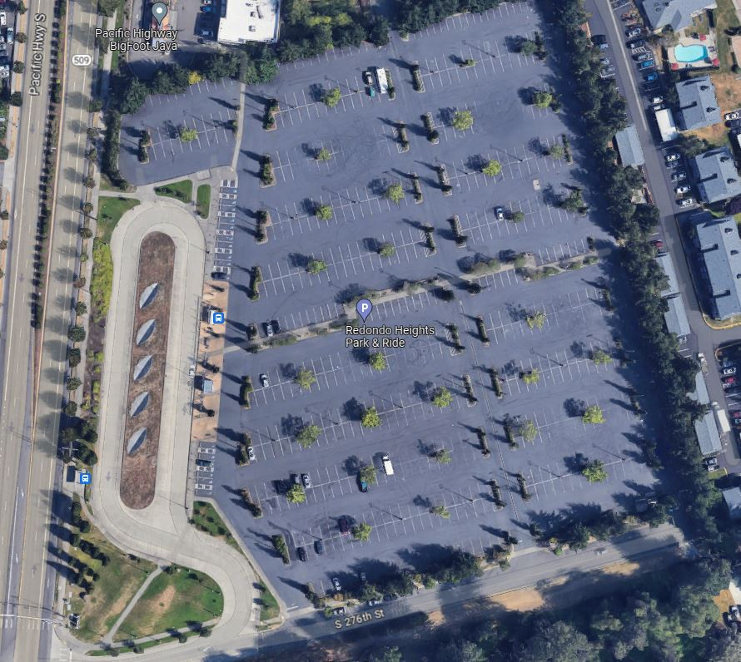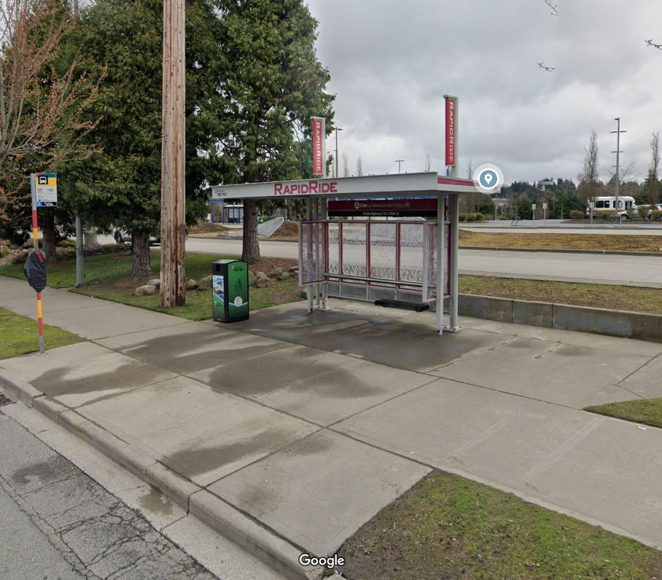

Property Owner: King County Metro Transit Department
Address: 27454 Pacific Hwy S, Federal Way, WA 98003
Sale Price: $5,230,000
Sale Area: 443,005 square feet, with Metro retaining a small easement area including the existing RapidRide station.
Assessor’s Parcel: 3322049012
Zoning: Community Business (BC)
Council District: Seven
Funding Source: Federal Transportation Administration (FTA) in 2000
Declared Surplus: March 1, 2022
Template Status: County template with some negotiated edits
Offer Expiration: Ordinance must be effective by December 13, 2023 per the terms of the Purchase and Sale Agreement. King County has an optional 90-day extension, which would extend the deadline to March 12, 2024.

Property Information
The property for consideration is the Redondo Heights Park and Ride, which consists of a 716-stall surface park and ride lot, including bus loading area for three buses, layover for up to four buses, operator comfort station, and bike racks.

Context:

Rationale for transaction: In 2017, King County Executive and Metro General Manager, along with Federal Way Public Schools (FWPS), and Sound Transit, entered into a Memorandum of Agreement regarding the Redondo Heights Park and Ride (Park and Ride).

FWPS’ property housing Mark Twain Elementary was impacted and partially acquired by Sound Transit for its Federal Way Link Extension. FWPS was seeking property suitable for relocating the elementary school. The Redondo Heights Park and Ride is historically underutilized, and all parties anticipated that utilization would drop further upon the opening of the new Link light rail station being constructed on S. 272nd, on the former Star Lake Park and Ride property. The parties undertook feasibility studies, including environmental studies and other work, to assess whether the Park and Ride would be a suitable site for construction of a new school. These studies and assessments have been completed and the parties have determined that the Park and Ride will be a suitable location for construction of a new school.

Policy considerations: The Park and Ride was originally acquired for use as a park and ride and the potential location of a future Link light rail station. However, the alignment of the Federal Way Link Extension rendered use of the property as a light rail station unnecessary. The Park and Ride’s historical underutilization, exacerbated by the COVID-19 pandemic and anticipated to be even lower upon the opening of the Federal Way Link Extension, renders the property surplus to Metro’s needs. The FTA, which provided grant funding to Metro purchase the property in 2000, encourages grant recipients to dispose of property for fair market value when it is no longer necessary to accomplish the original purpose of the grant. The FTA has provided a letter setting forth its concurrence with the proposed sale.

The only remaining bus service at the Park and Ride, once the Link extension opens, will be the RapidRide A Line. Comparison of the ridership of the A Line at that station to the number of vehicles parked in the Park and Ride demonstrates that no parking will be needed at that location in the future. In addition, the new Link light rail station will provide bus layover spaces and operator comfort stations, so neither will be needed at the existing Park and Ride.

Political considerations: The proposed sale of this parcel to FWPS supports relocating the elementary school, and FWPS will provide additional public benefits including community playfields.

Community considerations
or partnerships: A surface parking lot is not the highest and best use of this property, which is surrounded on two sides by multi-family housing, with an additional multi-family housing development currently under construction adjacent to the southern property boundary. FWPS will provide play fields to the community as an additional public benefit of the transaction.

Fiscal considerations: The fair market value appraised price of the property, which is the negotiated sale price, is $5,230,000.

Other Considerations: The County will retain an appurtenant easement for the maintenance and use of the existing RapidRide A Line station.

King County Strategic Plan impact: NA

Equity and Social Justice Impact: In accordance with Real Property Asset Management Plan (RAMP) policy, the Facilities Management Division and Transit reviewed this legislation for Equity and Social Justice (ESJ) impacts. This location is in the Redondo neighborhood of Federal Way and the proposed development is consistent with other property uses in the neighborhood. This proposed Ordinance furthers the King County Equity and Social Justice Strategic Plan by investing in community recreation space. No negative impacts are anticipated from this sale.

Surplus Process
Interest from other county agencies? No.
Property suitable for affordable housing? Exempt from affordable housing analysis under KCC 4.56.100.12.A.
Property determined to be surplus? Declared Surplus on October 5, 2023

Marketing and Sale
Indicate whether the property was marketed or not, and if so, how it was marketed:
MLS
Commercial Broker
County Website (number of website views:_______________)
Social Media
Onsite Signage
Not Marketed (briefly explain) Direct Sale

Appraisal Process
Date of valuation: April 4, 2023
Appraised by: Anthony Gibbons
Appraisal factors: Environmental contamination/cost to cure estimate $5,600,000
Comps analysis: Appropriate and timely comparable properties were utilized
Estimated FMV: $5,230,000
Review Appraisal by: Appraisal Group of the Northwest
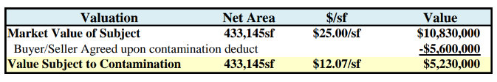
Vicinity View Map
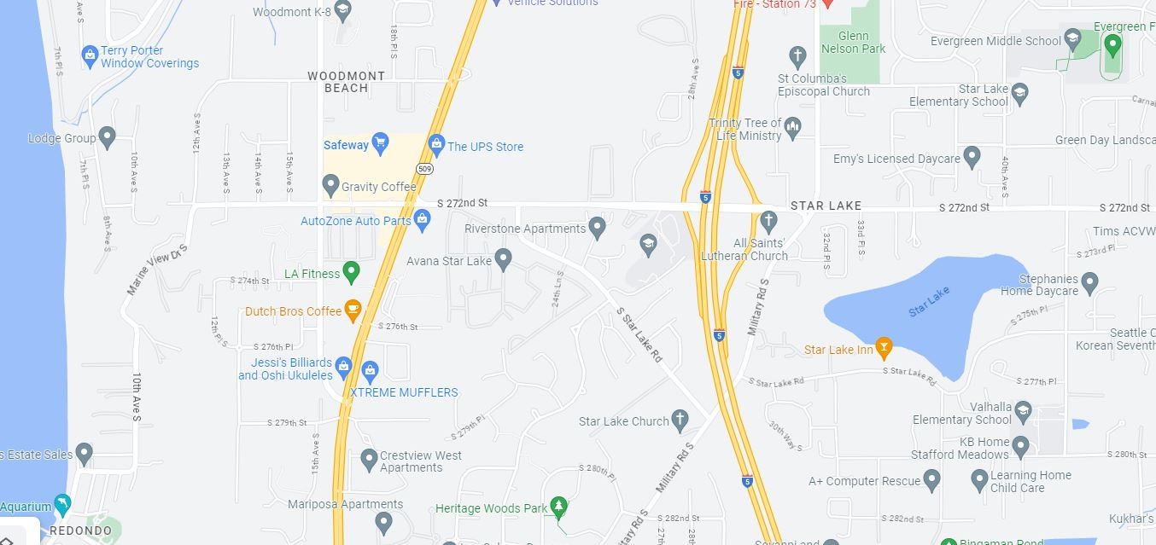

Parcel Map
