Lease Property Summary
Photo of Property

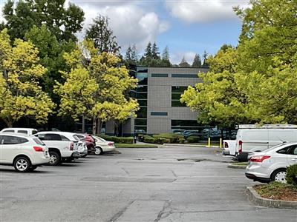

Property Owner: Curran Properties, LP
Address: 19125 North Creek Parkway, Bothell, WA 98011
Cost Per Sq. Ft.: $1.58 per month ($3,937.75/2,487sf)
Operational Costs: $2,895.72 per month (2023)
Term: Five years
Square Footage: 2,487 square feet.
Council District: One
Funding Source: EH Fund/Fees
Previous Location: Lease extension at the current location
Offer Expiration: None, current lease expires 9/30/2023 and allows for holdover. Holdover rent begins October 1, 2023 and is 125 percent of base rent.

Use Agreement Synopsis:
The Environmental Health Division of the King County Department of Public Health (Public Health) leased the Bothell North Creek Office Park facility beginning October 1, 2018. This location provides 15 workspaces, two hot desks, one conference room, and fleet car parking for Food and Facilities and other Environmental Health programs serving northeast King County. This location provides staff access to internet connectivity, printers, supplies, storage, and space to work individually or with others. This site improves operational functionality by minimizing field investigators’ deployment travel time in northeast King County, thereby improving efficiency and reducing costs of services.
Context
Rationale for transaction: This proposed lease amendment maintains Public Health’s presence in the current location, which is easily accessible to staff via major roads, highways, and transit services.

Policy considerations: This proposed lease amendment supports the work of the Food and Facilities Program’s mission of promoting healthy people and healthy communities through education and regulation of food service establishments and water recreational facilities.

Political considerations: N/A

Community considerations
or partnerships: Public Health carries out community-wide food safety and water recreational facilities program to promote health and prevent disease through education, training, and regulation. This system works in partnership with the people who make the day-to-day decisions that determine food safety, the operators and employees of food service establishments along with those at water recreational facilities.

Fiscal considerations: N/A

Other considerations: N/A

CIP/operational impacts: This location supports reduced program costs through minimizing drive times for north-end field investigation staff serving this geographic location and minimizing the adverse impact of traffic congestion that is frequently encountered in this area.

King County Strategic Plan impact: N/A

Equity and Social Justice impact: In accordance with Real Property Asset Management Plan (RAMP) policies, the Facilities Management Division (FMD) and Public Health reviewed this proposed legislation for Equity and Social Justice (ESJ) impacts. This location is in the North Creek Parkway area of Bothell, and is easily accessible to major roads, highways, and transit services. This is a renewal of an existing lease at this location for Public Health and the use is consistent with the location's zoning. No ESJ impacts are anticipated with this agreement.

Energy Efficiency impact: N/A

Use Agreement Alternatives Analysis
Summary: The Facilities Management Division and Public Health conducted a facility search before securing this location in 2018. In 2023 a market rate survey was performed and weighed against the costs of relocation. The North Creek Parkway site met and continues to meet Public Health’s needs.

Vicinity View Map
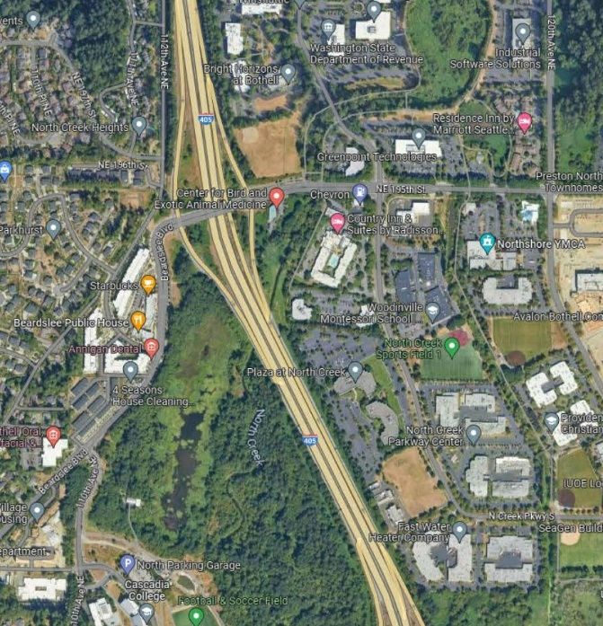

Parcel Map

