STAFF REPORT

Agenda Items: | 7 and 8 | Name: | Jenny Giambattista
Proposed No.: | 2023-0172 and 2023-0173 | Date: | May 10, 2023

SUBJECT
Proposed Ordinance 2023-0172. An ordinance relating to rates and charges for sewage treatment and disposal. The proposed ordinance increases the monthly sewer rate effective in 2024 to $55.11. The proposed ordinance would also set the capacity charge for new connections to the regional system occurring in 2024 at $74.23.
Proposed Ordinance 2023-0173. An ordinance making a net supplemental appropriation of $9,164,000 to the Wastewater Treatment Division and amending the 2023-2024 Biennial Budget Ordinance.
SUMMARY
Proposed Ordinance 2023-0172. The sewer rate is WTD’s primary funding source. The monthly sewer rate collected by the county goes to support all Wastewater Treatment Division (WTD) expenses, including operating costs, debt service, and capital expenses. The proposed ordinance increases the monthly sewer rate effective in 2024 by 5.75 percent from $52.11 to $55.11. A technical memo required by code is included with the rate transmittal and provides detailed information on the revenues, expenditures, debt service, operations, and capital program that inform the rate development process.
The 2024 proposed sewer rate includes a 10-year rate forecast which shows rates increasing by more than inflation each year. WTD made several adjustments to the forecast model to reduce the spikes in rates during the forecast period. However, even with adjustments to try and contain the level of annual increases, the rate is projected to increase by 7 percent annually by 2030.
The need for increasing revenues (rates) is driven largely by the growing capital project demand. The annual Capital Improvement Program (CIP) is expected to grow from $443 million in 2023 to over just over $1 billion by the end of the forecast period in 2033. While the forecast does not report the CIP needs beyond the forecast period, future CIP needs are expected to be even more substantial given the age of the system and regulatory requirements. These future unmet financial needs present an ongoing challenge for the wastewater system.
The proposed ordinance would also set the capacity charge for new connections to the regional system occurring in 2024 at $74.23 per Residential Customer Equivalent (RCE) per month, which is a 2.4% increase over the 2023 rate of $72.50. This is a smaller increase than projected in the 2023 forecast.
The tentative schedule for Council consideration is listed below:
- Transmittal of Sewer Rate—April 10
- Briefing only at RWQC—May 3
- Budget and Fiscal Management Committee—Discussion only May 10 and Discussion/Possible Action —May 24
- Council consideration/action—June 6, assuming action by BFM
- Approval date requirement for sewer rate—July 1

Proposed Ordinance 2023-0173 was transmitted concurrently with the sewer rate and would increase WTD’s operating budget appropriation by $9.2 million and 73 FTEs. According to the Office of Performance, Strategy and Budget (PSB), most of the funding for 73 positions has already been appropriated within the existing capital budget to support capital projects. The proposed ordinance appropriates funding for the operating expenditures associated with these positions and other expenditures.
BACKGROUND
Monthly Sewer Rate. King County provides wastewater treatment services for 18 municipalities, 15 sewer districts, and the Muckleshoot Tribe in King County, southern Snohomish County, and the northern tip of Pierce County. The county provides sewer interceptor lines that receive wastewater collected from residences and businesses by the cities and sewer districts, who bill their customers directly for both county and local utility charges. The sewer rate is charged by the county to the utilities that deliver, treat and discharge wastewater.
The monthly sewer rate collected by the county goes to support all Wastewater Treatment Division (WTD) expenses, including operating costs, debt service, and capital expenses. The monthly sewer rate for both residential and commercial customers is calculated based on Residential Customer Equivalents (“RCEs”). Traditionally, the annual capacity charge rate level has been incorporated into the sewer rate legislation, for the convenience of the participants in the regional system.
The sewer rate is WTD’s primary funding source. The sewer rate proposal is developed to ensure that wastewater can support its cash obligations, including operating expenditures, debt service repayment, and any financial policy targets such as cash to fund the capital program.
By contract with partner cities and sewer districts, the county is to complete its consideration of the sewer rate for the following year by July 1 of each year.
Policies Guiding the Sewer Rate. The determination of the sewer rate is guided by policies established in King County code 28.86.160.
FP-15: King County shall charge its customers sewer rates and capacity charges sufficient to cover the costs of constructing and operating its wastewater system. Revenues shall be sufficient to maintain capital assets in sound working condition, providing for maintenance and rehabilitation of facilities so that total system costs are minimized while continuing to provide reliable, high-quality service and maintaining high water quality standards.
1. Existing and new sewer customers shall each contribute to the cost of the wastewater system as follows:
a. Existing customers shall pay through the monthly sewer rate for the portion of the existing and expanded conveyance and treatment system that serves existing customers.
b. New customers shall pay costs associated with the portion of the existing wastewater conveyance and treatment system that serves new customers and costs associated with expanding the system to serve new customers. New customers shall pay these costs through a combination of the monthly sewer rate and the capacity charge. Such rates and charges shall be designed to have growth pay for growth.
2. Sewer rate. King County shall maintain a uniform monthly sewer rate expressed as charges per residential customer equivalent for all customers.
Sewer rates shall be designed to generate revenue sufficient to cover, at a minimum, all costs of system operation and maintenance and all capital costs incurred to serve existing customers.
3. Capacity charge. The amount of the capacity charge shall be a uniform charge applied to each residential customer class structure type based on an estimate of the average persons-per-household occupancy for each such a residential customer class structure type. The amount shall be approved annually and shall not exceed the cost of capital facilities necessary to serve new customers.

Required Information. The policies listed below specify the contextual information that is to accompany the rate transmittal. WTD has prepared a technical memo with the required information that provides detailed information on the revenues, expenditures, debt service, operations, and capital programs that inform the rate development process. Please see Attachment 4 to this staff report.
FP-16: The executive shall prepare and submit to the council a report in support of the proposed monthly sewer rates for the next year, including the following information:
Key assumptions: key financial assumptions such as inflation, bond interest rates, investment income, size and timing of bond issues, and the considerations underlying the projection of future growth in residential customer equivalents.
Significant financial projections: all key projections, including the annual projection of operating and capital costs, debt service coverage, cash balances, revenue requirements, revenue projections and a discussion of significant factors that impact the degree of uncertainty associated with the projections.
Historical data: a discussion of the accuracy of the projections of costs and revenues from previous recent budgets, and
Policy options: calculations or analyses, or both, of the effect of certain policy options on the overall revenue requirement. These options should include alternative capital program accomplishment percentages (including a ninety percent, a ninety-five percent, and a one hundred percent accomplishment rate), and the rate shall be selected that most accurately matches historical performance in accomplishing the capital program and that shall not negatively impair the bond rating.

Historical Sewer Rate. Table 1 below depicts the anticipated sewer rates through 2026. Increases have historically been structured effectively as biennial rates, with rate adjustments in alternating years. In 2021, after engagement with cities and sewer districts through the Metropolitan Water Pollution Abatement Advisory Committee (MWPAAC), the Executive recommended annual, rather than biennial adjustments to sewer rates.

Table 1
Sewer Rate (2009-2023 Actual; 2024 Proposed; 2025-2026 Projected)

Year(s) | Rate  ($/RCE/ Month) | % Increase
2009 – 2010 | $31.90 | 14.1%
2011 – 2012 | $36.10 | 13.2%
2013 – 2014 | $39.79 | 10.4%
2015 – 2016 | $42.03 | 5.6%
2017 | $44.22 | 5.2%
2018 | $44.22 | 0.0%
2019 | $45.33 | 2.5%
2020 | $45.33 | 0.0%
2021 | $47.37 | 4.5%
2022 | $49.27 | 4.0%
2023 | $52.11 | 5.75%
2024 | $55.11 | 5.75%
2025 | $58.28 | 5.75%
2026 | $61.64 | 5.75%

ANALYSIS
Proposed 2024 Sewer Rate and Projected 2025-2033 Forecast. As shown below in Table 2, the sewer rate is proposed to increase by 5.75 percent in 2024. This is the same level of increase for 2024 as projected in the 2023 forecast and “smooths” the rate spikes projected in later half of the 2023 forecast. For example, the 2023 forecast projected annual increases of 9 percent starting in 2028. Under the new forecast as shown in Table 2, the rates will continue to increase by 5.75 percent annually until 2027 and then increase by 6.5 percent annually from 2027-2029 and peak at 7 percent annual increase until the end of the forecast period. As will be discussed below, WTD made several adjustments to the 2024 rate model forecast to achieve a more gradual increase in rates.
Table 2.
Proposed 2024 Sewer Rate and Projected 2025-2033 Sewer Rate

Major Assumptions Have Changed Since 2023 Forecast. As discussed below, several assumptions in the forecast model have changed. These changes result in a reduction in the level of rate increases forecast for future years when compared to the preliminary forecast in February or the 2023 rate forecast.
The Forecasted Accomplishment Rate Has Changed. Among the variables changed in the forecast model, according to WTD the change to the accomplishment rate assumption has the most significant impact on the rate. The accomplishment rate is the expected CIP expenditures that can be completed in a given year compared with the amount of capital spending forecast. Applying the accomplishment rate to CIP expenditures is used to determine the amount of funding (cash and debt) that will be needed to pay for the CIP and is an important assumption in the rate setting process. If the accomplishment rate is set too high, it could result in raising rates to generate revenue before there is an ability to actually spend those funds.
For the 2024 forecast period, WTD slightly lowered the accomplishment rates in the first five years when compared to the prior forecast based on past performance and an assessment of CIP capacity across WTD. What changed for 2024 was the “catch-up” assumption. Previously, if WTD forecasted accomplishment rate was below 85 percent, WTD assumed it would make it up in later years (“catch up”) and would have accomplishment rates over 85 percent. WTD re-evaluated that assumption and determined it wasn’t realistic to have accomplishment rates in the high 90 percent and over 100 percent; so WTD capped it at 85 percent for the forecast. As a result, the average accomplishment rate across the forecast period is 80 percent.
While applying an accomplishment rate is standard practice, it also means that the capital costs not forecasted to be spent during the forecast period should be assumed to carry over until next forecast period. For WTD, this means $1.8 billion will need to be carried over into future forecast periods.
Council staff asked for additional information on how project prioritization will occur across the CIP portfolio given the assumed low accomplishment rates through 2027.
WTD reports:
WTD uses Portfolio Management (PfM) to evaluate existing projects and new projects when determining priority. PfM is an objective process which brings subject matter experts together to prioritize projects based on criticality, risk of failure, and other factors. We will of course strive to achieve higher accomplishment rates each year but using a more realistic rate helps to avoid unnecessarily higher sewer rates. ​

Table 3.
Capital Spending After Accomplishment Rate

2024 Baseline + CSI I/I Deferral | 2023 | 2024 | 2025 | 2026 | 2027 | 2028 | 2029 | 2030 | 2031 | 2032 | 2033 |  | 2023-2033
Aggregated CIP Project Forecasts | $443 | $440 | $663 | $666 | $721 | $772 | $975 | $1,079 | $1,087 | $1,005 | $1,007 |  | $8,858
Accomplishment Rate (AR) | 71% | 74% | 61% | 70% | 74% | 85% | 83% | 84% | 85% | 85% | 85% |  | 80%
Capital Spending after AR | $316 | $328 | $406 | $469 | $534 | $656 | $805 | $912 | $924 | $854 | $856 |  | $7,060

Changing the Cash Funding Calculations for the Capital Improvement Program. Since 2017, the sewer rate has been set at a level to ensure that on average over the ten-year forecast, 40 percent of the capital spending forecast funding is generated from revenues (cash) and the remainder from debt. The 2024 ten-year forecast changes the estimated percentage of cash funding assumed over the forecast period to 33.9 percent based on a different approach to cash funding.
According to WTD, the 40 percent cash spending practice has helped to strengthen WTD’s financial capability and limit growth in debt balances. WTD reports that, due to conservative forecasting assumptions and timely use of refunding opportunities, it has effectively cash-funded 55 percent of its CIP in the last six years and reduced the growth of debt balances more than originally expected. The 40 percent cash funding approach is not adopted in code. The current practice of 40 percent cash funding was developed in consultation with MWPAAC between 2014 and 2016 and implemented with the adoption of the 2017 sewer rate.
With the expected rapid increase in CIP requirements (assuming no other changes), WTD reports the 40 percent cash funding approach would mean significant rate hikes in the future to cover the cash needed to meet the 40 percent. Table 4 below shows the rate increases if the 40 percent cash strategy were applied to this forecast period.
Table 4.
2024 Sewer Rate Projection with 40 Percent Cash Funding (Current practice)

In 2022, WTD began evaluating different cash-funding policy alternatives in an effort to avoid large rate increases and spikes during the forecast period. WTD is proposing an original cost depreciation method for setting cash funding targets for its capital program. Under the proposed original depreciation approach, the cash funding amount for a given year would be equal to the annual depreciation amount across all WTD assets. To calculate the ratio of cash to debt for a given year, the annual depreciation amount is divided by the annual CIP.
WTD reports it will use the average expected annual depreciation amount to determine the annual cash contribution to the CIP over the forecast period. According to WTD, this depreciation approach reduces the near-term rate spikes caused by large CIP investments in a particular year because the fiscal impact of the CIP investment is spread out over the useful life of the asset. Under this approach, a large increase in CIP annual proposal would only increase the amount of cash needed in a year by the depreciation amount in that year. In other words, the size of an annual CIP does not change the required cash contribution each year since that is determined by the annual depreciation amount.
Table 5 shows the projected annual cash funding over the forecast period. As the forecasted CIP grows faster than the annual depreciation, the cash-funding ratio is expected to decrease. As shown below, the first year of projected cash funding ratio below 40 percent is 2028.
Table 5.
Projected Annual Cash Funding in Millions (2024-2033)

 | 2024 | 2025 | 2026 | 2027 | 2028 | 2029 | 2030 | 2031 | 2032 | 2033
Forecasted Annual Depreciation Across all Assets  (Equals cash target for that year) | $190 | $199 | $201 | $219 | $229 | $236 | $232 | $241 | $252 | $287
Forecasted Annual CIP | $328 | $406 | $469 | $534 | $656 | $805 | $912 | $924 | $845 | $856
Cash Funding Ratio (Annual depreciation/ Annual CIP) | 58.0% | 48.9% | 42.8% | 41.0% | 34.9% | 29.3% | 25.5% | 26.1% | 29.5% | 33.6%

WTD reports this approach would operate within the confines of the 1.4 debt service coverage ratio discussed later in this staff report. (Debt service coverage ratio is calculated by taking the amount of cash available after paying for operations and maintenance and dividing it by current debt obligations.) WTD reports it would not pursue a cash funding amount prescribed by an original depreciation approach in a given year if doing so would result in WTD having more debt than allowed to meet the 1.4 debt to cash ratio.
While this original depreciation approach does result in fewer spikes and smaller rate increases because less rate revenue (cash) will be needed, increasing debt does increase interest costs in the outyears. Because the forecast is limited to ten-years, it is difficult to evaluate the rate impact of these near-term decisions on the amount of debt versus cash in the next forecast period.
For additional details on cash funding policy, please see the Attachment 9, Financial Policy Review, Cash-Funding Alternatives (October 2022). Additionally,
Concern Raised By MWPAAC. In its letter (Attachment 10) to the Council, MWPAAC notes this change in cash policy would not reduce the 2024 rate and would have no impact on the rate path until 2027. In its comment letter, MWPAAC notes its interest in better understanding the short and long-term impacts of the cash funding policy. Council staff have asked WTD for more information on the impacts if there was a delay beyond the 2024 forecast of their internal adoption of the original cost depreciation method for determining cash funding.
WTD described the impacts of delaying the adoption of the original cost depreciation as follows:
More rate volatility in projections. The change in methods helps with affordability but it also makes the rate projections more predictable; we believe the actual rate will trend closer to forecasts. Unlike the 40 percent cash funding method, the depreciation method is anchored with historical costs which creates more stable cash targets for our sewer rate forecast.

Updated Capital Improvement Program Forecasts. Each year the annual rate proposal includes an updated 10-year CIP Forecast. To develop this forecast, WTD reviews the status of all CIP projects and considers the need for new projects. These updates resulted in a net increase in the CIP of about $900 million when compared to the prior forecast prior. However, once the accomplishment rates were factored in across the entire CIP forecast, the net increase over the 2023 forecast period was reduced to $185 million.
Other adjustments include deferring $316 million in Conveyance System Improvement (CSI) and infiltration and inflow (I/I) investments out of 10-year projection period. WTD is recommending deferral of conveyance system improvements (CSI) I/I with lower risk of capacity related overflows, which are those that have not had a capacity related overflow in the last 10 years, in order to address affordability and focus resources on other priority needs.
Other adjustments also include $723 million in increased expenditures for CSOs when compared to the prior forecast and then adding $350 million for CSO expenditures in 2033. WTD has assumed 2040 as the CSO project completion as a representative end date since the 2022 sewer rate proposal. WTD is currently in negotiations with EPA to modify its consent decree and project completion dates. The forecast assumes 58 percent of the total CSO costs ($2.5 billion out of $4.3 billion) with the remaining ($1.8 billion) assumed to be incurred after 2033 in a future rate forecast. This results in an increase of $1.1 billion, through 2033, from the $1.4 billion currently in the 2023 sewer rate forecast. If WTD does not prevail in its negotiations, the rate impacts could be severe.

The transmitted forecast also notes that economic conditions could impact the CIP forecast. Inflation rates reached historic levels during 2022 and 2023 and the potential impacts to capital budgets are dependent on the duration of currently high-cost inflation. Additionally, labor market constraints and supply chain constraints could impact the CIP forecast.
The incremental CIP change by category between 2023 and 2024 for the forecast period of 2023-2032 is summarized below in Table 6.

Table 6.
Incremental CIP Change between 2023 and 2024 Financial Forecast for 2023-2032

Total Change in CSO Projects | $723 m
Total Change in Other Projects | $503 m
Defer CSI I/I with no capacity related overflows | -$316 m
TOTAL Changes | $909 m
Total Changes after Accomplishment Rate | $185 m

The CIP Project Forecast Continues to Project Significant Growth. As shown in Figure 1, the annual CIP, after the accomplishment rate, is expected to go from $316 million in 2023 to $856 million annually by the end of the forecast period. The total CIP project forecast is estimated at $8.9 billion and $7.1 billion after the accomplishment rate. The difference between the CIP project forecast and the accomplishment rate total is assumed to be carried over into the next forecast period.
Given the significant increases in the WTD capital program, WTD plans to engage an independent, third-party review and feasibility assessment. According to WTD, the work would involve analyzing WTD’s capital portfolio approach, financial strategies, revenue/funding streams, resource needs and related market impacts, relevant timelines, and schedules.

Figure 1
Capital Improvement Program and Accomplishment Rate (2023-2033)
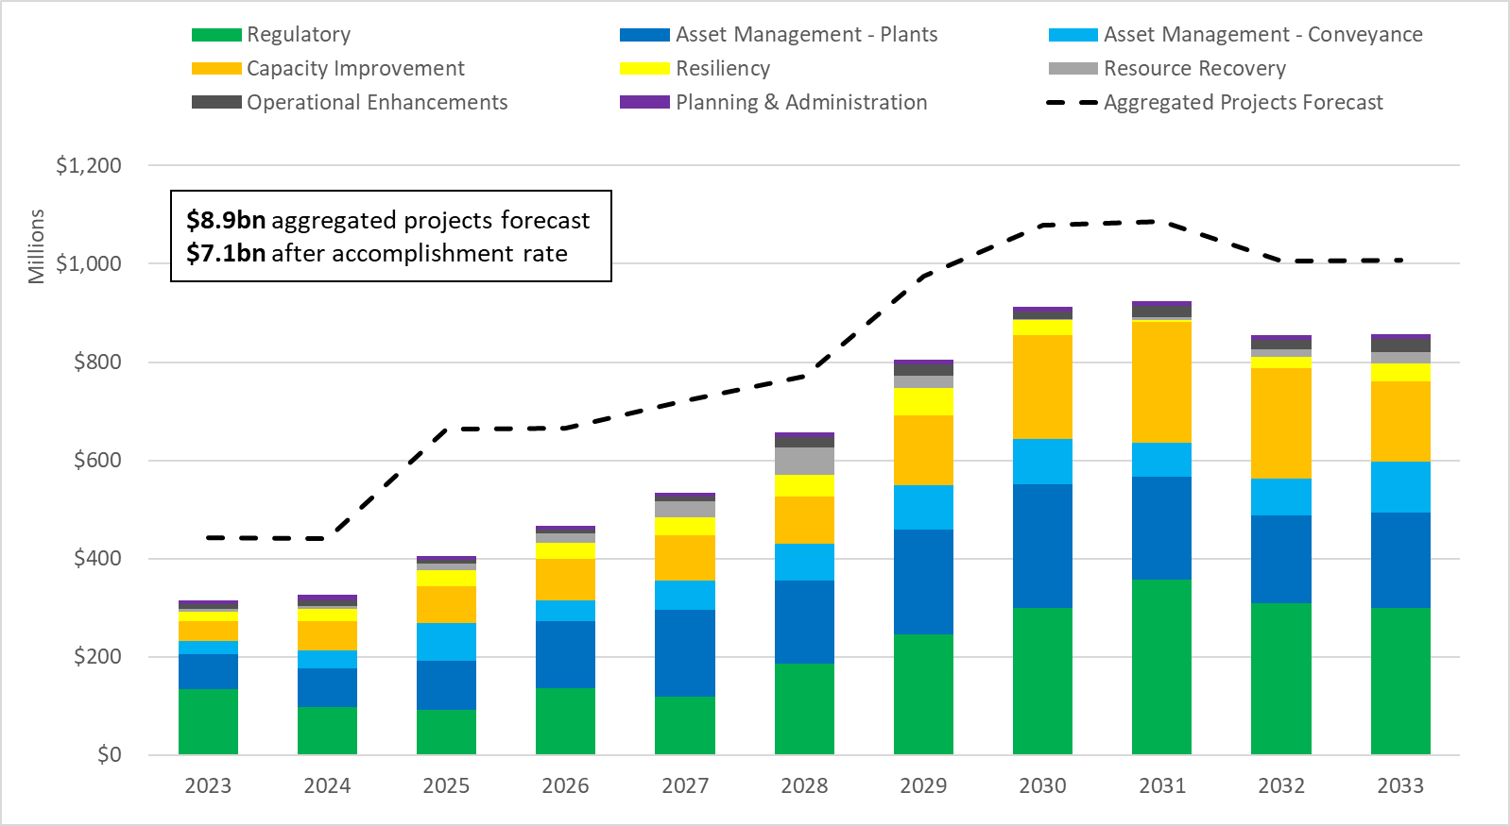
Capacity Charge. Since 1990, King County has levied a capacity charge on structures with new connections to the sewer system. The capacity charge is set annually by the County Council and is projected to account for about 14.6 percent of WTD’s annual revenues in 2024. It is a monthly charge that is billed quarterly for 15 years directly from King County. Customers with the newest sewer connections pay the charge so that “growth pays for growth.” The amount of the capacity charge for each structure depends on the size and/or type of structure.
As shown in the table below, the capacity charge for 2024 is proposed to increase by 2.4 percent to $74.23 and then in the remaining years of the capacity charge forecast it is projected to increase by 2.5 percent. In the prior forecast, the expected annual increase was 3 percent. The annual expected increase has been lowered based on slower connection growth following the COVID-19 pandemic.

Table 7
Proposed 2024 Capacity Charge and Projected 2025-2030 Capacity Charge (Total Revenues Reported in Millions)

WTD reports it has engaged a consultant to review the methodology used to develop the capacity charge and develop options for an updated methodology. WTD intends to transmit legislation to update the capacity charge methodology and it is tentatively listed in the 2024 RWQC work program for discussion in September.
Capacity Charge Revenues. Capacity charge revenue forecasts have historically used a conservative 6 percent year-over-year growth. More recently, this long-term growth assumption was reduced to 5 percent to reflect a reduction in new commercial connections. For 2023 and 2024, this assumption was reduced further to 3 percent to reflect reduced growth in capacity charge customers during the pandemic.
Revenue. The financial policies in King County Code 28.86 require WTD must ensure that its revenue can support its cash obligations, including operating expenditures, debt service repayment, and any financial policy targets. Revenue needs, driven by growing capital project demand, are expected to grow substantially over the forecast period.
As shown in Figure 2, the projected rate increases are intended to provide sufficient revenue to meet the annual revenue requirement. Figure 2 below shows the components that build to the total annual revenue requirement, compared with revenue under the existing and proposed sewer rate.

Figure 2.
2024-2033 Sewer Rate Forecast Revenue Requirements

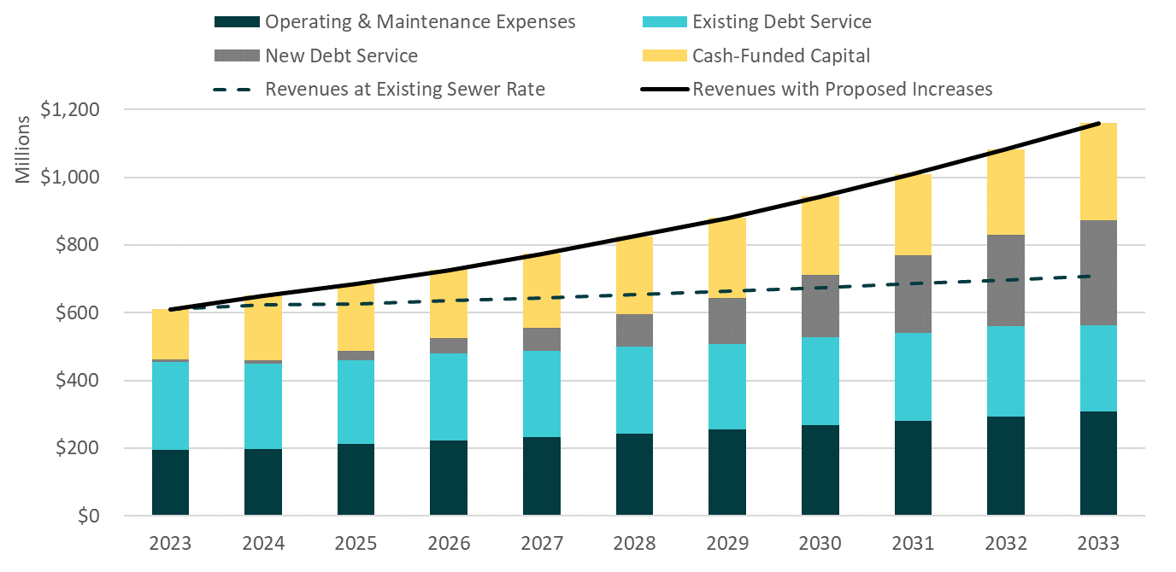

Debt Capacity. As discussed in this staff report and the WTD forecast, the 2024 10-year forecast as shown below anticipates an increasing amount of debt. In evaluating the level of debt, the debt service coverage ratio is a financial metric used to assess WTD’s ability to generate enough cash to cover its debt obligations. Debt service coverage ratio is calculated by taking the amount of cash available after paying for operations and maintenance and dividing it by current debt obligations. This method is broadly used in the industry and is of particular interest to bond rating agencies.
Figure 3 shows that debt coverage ratios are above the debt coverage standards in code and MWPAAC recommended levels. However, as shown in Table 8 the forecast is below the median for other AA sewer utilities and Moody’s recommendation.
Additionally, as noted in the MWPAAC letter (Attachment 10), the needed debt capacity in the future beyond the forecast period is not reported so it is difficult to assess beyond the forecast period.

Figure 3.
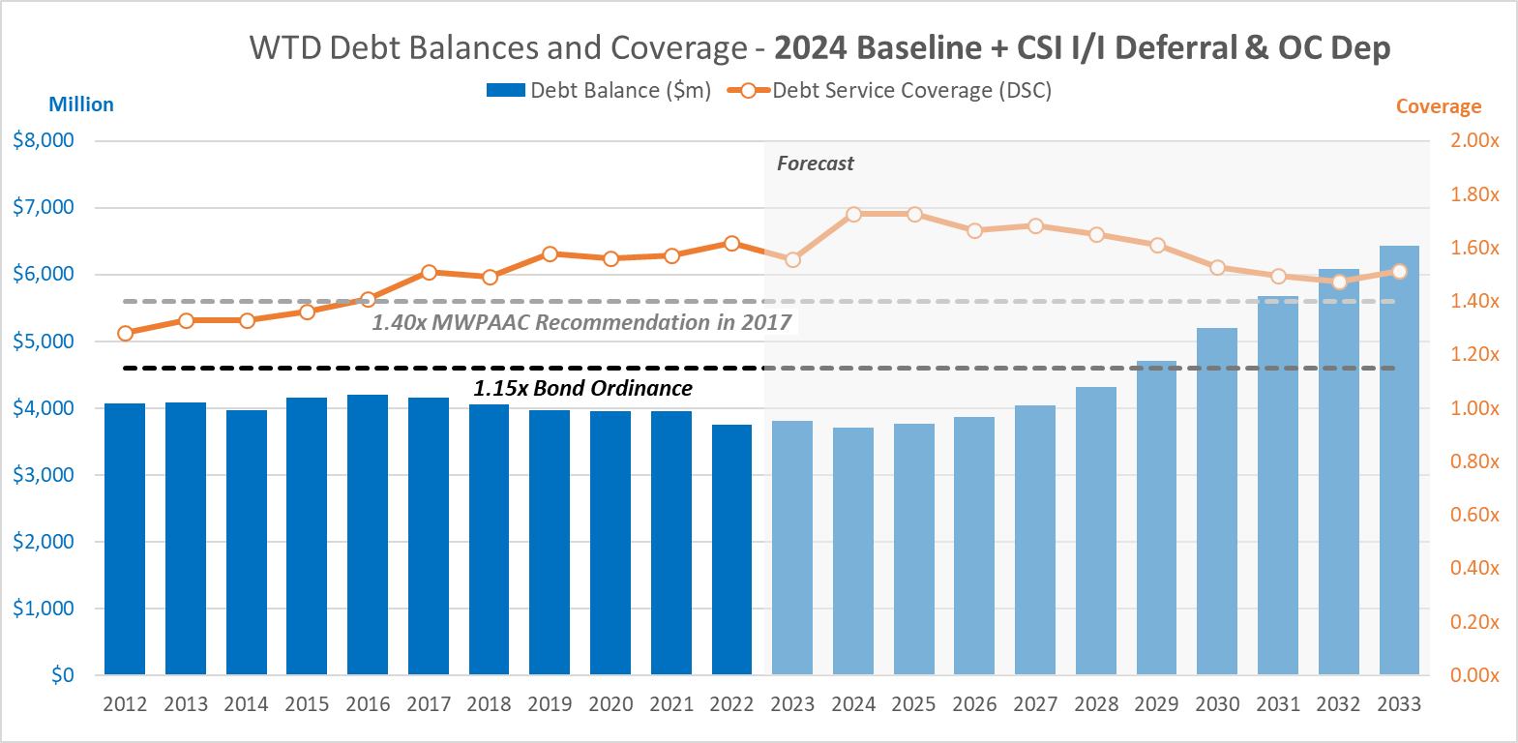

Table 8.
Debt Coverage Standards

Minimum Requirements of Debt Covenants and Code | Minimum for Rate Setting—Debt Review Recommendations (MWPAAC) | 2022 Actual (Unaudited) | Moody’s Recc. For Aa Rating | S&P Recc. For Aa Rating | 2018 Median for Aa Sewer Utilities
1.15x | 1.40x | 1.72x | 1.70x | 1.40x | 2.20x

While the 2024 forecast projects increasing amounts of debt, WTD does not anticipate that the 2024 proposed rate and 10-year projection will negatively impact WTD’s bond ratings. WTD reports it is projecting to again well-exceed the recommended 1.40x minimum coverage. Additionally, according to WTD, total debt balances are projected to grow at a slower pace than total assets. Lastly, WTD is also maintaining conservative forecasting assumptions such as a 5 percent long-term interest rate and they report this will allows them to routinely outperform the forecasts presented to rating agencies.
Proposed Ordinance 2023-0173 (Supplemental Appropriation and Request for 73 FTEs)
Proposed Ordinance 2023-0173 would increase WTD’s operating budget appropriation by $9.2 million and 73 FTEs.
Table 9 shows major expenditure categories which make up the $9.2 million in Proposed Ordinance 2023-0173.
Table 9.
Proposed Ordinance 2023-0173 Expenditures by Category
Category | Expenditure | Description
Wages and Benefits | $3,564,210 | Operating portion of the 73 FTEs
Supplies | $3,063,969 | Chemicals for wastewater treatment
Service-other Charges | $2,223,484 | This includes $1 million for wastewater discharge permit fees and $535,000 for consultants
Intragovernmental Services | $429,654
Extraordinary Expenses | -$117,650
Total | $9,163,667

WTD reports these increases were estimated in the 2023 sewer rate forecast, but not requested in the 2023-2024 Biennial Budget because the necessary revenue from the 2024 rate had not been adopted.
Staffing. WTD is requesting an additional 73 positions. (See Attachment 9.) According to PSB, most of the funding for these positions has already been appropriated within the existing capital budget to support capital projects; so, a significant portion of these FTEs will be funded through debt and paid off over 30 years. The proposed ordinance appropriates funding for the operating expenditures associated with these positions. WTD reports it conducted an analysis of past capital expenditures in relation to the number of WTD FTEs to estimate the number of additional staff needed for the proposed CIP forecast. WTD has provided a complete list of requested positions. See Attachment 8.

Historical Staffing. According to WTD, Table 9 below shows the distinction between historical and projected FTEs numbers. WTD reports it shows very little FTE growth, since Brightwater.

Table 10.
Past FTE Count and Future FTE Projections

Status of 2023 FTEs. In 2022 WTD increased the number of FTEs by 4.6 percent and in 2023 by 13.7 percent. Council staff asked WTD the status of the significant hiring scheduled for 2023. Below is the response from WTD:
“Of those 96 requisitions, in the first quarter we have completed or made substantial progress on nearly half of the total in including 14 completed hirings, and 30 that are at various stages of recruitment from initiation to making final selections. The remaining have been scheduled to begin recruitment in the 2nd quarter or partly into the 3rd quarter.”

Council staff asked WTD why the additional 73 positions are being requested if the 96 previously requested positions have not yet been filled. WTD’s response is below:
The approved and new FTE requests are necessary to support the growing capital program over the next 10+ years, and other complementary needs at WTD. We anticipate the 96 position requests to be filled by Q4 2023. WTD has regularly maintained a large capital program of over 200 projects and the list is growing in number, size, and complexity in the coming decade and beyond. New projects will continue to be added each year, on top of those added in previous years and the current list. Each project takes multiple years to plan, design, construct, and commission. The request of 73 FTEs will support the expanding capital program by adding additional project manager and project control staff in addition to capital program support staff in engineering, construction management, permitting, planning, and GIS services. WTD’s experience is that new staff require about 2 years to be fully able to carry needed multiple project loads. Other positions include additional Industrial Waste staffing to meet regulatory requirements, staffing to support the CBO program, and Operations plant and offsite staff to support additional preventative and reactive maintenance needs and response times.

Council staff have also asked for additional information to understand the implications on the rates and project delivery of partially funding or not funding these positions. The divisions response was as follows:
- Changes to FTE counts would have a small impact on the rate. The majority of the requested FTEs are for the capital program; so, a significant portion of these FTEs will be funded through debt and paid off over 30 years.
- Capital FTE costs are incorporated into the Capital forecast and would not change the cost of projects, only their timing as staff can complete the work.
- There are implications of not approving or partially approving the FTE request, including:
  - Non-compliance with regulatory deadlines or requirements, resulting in fines, penalties, and increased regulatory requirements.
  - Lost opportunities to coordinate multiple projects at the same site, resulting in increased cost and project delays
  - Setbacks in completing asset management needs in a timely manner, which adds to risk profile
    - Risk of overflow/spill and consequent environmental damage and human health risk
  - Project deferrals to later years when costs are even higher
- The WTD capital program is projected to grow significantly in coming years, reflecting needed investments in priority asset management, increasing regulatory demands, and contractually required capacity improvements.
- Projects will grow in number, size, and complexity. So WTD is taking steps now to prepare for those needs including adding staff to develop and manage a much larger portfolio.
- The Executive proposed and the County Council approved 96 FTES for WTD for these purposes as a part of the 2023 sewer rate and 2023/24 budget.
- Significant progress toward filling those positions has been made in the first quarter of 2023, with over half filled or underway.
- The 73 proposed FTEs as a part of the 2024 sewer rate reflect this continued need for the expanding capital program. Future years are expected to have continued growth but at lower levels.
Metropolitan Water Pollution Abatement Advisory Committee Comments. The Metropolitan Water Pollution Abatement Advisory Committee (MWPAAC) advises the King County Council and Executive on matters related to water pollution abatement. It was created by state law (RCW 35.58.210) and consists of representatives from cities and local sewer utilities that operate sewer systems within King County’s sewer service area. These cities and sewer utilities deliver their sewage to King County for treatment and disposal.
MWPAAC forwarded an advisory letter to the County Executive and subsequently forwarded a letter similar in substance to Council (Attachment 11).
The letter to Council requests includes the following points:
- MWPAAC values the increased transparency and more thorough and timely rate information provided by WTD staff over the past year.
- MWPAAC supports the 2024 rate but does not have confidence in the proposed rate path.
- MWPAAC requests additional dialogue and information in the following areas:
  - The proposed strategy to reduce cash financing of capital based on original cost depreciation. MWPAAC has concerns about the long-term rate impacts of an over-reliance on debt and the issues that can arise for intergenerational equity with this policy.
  - The significant increase in staffing.
  - “Growth pays Growth.” Existing rate payers should not subsidize the cost of growth.
  - The future will have enormous costs for asset replacements and refurbishments. MWPAAC requests continued discussions about capital prioritization and decision-making related to the Asset Management program.

INVITED
- Kamuron Gurol, Director, Wastewater Treatment Division
- Devin ViBarnes, Rates, Capital, and Debt Management Manager, WTD
- Crystal Fleet, Capital Portfolio Planning and Analysis Unit Manager, WTD

ATTACHMENTS
- Proposed Ordinance 2023-0172 (and its attachment)
- Transmittal Letter Proposed Ordinance 2023-0172
- Fiscal Note Proposed Ordinance 2023-0172
- Technical Memo Proposed 2024 Sewer Rate and Capacity Charge
- Proposed Ordinance 2023-0173
- Transmittal Letter 2023-0173
- Fiscal Note Proposed Ordinance 2023-0173
- Financial Policy Review Cash-Funding Alternatives
- Listing of 73 FTEs requested in Proposed Ordinance 2023-0173
- Metropolitan Water Pollution Abatement Advisory Committee 2024 Rate Recommendation Letter to Executive
- Metropolitan Water Pollution Abatement Advisory Committee 2024 Rate Recommendation Letter to Council

Prior to applying the accomplishment rate
The County has a contractual relationship with cities and utility districts to collect wastewater from them and convey it to County treatment plants for treatment and discharge. The component agencies that provide direct services to the ratepayers and use the County conveyance and treatment facilities are charged for the customers within their districts. The utility providers, as direct service providers, set their own rates to recoup the payments required by use of County services plus their own “local” cost of service.
A single-family residence is one RCE. Commercial and industrial customers are charged based on the amount of wastewater they generate, calculated using the quantity of water consumed. For commercial and multi-family residences, the calculation is then converted into RCEs. One RCE (750 cubic feet of wastewater) represents the average amount of wastewater a single-family residence would generate in a month.
Partner city and sewer districts act after the county sets the sewer rate to establish their local rates, all of which go into effect on January 1, 2024.
Pre-payment is also available.
The capacity charge methodology is codified in the financial policies K.C.C. 28.86.160 in the Regional Wastewater Services Plan that ends in 2030. Therefore, the projections in the forecast only extend to 2030.
Refers to bond ratings. According to S&P Global Ratings, an entity with AA rating is defined as having a “very strong capacity to meet its financial commitments.”

