Illustrative Purposes Only: Map of Proposed Crisis Response Zones Showing Geographic Subregions

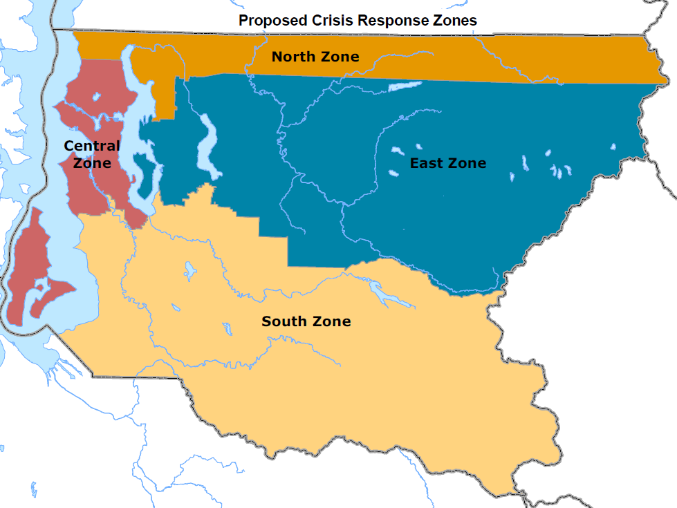

Map provided by Executive staff

