STAFF REPORT

Agenda Item: | 9 | Name: | Andy Micklow
Proposed No.: | 2022-0307 | Date: | November 7, 2022

SUBJECT

Proposed Ordinance 2022-0307 would authorize the execution of a franchise renewal agreement with the City of Seattle, for use of King County road rights of way in unincorporated King County for the construction and maintenance of electric transmission and distribution system facilities.

SUMMARY

King County Code Chapter 6.27 requires private or municipal corporations to obtain a franchise for the use of King County road rights-of-way (ROW) by submitting an application to the Facilities Management Division (FMD) and receiving approval from the Council. Proposed Ordinance (PO) 2022-0307 would authorize the Executive to execute the nonexclusive, negotiated franchise agreements with the City of Seattle for use of ROWs within unincorporated King County. The proposed agreement would have an initial term of ten years

Ordinance 18403, adopted by the Council in 2016, required that franchisees provide the County "reasonable compensation" in return for the right to use the ROW for utility facilities and outlines the factors and process to be used to determine the compensation amount. The proposed agreement would set the compensation at the following amounts, which would accrue to the general fund:

- Annual franchise compensation for 2023 through 2027 would be calculated at 8% of the total amount of revenue billed to the Franchisee's customers in unincorporated King County per calendar year. This is estimated to be $4.18 million in 2023 and 2024 and $4.52 million in 2025 and 2026.

- Beginning in 2028, the compensation would be based on 6% of revenue billed to Franchisee's customers in unincorporated King County per calendar year.

The base rate applied to customers in unincorporated King County is subject to the rate review process by the Seattle City Council and approval solely by Seattle City Council ordinance. The rate review process by the Seattle City Council is expected to result in an additional 8% rate differential to the base rates established for the Franchisee’s customers in the City of Seattle.
BACKGROUND

King County has the authority through state law (RCW 36.55.010) to grant franchises for the use of the rights-of-way (ROW) of county roads for the construction and maintenance of utilities, including waterworks, gas pipes, telephone, telegraph, and electric light lines, sewers, and any such facilities.

King County Code (K.C.C.) Chapter 6.27 requires private or municipal corporations to obtain a franchise for the use of the ROW, which must be consistent with the specific criteria laid out in that chapter of code. The application must be submitted to and negotiated with the Facilities Management Division (FMD) and approved by the Council.

K.C.C. 4A.675, together with K.C.C. 6.27.054, sets forth fees and charges to be paid for by the franchise applicant for the application. These fees include:

- A franchise application fee of $2,500;
- An advertising fee, which includes the full advertising costs associated with the application; and
- A surcharge to recover the actual costs incurred by the County in reviewing and processing an application.

The above fees include only those related to the franchise application. Throughout the life of the agreement, additional fees may be charged, including for permit applications for work in the ROW. Annual compensation is discussed later in this staff report.

Ordinance 18403, adopted by the Council in 2016, added a section to the K.C.C. requiring franchise agreements to include a requirement that the grantee of the franchise provides the County "reasonable compensation in return for the right to use the right-of-way for the purposes of constructing, operating, maintaining and repairing utility facilities and related appurtenances." K.C.C. 6.27.080 states that compensation shall be determined through consideration of the following relevant factors, not all of which must be applied to each franchise:

- The land value of right-of-way within the applicant's service area;
- The approximate amount of area within the right-of-way that will be needed to accommodate the applicant's use;
- A reasonable rate of return to King County for the applicant's use of the right-of-way;
- The business opportunity made available to the applicant;
- Density of households served;
- A reasonable annual adjustment; and
- Other factors that are reasonably related to the value of the franchise or the cost to King County of negotiating the franchise.

K.C.C. 6.27.080 also authorizes FMD to establish policies that create a process for the determination of franchise compensation, which may include different processes for the determination of franchise compensation depending on the size and complexity of the franchise. FMD adopted Public Rule RPM 9-2, Rules for Determining Franchise Compensation under K.C.C. 6.27.080, that further outlines how the previous factors will be used to generate the compensation amount, and which went into effect on January 29, 2018.

In January 2018, King County filed an action for declaratory relief in King County Superior Court against various water and sewer districts in King County regarding the legality of this provision. In September 2018, the Washington State Superior Court ruled in favor of the water and sewer districts and dismissed King County's complaint with prejudice. King County appealed to the Washington State Supreme Court. In December 2019, the Supreme Court ruled that King County has the authority to impose a franchise compensation charge for the use of ROW by private and public utilities.

According to the recitals in the proposed agreement, in 1982, the City of Seattle by and through Seattle City Light (Franchisee, SCL) was granted King County Franchise No. 5505, a twenty-five year franchise that expired in 2007. In 1998, SCL was granted King County Franchise No. 12965, a ten-year franchise that expired in 2008. In 2009, 2014, and 2017, Seattle City Light applied for a consolidated, nonexclusive franchise that grants SCL the right to place, maintain, and operate transmission and distribution facilities in the County ROW for public electric utility service within the franchise areas delineated by Franchises 5505 and 12965.

ANALYSIS

Proposed Ordinance 2022-0307 would authorize the execution of a franchise renewal agreement with the City of Seattle, for use of King County road rights of way in unincorporated King County for the construction and maintenance of electric transmission and distribution system facilities. Attachment A to the proposed ordinance outlines the terms and conditions of the franchise renewal.

Duration of Agreement. The proposed agreement has an initial term of ten years with an option for the FMD Director to approve an extension of up to fifteen years if requested by the Franchisee within the last year of the initial term of the agreement. The Franchisee must also have maintained substantial compliance with the terms of the franchise throughout the initial term.

Location of Franchise Area. Executive staff indicate that through the proposed franchise agreement, the City's two previous electric franchises are being combined into one franchise agreement. The franchise area covered by the proposed franchise agreement is shown in the following figure.

Figure 1. Seattle City Light Franchise Area Map
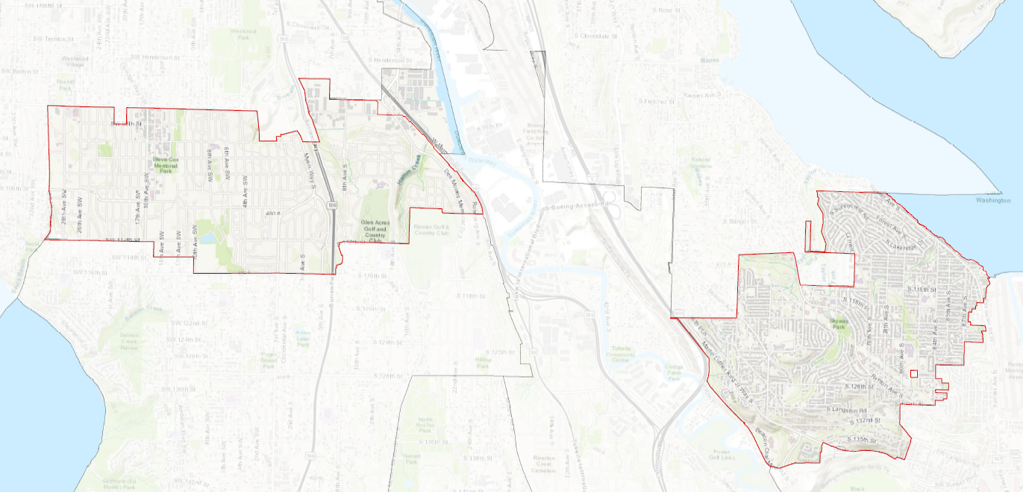

Additionally, 12 segments of County ROW are outlined in the Franchise Area Legal Description (Exhibit A to the proposed agreement). These are segments of ROW in which half of the ROW is Seattle and the other half is King County.

Franchise Compensation. Section 14 in the proposed agreement would require the Franchisee to pay the County franchise compensation in the nature of rent (referred to in the agreement as "Consideration") in exchange for the right to use and occupy the County ROW to place its facilities, as provided in KCC 6.27.080. The application fee paid by the City will be credited against the first franchise compensation payment.

The proposed agreement would set the compensation at the following amounts, which would accrue to the general fund:

- Annual franchise compensation for 2023 through 2027 would be calculated at 8% of the total amount of revenue billed to the Franchisee's customers in unincorporated King County per calendar year. This is estimated to be $4.18 million in 2023 and 2024 and $4.52 million in 2025 and 2026.

- Beginning in 2028, the compensation would be based on 6% of revenue billed to Franchisee's customers in unincorporated King County per calendar year.

The base rate applied to customers in unincorporated King County is subject to the rate review process by the Seattle City Council and approval solely by City Council ordinance. The rate review process by the Seattle City Council is expected to result in an additional 8% rate differential to the base rates established for the Franchisee’s customers in the City of Seattle.

The agreement would reserve the right to impose a utility tax on the Franchisee if such taxing authority is granted by the State. The terms for Consideration shall survive the expiration, revocation, or termination of the franchise until such time as all facilities have been removed or have been decommissioned in place in accordance with the proposed agreements.

According to Seattle City Light staff, City Light customers in unincorporated King County would pay 8% more than they would otherwise with the proposed agreement. This would be approximately $7 per month for a typical residential customer. Currently, rates for unincorporated customers are the same as for customers in the City of Seattle. City Light staff note that there will also be rate increases of 4.5% in 2023 and 2024, which will equate to a $4 per month increase for a typical residential customer. This is in addition to the increase in rate related to the proposed franchise agreement. SCL customers enrolled in the Utility Discount Program would only pay 40% of that amount.

The City of Seattle has existing franchise agreements with cities in its service area where a franchise is required for use of the right-of-way to provide electric service. Consideration amounts and the rate differential between the rate charged by SCL to customers within the City of Seattle and the rate charged by SCL to customers in these cities is consistent with that proposed for unincorporated King County.

Table 1. Seattle City Light Franchise Rates
 | Consideration to City | % Added to Base Rate
Burien* | 4% | 6%
Lake Forest Park* | 4% | 6%
Shoreline | 6% | 8%
SeaTac | 6% | 8%
Tukwila | 6% | 8%
* Franchise agreement allows for consideration and % added to base rate to increase to 6% and 8%, respectively

This is the third franchise agreement to come in front of the Council that includes a set compensation amount. The Council previously adopted Ordinances 19475 and 19476 in August 2022 authorizing franchise agreements with the City of Redmond that included annual franchise compensation amounts. Previous franchise agreements reserved the right to receive compensation and outlined a process for negotiating the amount but did not set a specific amount within the agreement approved by the Council. Addenda for franchise compensation were completed with the following utilities that were interested in discussing franchise compensation: Soos Creek Water & Sewer District; Lake Washington School District; and Puget Sound Energy.

Construction and Maintenance in the ROW. Under the proposed agreement, the Franchisee would be required to apply for and receive ROW construction permits from the Real Estate Services section for any construction or maintenance, unless an emergency is present at which point the Franchisee may take corrective action immediately. The need to take immediate corrective action in an emergency, however, does not relieve the Franchisee from its obligation to obtain a ROW construction permit or any other permits necessary for the corrective action. Any activities performed by the Franchisee shall be performed in accordance with all applicable County standards and upon completion of construction or maintenance, the site and any adjacent affected areas must be restored to as good or better than its previous condition.

Roadside Management Plan. Section 10 of the proposed agreement would require the Franchisee to submit a Roadside Management Assessment (RMA) within 180 days following the effective date that includes an assessment of whether any of its facilities are located above ground and if the above ground facilities comply with the Road Standards. If the Franchisee concludes that it has above ground facilities not in compliance with Road Standards and based on the County's review of the Assessment, the Franchisee shall submit a Roadside Management Plan to remediate Facilities located within the clear zone, within a reasonable time frame based on the evaluation of existing conditions, prioritization by parties, Franchisee capital funding ability, and other factors identified in the Assessment within 90 days of the County's completed RMA review.

Indemnification and Insurance. The proposed agreement would require the Franchisee to agree to release, indemnify, defend (at the County's option and using counsel reasonably acceptable to the County), and hold harmless the County from and against claims to the extent caused by, arising out of, incidental to, or related to the acts or omissions of the Franchisee in connection with Franchisee's exercise of rights and obligations under this franchise. Indemnification terms are outlined in Section 15 of the agreement.

Section 17 of the proposed agreement outlines the insurance requirements and would allow for the County Risk Manager to review and reasonably adjust the insurance section with each amendment and at the end of every five years. The proposed agreement requires $5 million per occurrence and $5 million in the aggregate for general liability insurance.

Default and Dispute Resolution. Under the proposed agreement, the County could revoke or terminate the franchise if the Franchisee defaults on any term or condition of the franchise. Section 21.2 would establish the notification requirements and process for curing the default. Upon revocation or termination, all rights of the Franchisee granted by the franchise shall cease, and the County may suspend or withdraw approval of any active ROW construction permits.

In the case of disputes that may arise throughout the duration of the proposed agreements, Section 22 would set up a dispute resolution process wherein the Franchisee and the County would be required to meet within thirty days to make a "good faith effort" to achieve resolution. If resolution is not reached, the Franchisee and the County would enter into mediation with any expenses incidental to mediation borne equally by the parties unless otherwise agreed. If mediation fails to resolve the dispute within thirty days, then either party may then pursue any remedy under the franchise or under applicable laws.

Amendments and Modifications to the Agreement. King County Council and Seattle City Council approval would be required for most amendments to the franchise agreement, with the following exceptions:

- The Franchise Area could be changed. Additionally, if during the term of the proposed agreements, any portion of the ROW is incorporated or annexed into a city or vacated, the affected portions of the ROW would be removed from the Franchise Area;
- The FMD Director could extend the term of the agreements for up to fifteen years beyond the original expiration date;
- The County Risk Manager could amend the insurance section of the proposed agreements at every amendment or at the end of every five years of the agreements; and
- Minor technical corrections or updates.

Legal. The Council's legal counsel has reviewed the proposed agreement.

Timing and Consequences of Inaction. According to Executive staff, King County cannot collect the negotiated franchise compensation until the franchises are approved by the King County Council and executed by the parties.

In accordance with RCW 36.55.040 and KCC 6.27.050, fifteen days public notice before the Council hearing is required.

AMENDMENT

Amendment 1 would attach a revised franchise agreement that:
- Adjusts the schedule of payment for franchise compensation to reflect agreement execution in 2023 (Sections 14.1 and 14.3);
- Adds language to the nondiscrimination consistent with Seattle Municipal Code (Section 26.2); and,
- Adds a list of segments of County right-of-way to the description of the franchise area, along with associated maps.

INVITED

- Anthony Wright, Division Director, Facilities Management Division
- Terri Hansen, Franchise Project Manager, Facilities Management Division

ATTACHMENTS

- Proposed Ordinance 2022-0307 (and its attachments)
- Amendment 1
- Transmittal Letter
- Fiscal Note
- Franchise Summary

https://kingcounty.gov/about/policies/aep/propertyaep/rpm92dp.aspx
Utility Discount Program (UDP) is available for Seattle City Light customers with 70% Area Median Income and below. Approximately 15% of residential customers are enrolled in the UDP.

