Franchise Summary

Franchisee City of Seattle, Department of City Light
Type of Franchise Electric power facilities
Description City Light’s service area within unincorporated King County
Council Districts Two, Five, Eight
Time Sensitive The City cannot implement the terms and franchise compensation until both Councils approve and the agreement is executed.
Template Status: Negotiated terms and conditions
Hearing and
Public Notice Required: Yes, posting and publication per KCC 6.27.050, RCW 36.55.040 and RCW 80.32.010

Project Information

A franchise agreement approved by the King County Council is required of all public and private utilities to construct, operate, and maintain facilities within King County road rights-of-way.
The parties negotiated a tentative franchise agreement that combines and updates several franchise areas previously authorized, updates the franchise terms, and establishes franchise compensation in exchange for use of County road rights-of-way consistent with KCC 6.27.080.

Context
Rationale for approval: This tentative franchise agreement meets the criteria for approval under K.C.C. 6.27.060 and prescribes the terms and conditions for City Light’s use of road rights-of-way in unincorporated King County.
Policy considerations: In addition to the criteria required by K.C.C. 6.27.060.A-C, this tentative franchise agreement also authorizes the County Risk Manager to review and adjust insurance requirements with each amendment and every five years.
The initial term of this franchise is 10 years. The Facilities Management Division (FMD) Director may approve an extension for up to 15 additional years, subject to Franchisee maintaining substantial compliance with the franchise terms and conditions.
The tentative franchise agreement also includes a reservation of the right to impose a utility tax.
Political considerations: The parties negotiated annual franchise compensation consistent with what City Light pays to communities outside of the City of Seattle where a franchise is required for use of the right-of-way to provide electric service. The rate review process by the Seattle City Council is expected to result in an additional 8% collected from customers in unincorporated areas who receive service from City Light, over the base rates charged to City Light’s customers in the City of Seattle. This 8% differential is consistent with what City Light collects from communities outside of the City of Seattle where a franchise is required for use of the right-of-way to provide electric service.
Community considerations: Ensures continuing electric power service to the residents served by Franchisee.
Other considerations: None.
Fiscal considerations: The City paid a franchise application fee of $2,500 at the time it submitted its initial application to update its franchise areas. The application fee is credited against franchise compensation. KCC 6.27.054.F.
KCC 6.27.080 requires that this franchise include franchise compensation in return for the right to use the right-of-way for construction, operation, and maintenance of electric power facilities. The parties negotiated annual franchise compensation consistent with what City Light pays to communities outside of the City of Seattle where a franchise is required for use of the right-of-way to provide electric service, as follows:
2022 - 2026 | 8% of the total amount of Revenue billed to Franchisee’s customers in unincorporated King County per calendar year
Beginning 2027 | 6% of the total amount of Revenue billed to Franchisee’s customers in unincorporated King County per calendar year

CIP/operational impacts: N/A
Change in property use: N/A
King County Strategic Plan impact: Approval of this right-of-way franchise furthers the King County Strategic Plan objective of exercising sound financial and risk management.
Equity/Social Justice impact: In accordance with Real Property Asset Management Plan (RAMP) policy, FMD reviewed this legislation for Equity and Social Justice (ESJ) impacts. This franchise provides flexibility for the parties to review and mutually agree to adjust minimum insurance requirements to avoid inadvertent disqualification of women- and minority-owned businesses on City Light’s construction contracts (Section 17.7). The parties negotiated franchise compensation, and agreed on terms that are consistent with what City Light collects from communities outside of the City of Seattle where a franchise is required for use of the right-of-way to provide electric service (Section 14).

Franchise Area Map
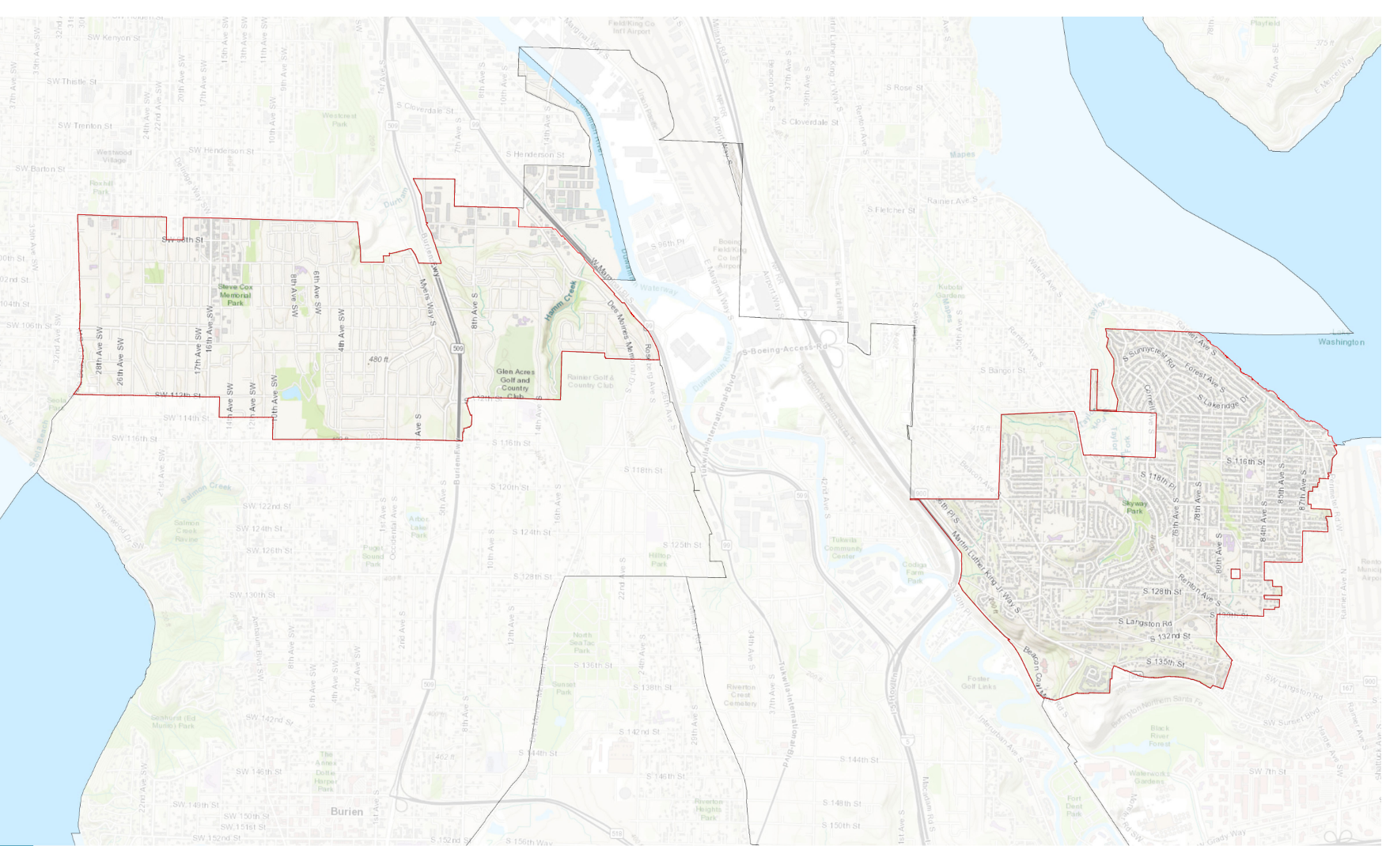

Description of county roads by reference to section, township and range in which the county roads or portions thereof are physically located (RCW 36.55.040):
King County right-of-way located within any of the following locations:

Area 1

All those portions lying outside incorporated cities and towns within Sections 1 and 12, Township 23 North, Range 3 East, W.M., Sections 4, 5, 6, 7, 8 and 9, Township 23 North, Range 4 East, described as follows:

Beginning at the intersection of the east margin of Seola Beach Drive SW with the westerly extension of the north right of way margin of SW 116th Street;

Thence easterly along the north right-of-way margin of SW 116th Street extended Westerly and along the centerline of dedicated SW 116th Street to the east right-of-way margin of 12th Avenue SW;

Thence southerly along the east right-of-way margin of 12th Avenue SW and Ambaum Boulevard SW to the north right of-way margin of SW 128th Street;

Thence easterly along the north right-of-way margin of SW 128th Street, South 128th Street and the easterly extension thereof, to the westerly boundary of the City of Tukwila;

Thence northerly along westerly boundary of the City of Tukwila to its intersection with the southerly boundary of the City of Seattle;

Thence southerly, southeasterly, westerly, and southwesterly along the southerly boundary of the City of Seattle to the point of beginning.

Also, together with those portions of Sections 1, 11, 12, 13, 14, Township 23 North, Range 4 East, W.M., and Sections 6, 7, and 18, Township 23 North, Range 5 East, W.M., described as follows:

Beginning at the intersection of the southerly boundary of the City of Seattle with the southwesterly boundary of Lake Washington;

Thence southeasterly along the southwesterly boundary of Lake Washington to the intersection of the westerly boundary of the City of Renton;

Thence southerly, southwesterly, southeasterly, and westerly along the westerly boundary of the City of Renton to its intersection with the easterly boundary of the City of Tukwila;

Thence northwesterly and northerly along the easterly boundary of the City of Tukwila to the centerline of South Juniper Street in the southerly boundary of the City of Seattle;

Thence running along with southerly boundary of the City of Seattle as follows:

Easterly along the centerline of South Juniper Street to the centerline of 59th Avenue South;

Thence northerly along the center line of 59th Avenue South to the centerline of South Leo Street;

Thence easterly along the centerline of South Leo Street and its extension easterly to the easterly line of Renton Avenue South;

Thence southeasterly along the easterly line of Renton Avenue South to the south line extended westerly Block 8 Lake Ridge Division No. 4 as recorded in Volume 40 of Plats, Pages 22 and 23, records of King County Washington;

Thence easterly along the extended south line of Block 8, the south line of said Block 8, and the south line of Block 8 Lake Ridge Division No. 3 as recorded in Volume 40 of Plats, Page 10, records of King County, Washington, southeast corner of said Plat of Lake Ridge division No. 3;

Thence northerly along the east line of said Plat to the north line of Section 12, Township 23 North, Range 4 East, W.M.;

Thence westerly along the north line of said Section 12, to the northwest corner thereof;

Thence northerly along the west line of Section 1, Township 23 North, Range 4 East, W.M., to the northwest corner of the Plat of Lakeridge Park Estates, as recorded in Volume 134 of Plats, Pages 90 and 91, records of King County, Washington;

Thence easterly along the north line of said Plat to the west boundary of Lakeridge Park;

Thence southerly along the west boundary of Lakeridge Park to the southwest corner thereof;

Thence easterly along the south boundary of Lakeridge Park to the southeast corner thereof;

Thence northerly along the easterly boundary of Lakeridge Park to the northeast corner thereof;

Thence easterly along the westerly extension of the center line of South Ryan Street and the centerline of dedicated South Ryan Street to the point of beginning.

Area 2
The centerline of City of Seattle’s – Seattle City Light Department, Bothell to Renton 230 kV Transmission Line Right of Way as described as follows:
Beginning up at north quarter corner of Section 4, Township 26 North, Range 5 East, W.M., and King County, Washington;

Thence southerly along the north-south centerline of said Section 4, and Sections 9, 16, 21, and 28, Township 26 North, Range 5 East, W.M., to the north line of said south half of the south half of said Section 28;

Thence South 14°53’42” East to the south line of said Section 28;

Thence southerly through the west half of the east half of Section 33, Township 26 North, Range 5 East, W.M., and Section 4, Township 25 North, Range 5 East, W.M., to the intersection of south line and centerline of said Section 4;

Thence southerly along the center lines of Section 9, 16, 21, 28, and 33, Township 25 North, Range 5 East, W.M., and Section 4, Township 24 North, Range 5 East, W.M., to the south line of said Section 4;

Thence southerly through the east half of the west half of Section 9, Township 24 North, Range 5 East, W.M., to the south quarter corner of said Section 9;

Thence southerly along the north-south centerline of Sections 16, 21, 28, and 33, Township 24 North, Range 5 East, W.M., to a line approximately 1,655 feet south of and parallel with the north line of said Section 33;

Thence South 09°47’00” East approximately 10,715 feet through the west half of the east half of Section 33, Township 24 North, Range 5 East, W.M., and the east half of Sections 4 and 9, Township 23 North, Range 5 East, W.M., to appoint in the southeast quarter of the northeast quarter of sad Section 9;

Thence south 05°49’00” West approximately 7,423 feet through the east half of Sections 9 and 16, Township 23 North, Range 5 East, W.M., to a point in the southwest quarter of the southeast quarter of said Section 16;

Thence South 52° 02’00” West to the south line of said Section 16 and the terminus of said centerline;

Except any portion lying within incorporated cities and towns.

