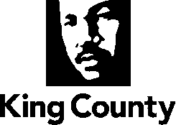

2022 Update to the 2016 King County Comprehensive Plan, as adopted by Ordinance 18427, and as amended by Ordinance 18623 Ordinance 18810, Ordinance 19034, and Ordinance 19146

March 2022

In Chapter 1 Regional Growth Management Planning, in the footnote, on page 1-24, amend as follows:

⁷ ((The plans currently in effect are the West Hill Community Plan, the Skyway-West Hill Land Use Strategy (Phase 1 of the Skyway-West Hill Subarea Plan), White Center Community Action Plan, Fall City Subarea Plan, and the Vashon-Maury Island Community Service Area Subarea Plan.))

In Chapter 1 Regional Growth Management Planning, following page 1-26, delete the Land Use Map and replace with the following:

Land Use Map
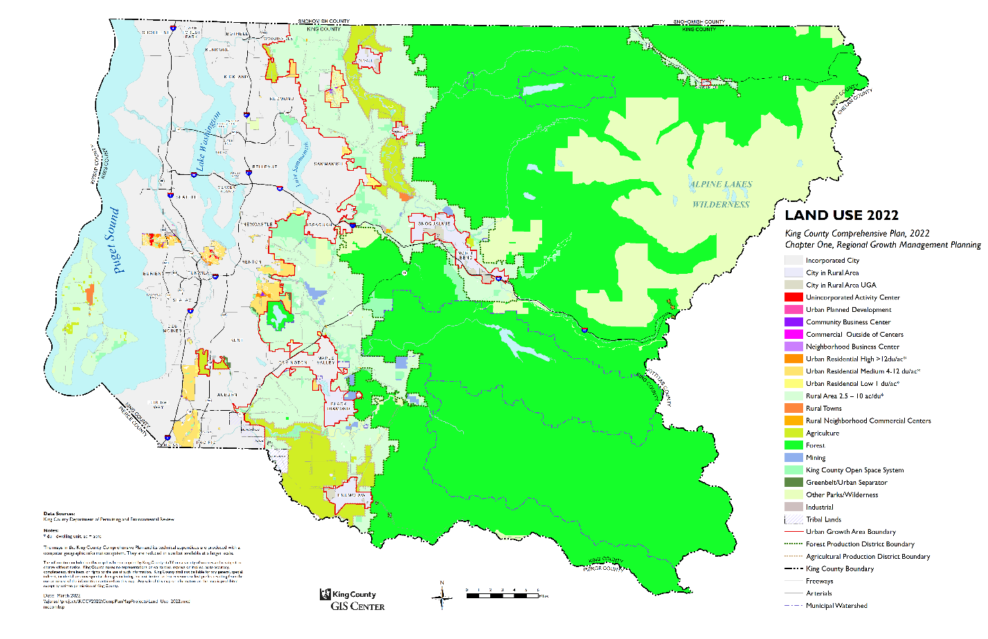

In Chapter 2 Urban Communities, on page 2-15, amend as follows:

U-129 King County supports mixed use developments in community and neighborhood business centers, ((the White Center Unincorporated Activity Center)) unincorporated activity centers, and in areas designated commercial outside of centers.

In Chapter 2 Urban Communities, on page 2-21, amend as follows:

Unincorporated activity centers are one of the primary locations for commercial and industrial development in urban unincorporated King County. ((Currently,)) White Center ((is)) and Skyway are the only designated unincorporated activity centers((, as other such centers are now parts of cities)). The ((White Center Community Action)) North Highline Community Service Area Subarea Plan establishes the size of, and mix of uses allowed in, the White Center Unincorporated Activity Center. The Skyway-West Hill Community Service Area Subarea Plan establishes the size and mix of uses in the Skyway Unincorporated Activity Center.

In Chapter 2 Urban Communities, on page 2-23, amend as follows:

((U 155 Development within the designated White Center Unincorporated Activity Center, as shown on the Comprehensive Plan Land Use Map, shall be in accordance with the White Center Community Action Plan.

U 156 The White Center Community Action Plan establishes the following zoning as appropriate within the White Center Unincorporated Activity Center: Urban Residential, with a density of twelve to forty eight dwelling units per acre, Neighborhood Business, Community Business, Office and Industrial.

U 157 In the White Center Unincorporated Activity Center, existing Industrial uses should be zoned and regulated to preserve their use into the future. Conversion of industrial properties to other uses shall be strictly limited.

White Center was selected as one of three case study areas for study as part of the King County Land Use Transportation Air Quality and Health project, also known as HealthScape . Information from the study showed the types of changes in an area’s urban form and transportation system that can lead to an increase in public health. These results have been used to guide development in the White Center area and to prioritize capital expenditures, such as the construction of the 98th Street Connector, which is a pedestrian walkway between Greenbridge and the commercial area of White Center.))

In Chapter 2 Urban Communities, on page 2-24, amend as follows:

U 158 ((In the White Center Unincorporated Activity Center, n)) New major residential, commercial, and mixed-use developments in unincorporated activity centers should include low impact design features and should promote public health by increasing opportunities for physical activity in daily life. The development should include: safe walkways and bicycle facilities for all ages and abilities with access to commercial areas, schools, and community facilities; trails; and pocket parks.

2. Community Business Centers
Community business centers are primarily retail developments designed to serve a nearby market area of 15,000 to 40,000 people. Community business centers should be sited so they do not adversely affect other centers and are easily accessible by motor vehicles or public transportation, walking or bicycling. Community business centers should be designed to be compatible with adjacent residential uses, and should promote pedestrian and bicycle access. As shown on the Urban Centers map at the end of this chapter, these centers include Fairwood, Roxhill((, Skyway)), Glendale and Top Hat.

In Chapter 2 Urban Communities, on page 2-25, amend as follows:

Neighborhood business centers are shopping areas offering convenience goods and services to local residents. Neighborhood business centers are intended to be small and compatible with adjacent residential areas and often are used on the way to another destination (for example, a fuel stop before or after commuting). Sometimes they consist of only one use or business. Neighborhood business centers should be designed to promote pedestrian and bicycle access.

As shown on the Urban Centers map at the end of this chapter, King County has ((eight)) seven of these centers, including Avondale Corner, Beverly Park, Jovita, Lake Geneva, Martin Luther King Jr. Way/60th Ave.-64th Ave. S, Rainier Ave. S./S. 114th St.-S. 117th St., and Spider Lake((, and Unincorporated South Park)).

In Chapter 2 Urban Communities, following the Potential Annexation Areas map after page 2-39, delete the Urban Centers and replace with the following:

Urban Centers Map
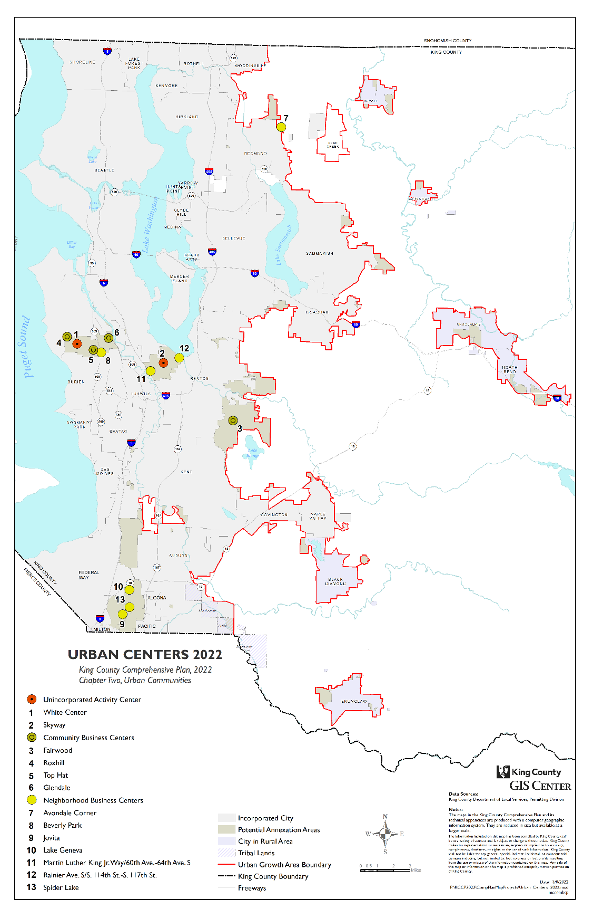
In Chapter 11 Community Service Area Planning, on page 11-4, amend as follows:

CP-100 King County shall implement a Community Service Area subarea planning program. This program includes the following components for the development and implementation of each subarea plan:
a. A subarea plan shall be adopted for each of the six rural Community Service Areas and five large urban Potential Annexation Areas consistent with the scheduled established in the Comprehensive Plan and King County Code Title 20. Each subarea plan shall be streamlined to be focused on locally-specific policies that address long-range community needs.
b. The County shall adopt and update on an ongoing basis, a list of services, programs, facilities, and capital improvements that are identified by the community for each geography, known as a community needs list, to implement the vision and policies in the subarea plan and other County plans and to build on the strengths and assets of the community.
c. The County should dedicate resources toward implementation of the subarea plans and community needs lists in coordination with each community so the highest priorities are addressed where the needs are greatest.
((c)) d. Implementation of each subarea plan and community needs list shall be monitored on an ongoing basis via established performance metrics.
((d)) e. Community engagement for development, review, amendment, adoption, and implementation of each subarea plan shall use the Office of Equity and Social Justice’s equity toolkit.
((e)) f. The King County Council shall have an established role in the Community Service Area subarea planning process, including in the development, review, amendment, adoption, and monitoring the implementation of each subarea plan and community needs list.

((This policy applies going forward with the subarea plans, starting with the North Highline subarea geography. The Skyway-West Hill PAA was under development prior to adoption of this policy. The County adopted a Phase 1 Land Use Strategy that includes a focus on land use, planning and the built environment, in July 2020 and the Executive continues to work with the community on the CSA Subarea Plan. To the extent possible, the County will follow this policy for the Skyway-West Hill Subarea Plan.))

In Chapter 11 Community Service Area Planning, on page 11-4, amend as follows:

Schedule of Community Service Area Subarea Plans
Planning | Adoption | Geography | Other Planning
2018-((21¹)) 22 | ((June)) December 2022 | Skyway-West Hill PAA
2019-((21²)) 22 | ((June)) December 2022 | North Highline PAA
2021-22 | June 2023 | Snoqualmie Valley/NE King CSA
2022-23 | June 2024 | No Subarea Plan | Eight-Year Comp. Plan Update
2023-24 | June 2025 | Greater Maple Valley/Cedar CSA
2024-25 | June 2026 | Fairwood PAA
2025-26 | June 2027 | Bear Creek/Sammamish CSA
2026-27 | June 2028 | Southeast King County CSA | Potential Midpoint Update
2027-28 | June 2029 | Four Creeks/Tiger Mountain CSA
2028-29 | June 2030 | East Renton PAA
2029-30 | June 2031 | Federal Way PAA
2030-31 | June 2032 | No Subarea Plan | Eight-Year Comp. Plan Update
Note: ((P)) Except for Skyway-West Hill and North Highline, planning for each geography is anticipated to take eighteen months, beginning in July and ending the following December. After transmittal of the plan to the Council on the first business day of January, review is anticipated to last six months with adoption anticipated to occur in June.
((1. The Skyway-West Hill Land Use Strategy, Phase 1 of the Skyway-West Hill Subarea Plan, adopted in 2020 is only a portion of the subarea plan anticipated by this schedule, accounting for the longer plan development timeline.
2. The plan development timeline for the North Highline Community Service Area Subarea Plan reflects changes made in the 2020 Comprehensive Plan update.))

In Chapter 11 Community Service Area Planning, on page 11-5, amend as follows:

((Highline Subarea Plan:  Initiate an update to the Highline Community Plan, and incorporate the updated subarea plan into the Comprehensive Plan. The updated subarea plan should include zoning and regulations that: address the historic wide gaps in equity of infrastructure investments and services; facilitate the revitalization of its neighborhoods, local economy, and quality of life of its residents; and have included outreach with the local community in their development.)) | ((West King County CSA – North Highline))

In Chapter 11 Community Service Area Planning, in the footnote, on page 11-7, amend as follows:

¹ ((The plans currently in effect are the West Hill Community Plan, the Skyway-West Hill Land Use Strategy (Phase 1 of the Skyway-West Hill Subarea Plan), White Center Community Action Plan, Fall City Subarea Plan, and the Vashon-Maury Island Community Service Area Subarea Plan)).

In Chapter 11 Community Service Area Planning, on page 11-40, amend as follows:

((The West Hill Community Plan and White Center Community Plan, applying to portions of the original Highline Community Plan, were the last plans adopted by King County (West Hill in 1993, White Center in 1994). They were prepared in conformance with the Growth Management Act (GMA) and are already incorporated as part of the 1994 King County Comprehensive Plan.))

In Chapter 11 Community Service Area Planning, starting on page 11-41, amend as follows:

C. North Highline and White Center Potential Annexation Areas
((Highline has one of the longest histories of any community planning area. Between its original adoption in 1976 as the "SeaTac Communities Plan" and adoption of the 1994 King County Comprehensive Plan, the Highline Community Plan has been updated or amended 13 times, and has been partially or wholly replaced by plans for smaller areas within Highline (e.g., West Hill, Burien Activity Center, White Center Community Action Plan, and SeaTac). The City of SeaTac incorporated in 1990, the City of Burien incorporated in 1993, and numerous portions of the planning area have been annexed by Tukwila and Des Moines. Although the planning area as a whole has grown slowly since 1970, the incorporations and annexations have resulted in a significant decrease in the unincorporated area population. Because the majority of the area has now transitioned into cities, none of the Highline Community Plan is readopted with the exception of West Hill and White Center, which were adopted in 1994 as part of the comprehensive plan but published separately.

The White Center Plan was adopted by King County in 1994, and as such was prepared in conformance with the Growth Management Act and incorporated as part of the 1994 King County Comprehensive Plan.))

Plan History
In 2018, the North Highline Community Service Area Subarea Plan process began. The plan was adopted in December 2022. The history of prior plans for the subarea is as follows:

- 1976 SeaTac Communities Plan. The adoption of the SeaTac Communities Plan pre-dated adoption of the Growth Management Act.
- 1977 Highline Community Plan and 1981 Area Zoning. In 1977, King County adopted the Highline Community Plan,¹ which covered a large area of then-unincorporated King County that today includes the Cities of Burien, Des Moines, Normandy Park, and SeaTac in addition to the currently unincorporated North Highline neighborhoods of White Center and Glendale. The plan was supplemented in 1981 by an Area Zoning Plan,² which implemented zoning consistent with the land use policies of the Highline Community Plan.
- 1994 White Center Community Action Plan and Area Zoning. In 1994, King County augmented the Highline Community Plan with the adoption of the White Center Community Action Plan and Area Zoning (Action Plan),³ a wide-ranging community planning document that implemented new zoning for White Center, in addition to establishing goals in the areas of health and human services, economic and community development, and environmental protection. The Action Plan was designed as a six- to ten-year plan for the area and it was prepared in conformance with the Growth Management Act and incorporated as part of the 1994 King County Comprehensive Plan.⁴
In December 2022, the County adopted the North Highline Community Service Area Subarea Plan, which replaces the policies in the 1994 White Center Community Action Plan. The 2022 subarea plan (bound as a separate document) is adopted as an element of the King County Comprehensive Plan.

Vision and Guiding Principles

Community Vision

Residing on the traditional land of the Duwamish people, North Highline celebrates its ethnic diversity, inter-generational roots and our ongoing inclusivity of diverse families and individuals, especially those most isolated and vulnerable. We call out race and place-based inequities and are committed to dismantling systems of power, privilege, and racial injustice. With mutual support and respect, we value and live out our brilliance and power through community-led initiatives, creating thoughtful development without displacing longtime residents and small business owners, forming and owning the policies that impact us, and building our individual and collective wealth, health, and well-being.

-------------------------------
¹Ordinance 3530
²Ordinance 5453
³Ordinance 11568
⁴Ordinance 13273 removed references to community plans, including the Highline Community Plan, which in effect repealed the Community Plan; however, the Action Plan remained active.
Guiding Principles

The following guiding principles support the community vision and informed and directed the development of the Subarea Plan:
- We are proud of our community and continue to share our collective history with others and to invest in this place, our home away from home for current residents and their future generations.
- We support community investments and programs that reduce the risks, and mitigate the impacts, of residential, economic, and cultural displacement.
- We live in thoughtfully designed housing and commercial spaces where inter-generational households and legacy businesses can stay and where affordability and ownership are realized.
- We support a thriving and equitable economy, with ethnically diverse, community-minded, small business owners, entrepreneurs, and employers.
- We support residents, especially children, youth, and young adults, with services and resources they and their families need to succeed.
- We promote the development of community-desired amenities to improve aesthetics, enrich the community’s diverse physical and cultural assets, and support gathering together as a community.
- We support regulations and investments that result in a safe, secure, and healthy community and compatible development.
- We support residents growing their work interests, skills, and wages.
- We enjoy neighborhoods with accessible and safe streets, roads, and alleyways, with well-connected hiking and biking trails.
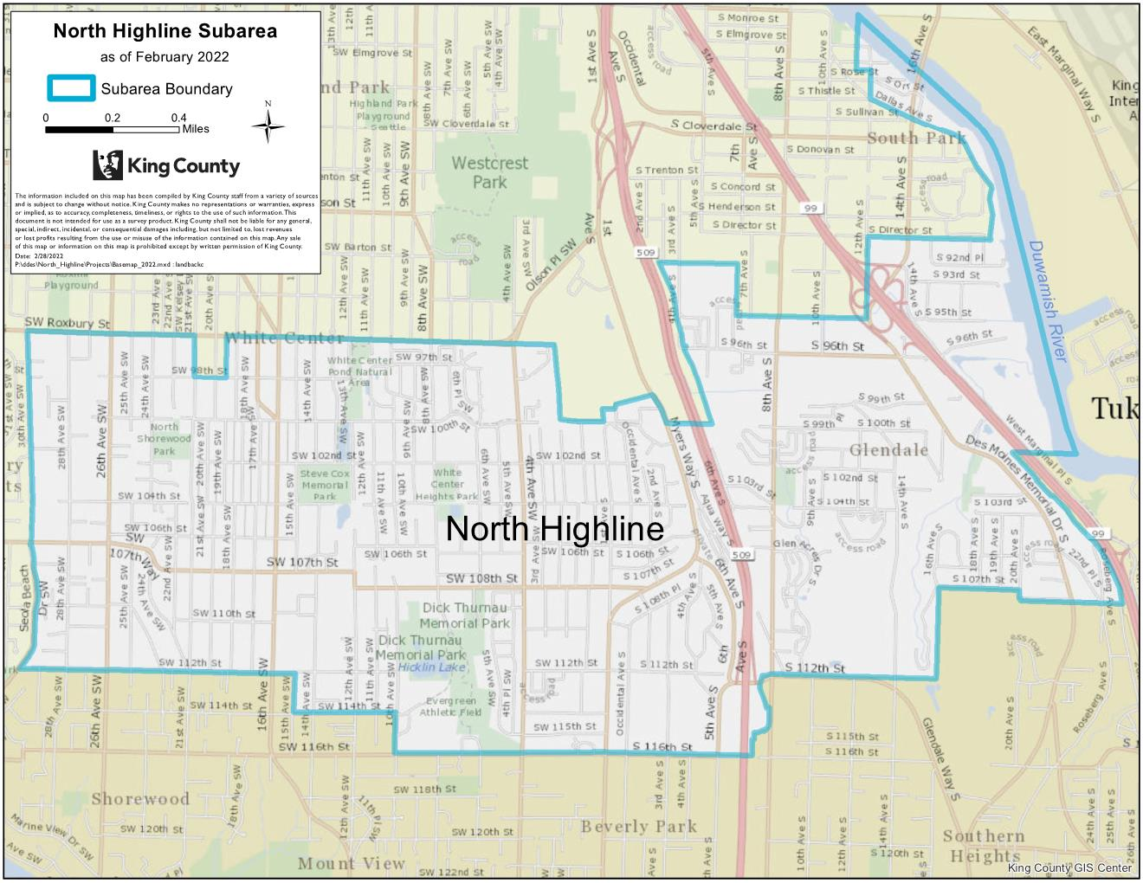

D. Skyway-West Hill Potential Annexation Area

Plan History

In 2018, the Skyway-West Hill Community Service Area Subarea Plan process began. The plan was adopted in December 2022. The history of prior plans for the subarea is as follows:

• 1994 West Hill Community Plan. The West Hill Community Plan was adopted by King County in 1993((, and as such was)). While prepared in conformance with the Growth Management Act ((and incorporated as part of)) it predated the adoption of the((1994 King County)) County’s first Growth Management Act compliant Comprehensive Plan, which was adopted in-1994.
• Community-led Skyway-West Hill Action Plan. In 2014 and 2015, the County ((adopted Motion 14221 and 14351, which called for a comprehensive update to the West Hill Community Plan. Around this same time, the County was also providing)) provided technical assistance to a community-led effort to update some elements of the Community Plan. This community-led effort resulted in the development of ((a local)) the Skyway-West Hill Action Plan, ((which)) or SWAP. The SWAP was proposed ((to be)) as an addendum to the existing Community Plan as part of the 2016 Comprehensive Plan update((. The)), but the County ultimately did not adopt the ((Action Plan in 2016,)) SWAP. Instead, ((as)) the County ((also)), as part of its reinitiated its Subarea Planning Program((. The County has)), committed to work with the community to ((complete a Community Service Area Subarea Plan that includes a review of the Action Plan and an)) update the Community Plan.
• Skyway-West Hill Land Use Strategy, Phase 1 of the Skyway West Hill Subarea Plan. ((A process to develop the Community Service Area Subarea Plan was initiated in 2018.)) As part of the 2020 Plan update, the County adopted a Land Use Strategy, Phase 1 of the Skyway-West Hill Subarea Plan, that outlined the potential policy and implementation steps for land use development in Skyway-West Hill. The Land Use Strategy called for the County to continue working with the community to develop the Skyway-West Hill Community Service Area Subarea Plan to replace the West Hill Community Plan and incorporate the Land Use Strategy.

((A)) In December 2022, the County adopted the Skyway-West Hill Community Service Area Subarea Plan ((that)), which replaces the West Hill Community Plan ((is expected to be adopted in 2022)) and the Land Use Strategy. ((The Subarea Plan will be developed based on a scope of work developed with the community.)) The 2022 subarea plan (bound as a separate document) is adopted as an element of the King County Comprehensive Plan.

Vision & Guiding Principles

Community Vision

Skyway-West Hill will grow into a vibrant, walkable, neighborhood where housing is affordable and local, community-based businesses are thriving. Skyway-West Hill will be an ethnically diverse and civically engaged community where the collective voice, wisdom, and expertise of its residents and business owners are vital in ongoing civic decision-making.

Guiding Principles

The following guiding principles support the community vision and were used to inform and direct the development of the Subarea Plan. The guiding principles were developed over several years of dialogue and work with the community on the subarea plan, drawing from prior community planning efforts and other community conversations. They are intended to express the community’s sentiments.
- Support community health by providing opportunities to access fresh foods, as well as routes and trails for walking and bicycling.
- Create healthy connected neighborhoods where residents have safe and adequate means to connect with their neighbors, schools, community services and programs, and local businesses.
- Encourage equitable development by promoting access to a variety of housing choices, incentivizing the creation of public amenities, addressing displacement, encouraging economic opportunity, and cultivating neighborhood character.
- Create sustainable, vibrant, and walkable business districts that provide opportunities for local businesses to succeed and jobs for area residents.
- Protect existing and create new affordable housing that focuses on preventing displacement and providing options and opportunities for Skyway-West Hill residents to remain in their community.
- Ensure the community grows in a well-planned and sustainable way and that it has the resources necessary for all its residents to thrive and enjoy a high quality of life.
- Ensure Skyway-West Hill’s youth are thriving and engaged in local decision-making so they can advocate for and receive the services and resources they and their families need to succeed.
- Promote the development of community-desired amenities and enrich the community’s diverse physical and cultural assets.
- Inform all policies, regulations, and County actions affecting Skyway-West Hill with the principles of equity and social justice.
- Protect and enhance the existing character of the community’s residential neighborhoods and enhance connections between these areas and business districts.
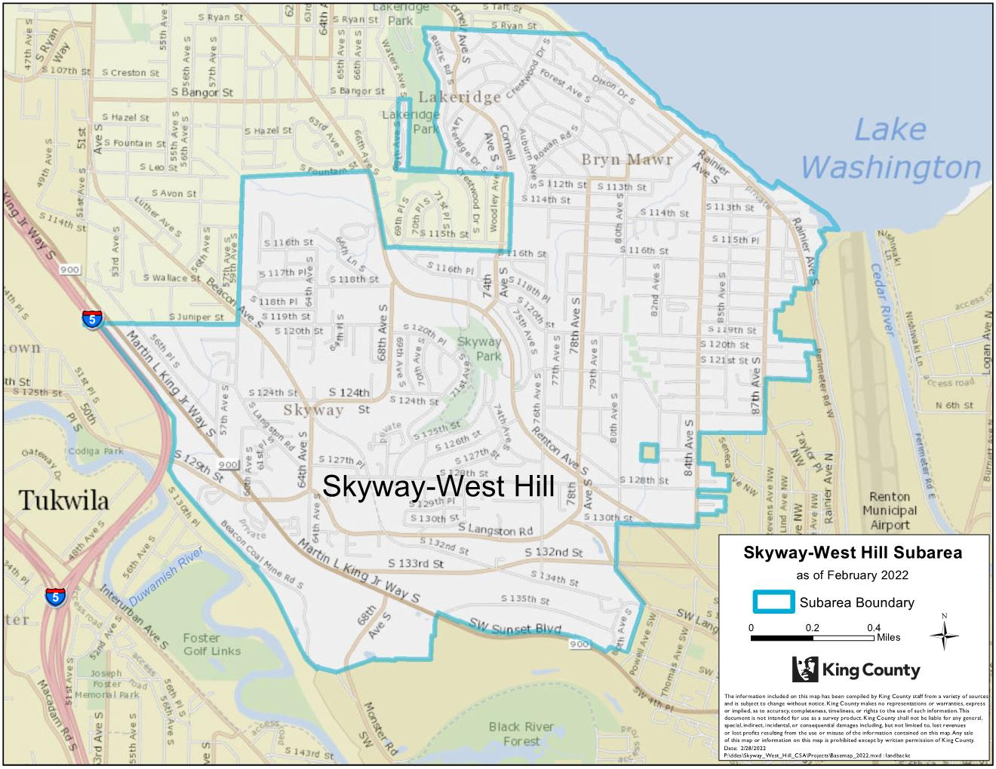

In Chapter 12 Implementation, Amendments and Evaluation, on page 12-10, amend as follows:

Comprehensive Plan Land Use Designations | Zoning Classifications*
Unincorporated Activity Center ((: White Center)) | R-12, R-18, R-24, R-48, NB, CB, O, I
Community Business Center | NB, CB, O
Neighborhood Business Center | NB, O
Commercial Outside of Centers | NB, CB, RB, O, I - this is the range of existing zoning in place when the Comprehensive Plan was adopted
Urban Planned Development | R-1, R-4, R-6, R-8, R-12, R-18,  R-24, R-48, NB, CB, RB, O, I
Urban Residential, High | R-18, R-24, R-48
Urban Residential, Medium | R-4, R-6, R-8, R-12
Urban Residential, Low | R-1
Urban Growth Areas for Cities in Rural Area | UR The following two zones were in place in the North Bend Urban Growth Area when the comprehensive plan was adopted in 1994: I, RB
Rural Town | R-1, R-4, R-6, R-8, R-12, R-18,  R-24, R-48, NB, CB, RB, O, I
Rural Neighborhood Commercial Center | NB
Rural Area | RA-2.5, RA-5, RA-10, RA-20
Industrial | I
Forestry | F, M
Agriculture | A-10, A-35
Mining | M
Greenbelt/Urban Separator | R-1
King County Open Space System | All zones
Other Parks/Wilderness | All zones
* This is the range of zoning that may be allowed within each comprehensive plan land use designations subject to comprehensive plan and subarea plan policies. Actual zoning on a specific property is determined through the area-wide zoning process or through a quasi-judicial rezone application.

Abbreviation | Zoning Classifications
A | Agricultural (10 or 35 acre minimum lot area)
F | Forest (80 acre minimum lot area)
M | Mineral
RA | Rural Area (2.5-acre, 5-acre, 10-acre or 20-acre minimum density)
UR | Urban Reserve
R | Urban Residential (base density in dwelling units per acre)
NB | Neighborhood Business
CB | Community Business
RB | Regional Business
O | Office
I | Industrial

